Nikko Thorne

2/1/2022

Case Project 5

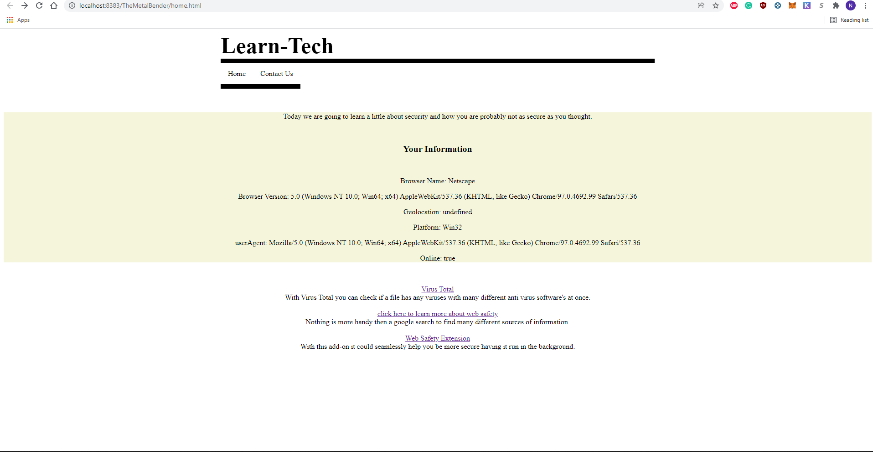

HTML:

<!DOCTYPE html>

<!--

Click nbfs://nbhost/SystemFileSystem/Templates/Licenses/license-default.txt to change this license

Click nbfs://nbhost/SystemFileSystem/Templates/Other/html.html to edit this template

-->

<html lang="en">

<head>

<meta charset="UTF-8">

<meta name="viewport" content="width=device-width, initial-scale=1.0">

<link rel="stylesheet" href="Home.css">

<script src="home.js" defer></script>

</head>

<body>

<div class="header">

<h1>Learn-Tech</h1>

<!-- navbar -->

</div>

<nav id="navbar1">

<ul>

<li><a href="home.html">Home</a></li>

<li><a href="about.html">Contact Us</a></li>

</ul>

</nav>

<br>

<br>

<div id="parentContainer">

<div id="childContainer">

<p>Today we are going to learn a little about security and how you are probably not as

secure as you thought.</p>

<br>

<h2>Your Information</h2>

<br>

<!-- example 1 browser -->

<p id="ex1"></p>

<script>

let browser = navigator.appName;

document.getElementById("ex1").innerHTML = "Browser Name: " + browser;

</script>

<!-- example 2 appVersion -->

<p id="ex2"></p>

<script>

let apV = navigator.appVersion;

document.getElementById("ex2").innerHTML = "Browser Version: " + apV;

</script>

<!-- example 3 geoLocation -->

<p id="ex3"></p>

<script>

let geoL = navigator.geoLocation;

document.getElementById("ex3").innerHTML = "Geolocation: " + geoL;

</script>

<!-- example 4 platform -->

<p id="ex4"></p>

<script>

let plt = navigator.platform;

document.getElementById("ex4").innerHTML = "Platform: " + plt;

</script>

<!-- example 5 userAgent -->

<p id="ex5"></p>

<script>

let usA = navigator.userAgent;

document.getElementById("ex5").innerHTML = "userAgent: " + usA;

</script>

<!-- example 6 onLine -->

<p id="ex6"></p>

<script>

let onL = navigator.onLine;

document.getElementById("ex6").innerHTML = "Online: " + onL;

</script>

</div>

<div id="childContainer2">

<br><p>

<!-- link to virus scan -->

<a href="https://www.virustotal.com/gui/home/upload">Virus Total</a><br>

With Virus Total you can check if a file has any viruses with many different anti virus software's at once.

<br><br>

<!-- link to web safety search -->

<a href="https://www.google.com/search?q=web+safety&rlz=1C1ONGR_enUS986US986&oq=web+safety+&aqs=chrome..69i57j46i199i465i512j0i512j46i175i199i512j0i512l6.1970j0j7&sourceid=chrome&ie=UTF-8">click here to learn more about web safety</a><br>

Nothing is more handy then a google search to find many different sources of information.

<br><br>

<!-- link to web safety addon -->

<a href="https://www.websafety.live/">Web Safety Extension</a><br>

With this add-on it could seamlessly help you be more secure having it run in the background.

</p>

</div>

</div>

</body>

</html>

CSS:

/*

Click nbfs://nbhost/SystemFileSystem/Templates/Licenses/license-default.txt to change this license

Click nbfs://nbhost/SystemFileSystem/Templates/ClientSide/css.css to edit this template

*/

/*

Created on : Jan 24, 2022, 10:27:50 PM

Author : Nikko Thorne

*/

/* Style inputs with type="text", select elements and textareas */

head {

}

body {

background-color: white;

}

h1 {

text-align: left;

background: white;

color: black;

font-size: 50px;

font-family: times;

border-bottom: 10px solid black;

width: 50%;

margin: auto;

}

h2 {

font-size: 20px;

text-align: center;

}

nav {

font-family: times, Verdana, sans-serif;

width: 50%;

margin: auto;

}

ul {

list-style-type: none;

margin: 0;

padding: 0;

overflow: hidden;

background-color: white;

}

li {

float: left;

border-bottom: 10px solid black;

}

li a {

display:block;

color: black;

text-align: center;

padding: 14px 16px;

text-decoration: none;

}

/* link hover */

li a:hover {

background-color: grey;

}

input[type=text], select, textarea {

width: 100%; /* Full width */

padding: 12px; /* Some padding */

border: 1px solid #ccc; /* Gray border */

border-radius: 4px; /* Rounded borders */

box-sizing: border-box; /* Make sure that padding and width stays in place */

margin-top: 6px; /* Add a top margin */

margin-bottom: 16px; /* Bottom margin */

resize: vertical /* Allow the user to vertically resize the textarea (not horizontally) */

}

/* Style the submit button with a specific background color etc */

input[type=submit] {

background-color: #04AA6D;

color: white;

padding: 12px 20px;

border: none;

border-radius: 4px;

cursor: pointer;

}

/* When moving the mouse over the submit button, add a darker green color */

input[type=submit]:hover {

background-color: #45a049;

}

/* Add a background color and some padding around the form */

.container {

background-color: #f2f2f2;

border-radius: 4px;

padding: 20px;

width: 50%;

position: absolute;

top: 50%;

left: 50%;

margin-right: -50%;

transform: translate(-50%, -50%);

}

#parentContainer {

text-align: center;

}

#childContainer {

background-color: beige;

}