Nikko Thorne

02-19-2022

Hands-On Projects 7

Hands-on project 7-1

SS: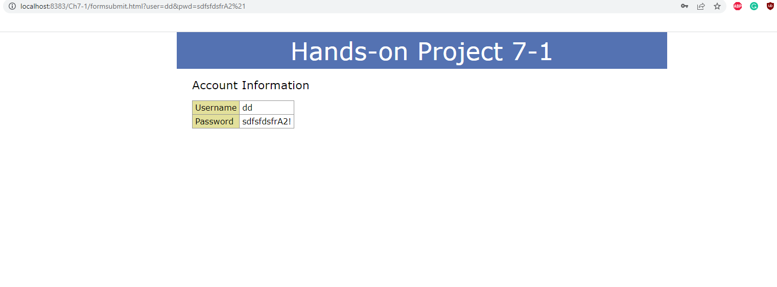

JS:"use strict";

/\* JavaScript 7th Edition

Chapter 7

Project 07-01

Project to validate a form used for setting up a new account

Author: Nikko Thorne

Date: 02-19-2022

Filename: project07-01.js

\*/

let signupForm = document.getElementById("signup");

signupForm.addEventListener("submit", function(e) {

let pwd = document.getElementById("pwd").value;

let feedback = document.getElementById("feedback");

e.preventDefault();

let regex1 = /[A-Z]/;

let regex2 = /\d/;

let regex3 = /[!\$#%]/;

if(pwd.length < 8) {

feedback.textContent = " your password must be at least 8 characters";

} else if (regex1.test(pwd) === false) {

feedback.textContent = "Your password must incluide an upper case";

} else if (regex2.test(pwd) === false) {

feedback.textContent = "Your password must include a number";

} else if (regex3.test(pwd) === false) {

feedback.textContent = "Your password must incluide one of the following '!$#%'";

}

else {

signupForm.submit();

}

}

);

Hands-On Project 7-2

SS: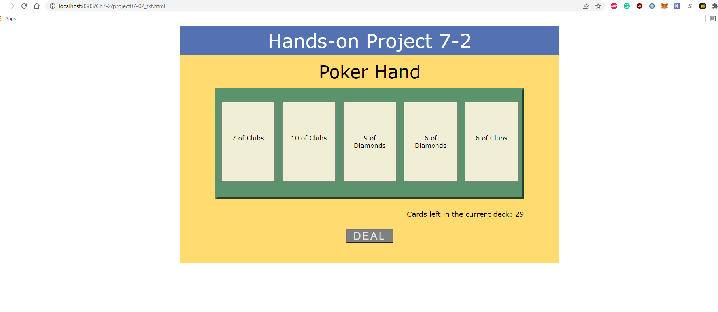

JS:

"use strict";

/\* JavaScript 7th Edition

Chapter 7

Project 07-02

Project to deal cards from a shuffled poker deck

Author: Nikko Thorne

Date: 02-19-2022

Filename: project07-02.js

\*/

let deckStr = `Ace of Hearts, King of Hearts, Queeen of Hearts, Jack of Hearts,

10 of Hearts, 9 of Hearts, 8 of Hearts, 7 of Hearts, 6 of Hearts,

5 of Hearts, 4 of Hearts, 3 of Hearts, 2 of Hearts,

Ace of Spades, King of Spades, Queeen of Spades, Jack of Spades,

10 of Spades, 9 of Spades, 8 of Spades, 7 of Spades, 6 of Spades,

5 of Spades, 4 of Spades, 3 of Spades, 2 of Spades,

Ace of Diamonds, King of Diamonds, Queeen of Diamonds, Jack of Diamonds,

10 of Diamonds, 9 of Diamonds, 8 of Diamonds, 7 of Diamonds, 6 of Diamonds,

5 of Diamonds, 4 of Diamonds, 3 of Diamonds, 2 of Diamonds,

Ace of Clubs, King of Clubs, Queeen of Clubs, Jack of Clubs,

10 of Clubs, 9 of Clubs, 8 of Clubs, 7 of Clubs, 6 of Clubs,

5 of Clubs, 4 of Clubs, 3 of Clubs, 2 of Clubs`;

let cards = document.querySelectorAll("div#hand span");

let cardsLeft = document.getElementById("cardsLeft");

let deck = [];

document.getElementById("deal").onclick = function() {

function newDeck() {

deck = deckStr.split(/,/g);

deck.sort(shuffle);

function shuffle(a, b) {

return 0.5 - Math.random();

}

}

for(let i = 0; i < cards.length; i++) {

if(deck.length === 0) {

newDeck();

}

cards[i].textContent = deck.pop();

cardsLeft.textContent = deck.length;

}

}

Hands-On Project 7-3

SS: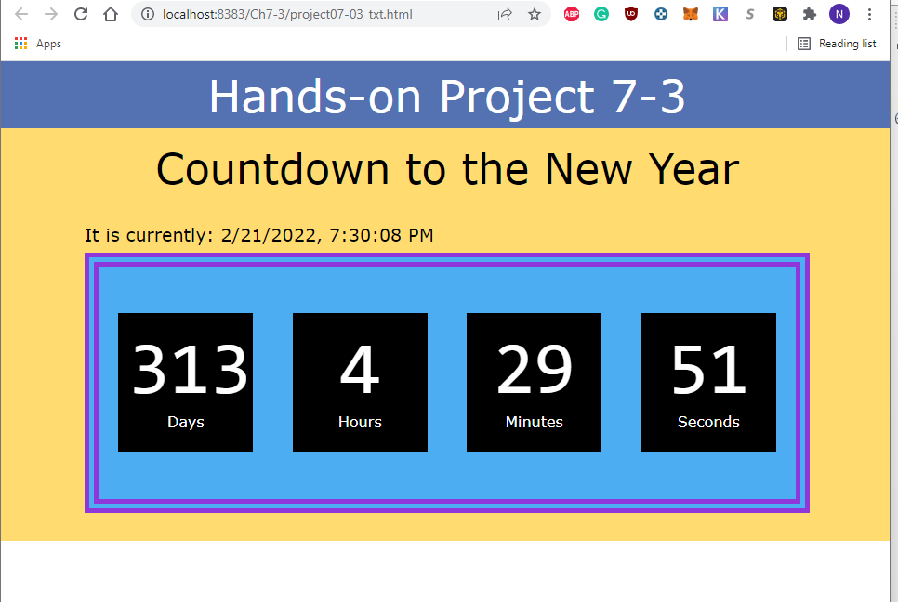

JS:

"use strict";

/\* JavaScript 7th Edition

Chapter 7

Project 07-03

Project to create a New Year's Eve countdown clock

Author: Nikko Thorne

Date: 02/19/2022

Filename: project07-03.js

\*/

let currentTime = document.getElementById("currentTime");

let daysLeftBox = document.getElementById("days");

let hrsLeftBox = document.getElementById("hours");

let minsLeftBox = document.getElementById("minutes");

let secsLeftBox = document.getElementById("seconds");

//set countdown to 1000

window.setInterval(countdown, 1000);

//create countdown function

function countdown() {

let now = new Date();

currentTime.textContent = now.toLocaleString();

let newYear = new Date(2024, 0, 1);

let nextYear = now.getFullYear() + 1;

newYear.setFullYear(nextYear);

let daysLeft = (newYear - now) / (1000 \* 60 \* 60 \* 24);

let hrsLeft = (daysLeft - Math.floor(daysLeft)) \* 24;

let minsLeft = (hrsLeft - Math.floor(hrsLeft)) \* 60;

let secsLeft = (minsLeft - Math.floor(minsLeft)) \* 60;

daysLeftBox.textContent = Math.floor(daysLeft);

hrsLeftBox.textContent = Math.floor(hrsLeft);

minsLeftBox.textContent = Math.floor(minsLeft);

secsLeftBox.textContent = Math.floor(secsLeft);

}

Individual Case Project

SS: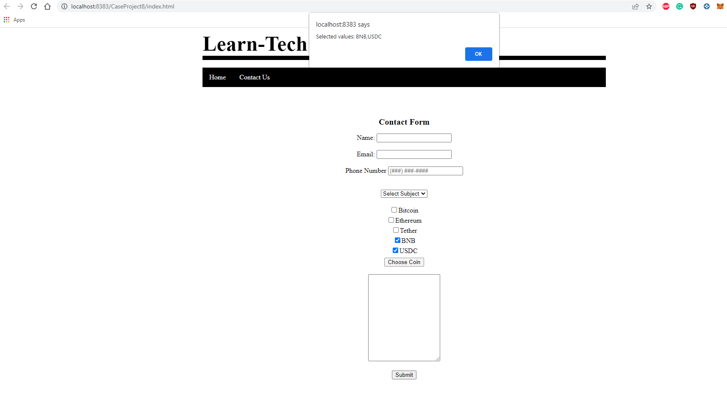

HTML:

<!DOCTYPE html>

<html lang="en-US">

<head>

<script src="classCrypto.js" defer></script>

<script src="usrInputToArray.js" defer></script>

<link rel="stylesheet" href="indx.css">

</head>

<body>

<div class="header">

<h1>Learn-Tech</h1>

<br>

<!-- navbar -->

</div>

<nav class="navbar1">

<ul>

<li><a href="home.html">Home</a></li>

<li><a href="about.html">Contact Us</a></li>

</ul>

</nav>

<br><br><br>

<div class="container">

<h2>Contact Form</h2>

<label>Name: <input name="Name" id="nameBox" type="text"></label><br><br>

<label>Email: <input name="Email" id="emailBox" type="text"></label> <br><br>

<label>Phone Number

<input name="phoneNumber" id="phoneBox" type="tel" pattern="^\d{10}$|^(\(\d{3}\)\s\*)?\d{3}[\s-]?\d{4}$"

required placeholder="(###) ###-####"></label>

<br><br>

<p> <select id="subject1" required>

<option value="">Select Subject</option>

<option value="TechSupport">Tech Support</option>

<option value="Billing">Billing</option>

<option value="Wholesale">Wholesale</option>

</select>

</p>

<table id="tblChecked">

<tr>

<td><input id="chkBitcoin" type="checkbox" value="Bitcoin"/><label for="chkBitcoin">Bitcoin</label></td>

</tr>

<tr>

<td><input id="chkEthereum" type="checkbox" value="Ethereum"/><label for="chkEthereum">Ethereum</label></td>

</tr>

<tr>

<td><input id="chkTether" type="checkbox" value="Tether"/><label for="chkTether">Tether</label></td>

</tr>

<tr>

<td><input id="chkBNB" type="checkbox" value="BNB"/><label for="chkBNB">BNB</label></td>

</tr>

<tr>

<td><input id="chkUSDC" type="checkbox" value="USDC"/><label for="chkUSDC">USDC</label></td>

</tr>

</table>

<br />

<input type = "button" value = "Choose Coin" onclick = "userInput()" /> <br><br>

<textarea id="textArea1" name="textArea1" placeholder="" style="height:200px" required></textarea>

<br><br>

<button onclick="">Submit</button>

<p id="log"></p>

</div>

</body>

</html>

~~~~~~~~~~~~~~~~~~~~~~~~~~~~~~~~~~~~~~~~~~~~~~~~~~~~~~~~~

JS:

usrInputToArray

function userInput() {

var selected = new Array();

var tblChecked = document.getElementById("tblChecked");

var checkd = tblChecked.getElementsByTagName("INPUT");

for (var i = 0; i < checkd.length; i++) {

if (checkd[i].checked) {

selected.push(checkd[i].value);

} else {

selected.pop(checkd[i].value);

}

}

if (selected.value !== 0) {

let selectedChoices = selected.toString();

alert("Selected values: " + selected.join(","));

}

};