Nikko Thorne

Chapter 1

Hello World

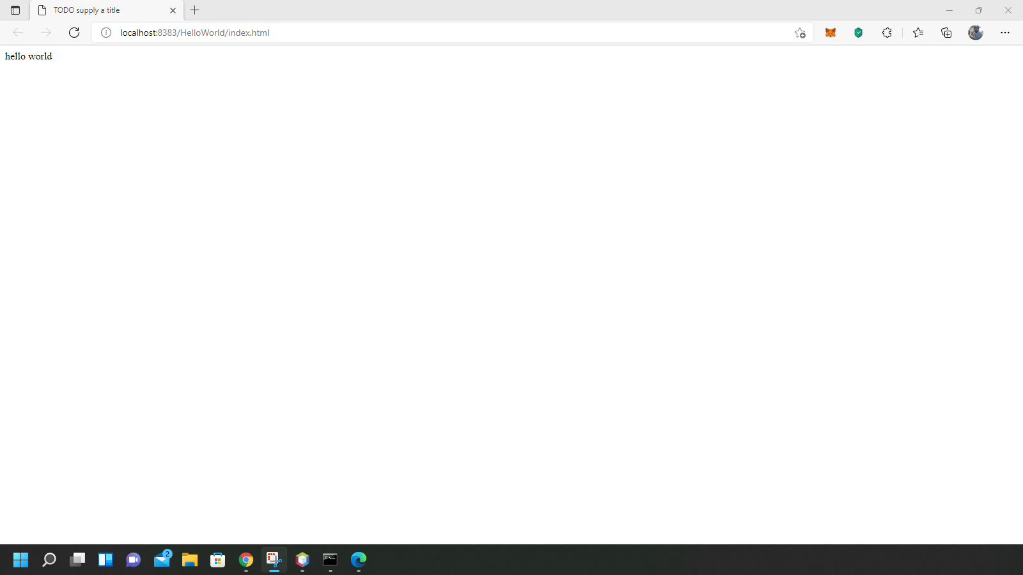

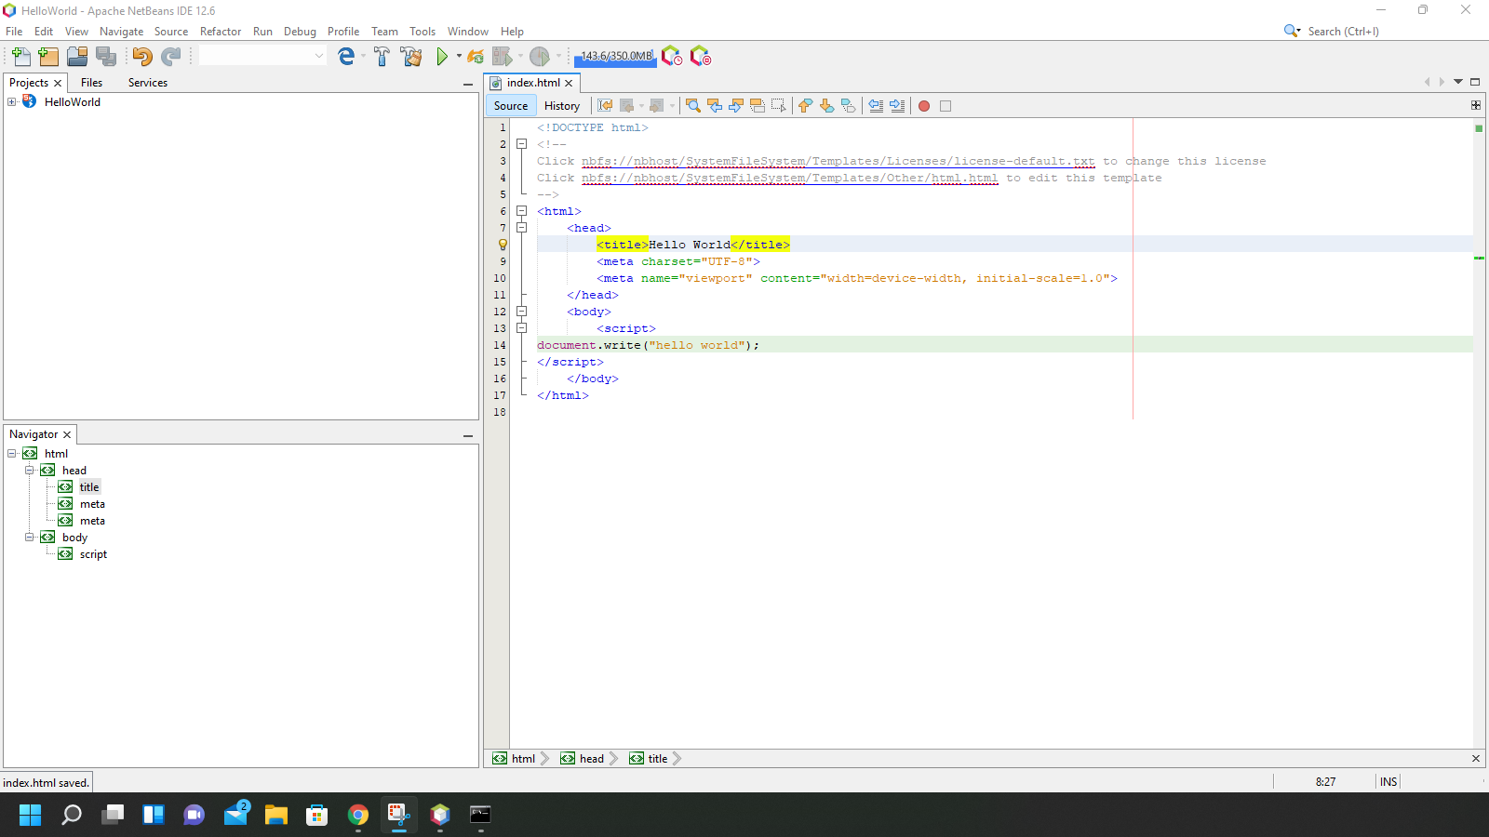

<!DOCTYPE html>

<!--

Click nbfs://nbhost/SystemFileSystem/Templates/Licenses/license-default.txt to change this license

Click nbfs://nbhost/SystemFileSystem/Templates/Other/html.html to edit this template

-->

<html>

<head>

<title>Hello World</title>

<meta charset="UTF-8">

<meta name="viewport" content="width=device-width, initial-scale=1.0">

</head>

<body>

<script>

document.write("hello world");

</script>

</body>

</html>