Nikko Thorne

Chapter 3

Hands-On Project 3-1

SS:

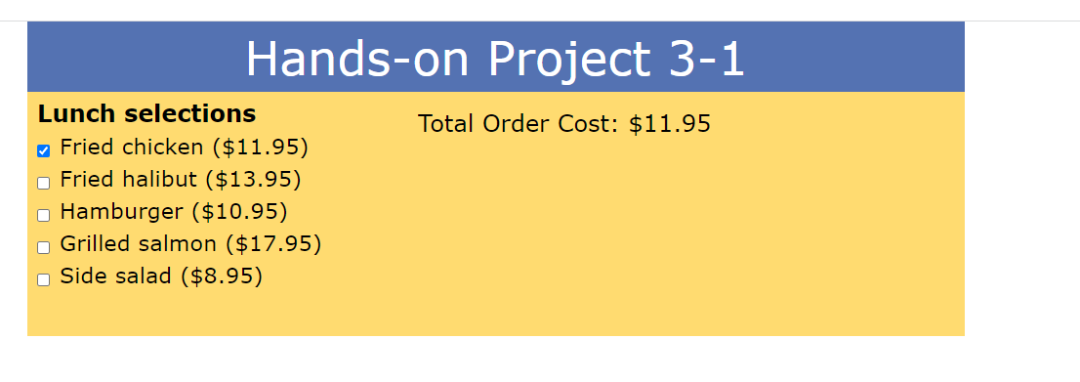

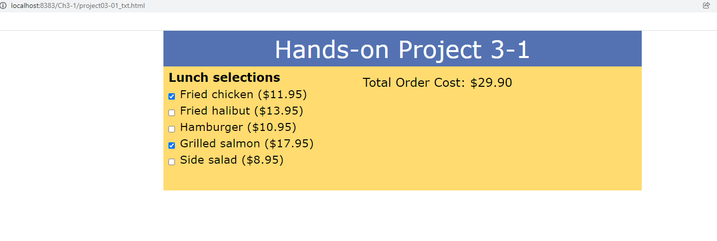

Code:

Html:

<!DOCTYPE html>

<html>

<head>

<!--

JavaScript 7th Edition

Chapter 3

Hands-on Project 3-1

Author: Nikko Thorne

Date: 01/15/2022

Filename: project03-01.html

-->

<meta charset="utf-8" />

<meta name="viewport" content="width=device-width,initial-scale=1.0">

<title>Hands-on Project 3-1</title>

<link rel="stylesheet" href="styles.css" />

</head>

<body>

<header>

<h1>

Hands-on Project 3-1

</h1>

</header>

<article>

<h2>Lunch selections</h2>

<form>

<input type="checkbox" class="menuItem" id="item1" value="11.95" />

<label for="item1">Fried chicken ($11.95)</label>

<input type="checkbox" class="menuItem" id="item2" value="13.95" />

<label for="item2">Fried halibut ($13.95)</label>

<input type="checkbox" class="menuItem" id="item3" value="10.95" />

<label for="item3">Hamburger ($10.95)</label>

<input type="checkbox" class="menuItem" id="item4" value="17.95" />

<label for="item4">Grilled salmon ($17.95)</label>

<input type="checkbox" class="menuItem" id="item5" value="8.95" />

<label for="item5">Side salad ($8.95)</label>

</form>

<aside>

Total Order Cost: <span id="billTotal">$0</span>

</aside>

</article>

<script src="project03-01_txt.js" defer></script>

</body>

</html>

~~~~~~~~~~~~~~~~~~~~~~~~~~~~~~~~~~~~~~~~~~~~~~~~~~~~~~~~~~~

Java

/* JavaScript 7th Edition

Chapter 3

Project 03-01

Application to calculate total order cost

Author: Nikko Thorne

Date: 01/15/2022

Filename: project03-01.js

*/

//variable for menu

let menuItems = document.getElementsByClassName("menuItem");

for(let i = 0; i < menuItems.length; i++) {

menuItems[i].addEventListener("click", calcTotal);

}

//Function for calcTotal

function calcTotal(){

let orderTotal = 0;

for(let i = 0; i < menuItems.length; i++) {

if(menuItems[i].checked) {

orderTotal += (Number(menuItems[i].value) * 1);

}

document.getElementById("billTotal").innerHTML = formatCurrency(orderTotal);

}

};

// Function to display a numeric value as a text string in the format $##.##

function formatCurrency(value) {

return "$" + value.toFixed(2);

}

Hands-On Project 3-2

SS:

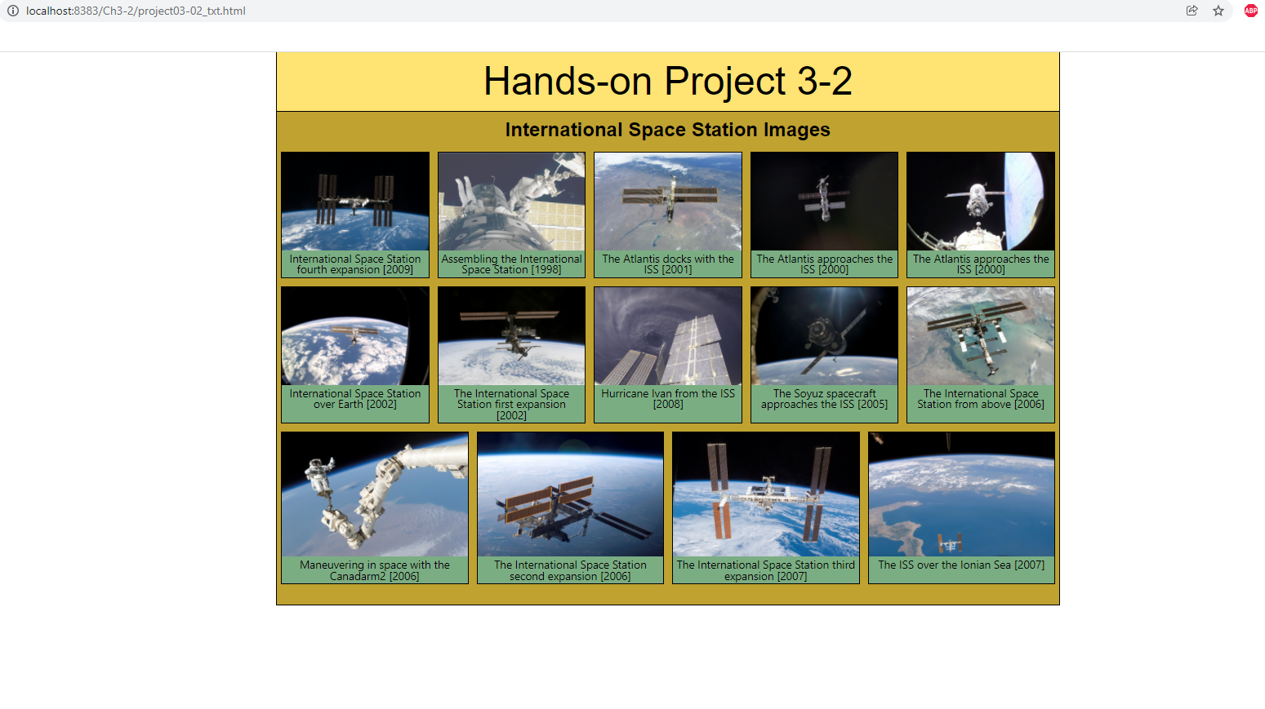

Code:

HTML: <!DOCTYPE html>

<html>

<head>

<!--

JavaScript 7th Edition

Chapter 3

Hands-on Project 3-2

Author: Nikko Thorne

Date: 01/16/2022

Filename: project03-02.html

-->

<meta charset="utf-8" />

<meta name="viewport" content="width=device-width,initial-scale=1.0">

<title>Hands-on Project 3-2</title>

<link rel="stylesheet" href="styles.css" />

</head>

<body>

<header>

<h1>

Hands-on Project 3-2

</h1>

</header>

<article>

<h2>International Space Station Images</h2>

<div id="gallery"></div>

</article>

<script src="project03-02_txt.js" defer></script>

</body>

</html>

~~~~~~~~~~~~~~~~~~~~~~~~~~~~~~~~~~~~~~~~~~~~~~~~~~

Javascript:

/* JavaScript 7th Edition

Chapter 3

Project 03-02

Application to generate a slide gallery

Author: Nikko Thorne

Date: 01/16/2022

Filename: project03-02.js

*/

let captions = new Array(14);

captions[0]="International Space Station fourth expansion [2009]";

captions[1]="Assembling the International Space Station [1998]";

captions[2]="The Atlantis docks with the ISS [2001]";

captions[3]="The Atlantis approaches the ISS [2000]";

captions[4]="The Atlantis approaches the ISS [2000]";

captions[5]="International Space Station over Earth [2002]";

captions[6]="The International Space Station first expansion [2002]";

captions[7]="Hurricane Ivan from the ISS [2008]";

captions[8]="The Soyuz spacecraft approaches the ISS [2005]";

captions[9]="The International Space Station from above [2006]";

captions[10]="Maneuvering in space with the Canadarm2 [2006]";

captions[11]="The International Space Station second expansion [2006]";

captions[12]="The International Space Station third expansion [2007]";

captions[13]="The ISS over the Ionian Sea [2007]";

let htmlCode = "";

for(i = 0; i < captions.length; i++) {

htmlCode += "<figure>";

htmlCode += "<img alt='' src='slide" + i + ".jpg' />";

htmlCode += "<figcaption>" + captions[i] + "</figcaption>";

htmlCode += "</figure>";

}

document.getElementById("gallery").innerHTML = htmlCode;

Hands-On Project 3-3

SS:

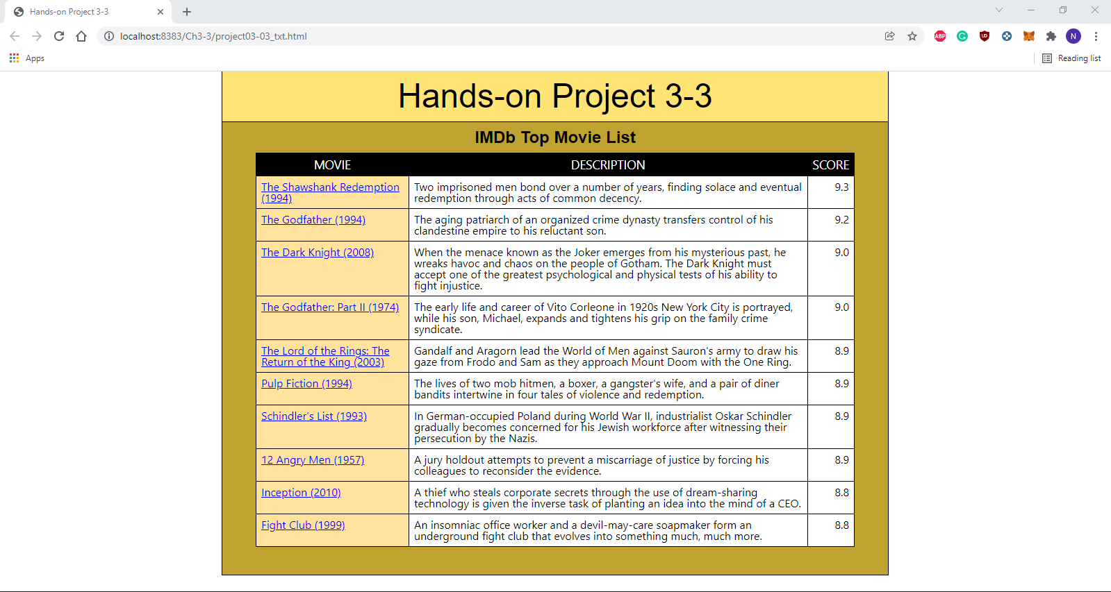

Code:

Html:

<!DOCTYPE html>

<html>

<head>

<!--

JavaScript 7th Edition

Chapter 3

Hands-on Project 3-3

Author: Nikko Thorne

Date: 01/17/2022

Filename: project03-03.html

-->

<meta charset="utf-8" />

<meta name="viewport" content="width=device-width,initial-scale=1.0">

<title>Hands-on Project 3-3</title>

<link rel="stylesheet" href="styles.css" />

<script src="project03-03_txt.js" defer></script>

</head>

<body>

<header>

<h1>

Hands-on Project 3-3

</h1>

</header>

<article>

<h2>IMDb Top Movie List</h2>

<div id="movieList">

<table>

<thead>

<th>Movie</th><th>Description</th><th>Score</th>

</thead>

<tbody>

</tbody>

</table>

</div>

</article>

</body>

</html>

~~~~~~~~~~~~~~~~~~~~~~~~~~~~~~~~~~~~~~~~~~~~~~~~~~~~~~~~~~~~~~~

Javascript:

/* JavaScript 7th Edition

Chapter 3

Project 03-03

Application to generate a movie list

Author: Nikko Thorne

Date: 01/17/2022

Filename: project03-03.js

*/

let titles = [];

titles[0] = "The Shawshank Redemption (1994)";

titles[1] = "The Godfather (1994)";

titles[2] = "The Dark Knight (2008)";

titles[3] = "The Godfather: Part II (1974)";

titles[4] = "The Lord of the Rings: The Return of the King (2003)";

titles[5] = "Pulp Fiction (1994)";

titles[6] = "Schindler's List (1993)";

titles[7] = "12 Angry Men (1957)";

titles[8] = "Inception (2010)";

titles[9] = "Fight Club (1999)";

let ratings = [];

ratings[0] = "9.3";

ratings[1] = "9.2";

ratings[2] = "9.0";

ratings[3] = "9.0";

ratings[4] = "8.9";

ratings[5] = "8.9";

ratings[6] = "8.9";

ratings[7] = "8.9";

ratings[8] = "8.8";

ratings[9] = "8.8";

let summaries = [];

summaries[0] = "Two imprisoned men bond over a number of years, finding solace and eventual redemption through acts of common decency.";

summaries[1] = "The aging patriarch of an organized crime dynasty transfers control of his clandestine empire to his reluctant son.";

summaries[2] = "When the menace known as the Joker emerges from his mysterious past, he wreaks havoc and chaos on the people of Gotham. The Dark Knight must accept one of the greatest psychological and physical tests of his ability to fight injustice.";

summaries[3] = "The early life and career of Vito Corleone in 1920s New York City is portrayed, while his son, Michael, expands and tightens his grip on the family crime syndicate.";

summaries[4] = "Gandalf and Aragorn lead the World of Men against Sauron's army to draw his gaze from Frodo and Sam as they approach Mount Doom with the One Ring.";

summaries[5] = "The lives of two mob hitmen, a boxer, a gangster's wife, and a pair of diner bandits intertwine in four tales of violence and redemption.";

summaries[6] = "In German-occupied Poland during World War II, industrialist Oskar Schindler gradually becomes concerned for his Jewish workforce after witnessing their persecution by the Nazis.";

summaries[7] = "A jury holdout attempts to prevent a miscarriage of justice by forcing his colleagues to reconsider the evidence.";

summaries[8] = "A thief who steals corporate secrets through the use of dream-sharing technology is given the inverse task of planting an idea into the mind of a CEO.";

summaries[9] = "An insomniac office worker and a devil-may-care soapmaker form an underground fight club that evolves into something much, much more.";

let links = [];

links[0] = "https://www.imdb.com/title/tt0111161/?ref_=adv_li_tt";

links[1] = "https://www.imdb.com/title/tt0068646/?ref_=adv_li_tt";

links[2] = "https://www.imdb.com/title/tt0468569/?ref_=adv_li_tt";

links[3] = "https://www.imdb.com/title/tt0071562/?ref_=adv_li_tt";

links[4] = "https://www.imdb.com/title/tt0167260/?ref_=adv_li_tt";

links[5] = "https://www.imdb.com/title/tt0110912/?ref_=adv_li_tt";

links[6] = "https://www.imdb.com/title/tt0108052/?ref_=adv_li_tt";

links[7] = "https://www.imdb.com/title/tt0050083/?ref_=adv_li_tt";

links[8] = "https://www.imdb.com/title/tt1375666/?ref_=adv_li_tt";

links[9] = "https://www.imdb.com/title/tt0137523/?ref_=adv_li_tt";

//htmlCode Variable

let htmlCode = "";

//for loop

for(let i = 0; i < titles.length; i++) {

htmlCode += "<tr>";

htmlCode += "<td>";

htmlCode += "<a href='" + links[i] + "'>" + titles[i] + "</a>";

htmlCode += "</td>";

htmlCode += "<td>";

htmlCode += summaries[i];

htmlCode += "</td>";

htmlCode += "<td>";

htmlCode += ratings[i];

htmlCode += "</td>";

htmlCode += "</tr>";

}

let tableBody = document.getElementsByTagName("tbody")[0];

tableBody.innerHTML = htmlCode;

Hands-On Project 3-4

SS:

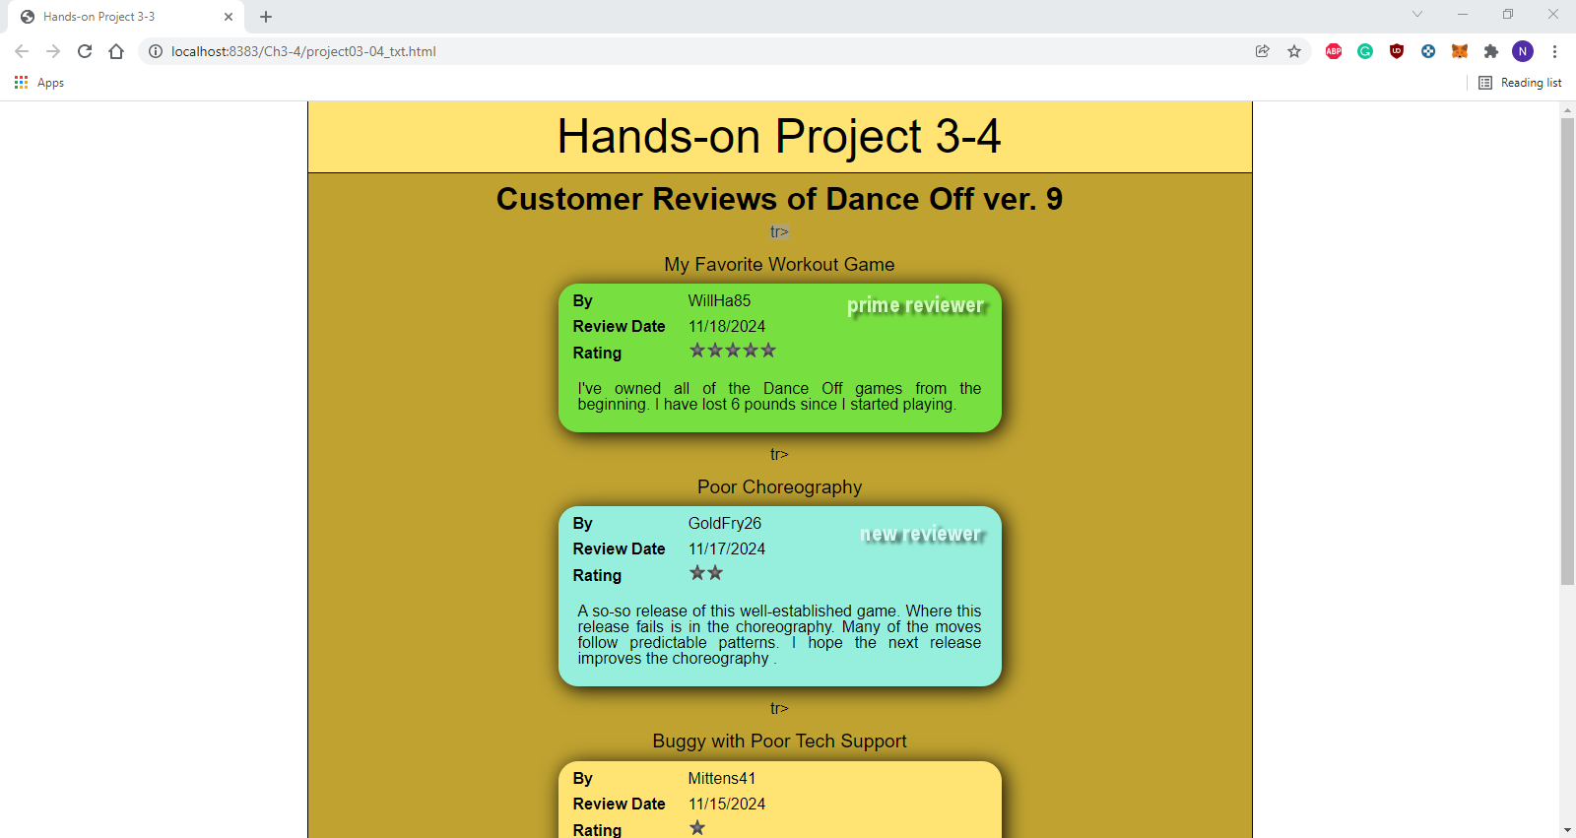

Code:

HTML:

<!DOCTYPE html>

<html>

<head>

<!--

JavaScript 7th Edition

Chapter 3

Hands-on Project 3-4

Author: Nikko Thorne

Date: 01/17/2022

Filename: project03-04.html

-->

<meta charset="utf-8" />

<meta name="viewport" content="width=device-width,initial-scale=1.0">

<title>Hands-on Project 3-3</title>

<link rel="stylesheet" href="styles.css" />

<script src="project03-04_txt.js" defer></script>

</head>

<body>

<header>

<h1>

Hands-on Project 3-4

</h1>

</header>

<article>

<h2>Customer Reviews of <em>Dance Off ver. 9</em></h2>

</article>

</body>

</html>

~~~~~~~~~~~~~~~~~~~~~~~~~~~~~~~~~~~~~~~~~~~~~~~

Javascript:

/* JavaScript 7th Edition

Chapter 3

Project 03-04

Application to write a list of customer reviews

Author: Nikko Thorne

Date: 01/17/2022

Filename: project03-04.js

*/

let reviewers = ["WillHa85", "GoldFry26", "Mittens41", "Tompkins8"];

let reviewType = ["P", "N", "", ""]

let stars = [5, 2, 1, 4];

let reviewDates = ["11/18/2024", "11/17/2024", "11/15/2024", "11/10/2024"];

let reviews = [

"I've owned all of the Dance Off games from the beginning. I have lost 6 pounds since I started playing.",

"A so-so release of this well-established game. Where this release fails is in the choreography. Many of the moves follow predictable patterns. I hope the next release improves the choreography .",

"The installation was buggy and kept crashing my gaming console. I spent several hours on tech support with no solution to my problem. I finally returned it and got my money back. I wish I could give it a zero star rating.",

"The latest version of Dance Off improves upon the 8th Edition only slightly; still is one of the best dance-style games on the market.",

];

let reviewTitles = ["My Favorite Workout Game", "Poor Choreography", "Buggy with Poor Tech Support", "Nice Improvement"];

//function

function starImages(rating) {

let imageText = "";

//for loop

for(let i = 1; i <= rating; i++) {

imageText += "<img src = 'star.png' alt=''>";

}

return imageText;

}

//for loop

for(let i = 0; i < reviewers.length; i++) {

let reviewCode = "";

if(reviewType[i] === "P") {

reviewCode += "<table class = 'prime' > ";

}

else if(reviewType[i] === "N") {

reviewCode += "<table class = 'new' > ";

}

else {

reviewCode += "<table>";

}

reviewCode += "<caption>" + reviewTitles[i] + "</caption>";

reviewCode += "<tr><th>By</th><td>" + reviewers[i] + "</td></tr>";

reviewCode += "<tr><th>Review Date</th><td>" + reviewDates[i] + "</td></tr>";

reviewCode += "<tr><th>Rating</th><td>" + starImages(stars[i]) + "</td></tr>";

reviewCode += "tr><td colspan='2'>" + reviews[i] + "</td></tr>";

reviewCode += "</table>";

document.getElementsByTagName("article")[0].insertAdjacentHTML("beforeEnd", reviewCode);

}