Case project 3

SS:

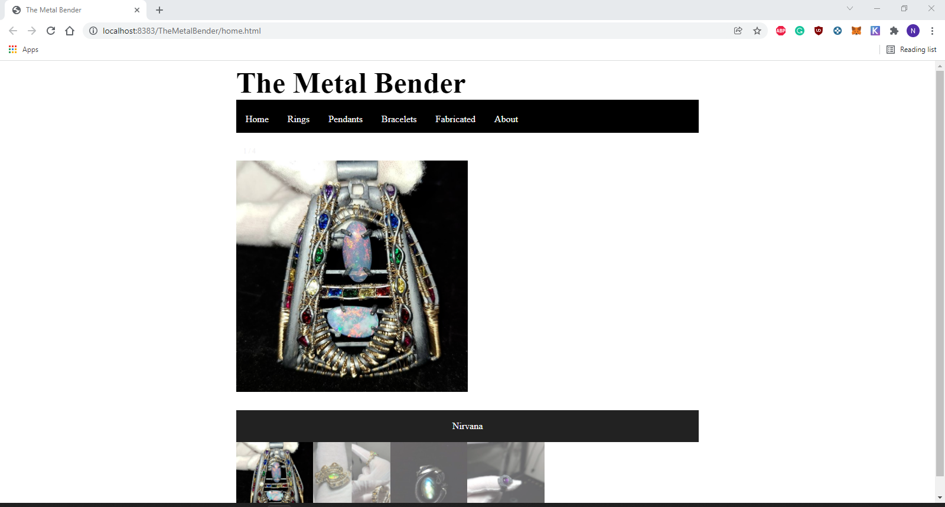

Code:

HTML:<!DOCTYPE html>

<!--

Click nbfs://nbhost/SystemFileSystem/Templates/Licenses/license-default.txt to change this license

Click nbfs://nbhost/SystemFileSystem/Templates/Other/html.html to edit this template

-->

<html>

<head>

<title>The Metal Bender</title>

<meta charset="UTF-8">

<meta name="viewport" content="width=device-width, initial-scale=1.0">

<link rel="stylesheet" href="Home.css">

<script src="home.js" defer></script>

</head>

<body>

<div class="header">

<h1>The Metal Bender</h1>

<!-- navbar -->

</div>

<nav class="navbar1">

<ul>

<li><a href="home.html">Home</a></li>

<li><a href="rings.html">Rings</a></li>

<li><a href="pendants.html">Pendants</a></li>

<li><a href="bracelets.html">Bracelets</a></li>

<li><a href="fabricated.html">Fabricated</a></li>

<li><a href="about.html">About</a></li>

</ul>

</nav>

<p></p>

<p></p>

<!-- slideshow gallery -->

<!-- Container for the image gallery -->

<div class="container">

<!-- Full-width images with number text -->

<div class="mySlides">

<div class="numbertext">1 / 4</div>

<img src="Capture1.png" style="width:50%">

</div>

<div class="mySlides">

<div class="numbertext">2 / 4</div>

<img src="capture2.jpg" style="width:50%">

</div>

<div class="mySlides">

<div class="numbertext">3 / 4</div>

<img src="capture3.jpg" style="width:50%">

</div>

<div class="mySlides">

<div class="numbertext">4 / 4</div>

<img src="capture4.jpg" style="width:50%">

</div>

<!-- Next and previous buttons -->

<a class="prev" onclick="plusSlides(-1)">&#10094;</a>

<a class="next" onclick="plusSlides(1)">&#10095;</a>

<!-- Image text -->

<div class="caption-container">

<p id="caption"></p>

</div>

<!-- Thumbnail images -->

<div class="row">

<div class="column">

<img class="demo cursor" src="Capture1.png" style="width:100%" onclick="currentSlide(1)" alt="Nirvana">

</div>

<div class="column">

<img class="demo cursor" src="capture2.jpg" style="width:100%" onclick="currentSlide(2)" alt="Ethiopian Ring">

</div>

<div class="column">

<img class="demo cursor" src="capture3.jpg" style="width:100%" onclick="currentSlide(3)" alt="Labradorite Pendant">

</div>

<div class="column">

<img class="demo cursor" src="capture4.jpg" style="width:100%" onclick="currentSlide(4)" alt="Amethyst Ring">

</div>

</div>

</div>

</body>

</html>

~~~~~~~~~~~~~~~~~~~~~~~~~~~~~~~~~~~~~~~~~~~~~~~~~~~~~~~~~~~~~~

CSS:

head {

}

body {

background-color: white;

}

h1 {

text-align: left;

background: white;

color: black;

font-size: 50px;

font-family: times;

border-bottom: 10px solid black;

width: 50%;

margin: auto;

}

h2 {

font-size: 20px;

text-align: center;

}

nav {

font-family: times, Verdana, sans-serif;

width: 50%;

margin: auto;

}

ul {

list-style-type: none;

margin: 0;

padding: 0;

overflow: hidden;

background-color: black;

}

li {

float: left;

}

li a {

display:block;

color: white;

text-align: center;

padding: 14px 16px;

text-decoration: none;

}

/\* link hover \*/

li a:hover {

background-color: grey;

}

/\* start of gallery \*/

\* {

box-sizing: border-box;

}

/\* Position the image container (needed to position the left and right arrows) \*/

.container {

position: sticky;

max-height: 250px;

min-height: 250px;

width: 50%;

margin: auto;

}

/\* Hide the images by default \*/

.mySlides {

display: none;

}

/\* Add a pointer when hovering over the thumbnail images \*/

.cursor {

cursor: pointer;

}

/\* Next & previous buttons \*/

.prev,

.next {

cursor: pointer;

position: static;

top: 40%;

width: auto;

padding: 16px;

margin-top: -50px;

color: white;

font-weight: bold;

font-size: 20px;

border-radius: 0 3px 3px 0;

user-select: none;

-webkit-user-select: none;

}

/\* Position the "next button" to the right \*/

.next {

right: 0;

border-radius: 3px 0 0 3px;

}

/\* On hover, add a black background color with a little bit see-through \*/

.prev:hover,

.next:hover {

background-color: rgba(0, 0, 0, 0.8);

}

/\* Number text (1/3 etc) \*/

.numbertext {

color: #f2f2f2;

font-size: 12px;

padding: 8px 12px;

position: static;

top: 0;

}

/\* Container for image text \*/

.caption-container {

text-align: center;

background-color: #222;

padding: 2px 16px;

color: white;

}

.row:after {

content: "";

display: table;

clear: both;

}

/\* Six columns side by side \*/

.column {

float: left;

width: 16.66%;

}

/\* Add a transparency effect for thumnbail images \*/

.demo {

opacity: 0.6;

}

.active,

.demo:hover {

opacity: 1;

}

~~~~~~~~~~~~~~~~~~~~~~~~~~~~~~~~~~~~~~~~~~

JS:

var slideIndex = 1;

showSlides(slideIndex);

// Next/previous controls

function plusSlides(n) {

showSlides(slideIndex += n);

}

// Thumbnail image controls

function currentSlide(n) {

showSlides(slideIndex = n);

}

function showSlides(n) {

var i;

var slides = document.getElementsByClassName("mySlides");

var dots = document.getElementsByClassName("demo");

var captionText = document.getElementById("caption");

if (n > slides.length) {slideIndex = 1}

if (n < 1) {slideIndex = slides.length}

for (i = 0; i < slides.length; i++) {

slides[i].style.display = "none";

}

for (i = 0; i < dots.length; i++) {

dots[i].className = dots[i].className.replace(" active", "");

}

slides[slideIndex-1].style.display = "block";

dots[slideIndex-1].className += " active";

captionText.innerHTML = dots[slideIndex-1].alt;

}