**Assigment 1**

Connection test:

SSH from NodeA → NodeB

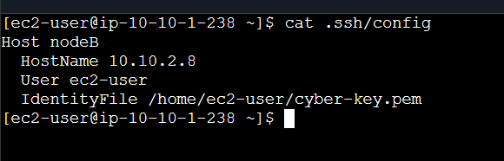

SSH from NodeB → NodeA

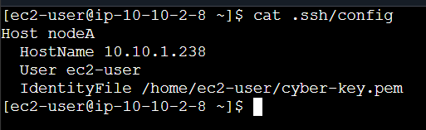

Outputs:

