**Assigment 1**

Connection test:

SSH from NodeA → NodeB

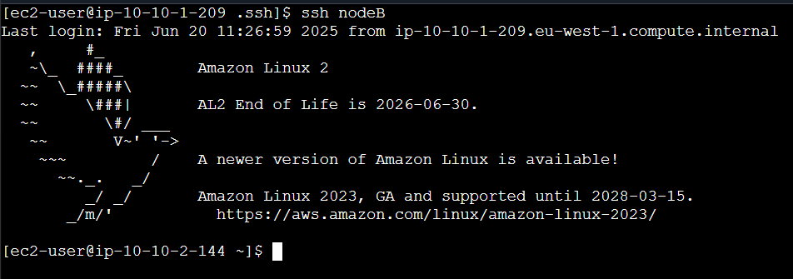

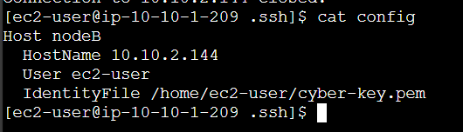

SSH from NodeB → NodeA

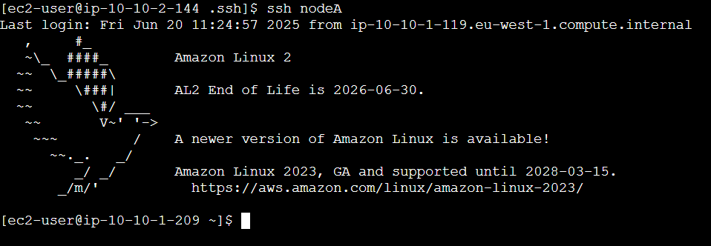

Outputs:

