AutoHotkey LinkManager



User’s Manual

Autohotkey LinkManager is a small tool that could come in handy to memorize and use links to frequently used directories, files, documents, URLs etc. To jump to a desired path or open a file, you have just to invoke the context menu by pressing your shortcut (which is Windows + middle mouse button by default) and select the particular entry. This LinkManager comes with a GUI to edit your links and setup the context menu.

## Credits

Special thanks to Robert Ryan. His Script FavoritFolders.ahk gave many initial ideas and inspirations for this project (also some of the code was reused).

Table of contents

Credits 1

Download and Execution 2

Tray Menu 3

Link manager 4

Adding a section 5

Adding an Entity 6

Modifying entities 6

IniFile 6

# Download and Execution

Since this LinkManager is still under development it comes as “portable” version. In this case it means you have to download the project and execute the exe-file in the project directory. Feel also free to join the developer team.

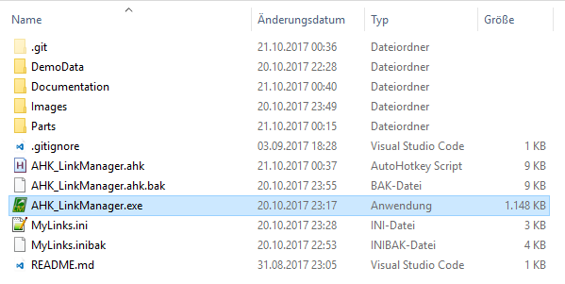

You will notice that an small folder symbol appears in your system tray. By hovering over it, it tells you it’s scriptname and version. The script is already ready to use.

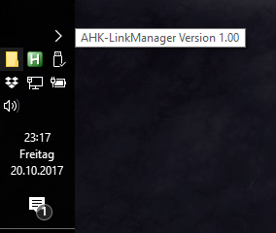

If you now hit the default hotkey-combination a default context menu will appear and give you a small impression of possible items in this manager. You will find submenus with links to paths, URLs, local executes (fear not, it is the command line interface) and different types of documents.

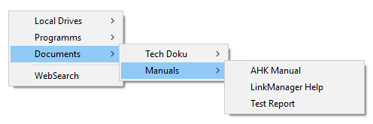

Note, that like in the case of the entry “WebSearch” you can also place identical names to different paths. As long as they are located in different submenu branches they can be discriminated.

But if you place two identical named entries (to different paths) in one submenu, both links will be display as one entry. And if you select it, both links will be opened (this is a potential hack if you want to open two path simultaneously with one entry).

To ensure that this LinkManager is started automatically with system startup, you can place a link to the exe in your startup-folder (just hit Win+R and type “shell:startup” then hit enter).

# Tray Menu

If you left-click in your system tray on the folder symbol, a tray menu appears. Besides the typical Autohotkey script options like pause and exit, some further options to setup the LinkManager where implemented which are described in the below.

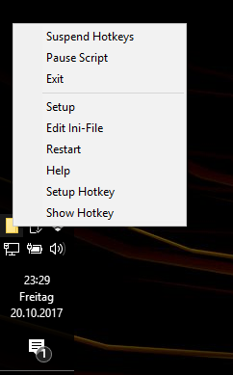

|  |  |
| --- | --- |
| Setup | Starts LinkManager GUI to setup the context menu |
| Edit Ini-File | Edits directly the configuration file (which is also generated by LinkManager GUI). This option is for experienced users only. |
| Restart | Restarts script to apply changes which are made directly in the ini-file |
| Help | Displays help file |
| Setup Hotkey | Starts hotkey-setup GUI to define users Hotkey |
| Show Hotkey | Shows currently applied hotkey |

The hotkey information looks like in the following picture. It just shows you the applied hotkey if you can’t memorize it immediately.

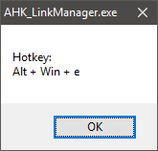

The Hotkey-Setup-dialogue is shown in the next picture. To define Hotkey you have to klick in the text field and just press your desired key. Note that for some special keys like Windows key or your Mouse buttons the further control elements have to be used.

Please also note that not all possible combinations are currently implemented in this menu. Hence if you want to use a hotkey which cannot be set, you can define your desired key in the Ini-File (see listing below, see also Autohotkey help for [keydefines](https://autohotkey.com/docs/Hotkeys.htm)). Don’t forget to restart your application after that.

You should also double-check if your desired shortcut is already used by [windows](https://support.microsoft.com/de-de/help/12445/windows-keyboard-shortcuts).

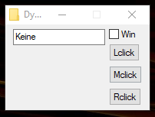

[User_Config]

ShortKey=#MButton ;this is the default hotkey

# Link manager

When you hit setup in your tray context menu (see chapter above) the LinkManager GUI appears. Here you can set up your link collection. The GUI is shown in the following picture, the control elements are discussed below. Please note that the operation is also possible with short cuts which can be displayed with Show Shortcuts.

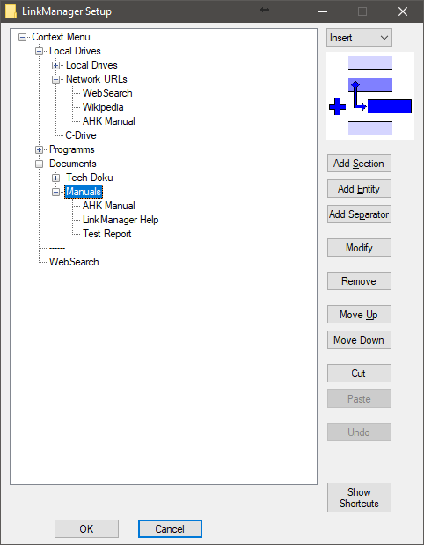

|  |  |
| --- | --- |
| Mode DropDown | In this drop down you can define which insert mode has to be applied on new elements. Three modes are possible:   * Prepend -> Inserts new element before a selected element * Insert -> tries to insert new element inside a selected element (this works only on sections) * Append -> Inserts new element after a selected element   The Mode is also illustrated in the picture below. |
| Add Section / Entity / Separator | This buttons invoke additional GUI elements to define new entries :   * Section: Represents a submenu. * Entity: Represents an actual link. * Separator: Represents a separator. |
| Modify | Modifies selected element. |
| Remove | Deletes selected element. |
| Move Up/Down | Moves the selected element within its level up or down. |
| Cut / Paste | Cuts selected element and pastes by applying selected mode in drop down menu. |
| Undo | Reverts last changes. |

After Setup you can confirm your configuration by clicking OK. This safes your menu tree in the ini-file. Cancel will reject all changes.

Feel free to study the implementation in the source and ini-file. Many changes can be done after some study of the applied structure much faster by using the editor to edit the ini-file. There are also checking routines implemented to check the ini-file on startup for recursions and duplets so don’t worry.

Be careful and save your menu structure frequently when you are applying major changes. The depth of the undo-stack was never tested.

The following picture shows the particular context menu for the default configuration which is also shown in the Manager GUI picture above.



## Adding a section

If you hit the Add Section button a simple input box will appear which asked you for the intended name. Please note that the new section is displayed in bold. You should add your desired entities immediately since you can’t differ an empty section from a simple entity later (only much later, when you see an empty submenu).

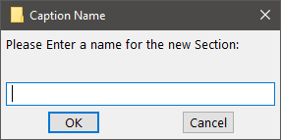

## Adding an Entity

If you hit the Add Entity button a more sophisticated input box will appear which asked you for the intended name and path.

You can browse to your desired paths by hitting the buttons below, or by simply copying some path in the path field. But you can also paste URLs in this text field.

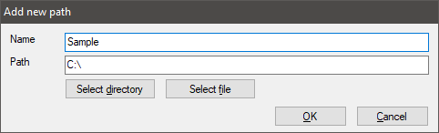

## Modifying entities

If you hit modify dependent on the selected entity, either the add Entity or the add section dialogue will appear, where you have to change the entity name

# IniFile

As mentioned before you can also put new entities directly in the ini-file. Copy a backup of your old file in case you don’t have an idea how to revert changes if everything crashed.

The ini-file is organized in sections and keys

In the first section [User_Config] you may only change the ShortKey-key. The Rook-key points to the root section and shouldn’t be changed.

In the section [Menu_Root] further keys determine ether further sections or entities. Take time to study the default example. You will see a pattern very quickly and be able to make changes directly in the ini-file.

After you modified the ini-file you have to restart the script in order to apply your changes in the context menu.

By startup some routines check the ini-file for recursions and duplet sections and warn you in that case, so you will find a bug or misrouting easily.