**Machine Learning :**

Robot Vision

Asser Moustafa 1), Diego Esquivel 2), Jo Ishizaki 3), Nestor Gutierrez4)

1) Computer Science and Engineering, Naperville, USA

2) Computer Science and Engineering, Naperville, USA

3) Computer Science and Engineering, Naperville, USA

4) Mechanical and Electrical Engineering, Naperville, USA

Abstract— Depth perception is an important part in determining how far an object is from a fixed position. Using machine learning and the empirical method to accurately predict an object's depth perception based off pixel position of a taken image.

# **Introduction**

For this project, we will refer to depth perception as the distance of an object from an object on a camera on a robot. This robot knows the angle of its field of view and when an object changes position, the robot determines the object's depth perception. Linear perspective is the idea of drawing a horizontal line and a vanishing point to project a 3D object on 2D plane, in this case being the camera. Before linear perspective there was reverse perspective in which parallel lines splay rather than converge as they approach a horizontal line [1]. With this it is determined that objects above the eye lean downward, while objects below the viewer's eye lean upward. This was a significant step in the application of linear perspective [1].

# **Methods**

In this model, there are two variables, one for the height of the object in the camera frame. The camera should be mounted to the robot. The other variable is for the real-world distance measurement between the robot and the object being detected. We use the former data as x, which is an independent variable, and the latter as y, a dependent variable. A set of these two data are put into a Linear Regression model built using either PyTorch, TensorFlow, or Scikit-Learn, and then each of these models train to give the best accuracy in predicting the distance between the robot and the object.

Fig 1. Machine Learning Model

# **Results**

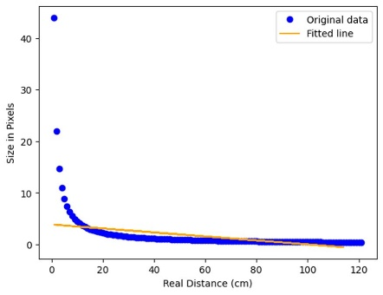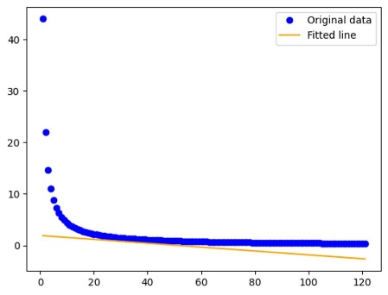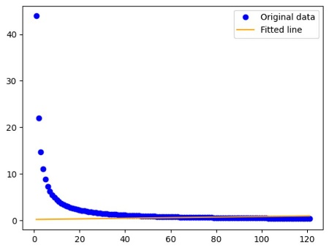

Fig 2. Scikit-Learn Fig 3. Py-Torch Fig 4. TensorFlow

We used Sckit-Learn, Py-Torch, and TensorFlow as methods to test our data and determine the best method to determine which method was able to predict the distance of the placed object more accurately. To determine accuracy of models, we used the mean squared error (MSE) which is used in machine learning to measure the amount of error in a statistical model [2]. The MSE is calculated by taking the mean squared difference between the observed and predicted valued, so the greater the MSE the more inaccurate the model.

Scikit-Learn: 78.4 MSE

Py-Torch: 6.46 MSE

TensorFlow: 65 MSE

With the given MSE results above, it can be determined that the Py-Torch model is more accurate in determining the correct distance. One of the observations that we made when completing the code was that while the MSE score was greater for TensorFlow and Sckit-Learn, the models still showed their fitted lines being correlated to the original data. Another observation that we made is that all three of the models have a huge variety for their mean squared error rate, and at times Py-Torch was not the lowest one. Overall, with the different test completed, we did find that typically Py-Torch did usually have lowest mean squared error rate.

# **Conclusion**

In conclusion, we were able to accurately predict an object's depth perception from the mounted camera on a robot. We can also conclude that vanishing points are an essential part in computer science and computer engineering. We used vanishing points and horizontal lines to highlight 3D objects on a 2D plane to obtain the distance. This technology can have various kinds of applications, one of them being used on self-driving cars and Roomba, when determining how far an obstacle might be and determining the best course of action. Some other applications include microscopic situations, such as surgeries, and any kind of dangerous environment, where sending a robot could be more efficient.

##### **Acknowledgment**

We would like to thank Dr. Kwon who guided us on this journey learning about Data Mining and Machine Learning. We want to thank you for your advice and help on this journey.

##### **References**

1. The Art Institute of Chicago, “What is Perspective?.” ArtIC. https://archive.artic.edu/sciarttech/2d1.html (accessed March 2023)
2. Frost, J. (2021, November 14). *Mean squared error (MSE)*. Statistics By Jim. Retrieved April 20, 2023, from https://statisticsbyjim.com/regression/mean-squared-error-mse/