The application can be launched from the icon presented in figure 1.

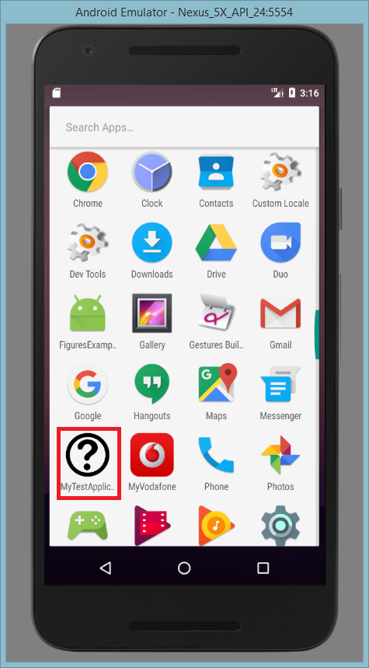

**Figure 1.** Application launcher icon

LogIn Page

This page is an authorization page. Here a 2 inputs, label for each of them, and hints in this inputs. The red error text will appear when the validation for one of the inputs fails. The login page is present in figure 2.  
  
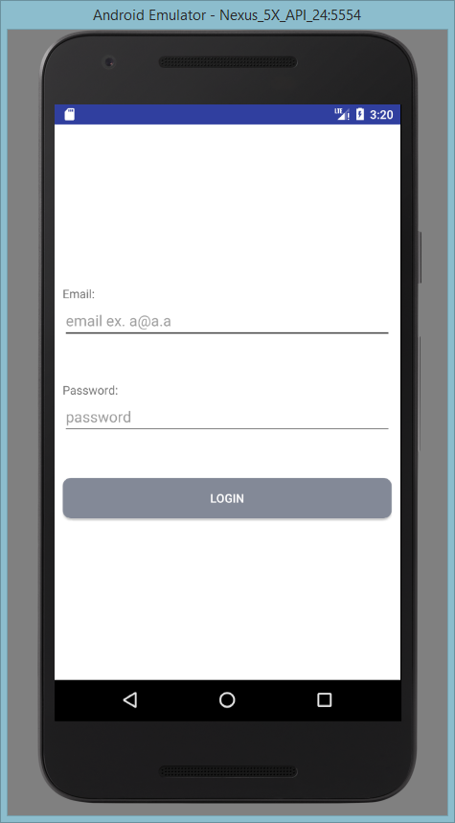  
**Figure 2.** Login page

To save the user data after the authorization passes well, I used shared preferences object. I used this simple saving mechanism because there are no big data for saving, and I saw it as a good way for saving user data, consisted from two values: email and password. After pressing Login button, the data is validated and if all fields are not empty, the data is saved and we then the main page is displayed.

Main Page

The main page is displayed by three tabs: Questions tab, Settings tab, Profile tab. The illustration of main page is present in figure 3.

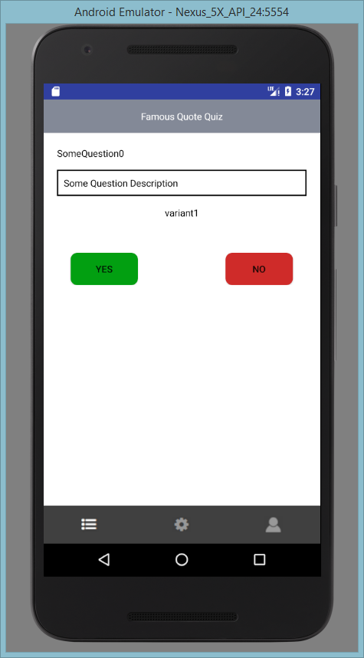  
**Figure 3.** Main page

I decided to use TabHost to display tabs. In my opinion, it is a very useful mechanism for working with tabs. Each tab has two states: active and inactive. To manage the states there was created a selector that knows the state of the tab, and attach a corresponding image. Each of tabs is an activity. In first tab, we have to different behaviors according to the choice mode selected. By default is binary choice mode. To manage the choice modes I created two fragments for the first tab. First fragment illustrates Binary choice mode, the second fragment is for multiple choice mode. I made three variants for each question. In case of binary choice when the question is loaded, the potential answer is loaded in a random way. When user answers, the system is checking if the displayed answer and the correct answer are equals. In the list of question, I put the first variant as a correct question. When the answer validation is passed the message with right or wrong context is displayed with the Ok button and the next question is loaded. This message is present in figure 4.

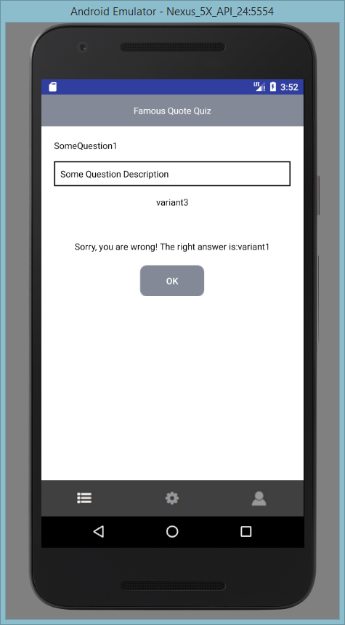

**Figure 4.** Answer validation message

If the question description is not present, the bordered bloc is hidden. When all the 10 questions are answered, a dialog window is displayed with statistic with count of right and wrong answers. There is a button “start again”, if it is pressed the game is launched again. This dialog is present in figure 5.

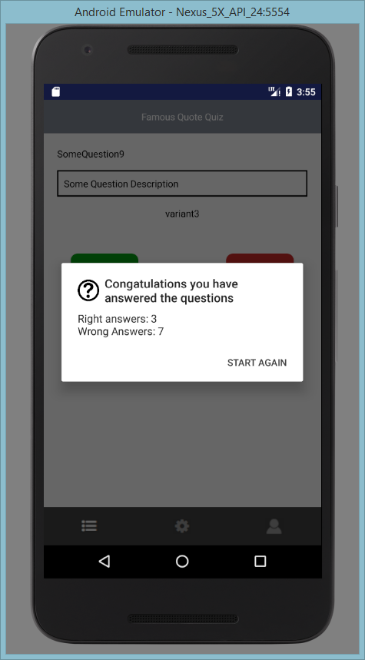

**Figure 5.** Statistic dialog

I decided to use dialog mode of visualization of this information because there is not a lot of information and there is no sense to make a separate activity or fragment for displaying it.

The anther choice mode is multiple. The multiple choice mode screen can be found in figure 6. There are loaded all variants of answers. The buttons with the answers are loaded dynamically. So if the question has two or four variants of answer then all of them will be displayed correctly. Choosing one of the answer system will compare it with the correct answer. Then after validation, it will display a corresponding message. When the limit of questions is achieved then the dialog is displayed with the statistics of right and wrong answers.

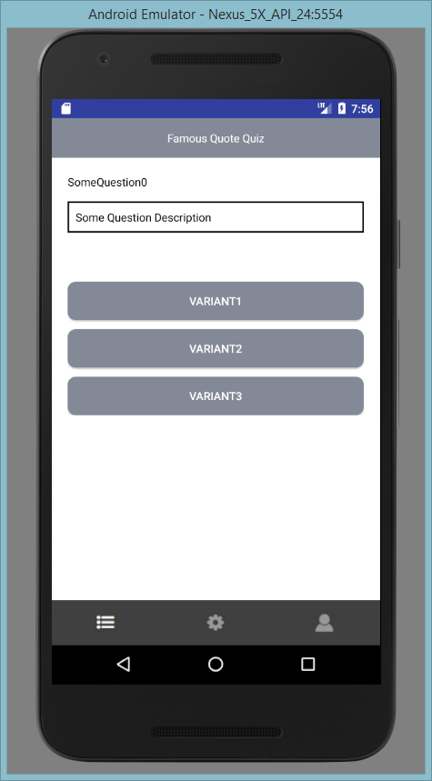

**Figure 6.** Multiple choice screen

Setting tab is a tab with an option with a switcher between choice modes. By default it is false, and the binary choice model is displayed. If user switch the option then the multiple choice mode will be activated. Setting tab is presented in figure 7. Profile page displays user’s information according to his credentials. Log out button redirects user to login page, and all user saved data is deleted. Profile page can be found in figure 8.

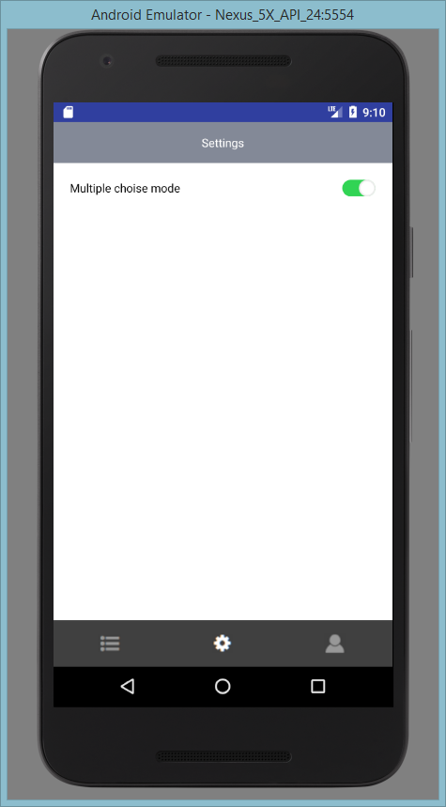

**Figure 7.** Settings screen

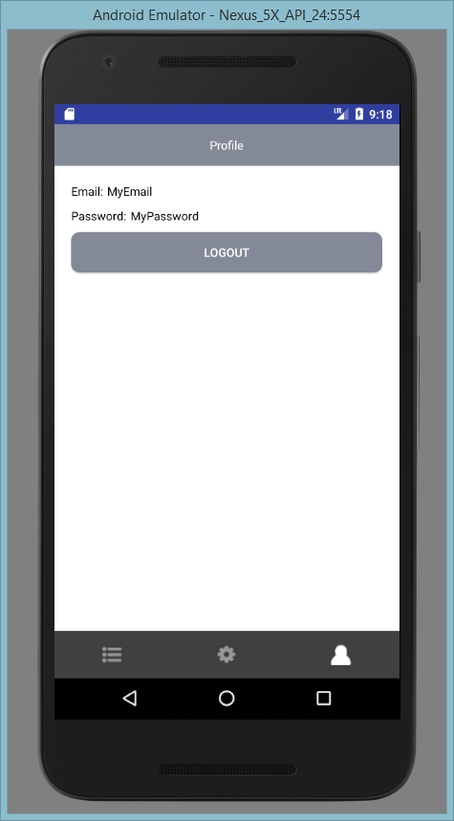

**Figure 8.** User profile page