Kuanysh Beibarys SE-2413

Report Assignment 1: Builder Pattern:

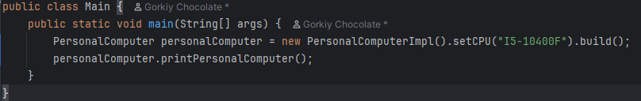The Main class runs the program.  
It uses PersonalComputerImpl to build a computer step by step.  
Then it prints computer parts.

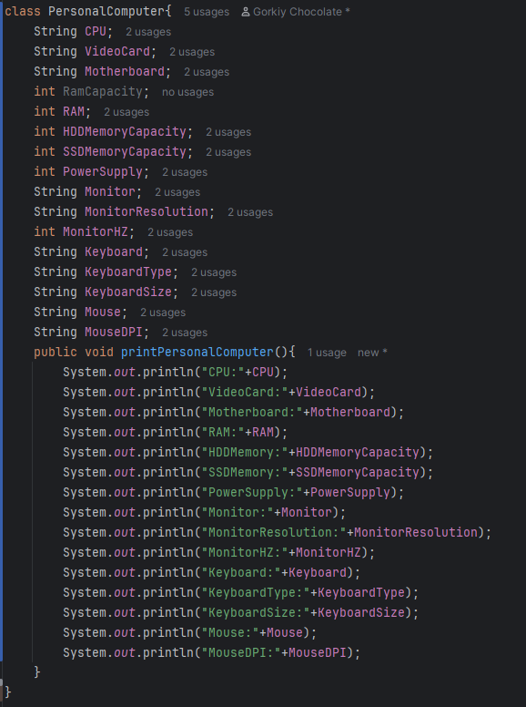

PersonalComputerBuilder is a builder interface.  
It has methods to set each part of the computer.  
It also has build() to create the final object.

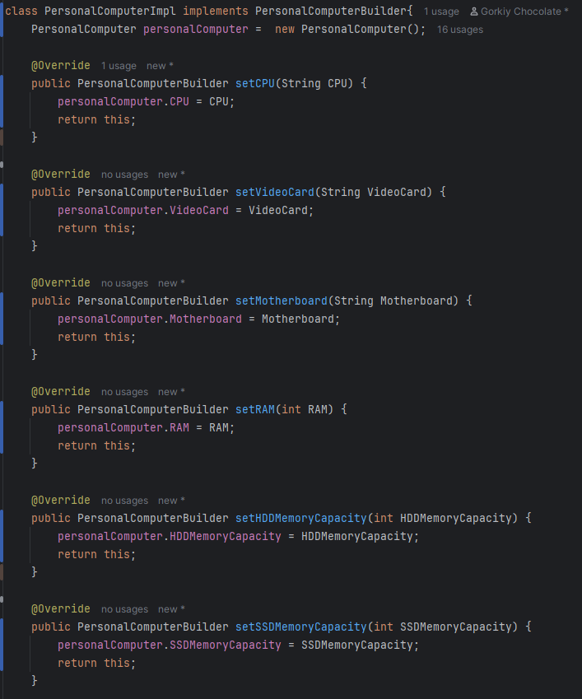

PersonalComputerImpl is the builder implementation.  
It fills the fields of PersonalComputer.  
Each method sets one part and returns the builder.  
The build() method gives the final PersonalComputer object.

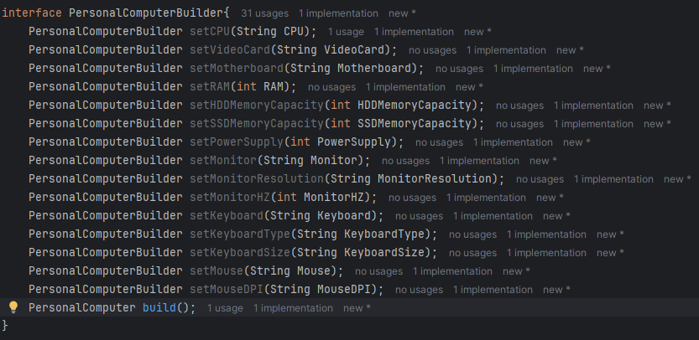

PersonalComputerBuilder is a builder interface.  
It has methods to set each part of the computer.  
It also has build() to create the final object.