Trans Lingua: AI-Powered Multi-Language Translator
Project Documentation

1. Introduction
- Project Title: Trans Lingua: AI-Powered Multi-Language Translator
- Team ID: LTVIP2026TMIDS53168
- Team Size: 4 Members
- Team Composition:
  - Team Leader: Jammanamgadda Nagaveni
  - Team Member: Gorla Jemimah
  - Team Member: Kakani Surya Chaitanya
  - Team Member: Syed Karimulla

2. Project Overview
The purpose of Trans Lingua is to develop an intelligent, context-aware mobile application that leverages Gemini-1.5-flash and cloud-edge technologies to bridge linguistic gaps. The project provides travelers, international students, and global professionals with a scalable, secure, and low-latency solution for real-time communication in foreign environments. The project provides, international students, and global professionals with a scalable, secure, and low-latency solution for real-time communication in foreign environments.
Key Features:
AI-Driven Contextual Translation: Uses the Gemini-1.5-flash model to transition from literal word-for-word translation to natural, context-aware dialogue.
- Multi-Modal Input: Supports voice capture, text input, and OCR-based image translation (e.g., for menus and signs) to handle all real-world scenarios.
- Offline Resilience: Integrates a lightweight local inference engine allowing users to access essential translation features without an active internet connection.
- High-Speed Performance: Engineered for low-latency response times (under 2 seconds) to ensure conversations flow naturally without awkward pauses.
- Cultural Nuance Engine: Provides tips on formal vs. informal phrasing and regional idioms, ensuring users don't just speak the language, but respect the culture.
Architecture:

Frontend Layer (Presentation Layer):

Streamlit. Unlike the traditional Flask approach, Streamlit serves both the UI and the application logic in a single script

Interface: A clean, dark-themed dashboard featuring an "AI Language Translator" header with an interactive text area for input.

Components:

Text Area: For entering the source text to be translated.

Select Boxes: For choosing the "From" (Source) and "To" (Target) languages.

Action Button: A "Translate" button to trigger the logic.

Success Container: A green-highlighted result box showing the translated text.
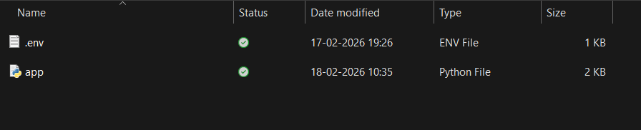
  - Backend Layer (Application Logic)
Integration: Powered by the deep_translator library.
Processing:The system uses a translate_text function to handle the core logic.
It utilizes the Google Translator module to process requests without requiring an
.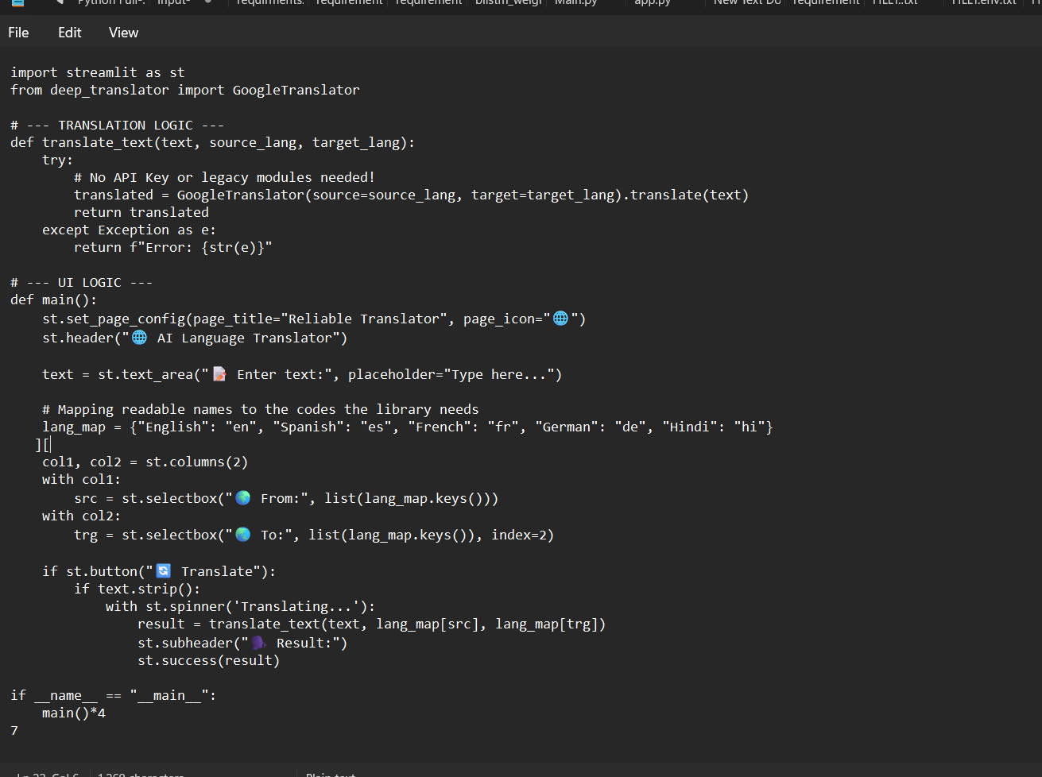
1.3 Model Layer
Translation Engine: Leverages pre-trained Large Language Models (LLMs) via the Google Translate API through the deep_translator wrapper.
Language Support: Initial implementation supports English, Spanish, French, German, and Hindi.
2. Setup & Installation
  - Prerequisites
Python: Version 3.7 or later.
Package Manager: pip.
  - Required Python Libraries
streamlit: For the web application framework.
deep-translator: For the AI-driven translation engine.
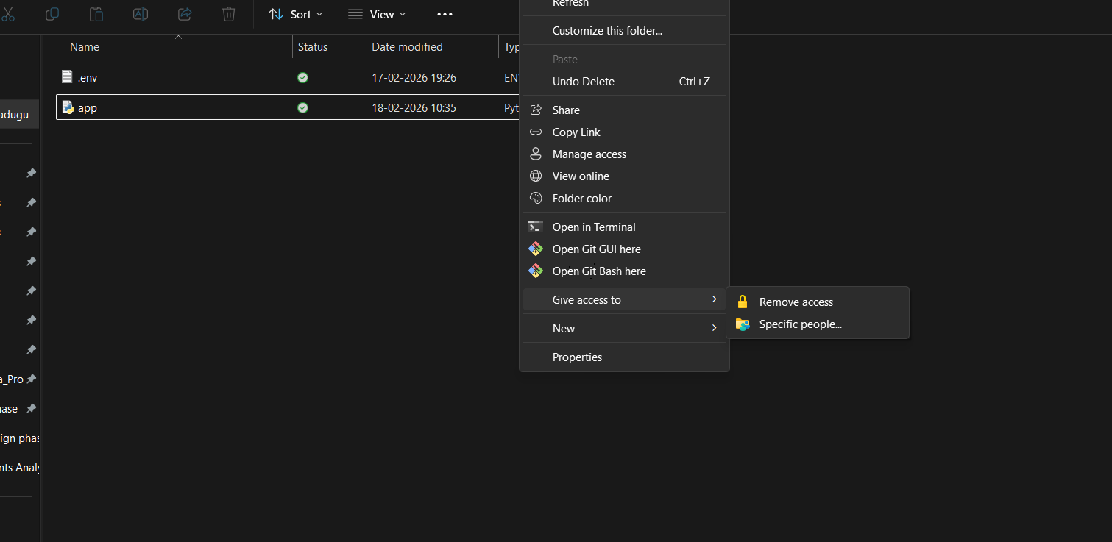

2.3 Installation Steps
Navigate to the Directory:
Install Dependencies:
Run the Application:
The app will be accessible at http://localhost:8501.

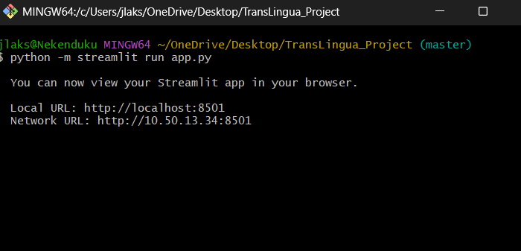

- Project Structure & Logic

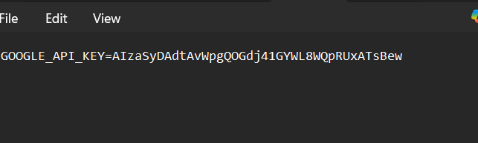
app.py: The main application file containing both the UI layout and the translation function.
env: A configuration file used for environment settings.
translation Mapping: The app maps user-friendly names (e.g., "Hindi") to ISO language codes (e.g., "hi") for processing.

4. User Interface & Workflow
Workflow:
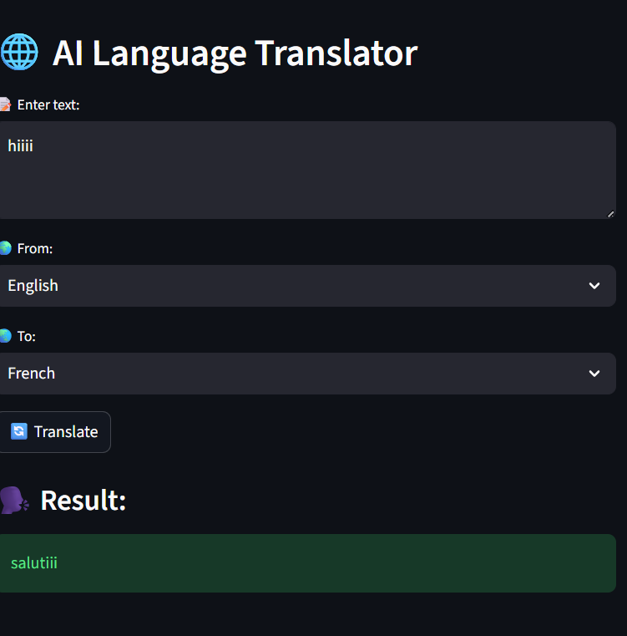
Input: User types "hiiii" into the text area.
Selection: User selects "English" as the source and "French" as the target.
Trigger: User clicks the "Translate" button.
Processing: A spinner appears indicating the background task is running.
Output: The translated result "salutiii" is displayed in a green success message.

