**This Week’s Parkruns In Graphs**

It’s been a frosty weekend, with snow covering many parts of the UK and temperatures dropping to well below zero. Nevertheless a brave bunch of perseverant parkrunners took to the parks, in search of a 5k PB. In fact this week saw 88450 runners across 539 different parks in the UK.

As should be expected the weather led to quite a rise in cancelled events, with 245 not uploading results for this week. This has affected roughly 41,000 people who would otherwise have ran.

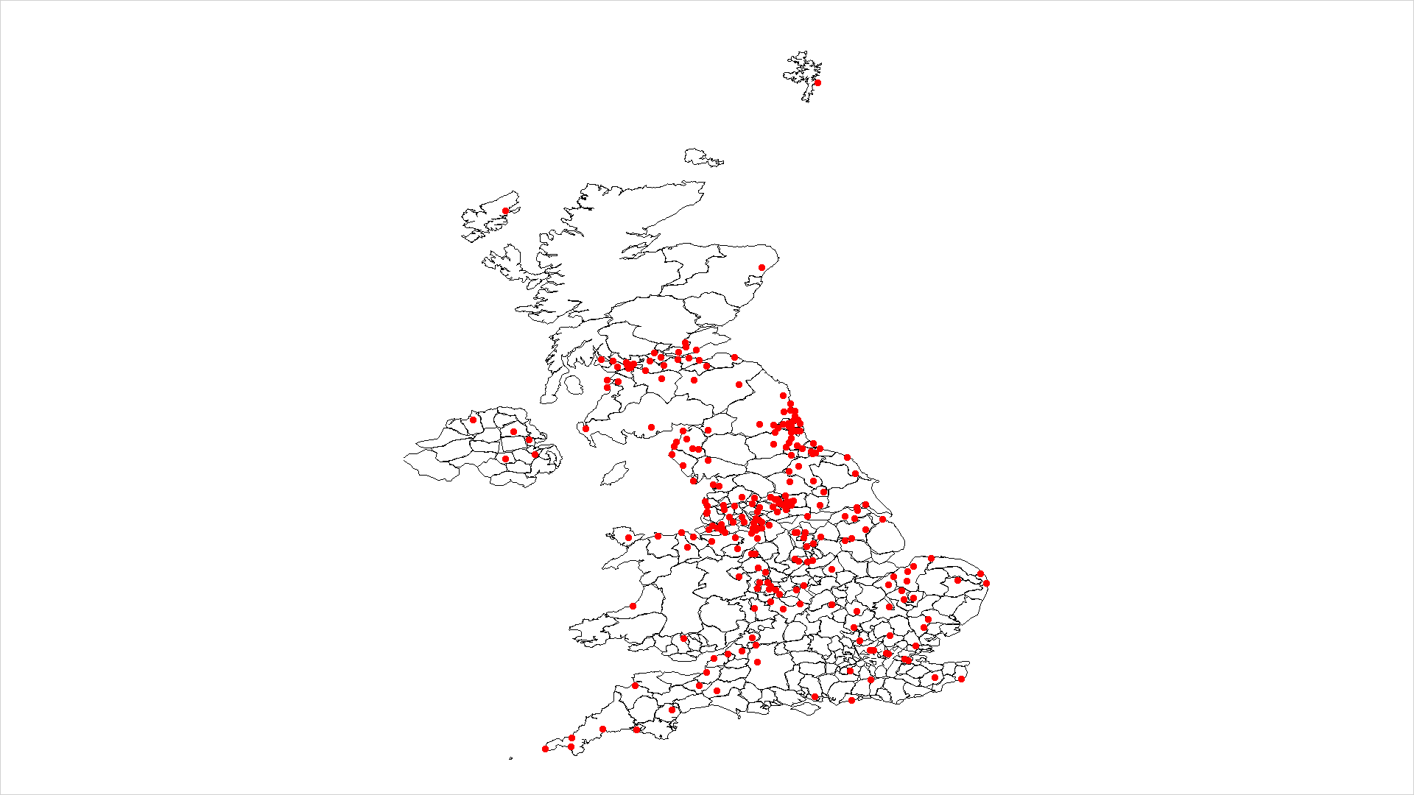

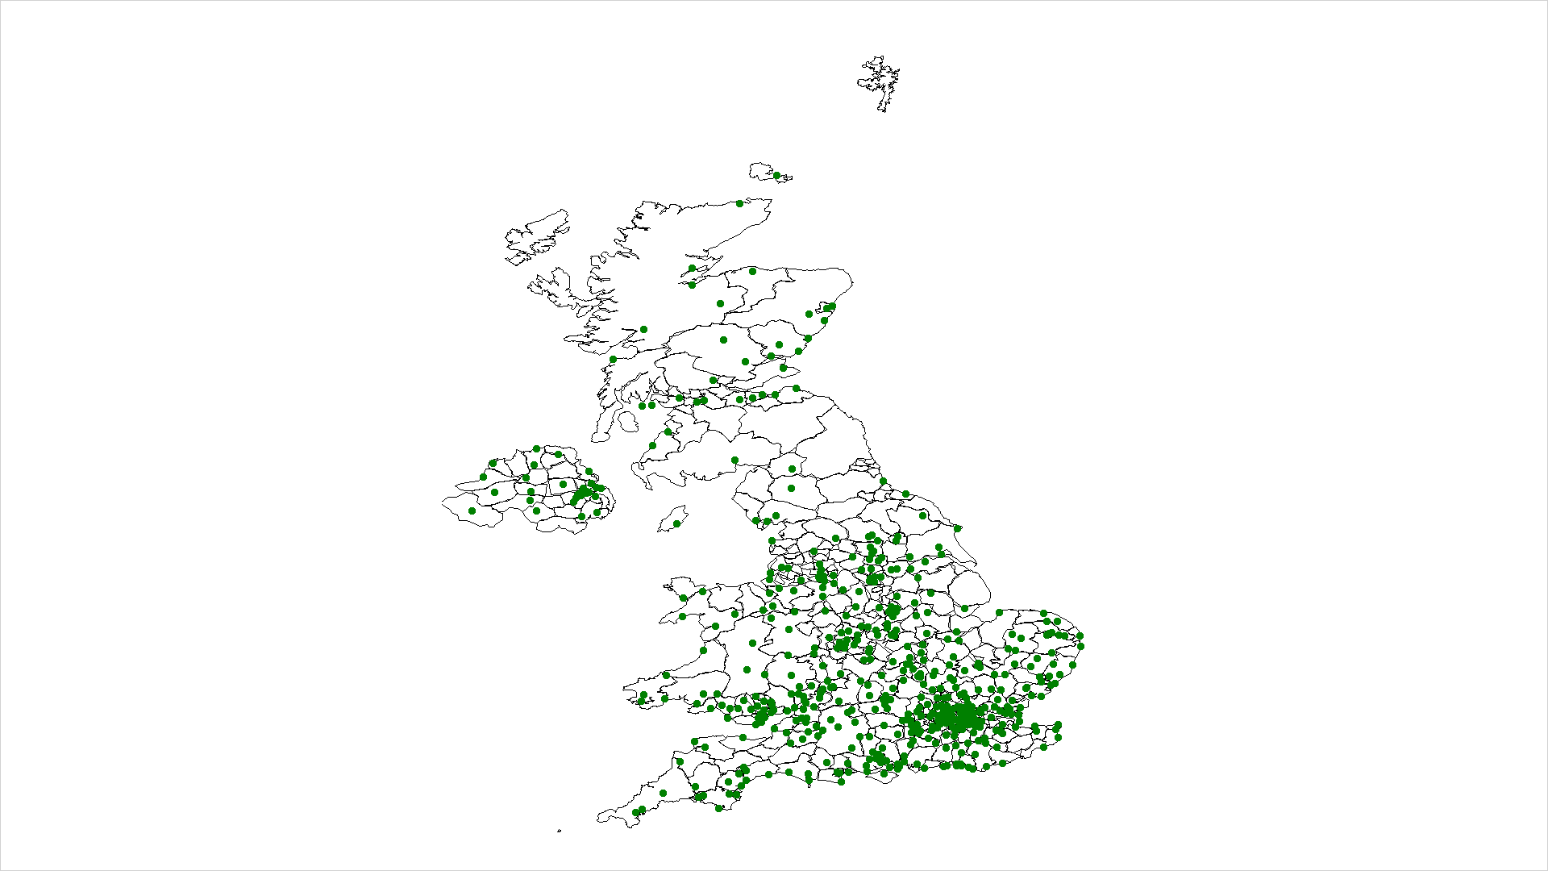

This first graph shows the parkruns that were cancelled this week, and next those that went ahead. Perhaps unsurprisingly the North East and West (which saw colder weather over the weekend) showed many more cancellations than in the south. As a resident of the North East, I too have had to endure (or rather relished) a parkrunless Saturday morning this week.

Despite the undeniably miserable conditions, we still saw some mightily impressive times laid down by some of the quickest runners in the UK:

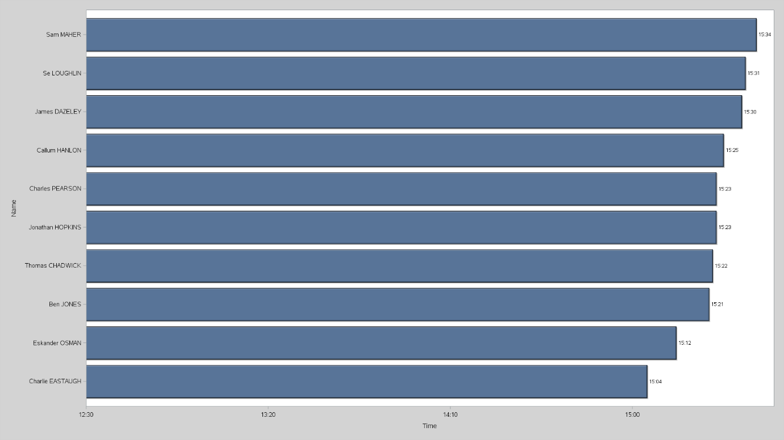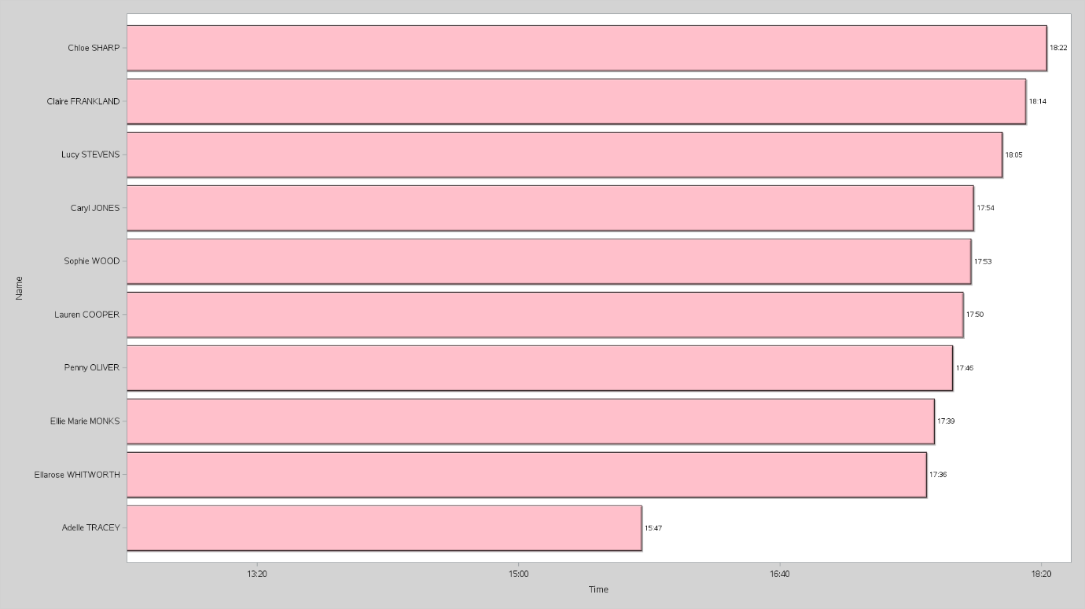

The top spot for the men this week was taken by Charlie Eastaugh, running for Hercules Wimbledon AC at Dulwich park, clocking in at 15:04. This is slightly slower than his PB of 14:49 at Dulwich (although his track PB is an even more impressive 14:18!).

For the women, the top spot was taken by Adelle Tracey, running for Guildford & Goldalming also at Dulwich park, setting an impressive 15:47. Despite being only her second parkrun, Tracey has represented England at several major championships in both the 800 and 1500 so perhaps this performance shouldn’t be a huge shock.

And as always, the most perseverant Parkrunners this week kept on carrying on:

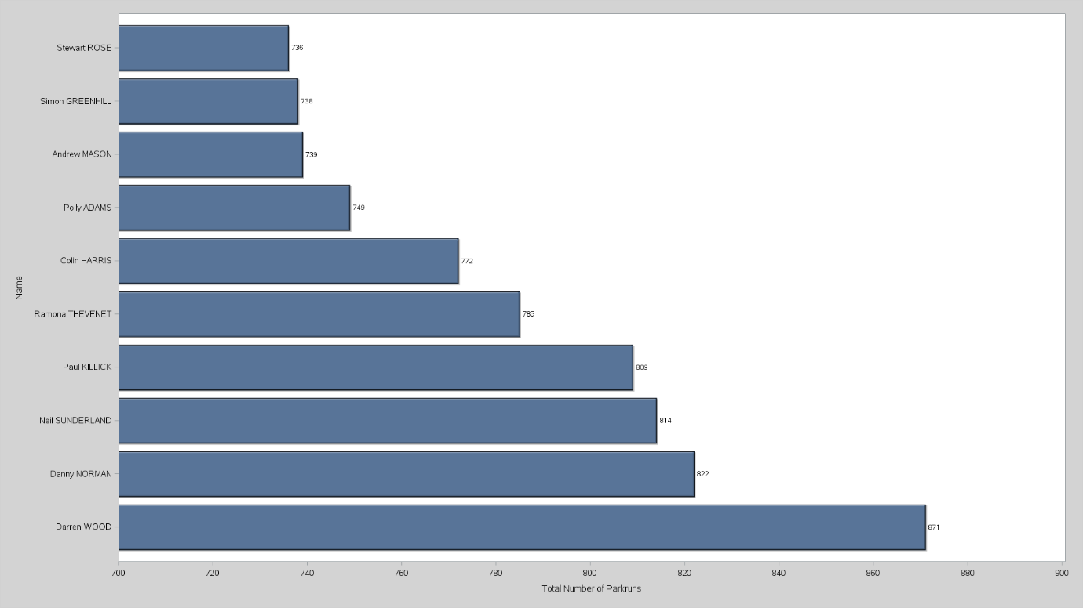

Darren Wood ran his 871st parkrun this week and is currently leading the pack by quite a margin when it comes to number of parkruns. There have been a total of 959 parkruns at Bushy Park (the home of parkrun), so this gives Darren more than 90% attendance.

And if you interested in how you compared to everyone else this week, here are the average times for each age group, for the parkruns ran this week:

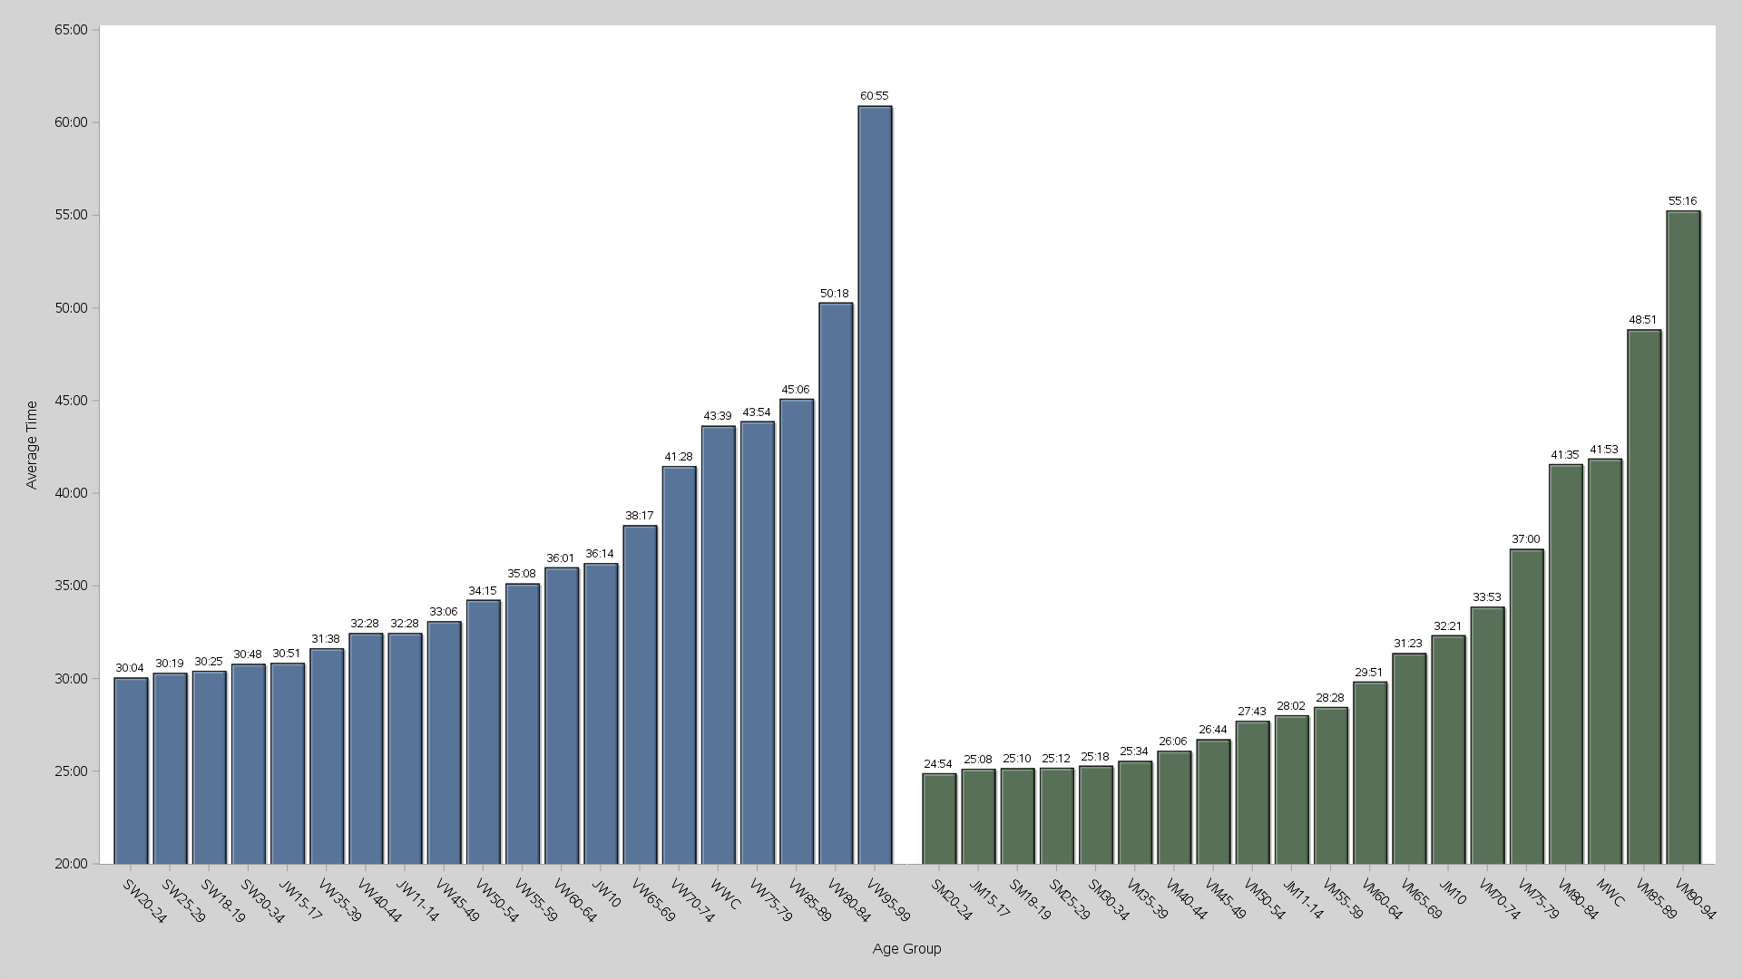

And for those interested in getting into parkrunning, there is no need to be intimidated by those who have ran hundreds already. Although doing more parkruns does usually mean that you’ll start running quicker (up to a point!), there is actually very little correlation with the number of parkruns somebody has done and their time;

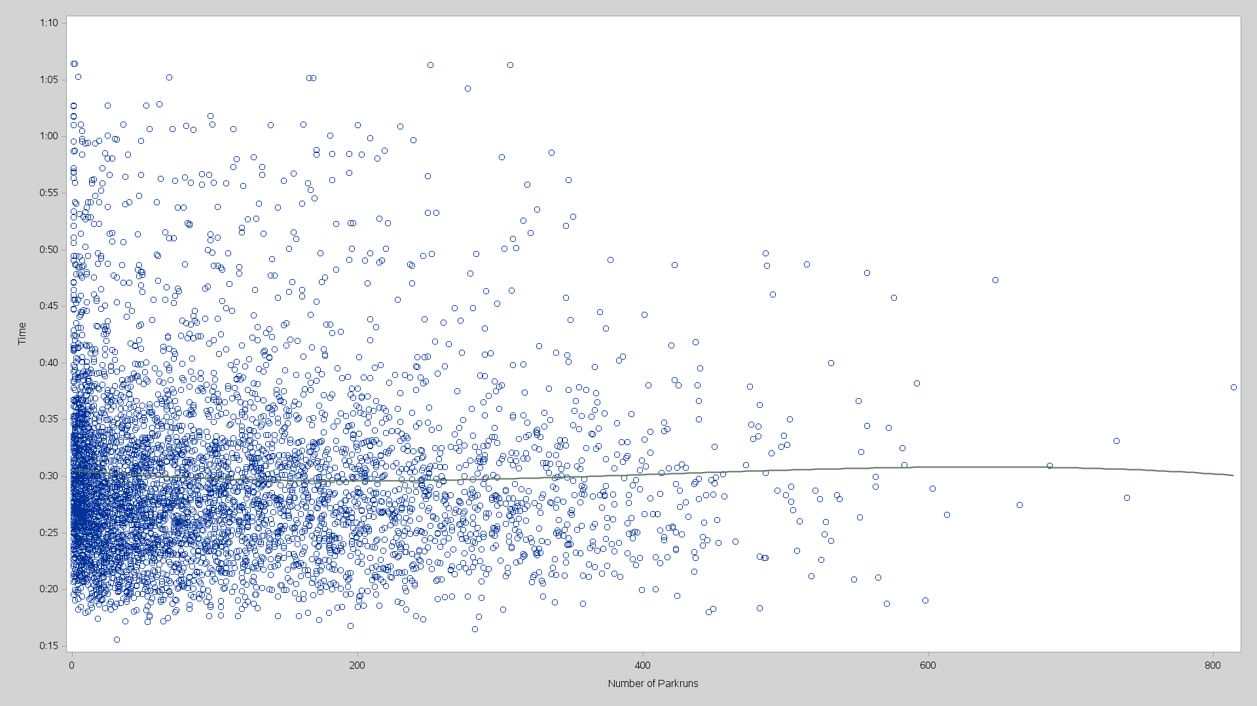

Here we see a random sample of 5000 parkrunners which a cubic line of best fit. For the stats nerds out there, across the whole dataset we have a r value of 0.0196 on 88450 data points.

Another question you might ask, is which is the best park to run in if you want to have the quickest time? You might guess Dulwich, given that both the male and female fastest runners ran there, and may just be the best one to compete in, however it’s not quite that simple…

The problem with answering this question is that by simply taking the mean time at each event, it is almost always the case that parkruns with close to zero people take the top spot as the variance in their average times every week is just much higher. The more people that take part in the parkrun, the more the average time tends towards to UK average. The variance of times in these smaller events makes them somewhat incomparable to other events as well.

 Instead consider these two (similar but distinct) questions;

1. Which parkruns have the highest average age grading?

Age grading is the statistic that parkrun uses to compare how good athletes are compared to one another. Rather than taking the raw time (which is heavily affected by age and gender), parkrun instead compares people by an age grading which represents how well they run for their age, by comparing their time to the world record for that age group.

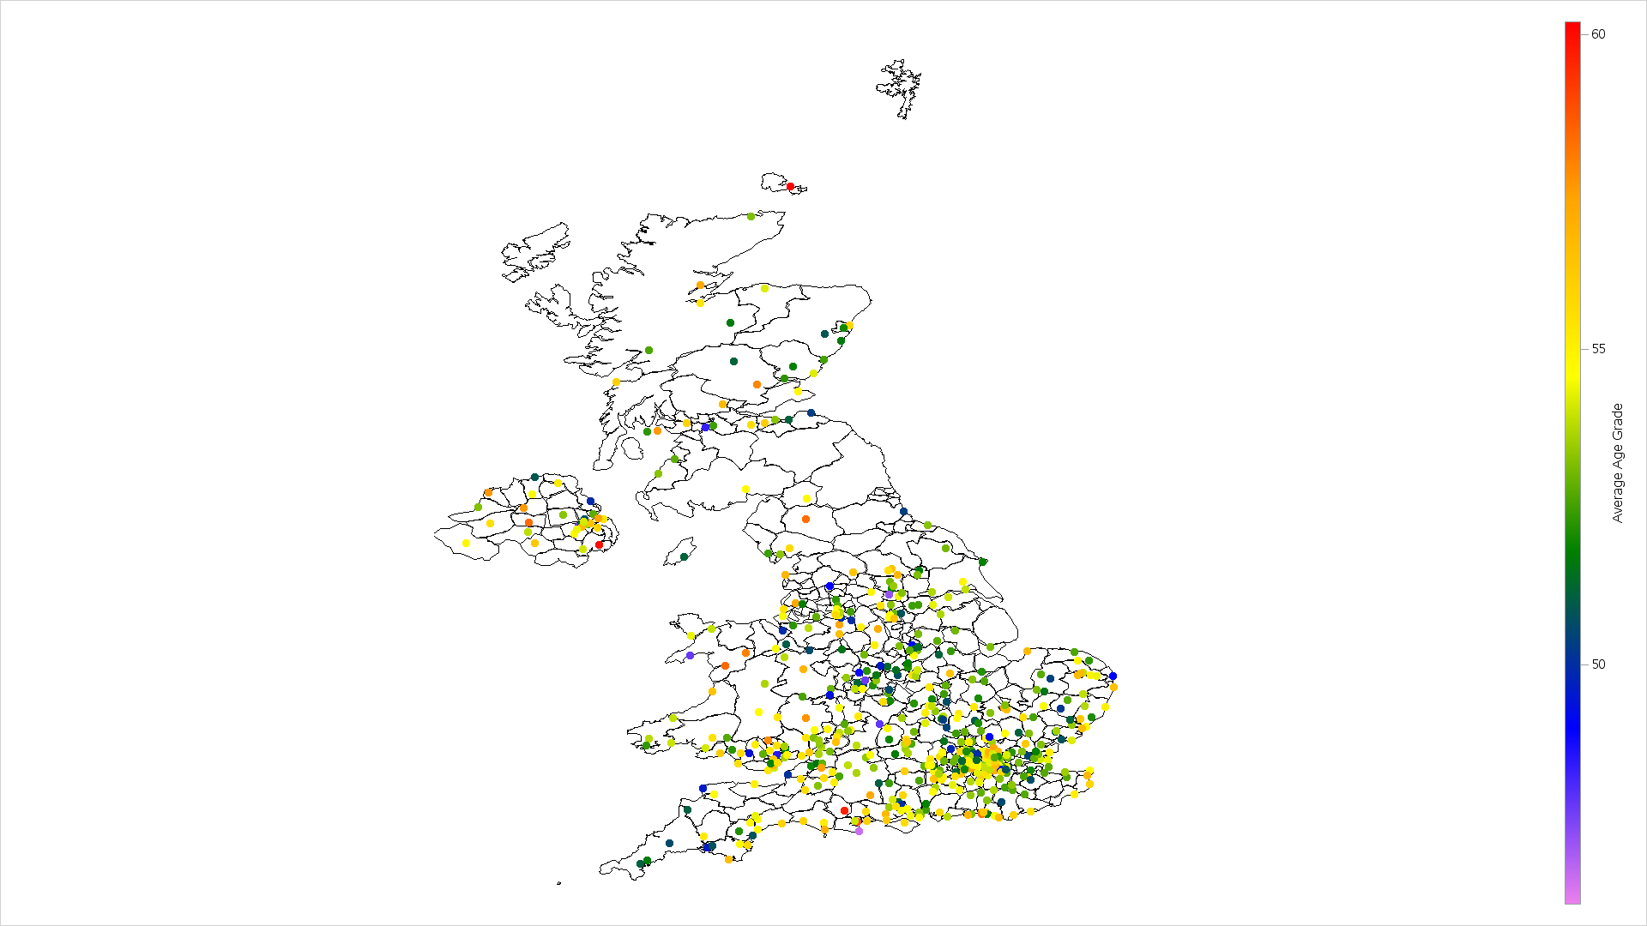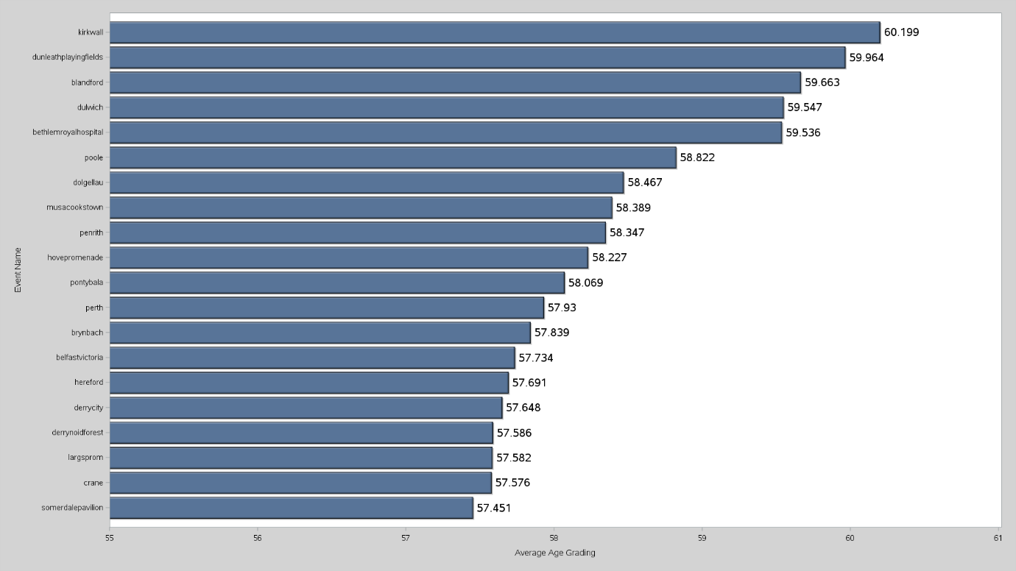

This is all well and good but I take issue with this for a few reasons:

* Parkrun doesn’t share the table used to calculate age gradings. This lack of transparency leaves the age gradings open to parkrun’s interpretation and so might not be the most objective score.
* The grading is based on the world record for that a given person’s age group. Although we don’t know exactly what values are used (thanks parkrun) we can assume that these world records may not necessarily be set in the UK and are, most likely, not performed at the same time of year as the parkrun. These variables make a significant impact when it comes to running.
* These scores are hard to interpret. Although we know the ordering, the fact that one parkrun gives an average grade of 60% and another an average grade of 40% doesn’t mean anything to the people running. We know one is faster than the other but that’s about it.

For these reasons, I propose a different method. Rather than looking at average age grading, instead consider adjusting the times. By finding the average time for each age group across the UK, we can then subtract the average time for a given runner’s age group from their achieved time. This adjusted time represents times ran in the UK, in UK weather conditions and ran on the same date at the same time. Furthermore, since the resultant value is a time, we can see how a parkrun will actually affect performances. So the question then becomes;

2. Which parkrun has the lowest adjusted time?

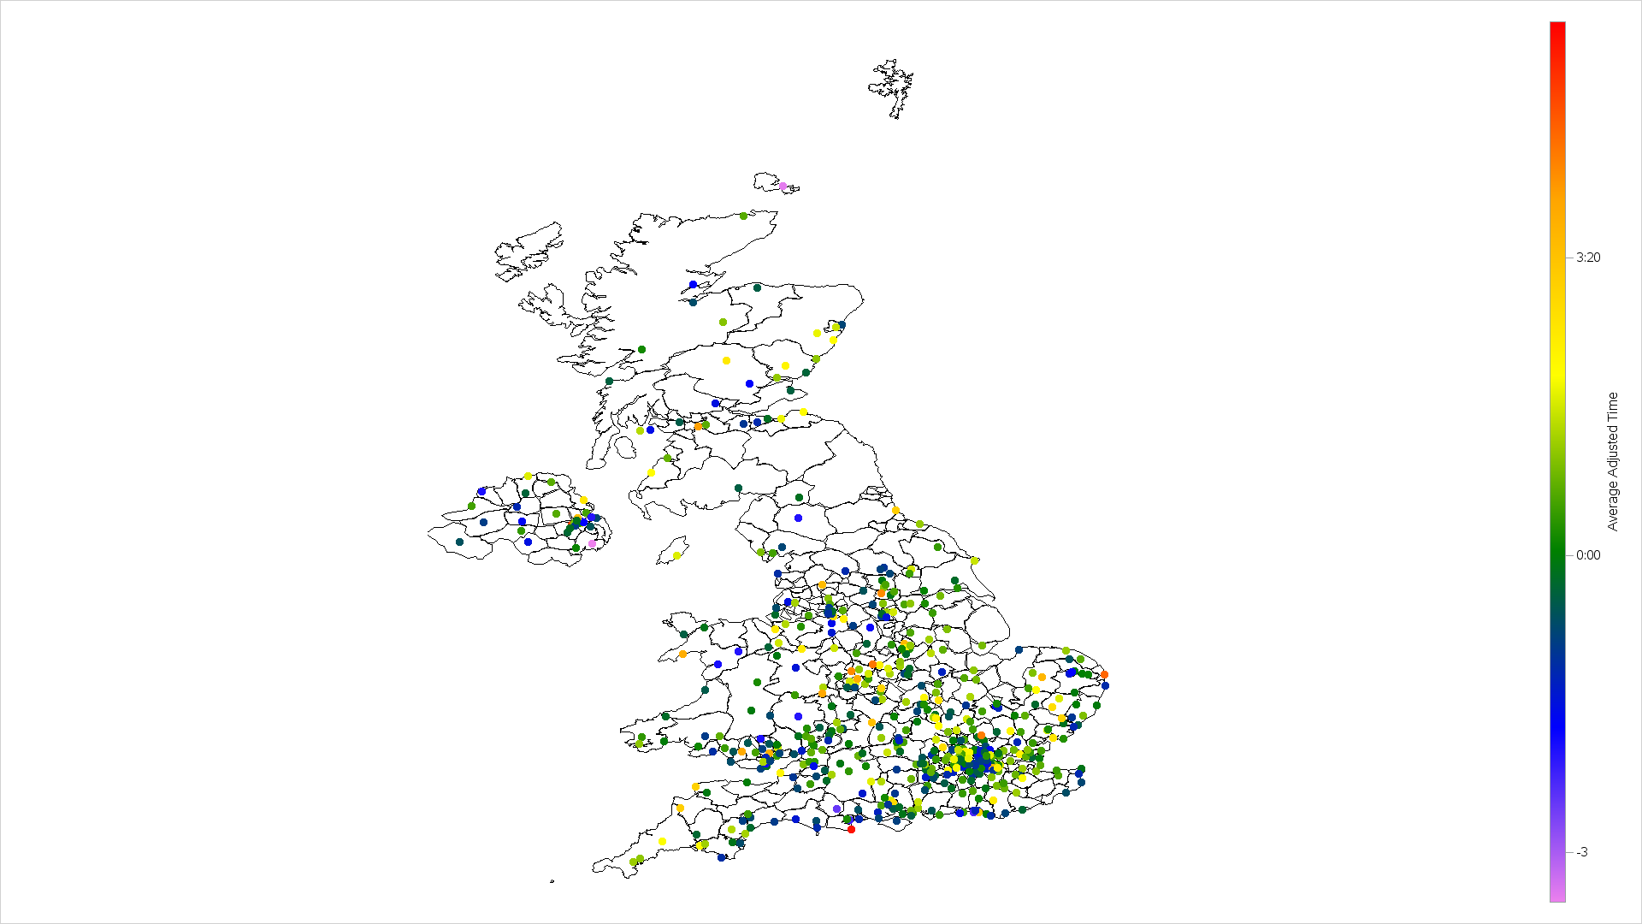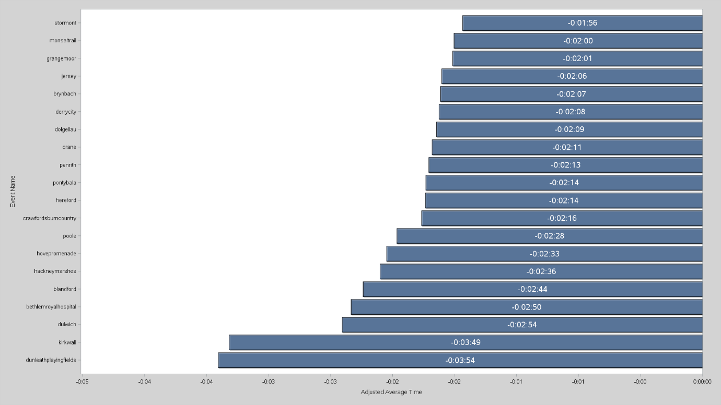

We can see that both methods in fact give similar answers (since they are looking at the same approximate thing, this is relatively unsurprising) Kirkwall and Dunleath Playing Fields come out the fastest, with an average adjusted time. These values should probably be taken with a pinch of salt since Kirkwall only had 17 runners and Dunleath only had 51. For a proper race I would recommend Blandford or Dulwich as these each had a significant amount more runners.

If anyone knows of a statistic that would be more resilient to smaller numbers of runners, then I would be very interested. It is likely that taking adjusted times in this way has a southern bias (especially in the winter) so it is not an ideal measure, but in my opinion, better than age graded scores.

But moving on from that debate, another obvious question is which parkruns were the busiest this week:

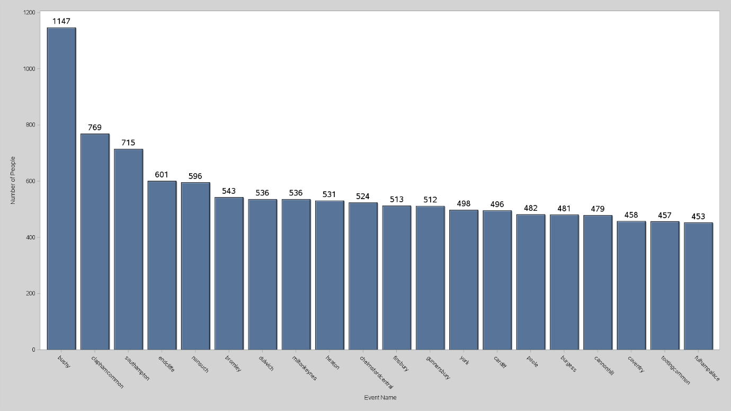

The home of parkrun, Bushy Park comes out on top this week with a colossal 1147 runners. South West of London, Bushy Park held its first parkrun on the 2nd October 2004 with 13 runners, 3 volunteers and a stopwatch. Humble beginnings for what became the phenomenon of parkrunning.

And now for some more colourful graphs! Parkrun is of course all across the UK (and the world in fact) but how do regional differences affect the results? First lets consider the number of runners.

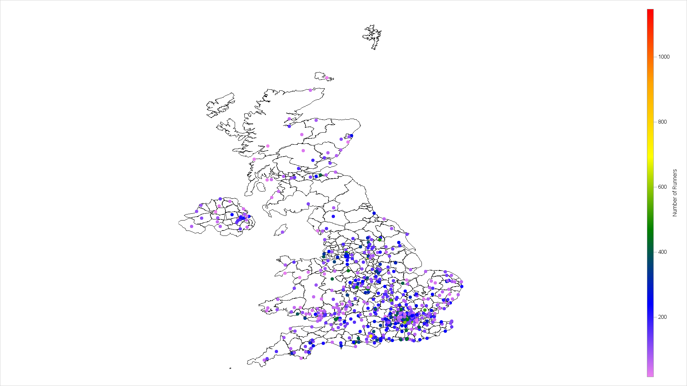

We see that parkruns in the centre of big cities have much more runners than outside. Although the weather has had a strong impact this week, we generally see larger numbers of runners in parks which are more southern.

Another aspect I found somewhat surprising is the percentage of runners that are male was 60% this week. The following map shows the percentage of male runners across parkruns in the UK.

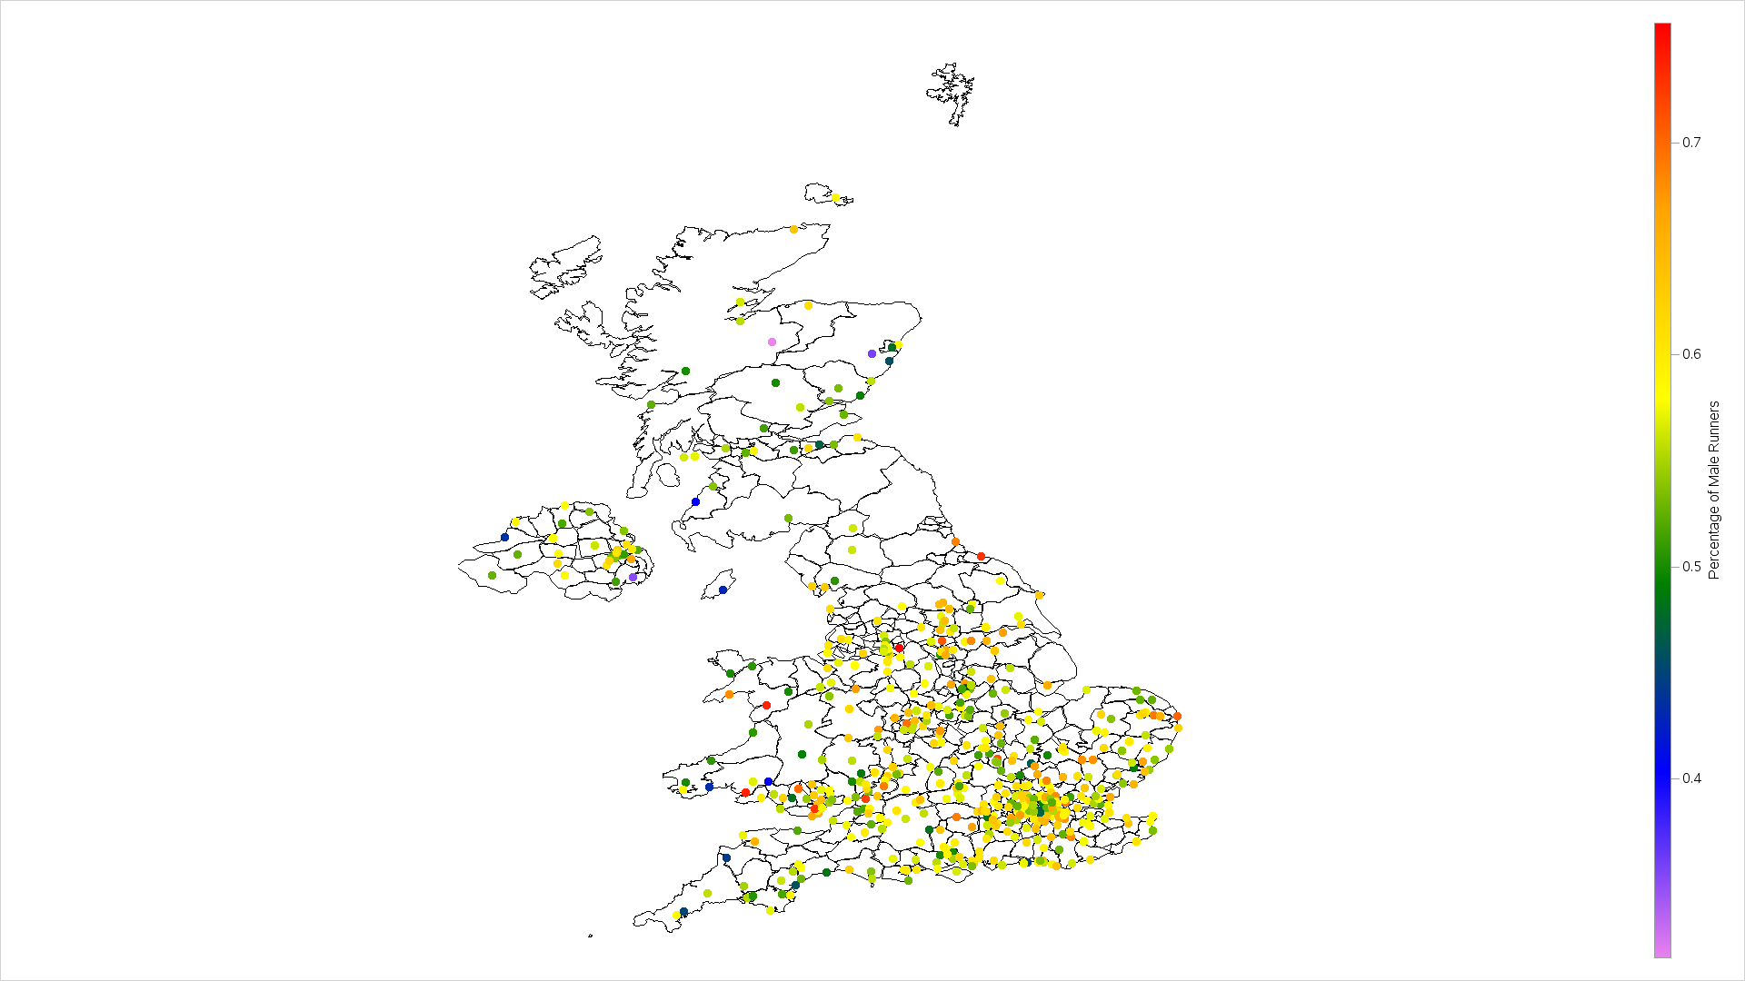

The next graph was also a surprise. Since parkrun tracks how many parkruns each individual has done, we can also ask which event has the most committed runners or in other words, which event has the highest average number of parkruns. Surprisingly (to me at least) the mean number of parkruns that have been done is 105.0, showing just how committed parkrunners are.

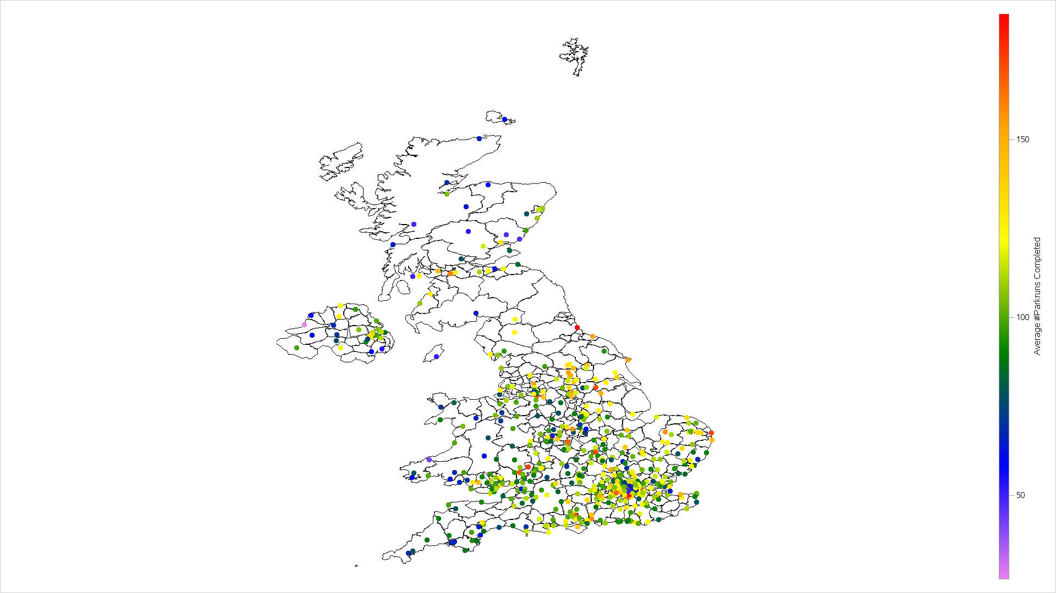

And that's all I have for this week! I would very much appreciate any comment, queries, advice and anything else that anyone has to offer.

Thanks for reading :)