УО «Белорусский государственный университет информатики и радиоэлектроники»

Кафедра ПОИТ

Отчет по лабораторной работе №2

по предмету «Теория информации»

Вариант 5

Выполнил:

Горник А.

Гр. 351003

Проверил:

Болтак С. В.

Минск 2025

1. Шифрование текста:

Исходный текст

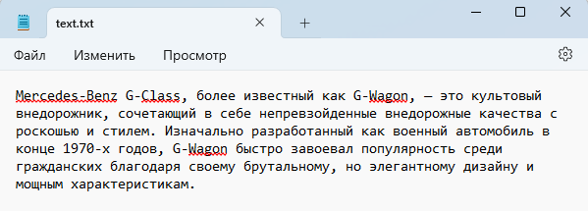

Результат работы шифратора:

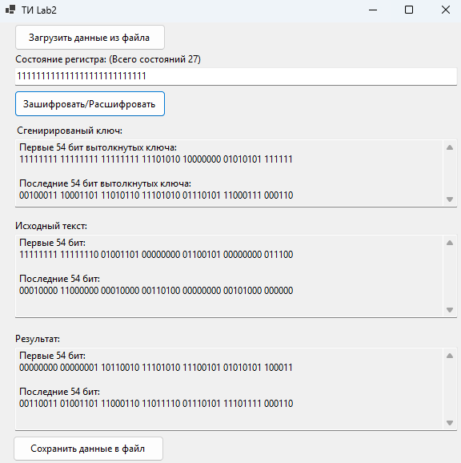

Зашифрованный текст:

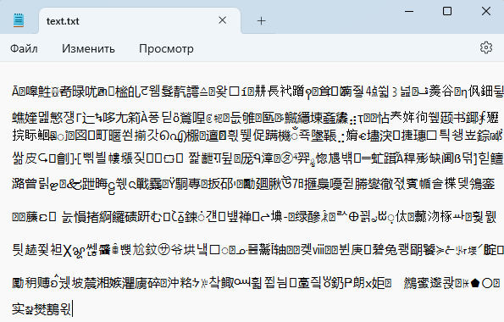

Результат работы дешифратора:

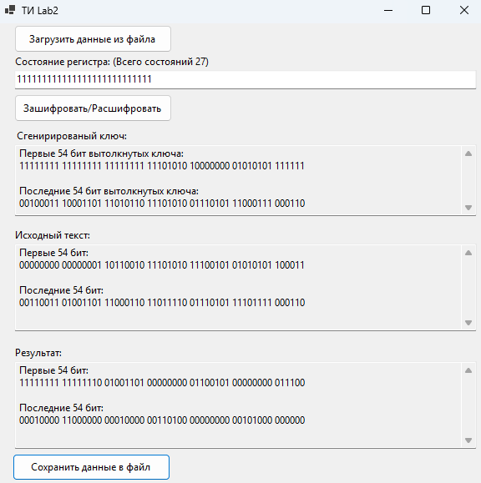

Расшифрованный текст:



1. Шифрование фотографии:

Исходная фотография:

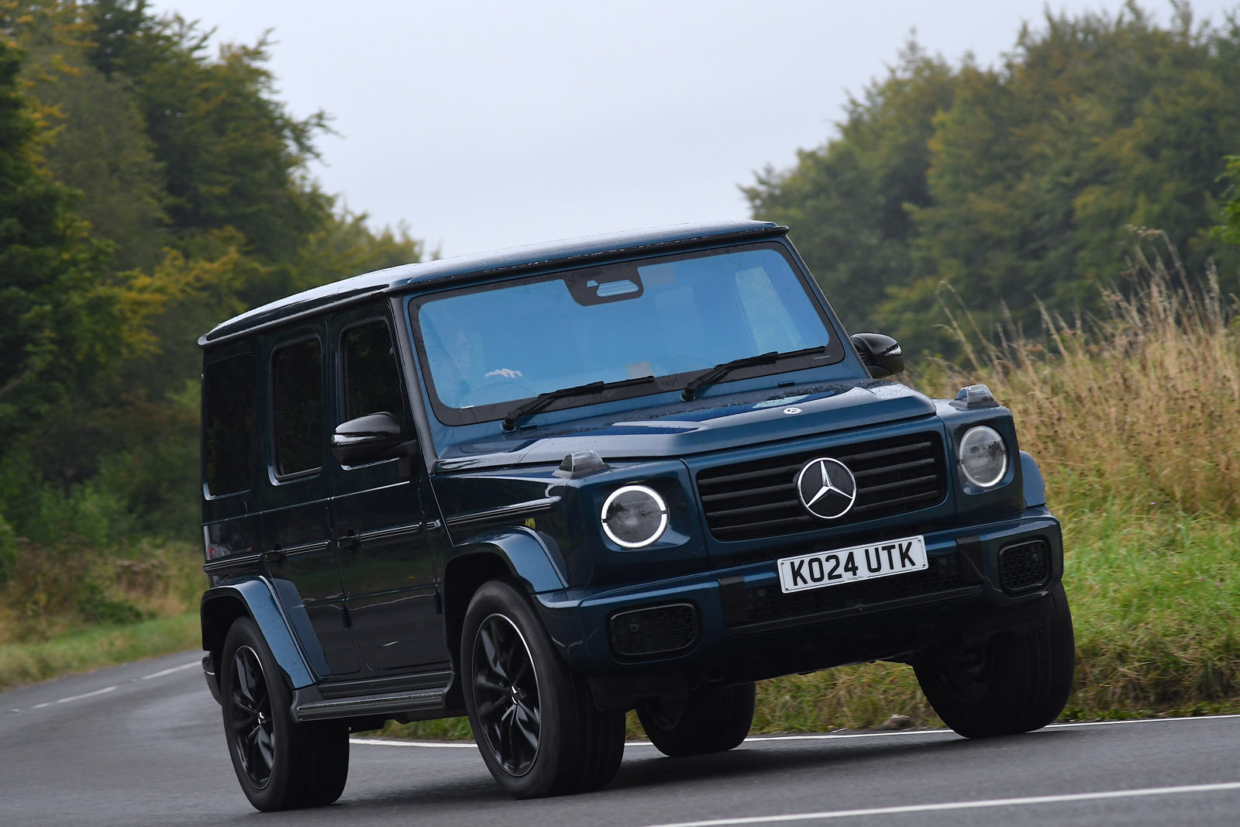

Результат работы шифратора:

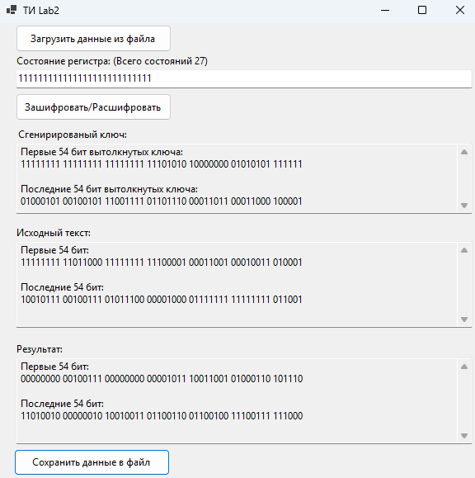

Зашифрованная фотография:

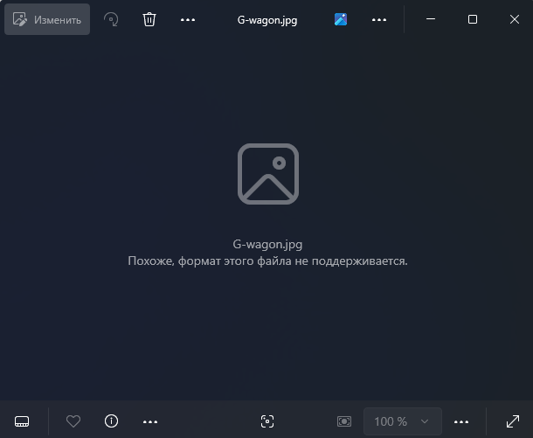

Результат работы дешифратора:

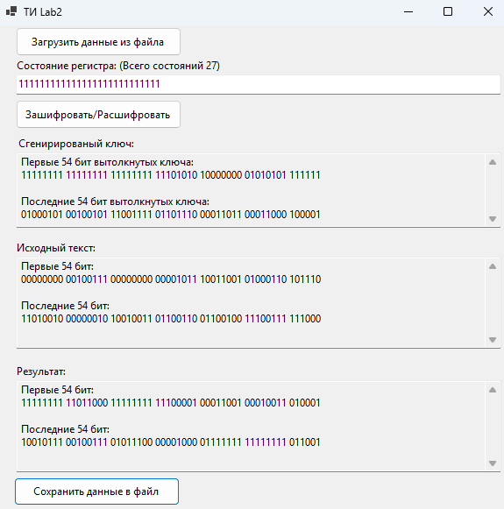

Расшифрованная фотография:

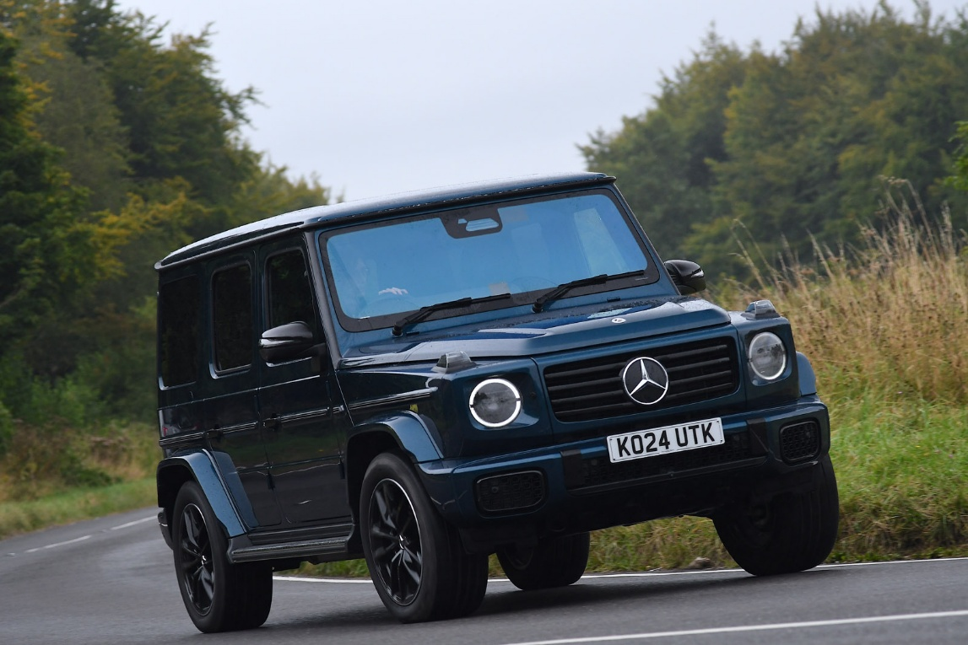

1. Шифрование аудио:

Исходное аудио:



Результат работы шифратора:

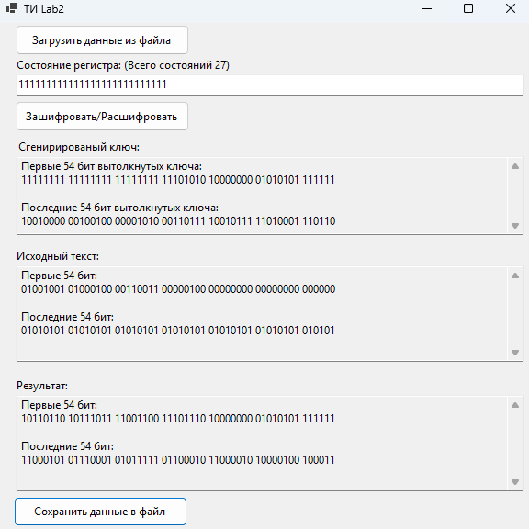

Зашифрованное аудио:

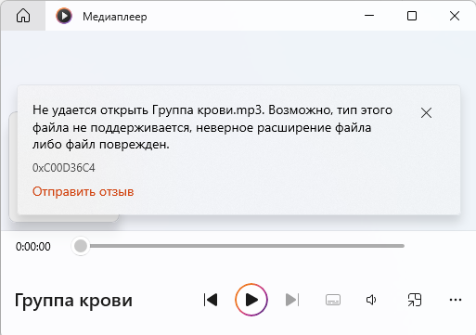

Результат работы дешифратора:

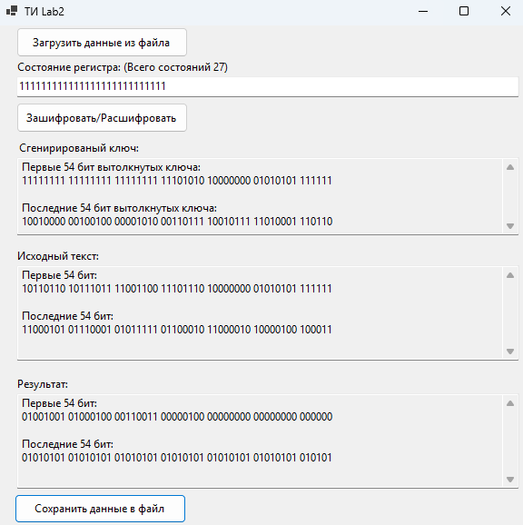

Расшифрованное аудио:



|  |  |  |  |  |  |  |  |  |  |  |  |  |  |  |  |  |  |  |  |  |  |  |  |  |  |  |  |  |
| --- | --- | --- | --- | --- | --- | --- | --- | --- | --- | --- | --- | --- | --- | --- | --- | --- | --- | --- | --- | --- | --- | --- | --- | --- | --- | --- | --- | --- |
|  | **27** | **26** | **25** | **24** | **23** | **22** | **21** | **20** | **19** | **18** | **17** | **16** | **15** | **14** | **13** | **12** | **11** | **10** | **9** | **8** | **7** | **6** | **5** | **4** | **3** | **2** | **1** | **XOR** |
| 1 | 1 | 1 | 1 | 1 | 1 | 1 | 1 | 1 | 1 | 1 | 1 | 1 | 1 | 1 | 1 | 1 | 1 | 1 | 1 | 1 | 1 | 1 | 1 | 1 | 1 | 1 | 1 | 0 |
| 2 | 1 | 1 | 1 | 1 | 1 | 1 | 1 | 1 | 1 | 1 | 1 | 1 | 1 | 1 | 1 | 1 | 1 | 1 | 1 | 1 | 1 | 1 | 1 | 1 | 1 | 1 | 0 | 1 |
| 3 | 1 | 1 | 1 | 1 | 1 | 1 | 1 | 1 | 1 | 1 | 1 | 1 | 1 | 1 | 1 | 1 | 1 | 1 | 1 | 1 | 1 | 1 | 1 | 1 | 1 | 0 | 1 | 0 |
| 4 | 1 | 1 | 1 | 1 | 1 | 1 | 1 | 1 | 1 | 1 | 1 | 1 | 1 | 1 | 1 | 1 | 1 | 1 | 1 | 1 | 1 | 1 | 1 | 1 | 0 | 1 | 0 | 1 |
| 5 | 1 | 1 | 1 | 1 | 1 | 1 | 1 | 1 | 1 | 1 | 1 | 1 | 1 | 1 | 1 | 1 | 1 | 1 | 1 | 1 | 1 | 1 | 1 | 0 | 1 | 0 | 1 | 0 |
| 6 | 1 | 1 | 1 | 1 | 1 | 1 | 1 | 1 | 1 | 1 | 1 | 1 | 1 | 1 | 1 | 1 | 1 | 1 | 1 | 1 | 1 | 1 | 0 | 1 | 0 | 1 | 0 | 1 |
| 7 | 1 | 1 | 1 | 1 | 1 | 1 | 1 | 1 | 1 | 1 | 1 | 1 | 1 | 1 | 1 | 1 | 1 | 1 | 1 | 1 | 1 | 0 | 1 | 0 | 1 | 0 | 1 | 0 |
| 8 | 1 | 1 | 1 | 1 | 1 | 1 | 1 | 1 | 1 | 1 | 1 | 1 | 1 | 1 | 1 | 1 | 1 | 1 | 1 | 1 | 0 | 1 | 0 | 1 | 0 | 1 | 0 | 0 |
| 9 | 1 | 1 | 1 | 1 | 1 | 1 | 1 | 1 | 1 | 1 | 1 | 1 | 1 | 1 | 1 | 1 | 1 | 1 | 1 | 0 | 1 | 0 | 1 | 0 | 1 | 0 | 0 | 0 |
| 10 | 1 | 1 | 1 | 1 | 1 | 1 | 1 | 1 | 1 | 1 | 1 | 1 | 1 | 1 | 1 | 1 | 1 | 1 | 0 | 1 | 0 | 1 | 0 | 1 | 0 | 0 | 0 | 0 |
| 11 | 1 | 1 | 1 | 1 | 1 | 1 | 1 | 1 | 1 | 1 | 1 | 1 | 1 | 1 | 1 | 1 | 1 | 0 | 1 | 0 | 1 | 0 | 1 | 0 | 0 | 0 | 0 | 0 |
| 12 | 1 | 1 | 1 | 1 | 1 | 1 | 1 | 1 | 1 | 1 | 1 | 1 | 1 | 1 | 1 | 1 | 0 | 1 | 0 | 1 | 0 | 1 | 0 | 0 | 0 | 0 | 0 | 0 |
| 13 | 1 | 1 | 1 | 1 | 1 | 1 | 1 | 1 | 1 | 1 | 1 | 1 | 1 | 1 | 1 | 0 | 1 | 0 | 1 | 0 | 1 | 0 | 0 | 0 | 0 | 0 | 0 | 0 |
| 14 | 1 | 1 | 1 | 1 | 1 | 1 | 1 | 1 | 1 | 1 | 1 | 1 | 1 | 1 | 0 | 1 | 0 | 1 | 0 | 1 | 0 | 0 | 0 | 0 | 0 | 0 | 0 | 0 |
| 15 | 1 | 1 | 1 | 1 | 1 | 1 | 1 | 1 | 1 | 1 | 1 | 1 | 1 | 0 | 1 | 0 | 1 | 0 | 1 | 0 | 0 | 0 | 0 | 0 | 0 | 0 | 0 | 1 |
| 16 | 1 | 1 | 1 | 1 | 1 | 1 | 1 | 1 | 1 | 1 | 1 | 1 | 0 | 1 | 0 | 1 | 0 | 1 | 0 | 0 | 0 | 0 | 0 | 0 | 0 | 0 | 1 | 0 |
| 17 | 1 | 1 | 1 | 1 | 1 | 1 | 1 | 1 | 1 | 1 | 1 | 0 | 1 | 0 | 1 | 0 | 1 | 0 | 0 | 0 | 0 | 0 | 0 | 0 | 0 | 1 | 0 | 1 |
| 18 | 1 | 1 | 1 | 1 | 1 | 1 | 1 | 1 | 1 | 1 | 0 | 1 | 0 | 1 | 0 | 1 | 0 | 0 | 0 | 0 | 0 | 0 | 0 | 0 | 1 | 0 | 1 | 0 |
| 19 | 1 | 1 | 1 | 1 | 1 | 1 | 1 | 1 | 1 | 0 | 1 | 0 | 1 | 0 | 1 | 0 | 0 | 0 | 0 | 0 | 0 | 0 | 0 | 1 | 0 | 1 | 0 | 1 |
| 20 | 1 | 1 | 1 | 1 | 1 | 1 | 1 | 1 | 0 | 1 | 0 | 1 | 0 | 1 | 0 | 0 | 0 | 0 | 0 | 0 | 0 | 0 | 1 | 0 | 1 | 0 | 1 | 0 |
| 21 | 1 | 1 | 1 | 1 | 1 | 1 | 1 | 0 | 1 | 0 | 1 | 0 | 1 | 0 | 0 | 0 | 0 | 0 | 0 | 0 | 0 | 1 | 0 | 1 | 0 | 1 | 0 | 1 |
| 22 | 1 | 1 | 1 | 1 | 1 | 1 | 0 | 1 | 0 | 1 | 0 | 1 | 0 | 0 | 0 | 0 | 0 | 0 | 0 | 0 | 1 | 0 | 1 | 0 | 1 | 0 | 1 | 1 |
| 23 | 1 | 1 | 1 | 1 | 1 | 0 | 1 | 0 | 1 | 0 | 1 | 0 | 0 | 0 | 0 | 0 | 0 | 0 | 0 | 1 | 0 | 1 | 0 | 1 | 0 | 1 | 1 | 1 |
| 24 | 1 | 1 | 1 | 1 | 0 | 1 | 0 | 1 | 0 | 1 | 0 | 0 | 0 | 0 | 0 | 0 | 0 | 0 | 1 | 0 | 1 | 0 | 1 | 0 | 1 | 1 | 1 | 1 |
| 25 | 1 | 1 | 1 | 0 | 1 | 0 | 1 | 0 | 1 | 0 | 0 | 0 | 0 | 0 | 0 | 0 | 0 | 1 | 0 | 1 | 0 | 1 | 0 | 1 | 1 | 1 | 1 | 1 |
| 26 | 1 | 1 | 0 | 1 | 0 | 1 | 0 | 1 | 0 | 0 | 0 | 0 | 0 | 0 | 0 | 0 | 1 | 0 | 1 | 0 | 1 | 0 | 1 | 1 | 1 | 1 | 1 | 1 |
| 27 | 1 | 0 | 1 | 0 | 1 | 0 | 1 | 0 | 0 | 0 | 0 | 0 | 0 | 0 | 0 | 1 | 0 | 1 | 0 | 1 | 0 | 1 | 1 | 1 | 1 | 1 | 1 | 1 |
| 28 | 0 | 1 | 0 | 1 | 0 | 1 | 0 | 0 | 0 | 0 | 0 | 0 | 0 | 0 | 1 | 0 | 1 | 0 | 1 | 0 | 1 | 1 | 1 | 1 | 1 | 1 | 1 | 0 |
| 29 | 1 | 0 | 1 | 0 | 1 | 0 | 0 | 0 | 0 | 0 | 0 | 0 | 0 | 1 | 0 | 1 | 0 | 1 | 0 | 1 | 1 | 1 | 1 | 1 | 1 | 1 | 0 | 1 |
| 30 | 0 | 1 | 0 | 1 | 0 | 0 | 0 | 0 | 0 | 0 | 0 | 0 | 1 | 0 | 1 | 0 | 1 | 0 | 1 | 1 | 1 | 1 | 1 | 1 | 1 | 0 | 1 | 1 |
| 31 | 1 | 0 | 1 | 0 | 0 | 0 | 0 | 0 | 0 | 0 | 0 | 1 | 0 | 1 | 0 | 1 | 0 | 1 | 1 | 1 | 1 | 1 | 1 | 1 | 0 | 1 | 1 | 0 |
| 32 | 0 | 1 | 0 | 0 | 0 | 0 | 0 | 0 | 0 | 0 | 1 | 0 | 1 | 0 | 1 | 0 | 1 | 1 | 1 | 1 | 1 | 1 | 1 | 0 | 1 | 1 | 0 | 0 |
| 33 | 1 | 0 | 0 | 0 | 0 | 0 | 0 | 0 | 0 | 1 | 0 | 1 | 0 | 1 | 0 | 1 | 1 | 1 | 1 | 1 | 1 | 1 | 0 | 1 | 1 | 0 | 0 | 1 |
| 34 | 0 | 0 | 0 | 0 | 0 | 0 | 0 | 0 | 1 | 0 | 1 | 0 | 1 | 0 | 1 | 1 | 1 | 1 | 1 | 1 | 1 | 0 | 1 | 1 | 0 | 0 | 1 | 1 |
| 35 | 0 | 0 | 0 | 0 | 0 | 0 | 0 | 1 | 0 | 1 | 0 | 1 | 0 | 1 | 1 | 1 | 1 | 1 | 1 | 1 | 0 | 1 | 1 | 0 | 0 | 1 | 1 | 0 |
| 36 | 0 | 0 | 0 | 0 | 0 | 0 | 1 | 0 | 1 | 0 | 1 | 0 | 1 | 1 | 1 | 1 | 1 | 1 | 1 | 0 | 1 | 1 | 0 | 0 | 1 | 1 | 0 | 1 |
| 37 | 0 | 0 | 0 | 0 | 0 | 1 | 0 | 1 | 0 | 1 | 0 | 1 | 1 | 1 | 1 | 1 | 1 | 1 | 0 | 1 | 1 | 0 | 0 | 1 | 1 | 0 | 1 | 1 |
| 38 | 0 | 0 | 0 | 0 | 1 | 0 | 1 | 0 | 1 | 0 | 1 | 1 | 1 | 1 | 1 | 1 | 1 | 0 | 1 | 1 | 0 | 0 | 1 | 1 | 0 | 1 | 1 | 0 |
| 39 | 0 | 0 | 0 | 1 | 0 | 1 | 0 | 1 | 0 | 1 | 1 | 1 | 1 | 1 | 1 | 1 | 0 | 1 | 1 | 0 | 0 | 1 | 1 | 0 | 1 | 1 | 0 | 0 |
| 40 | 0 | 0 | 1 | 0 | 1 | 0 | 1 | 0 | 1 | 1 | 1 | 1 | 1 | 1 | 1 | 0 | 1 | 1 | 0 | 0 | 1 | 1 | 0 | 1 | 1 | 0 | 0 | 1 |
| 41 | 0 | 1 | 0 | 1 | 0 | 1 | 0 | 1 | 1 | 1 | 1 | 1 | 1 | 1 | 0 | 1 | 1 | 0 | 0 | 1 | 1 | 0 | 1 | 1 | 0 | 0 | 1 | 1 |
| 42 | 1 | 0 | 1 | 0 | 1 | 0 | 1 | 1 | 1 | 1 | 1 | 1 | 1 | 0 | 1 | 1 | 0 | 0 | 1 | 1 | 0 | 1 | 1 | 0 | 0 | 1 | 1 | 1 |
| 43 | 0 | 1 | 0 | 1 | 0 | 1 | 1 | 1 | 1 | 1 | 1 | 1 | 0 | 1 | 1 | 0 | 0 | 1 | 1 | 0 | 1 | 1 | 0 | 0 | 1 | 1 | 1 | 0 |
| 44 | 1 | 0 | 1 | 0 | 1 | 1 | 1 | 1 | 1 | 1 | 1 | 0 | 1 | 1 | 0 | 0 | 1 | 1 | 0 | 1 | 1 | 0 | 0 | 1 | 1 | 1 | 0 | 1 |
| 45 | 0 | 1 | 0 | 1 | 1 | 1 | 1 | 1 | 1 | 1 | 0 | 1 | 1 | 0 | 0 | 1 | 1 | 0 | 1 | 1 | 0 | 0 | 1 | 1 | 1 | 0 | 1 | 0 |
| 46 | 1 | 0 | 1 | 1 | 1 | 1 | 1 | 1 | 1 | 0 | 1 | 1 | 0 | 0 | 1 | 1 | 0 | 1 | 1 | 0 | 0 | 1 | 1 | 1 | 0 | 1 | 0 | 1 |
| 47 | 0 | 1 | 1 | 1 | 1 | 1 | 1 | 1 | 0 | 1 | 1 | 0 | 0 | 1 | 1 | 0 | 1 | 1 | 0 | 0 | 1 | 1 | 1 | 0 | 1 | 0 | 1 | 0 |
| 48 | 1 | 1 | 1 | 1 | 1 | 1 | 1 | 0 | 1 | 1 | 0 | 0 | 1 | 1 | 0 | 1 | 1 | 0 | 0 | 1 | 1 | 1 | 0 | 1 | 0 | 1 | 0 | 1 |
| 49 | 1 | 1 | 1 | 1 | 1 | 1 | 0 | 1 | 1 | 0 | 0 | 1 | 1 | 0 | 1 | 1 | 0 | 0 | 1 | 1 | 1 | 0 | 1 | 0 | 1 | 0 | 1 | 0 |
| 50 | 1 | 1 | 1 | 1 | 1 | 0 | 1 | 1 | 0 | 0 | 1 | 1 | 0 | 1 | 1 | 0 | 0 | 1 | 1 | 1 | 0 | 1 | 0 | 1 | 0 | 1 | 0 | 0 |
| 51 | 1 | 1 | 1 | 1 | 0 | 1 | 1 | 0 | 0 | 1 | 1 | 0 | 1 | 1 | 0 | 0 | 1 | 1 | 1 | 0 | 1 | 0 | 1 | 0 | 1 | 0 | 0 | 0 |
| 52 | 1 | 1 | 1 | 0 | 1 | 1 | 0 | 0 | 1 | 1 | 0 | 1 | 1 | 0 | 0 | 1 | 1 | 1 | 0 | 1 | 0 | 1 | 0 | 1 | 0 | 0 | 0 | 0 |
| 53 | 1 | 1 | 0 | 1 | 1 | 0 | 0 | 1 | 1 | 0 | 1 | 1 | 0 | 0 | 1 | 1 | 1 | 0 | 1 | 0 | 1 | 0 | 1 | 0 | 0 | 0 | 0 | 0 |
| 54 | 1 | 0 | 1 | 1 | 0 | 0 | 1 | 1 | 0 | 1 | 1 | 0 | 0 | 1 | 1 | 1 | 0 | 1 | 0 | 1 | 0 | 1 | 0 | 0 | 0 | 0 | 0 | 0 |
| 55 | 0 | 1 | 1 | 0 | 0 | 1 | 1 | 0 | 1 | 1 | 0 | 0 | 1 | 1 | 1 | 0 | 1 | 0 | 1 | 0 | 1 | 0 | 0 | 0 | 0 | 0 | 0 | 1 |
| 56 | 1 | 1 | 0 | 0 | 1 | 1 | 0 | 1 | 1 | 0 | 0 | 1 | 1 | 1 | 0 | 1 | 0 | 1 | 0 | 1 | 0 | 0 | 0 | 0 | 0 | 0 | 1 | 1 |