l-theanine

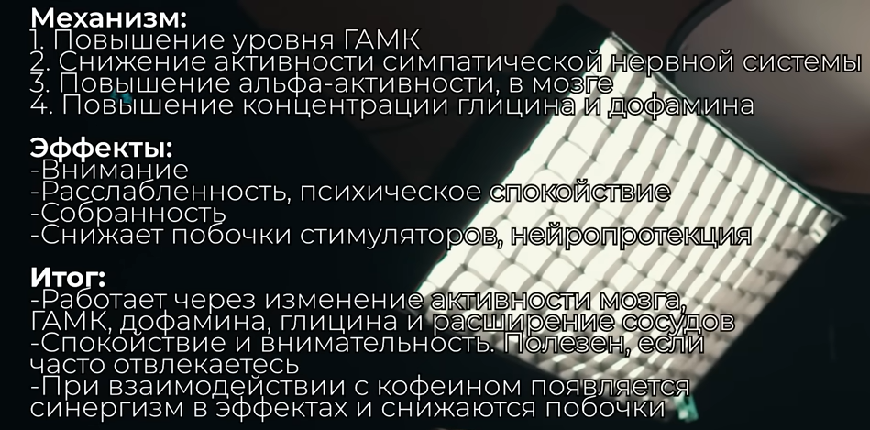

-----------------------------------------------------------------------------------------------------------------------------------------------

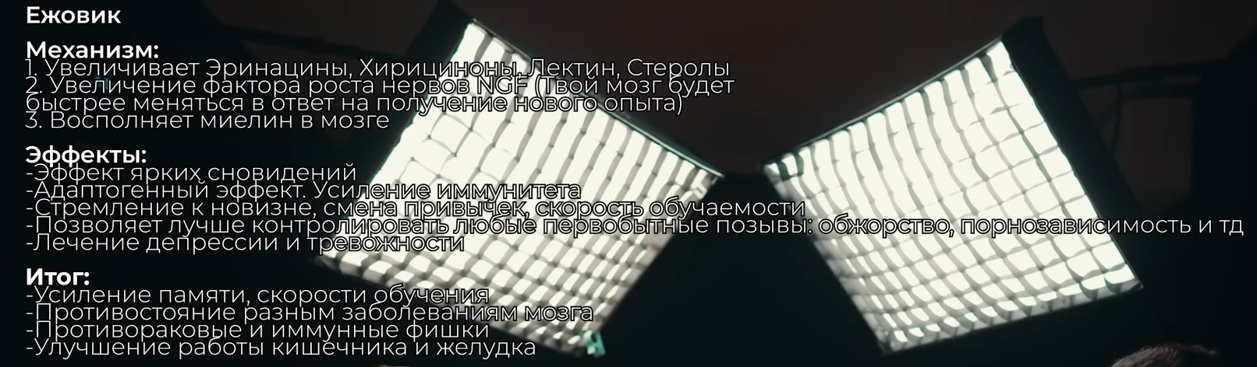

-----------------------------------------------------------------------------------------------------------------------------------------------

Ацетилхолин



