Checklist: Convert E-book to a Tripwire

**Step 1: Convert e-book to a hard cover book**

The easiest way I have found to convert an e-book to an actual cover book is by using the folks at Blurb.com. It’s affordable and very simple to use.

* Sign up to Blurb.com
* Use their *PDF to Book* converter - <http://www.blurb.com/pdf-to-book>
* Using their platform complete your Amazon book listing
  + Create a book preview for Amazon
  + Complete your author profile
  + Write an enticing description about your book
  + Setup the retails price for your book

**Step 2: Add Your “Real” Book to Your Site**

These steps are for credibility purposes only. Remember, we are going to send people to a special “tripwire” to download your e-book.

* Change ALL your current call-to-actions (CTA) on your website for your e-book to “Get Your Copy” – “Now Available on Amazon”
* Point ALL your website CTA’s to your amazon listing

**Step 3: Setup Your Tripwire**

* Create a landing page for your e-book
  + Make sure to mention in the copy that the retail price of your book is X amount on Amazon (link to your amazon listing), but that the digital version (e-book) is only available from your site at a special price.
  + Decide the price that you’d like offer the digital version of your book. **Remember**, successful tripwires can start as low as $1. As long as there’s an exchange on money your audience will build more trust in you and, if it’s valuable to them, it could potentially open the door for them to buy products from you at a higher price.
  + Create your CTA button. Example: *Get your digital copy NOW for just $X*
  + Point the CTA button to your shopping cart.
* Have your shopping cart platform send your e-book right after purchase.
* Create an upsell email sequence for people who purchased your tripwire.
  + Day 1: Send the a really powerful piece content that can help them get even more out of the book.
  + Day 2: No email
  + Day 3: Start indirectly introducing your core product. Sample headline: *“Use THIS to become an Authority (in the market)…*
  + Day 4: No email
  + Day 5: CTA/Invitation email - use this email to directly upsell your core product
  + Day 6: Logic Email – Talk about the logical benefits about what you are trying to sell. Use testimonials from others, if possible.
  + Day 7: FOMO Email: Create an email that will make them feel like they will miss out if they don’t take action. Example: Last Chance to Save $X

**Note**: I typically only send up to 5 emails for a tripwire follow up sequence, because given the low barrier of entry if they don’t buy within a few days your best bet is to move on or offer them a different tripwire (if you have one)

* Now that your landing page and your email sequence are completed, gather all your lead magnets that are related to this e-book tripwire
* Replace your standard “Thank You for Downloading…” page to the tripwire landing page

**Optional step, but highly recommended**

* Add a deadline to your e-book tripwire page. This has been proven to increase conversions
  + Tool I recommend:
    - DeadlineFunnel.com
* Add a *Recently Downloaded* pop-pp: This is really hot right now and it’s working incredibly well for my clients.
  + Tool I recommend:
    - useproof.com
* Add a cart abandonment follow up series for people who showed interest in your tripwire, but didn’t purchase
  + Tools I recommend:
    - SamCart.com
    - ThriveCart.com (coming soon)

Add CTA at the end of the checklist for people to join my FB Group. Something like this:

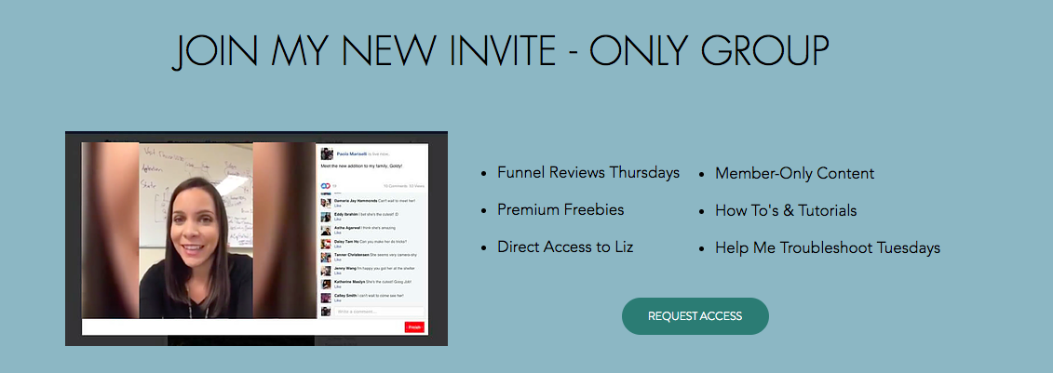

<button link to join the group is: https://www.facebook.com/groups/2000352850200130>