PME 3433 Machine Design EXAM #3 Dec. 15, 2014

(Open book)

1. The following figure shows a torque-displacement function. The nominal speed of the engine is 250 rad/sec. (35%)
   1. Integrate the torque-displacement function for one cycle and find the energy that can be delivered to a load during the cycle. (5%)
   2. Determine the average torque Tavg. (5%)
   3. If a coefficient of speed fluctuation Cs = 0.1 is required, find a suitable value for the flywheel inertia. (10%)
   4. Find the ωmax and ωmin. (5%)
   5. If the flywheel is not used, find the ωmax and ωmin. (10%)



1. A round wire helical tension spring is to be used as a return spring on a cam-driven lever, as shown below. The spring must be pretensioned to exert a 10 lbf at the bottom of its stroke, and should have a spring rate of 20 lbf/in. The peak-to-peak operating deflection for this spring is 1 inch. The spring is to be made of no. 33 music wire. It is desired to have a safety factor of 1.5. Please design the spring with infinite life for this application. (30%)

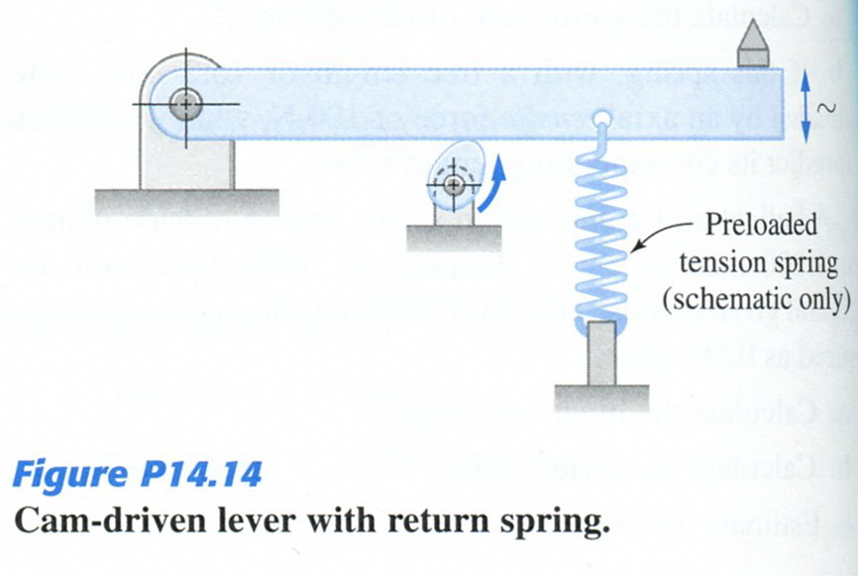

1. A helical-coil tension spring is designed as a shutter return for a small camera. Preliminary design specifications estimate a wire diameter of d = 0.5 mm, a mean coil diameter of D = 2 mm, and a tensile force of F = 5 N are required. The spring is to be made from hard-drawn steel (G = 79 GPa). The end-loops are to have the geometry shown in Figure 3 (a) and (b), with rmA = 1 mm and rmB = 0.5 mm. Determine the maximum shear stress in the body and the end-loop, as well as the maximum normal stress in the end-loop. (20%)
2. A block-type brake is schematically shown in Figure 1. What is the dimension of “c” to make the self-locking phenomenon occurs? In this figure, a = 60mm，b = 40mm，d = 100mm，μ = 0.35。(15%)

|  |  |
| --- | --- |
|  |  |
| Problem 3 | Problem 4 |