PME 3433 Machine Design EXAM #3 Dec. 07, 2015

(Closed book)

1. The following figure shows a doorstop. Assume that the pressure acting on the friction pad is uniform; please draw a free-body diagram of the doorstop for leftward movement of the floor? Also, draw a free-body diagram for rightward movement of the floor? Derive the equations to show when self-locking and self-energizing phenomena occur. (20%)

|  |
| --- |
|  |

1. What are the function of coupling and clutch, respectively? (5%)
2. What is the purpose of the flywheel? (5%)
3. Draw the physical model of a type of bicycle brakes and then derive the related equations for that brake. (10%)
4. Presetting or set removal is the process for obtaining the useful residual stress of compressive springs. Please explain how to achieve this process. (5%) What is the purpose of the useful residual stress? (5%)
5. Examine the following figures. What types of the stresses at points A and B of the figures (a) and (b), which show the original design, are? (5%) (2) Figures (c) and (d) show an improved design of the figures (a) and (b), why? (5%)

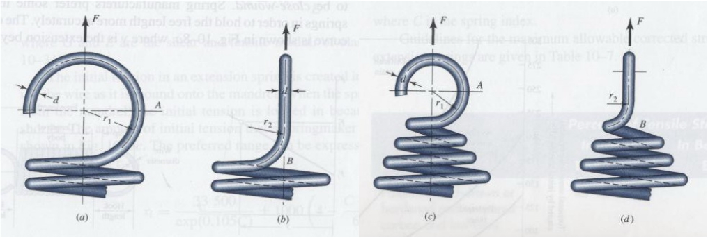

1. A disk clutch shown below has only one friction surface. The coefficient of friction f = 0.15, the outside diameter ro = 250 mm, the inside diameter ri = 120 mm. An axial force, F = 400 N, is acting on the clutch. (1) Derive equations and calculate the torque capacity (T) based on uniform wear theory (10%); (2) Repeat (1) based on uniform pressure theory (10%); (3) Under what circustance do you use uniform wear theory? (5%)

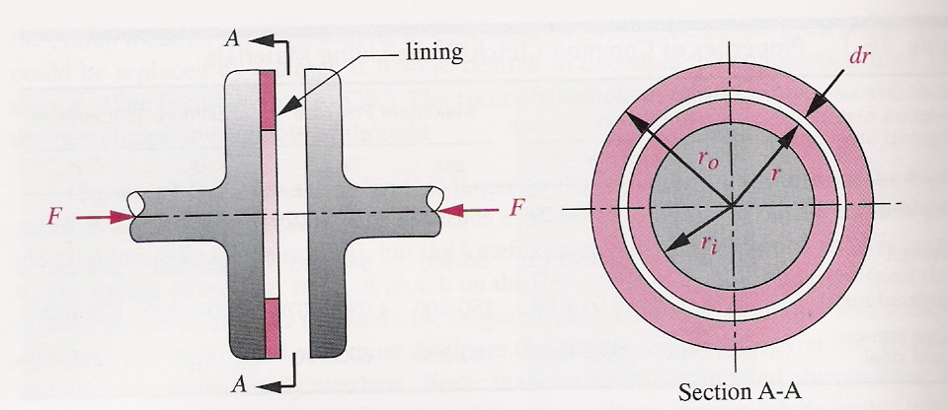

1. The wire and coil diameters of a helical compressive spring are d = 5 mm and D = 100 mm, respectively. The shear modulus and the maximum allowable stress of the spring are G = 80,000 Mpa and Ssy = 600 Mpa. To design a spring with the spring rate K = 1000 N/m, how many active turns of the spring are required? (10%) If the number of active turns is cut into half, what is the spring rate? (5%)