**PME 3433 Machine Design EXAM #6 Jan. 8, 2016**

(Open book)

1. The figure shows a gear-driven squeeze roll that is used to produce laminated wood product. The rolls are designed to exert a normal force of 5000N/m, and a pull of 4000 N/m on the material. The roll speed is 500 rpm. Please design the hydrodynamic bearing at location A. (30%)

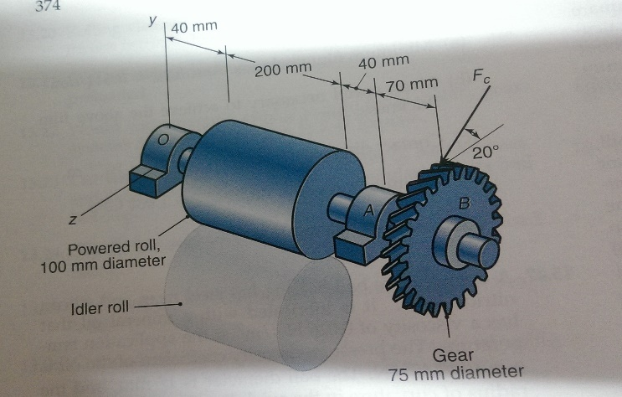

1. The press shown in Problem 8-6 of Page 451 has a rated load of 6,000 lbf. The twin screws have Square threads, a diameter of 2 in, and a pitch of 1/4 in. Coefficients of friction are 0.06 for the threads and 0.07 for the collar bearings. Collar diameters are 3.5 in. The gears have an efficiency of 0.96 and a speed ratio of 60:1. A slip clutch, on the motor shaft, prevents overloading. The full-load motor speed is 1720 rpm.
   1. When the motor is turned on, how fast will the press head move? (10%)
   2. What should be the horsepower rating of the motor? (10%)
   3. Determine the von Mises stress at the root of the thread. (10%)

1. Gogoro電動機車原本就沒有採用變速齒輪箱，而是採用一段減速比的減速齒輪箱，請依給大家的專題投影片內相關資訊，計算該減速齒輪箱的大致減速比應為若干？(15%)請把計算出來的相關結果畫在課本例題3-1的圖上。(10%)請計算兩個軸AB與CD的直徑，並選擇適當的滾珠軸承。每一軸承的可靠度為0.96，軸承的壽命應為200x106 Cycles. (15%)