Airport Management System
Student Name: Subhrojit mohanty
Branch: B.Tech CSE
Roll Number: 2427030637
Supervisor/Guide Name: Rishi Gupta
Department: Computer Science
College/University: Manipal University Jaipur

ABSTRACT

The Airport Management System is designed to efficiently manage and automate airport operations such as flight scheduling, airline and aircraft management, and passenger reservations. The system integrates various modules including Airport, Airline, Aircraft, Flight, Passenger, and Reservation management. The objective is to ensure smooth coordination between all entities to improve overall operational efficiency. The project uses relational database design principles, with each entity represented as a table connected via primary and foreign keys. The findings demonstrate how structured database management can enhance information flow, minimize redundancy, and improve accuracy. The conclusion highlights the system’s potential to support large-scale airport operations with better data consistency and management.

1. Introduction
The Airport Management System is a database-driven solution designed to manage the complex activities and data involved in airport operations. Airports require efficient coordination between flights, airlines, aircraft, and passengers to ensure timely departures, arrivals, and reservations. This project provides a systematic approach to storing, retrieving, and managing information using a relational database model.

1.1 Objectives
• To design a centralized database system for airport management.
• To manage flights, airlines, passengers, and reservations efficiently.
• To reduce redundancy and improve data accuracy.
• To generate reports and queries for operational analysis.

1.2 Scope and Limitations
The system covers major airport management functions including scheduling, aircraft tracking, and passenger booking. However, it does not include live flight tracking, payment gateway integration, or advanced security modules in this version.

2. Literature Review
Airport management systems have evolved from manual record-keeping to fully automated and cloud-integrated systems. Modern systems utilize relational databases to ensure data integrity, support scalability, and improve operational efficiency. Existing research highlights the importance of real-time data management, integration with airline systems, and use of AI for predictive scheduling. This project builds upon those principles using a structured ER model and relational schema.
3. System Design
The system design is based on the Entity-Relationship (ER) model, which represents the data entities and their relationships within the Airport Management System. The main entities are Airport, Airline, Aircraft, Flight, Passenger, and Reservations. Each entity is linked through unique identifiers to ensure data integrity.
airline: Stores the details of each airline operating flights. ​aircraft: Contains information about each aircraft, its registration, capacity, and associated airline. airport: Lists all airports with their names, locations, and unique codes.
flight: Records each scheduled flight, including assigned airline, aircraft, route, status, and timings. ​ passenger: Holds personal details of passengers registered in the system.
reservations: Stores booking information linking passengers to their reserved flights.
​

3.1 ER Diagram Description
The ER diagram shows the relationships between key entities:
• Each Airline operates multiple Aircraft.
• Each Aircraft is assigned to specific Flights.
• Flights are scheduled between two Airports (Departure and Arrival).
• Passengers make Reservations for Flights.
This relational model ensures a well-connected and normalized database structure.
3.2 List of Figures and Tables
Figure 1: ER Diagram of Airport Management System
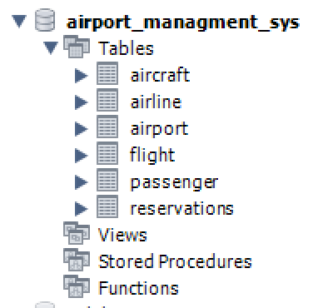

Table 1: Airport Table Structure

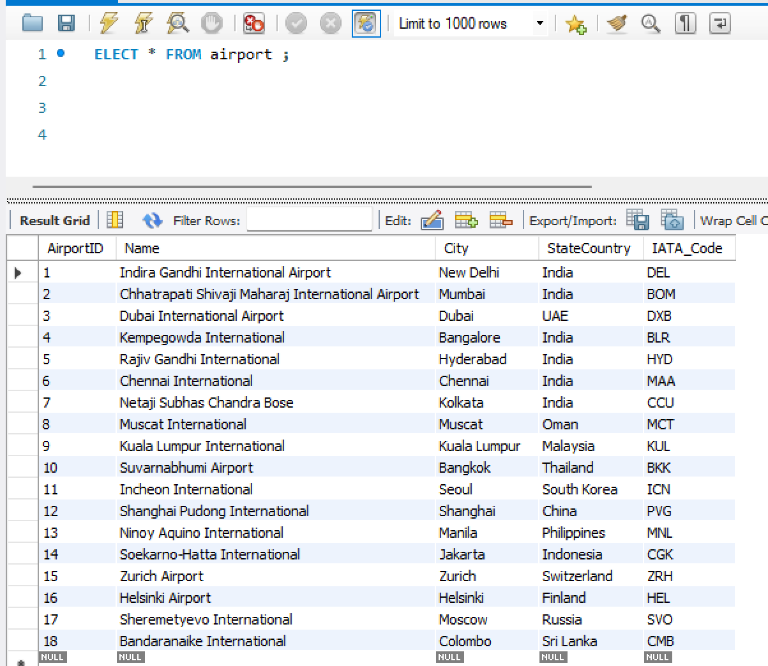

Table 2: Airline Table Structure
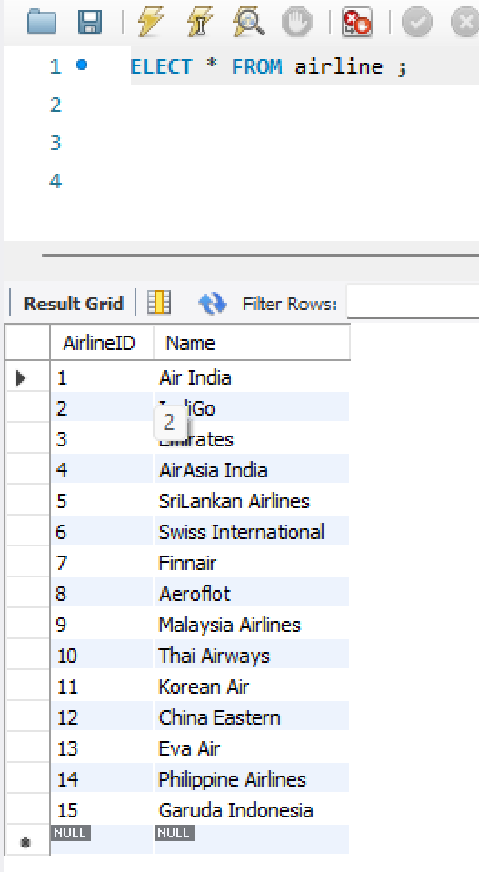

Table 3: Aircraft Table Structure
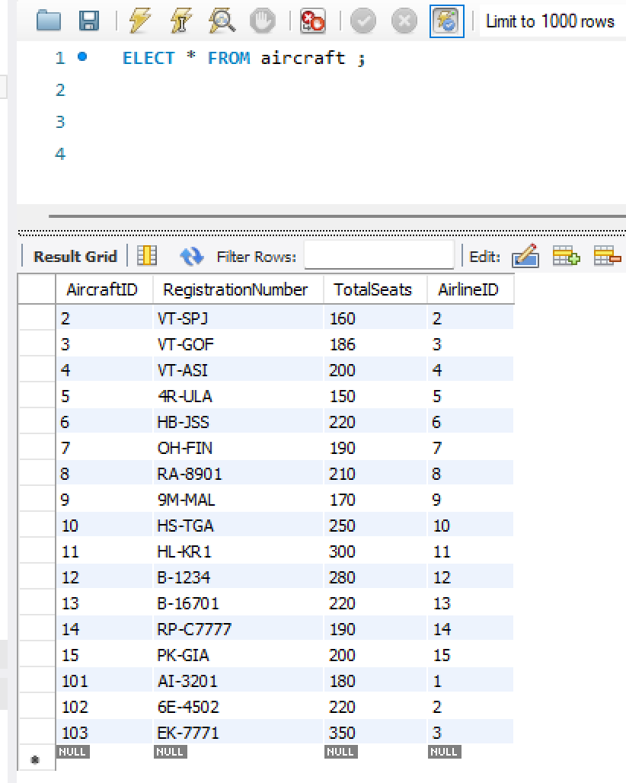

Table 4: Flight Table Structure
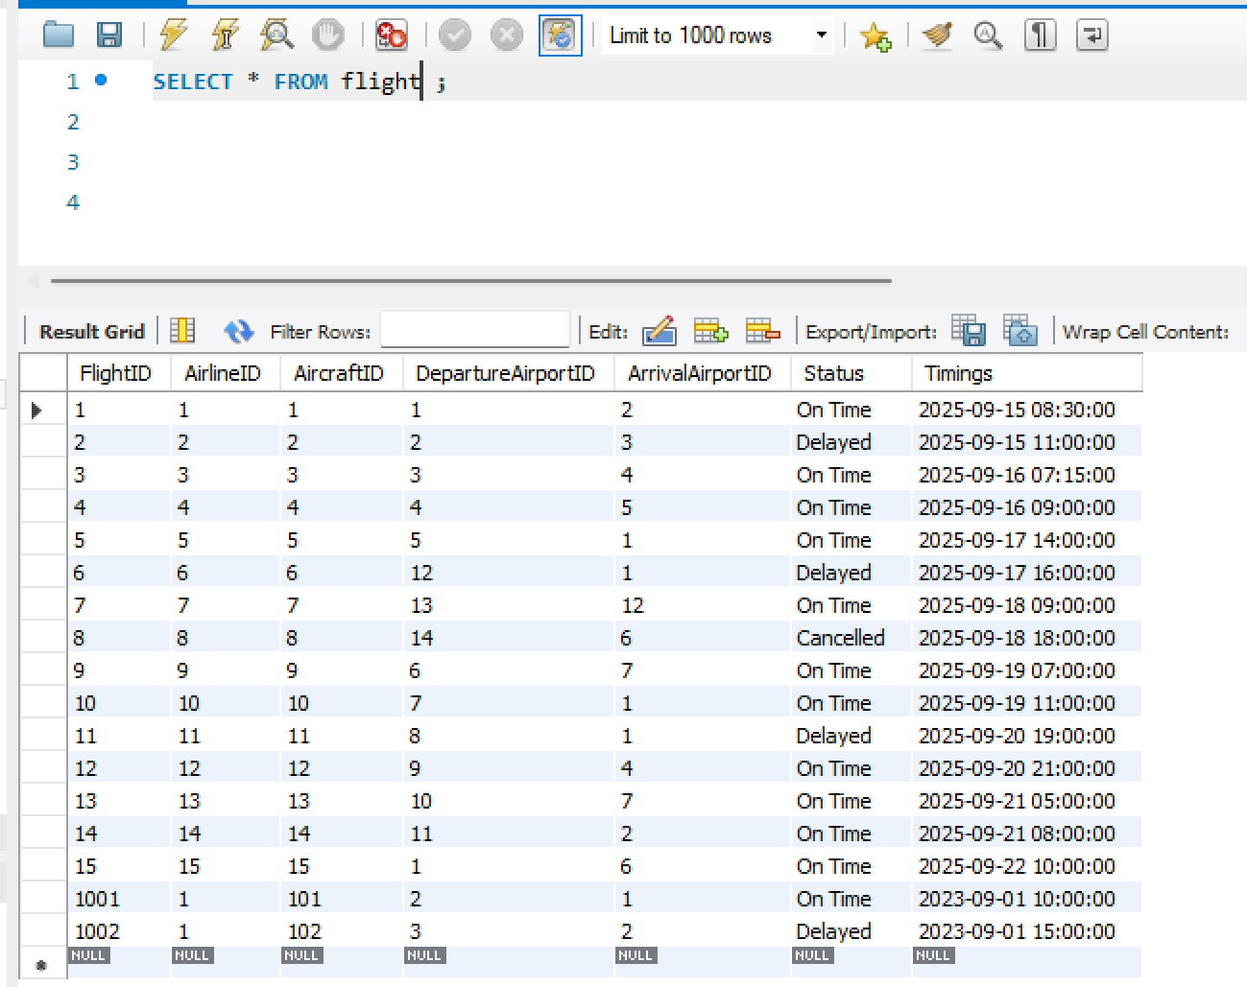

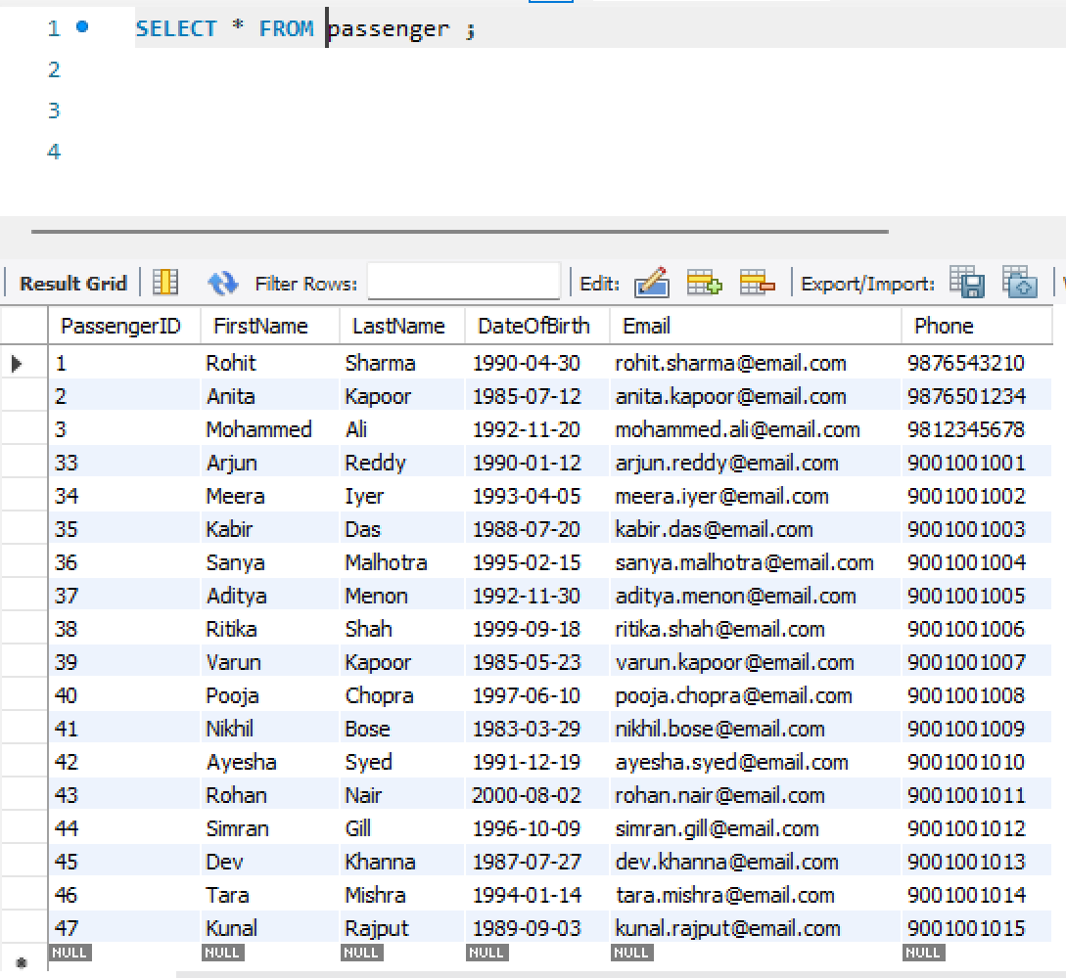
Table 5: Passenger Table Structure

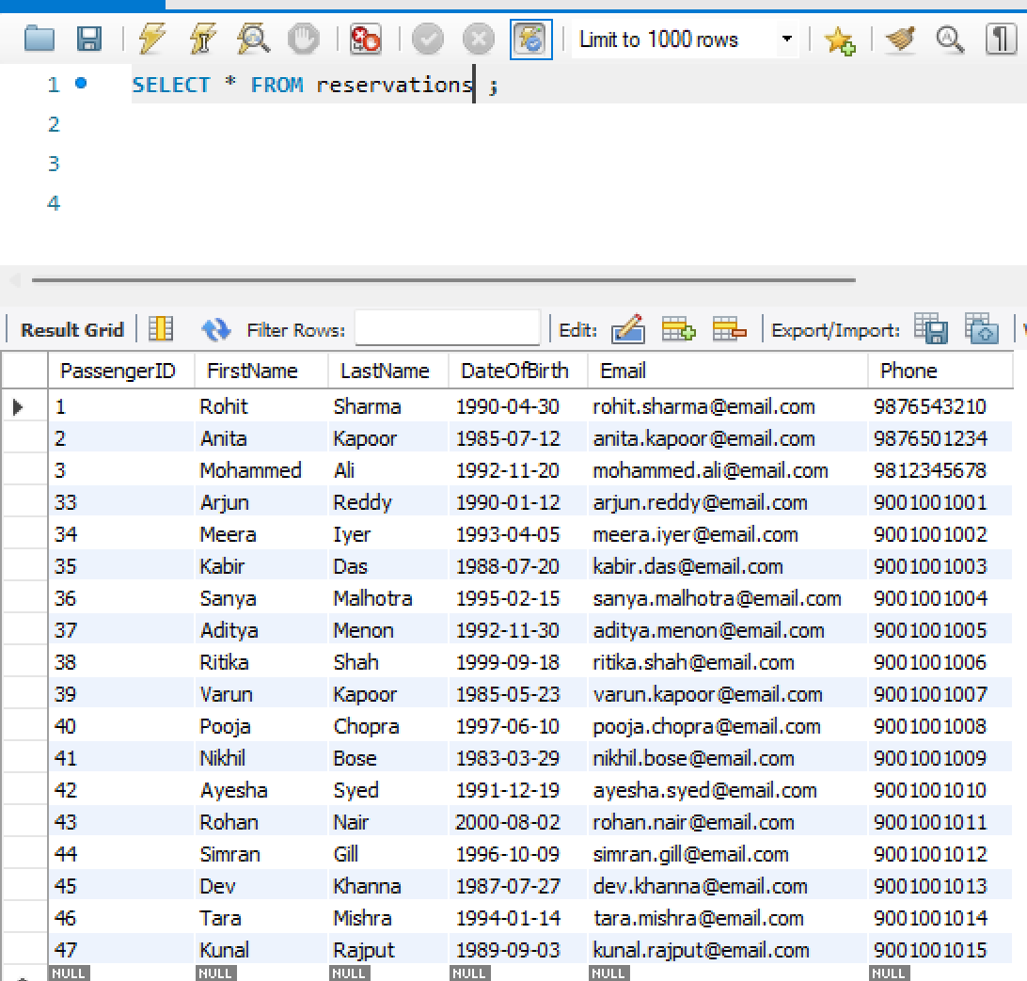
Table 6: Reservation Table Structure

4. Results and Discussion
The Airport Management System successfully manages all airport-related data through structured database tables. Sample SQL queries were executed to validate relationships between entities. For example:
• Retrieving all flights operated by 'Air India'.
• Listing passengers booked on a specific flight.
• Checking aircraft availability based on scheduled flights.
The results confirm that the relational model supports data integrity and accurate retrieval across multiple entities.
5. Conclusion
This project demonstrates a well-structured Airport Management System capable of efficiently handling key airport operations. It provides a foundation for data-driven management by integrating information about flights, passengers, and airlines. The project achieved its objectives of building a relational model and validating data relationships using SQL queries.

6. Future Work
Future enhancements could include:
• Integration of real-time flight tracking systems.
• Online booking and payment integration.
• Data analytics for passenger trends and flight optimization.
• Cloud deployment for multi-airport coordination and scalability.

7. References
[1] Database System Concepts by Abraham Silberschatz et al.
[2] Fundamentals of Database Systems by Elmasri and Navathe.
[3] Research papers on Airport Information Systems.
[4] Official websites of Indian Airports and Airlines.

Appendices
Additional code snippets, SQL queries, or ER diagrams can be attached here.

