**Olga Bergen**

CEO and Co-founder

A corporate strategist with many years of experience in the advertising and information technology industry. In recent years, is engaged in accelerating startups.

*«I have been engaged in accelerating the startup projects for several years. EcoStart is definitely a powerful project with great potential. There are many enterprising young people in the world who really need our help. Together with you we will do a very important and necessary thing!»*

**Michael McKee**

Chief Visionary Officer

Before starting out into ICO Advisory, Michael spent 13 years as Social Media Influencer and Digital Marketer for several dot com startups. After a successful career helping various clothing companies and aspiring musicians, Michael now advises ICOs and Startups on how to market their projects on social media and through SEO. Michael has been a serial ICO investor since 2016 and one of the fastest growing Blockchain Influencers with over 350,000 followers in total.

**Aleksandr Goldobin**

CFO (Chief Financial Officer)

The financial dirTETor responsible for managing the financial flows of the business with vast managerial experience in a wide range of industries. Alexander oversaw environmental activities "Zero waste" in the preparation of the 2014 Winter Olympic Games in Sochi

*“My motto is think globally-act locally! That is why I proposed to bring the project Ecostart to the international level. I believe such initiatives are important for the world community. Our financial support is needed by many ecological projects!”*

**Olga Gershenzon**

Head of Aerospace Monitoring

Co-Founder, Chief Strategy Officer at RBCSignals

*«From the solar system, we still cannot get out for a long time. Therefore, one must learn to live on earth and better on ecologically friendly»*

**Teymur Nurullaev**

COO (Chief Operating Officer)

Chief Operating Officer, a successful businessman, a programmer, one of the first adepts of the blockchain

*“I support the project EcoStart because the Cryptocurrency will gain momentum in the event that we start creating as many projects as possible on blockchain. I manage a whole army of bots - they will help us in this project too!”*

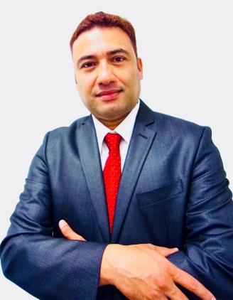

**Dhana Timilsina,**

*Chief strategy officer*

Dhana is an innovative and dynamic world citizen and serial international entrepreneur, consultant, advisor, engineer, trader, businessman, founder, co-founder, owner, investor, researcher, and promoter. Dhana wears several hats and works and supports for several startups, companies, ICOs and projects across the world.

*«Without your strategy, you will depend on someone else's tactics»*

[linkedin.com/in/we-love-technologies](https://www.linkedin.com/in/we-love-technologies?lipi=urn%3Ali%3Apage%3Ad_flagship3_profile_view_base_contact_details%3BBrkji%2BH1TimmNTWWzPL46g%3D%3D)