MODULE-1

ASSIGENMENT

**Q.1 What is software? What is software engineering?**

Answer:-

 Software is a set of instructions, data or programs used to operate computers and execute specific tasks. It is the opposite of hardware, which describes the physical aspects of a computer. Software is a generic term used to refer to applications, scripts and programs that run on a device.

Software Engineering is the process of designing, developing, testing, and maintaining software.

1. **Analysis & Design Environment**

• The analysis and design environment is aligned to the planning and analysis phases of the SDLC. In this environment, the main processes that take place include carrying out an in-depth examination of the current system and the proposed system. The system architecture is also defined and includes developing the design of the hardware, software, and network requirements for the system. Within this environment, systems and business analysts work closely with software engineers.

**2. The development environment**

• The development environment can also be a physical space where development takes place and where software engineers interact. Another example of the development environment is the integrated development environment (IDE). The IDE provides a platform where tools and development processes are coordinated in order to provide software engineers a convenient way of accessing the resources they require during the development process.

**3.The common build environment**

• The common build environment is closely aligned to the development phase of the SDLC. In this environment, software engineers merge the work done in the development environment. Within this environment, software engineers build systems. These are used to automate the process of software compilation.

**4. The testing environment**

• The test environment is where testing teams evaluate the application/quality. program’s This also allows computer programmers to find out and solve any defects that may interfere with the application’s smooth operation .

**5.The production environment**

• When the end-user use a web/mobile application, the program is operating on a production server. It’s been created in the production environment

**Software Diagram:-**

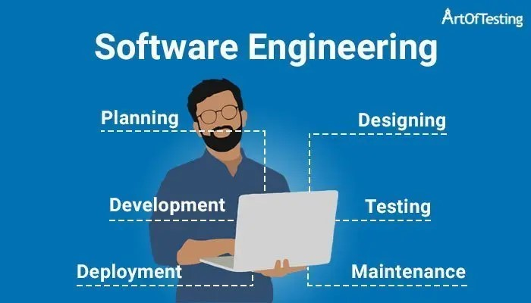

**Q.2 Explain types of software ?**

Answer:-

**●Application software**

**● System software**

**● Driver software**

**● Middleware**

**● Programming software**

**Explain:-**

**1.Application Software :-**

- The most common type of software, application software is a computer software package that performs a specific function for a user, or in some cases, for another application.

- An application can be self-contained, or it can be a group of programs that run the application for the user.

**- Examplesof Modern Applications include office suites, graphics software, databases and database management programs, web browsers, word processors, software development tools, image editors and communication platforms.**

2.**System Software :-**

- These software programs are designed to run a computer's application programs and hardware.

- System software coordinates the activities and functions of the hardware and software.

- It controls the operations of the computer hardware and provides an environment or platform for all the other types of software to work in.

- The OS is the best example of system software; it manages all the other computer programs. - Other examples of system software include the firmware, computer language translators and system utilities..

**-Example:Notepad ,Calculator etc..**

1. **Driver Software :-**

- Also known as device drivers, this software is often considered a type of system software.

- Device drivers control the devices and peripherals connected to a computer, enabling them to perform their specific tasks.

- Every device that is connected to a computer needs at least one device driver to function.

**- Examples include software that comes with any nonstandard hardware, including special game controllers, as well as the software that enables standard hardware, such as USB storage devices, keyboards, headphones and printers. Example: Audio Driver,Video Driver etc..**

1. **Middleware:-**

- The term middleware describes software that mediates between application and system software or between two different kinds of application software. For example, middleware enables Microsoft Windows to talk to Excel and Word.

- It is also used to send a remote work request from an application in a computer that has one kind of OS, to an application in a computer with a different OS. It also enables newer applications to work with legacy ones.

**-Example: database middleware,application server middleware**

1. **Programming Software:-**

- Computer programmers use programming software to write code. Programming software and programming tools enable developers to develop, write, test and debug other software programs.

**- Examples of programming software include assemblers, compilers, debuggers and interpreters. Examples : Turbo c,Eclipse,Sublime etc..**

**Q.3 What is SDLC? Explain each phase of SDLC?**

**Answer:-**

• The Software Development Life Cycle (SDLC) refers to a methodology with clearly defined processes for creating high-quality software. in detail, the SDLC methodology focuses on the following phases of software development:

1. **Requirement Gathering**
2. **Analysis**
3. **Designing**
4. **Implementation**
5. **Testing**
6. **Maintenance**

**Phase of SDLC:-**

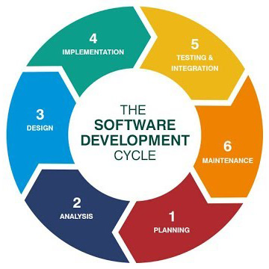

**Q.4 What is DFD? Create a DFD diagram on Flipkart**

**Answer:-**

A data flow diagram (DFD) is a graphical or visual representation using a standardized set of symbols and notations to describe a business's operations through data movement. **They are often elements of a formal methodology such as Structured Systems Analysis and Design Method (SSADM).**

**DFD diagram on Flipkart:-**

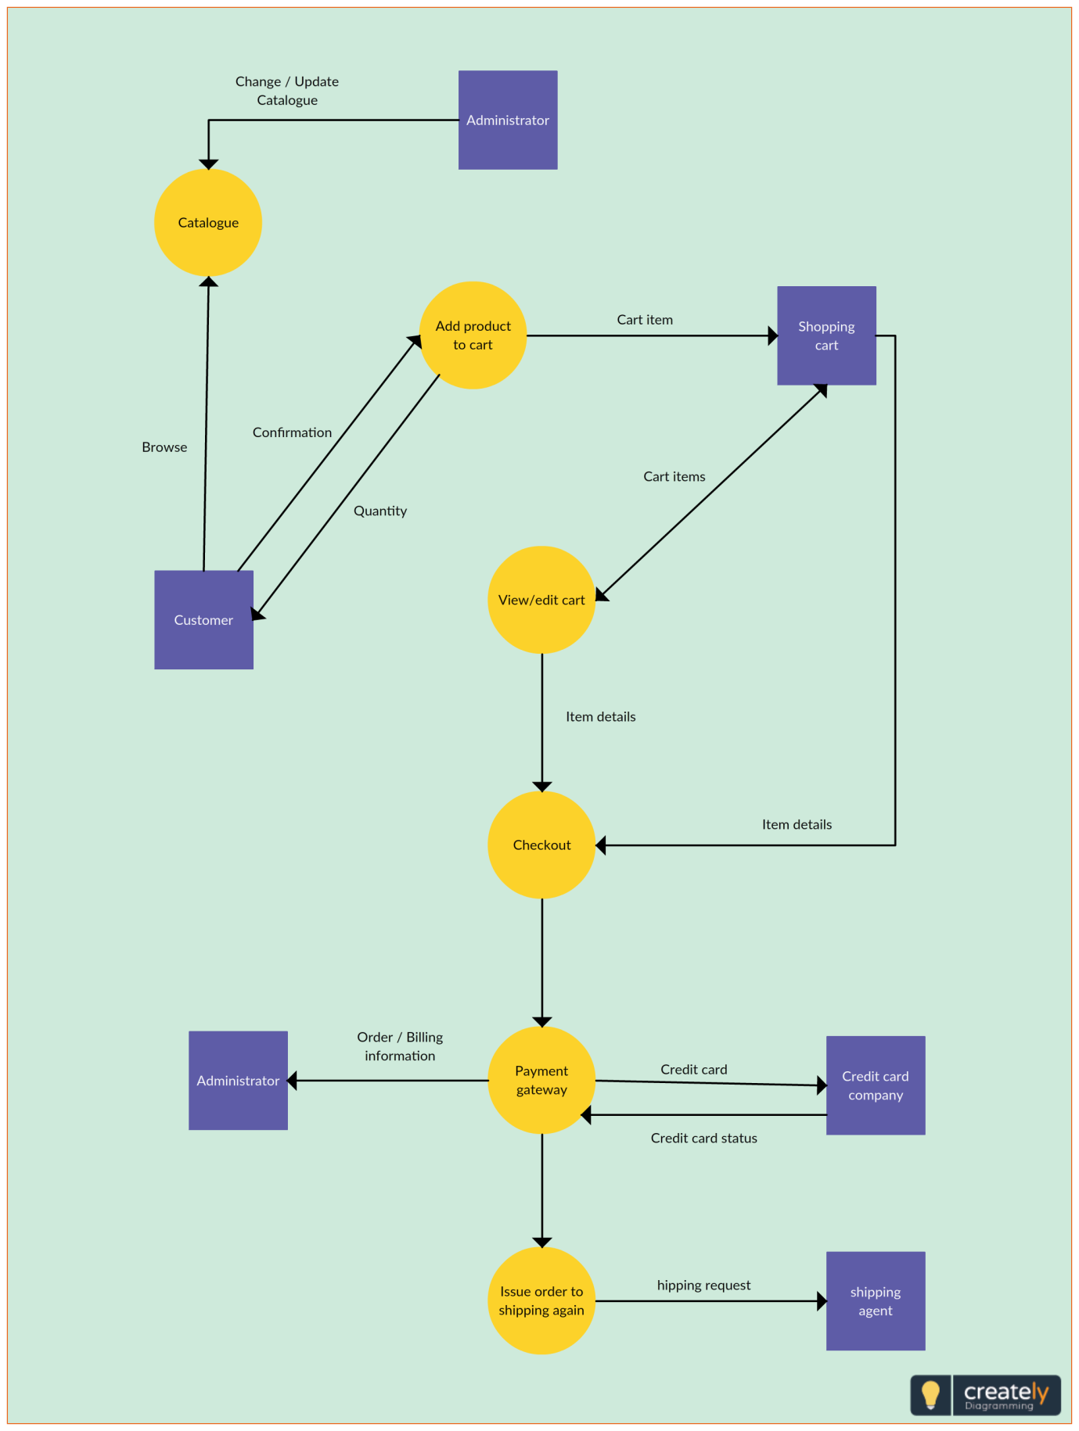

**Q.5 What is Flow chart? Create a flowchart to make addition of two numbers**

**Answer:-**A flowchart is a diagram that depicts a process, system or computer algorithm. They are widely used in multiple fields to document, study, plan, improve and communicate often complex processes in clear, easy-to-understand diagrams. Flowcharts, sometimes spelled as flow charts, use rectangles, ovals, diamonds and potentially numerous other shapes to define the type of step, along with connecting arrows to define flow and sequence. They can range from simple, hand-drawn charts to comprehensive computer-drawn diagrams depicting multiple steps and routes. If we consider all the various forms of flowcharts, they are one of the most common diagrams on the planet, used by both technical and non-technical people in numerous fields.

Flowcharts are sometimes called by more specialized names such as Process Flowchar, Process Map, Functional Flowchart, Business Process Mapping, Business Process Modeling and Notation (BPMN),  or Process Flow Diagram (PFD). They are related to other popular diagrams, such as Data Flow Diagrams (DFDs) and Unified Modeling Language (UML) Activity Diagrams.

**Flowchart to make addition of two numbers**:-

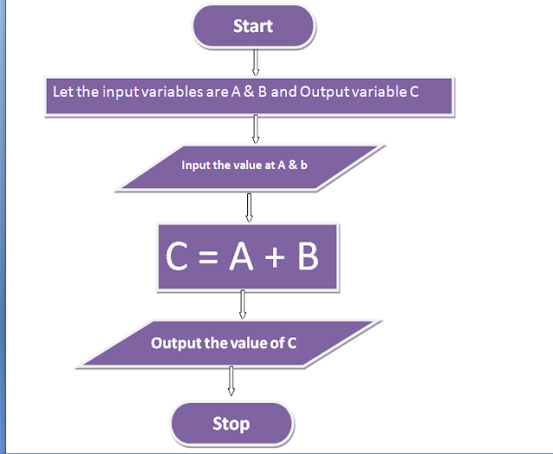

**Q.6 What is Use case Diagram? Create a use-case on bill payment on paytm.**

**Answer:-**

Use-case diagrams describe the high-level functions and scope of a system. These diagrams also identify the interactions between the system and its actors. The use cases and actors in use-case diagrams describe what the system does and how the actors use it, but not how the system operates internally.

**Use-case on bill payment on paytm :-**

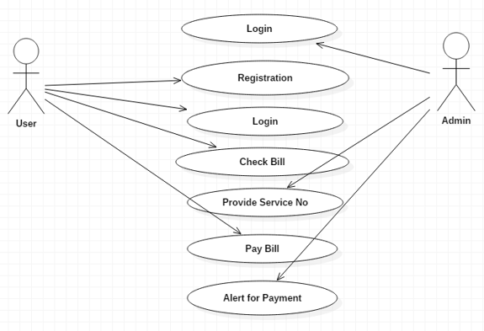

**CRECREATED BY HELLY GOSAI…**

**DATE:-05/07/2023.**