Lab Report: Random Bible Verse Generator in Kotlin
Joshua Easo
COMP-322-01
9/4/24

This lab aimed to introduce students to fundamental concepts in Kotlin, including functions, data types, data structures, and conditions. The task was to create a Kotlin program that randomly selects a Bible verse from a predefined list and prints it to the console. The selection process should occur within a function that returns the chosen verse to the main function for display.

In this lab, I created a Kotlin program that:
- Defines a list of ten Bible verses using Kotlin's List data structure.
Implements a function that randomly selects one verse from the list.
- Calls this function in the main function to print the selected verse to the console.
- I used ChatGPT to generate a list of ten Bible verses, adhering to the course guidelines. The random selection process was handled using Kotlin's Random class.

Below is the Kotlin source code developed for this lab:
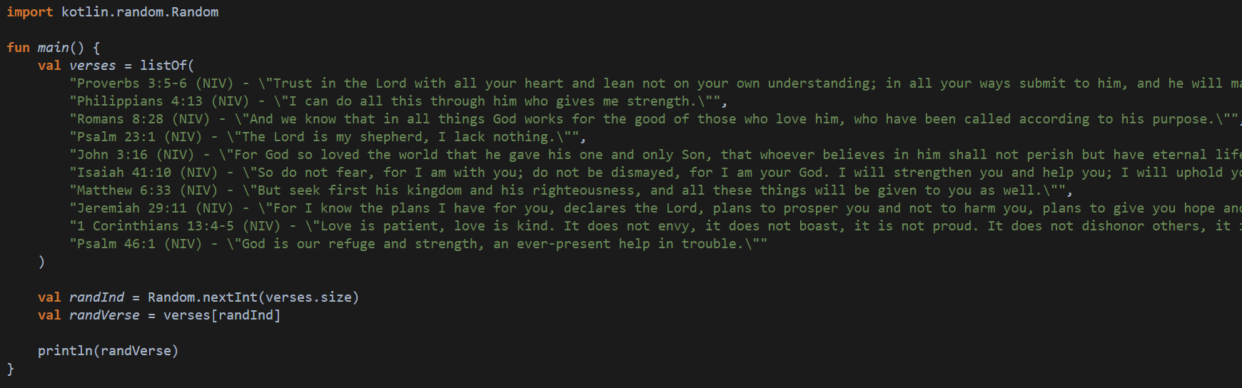

- Data Structure: The Bible verses were stored in a List of strings, which is a simple and efficient data structure in Kotlin.
- Functionality: The Random.nextInt() function was used to generate a random index within the range of the list. This index was then used to select a verse from the list.
- Main Function: The main() function handles the printing of the randomly selected verse to the console.
Example of Code Execution:
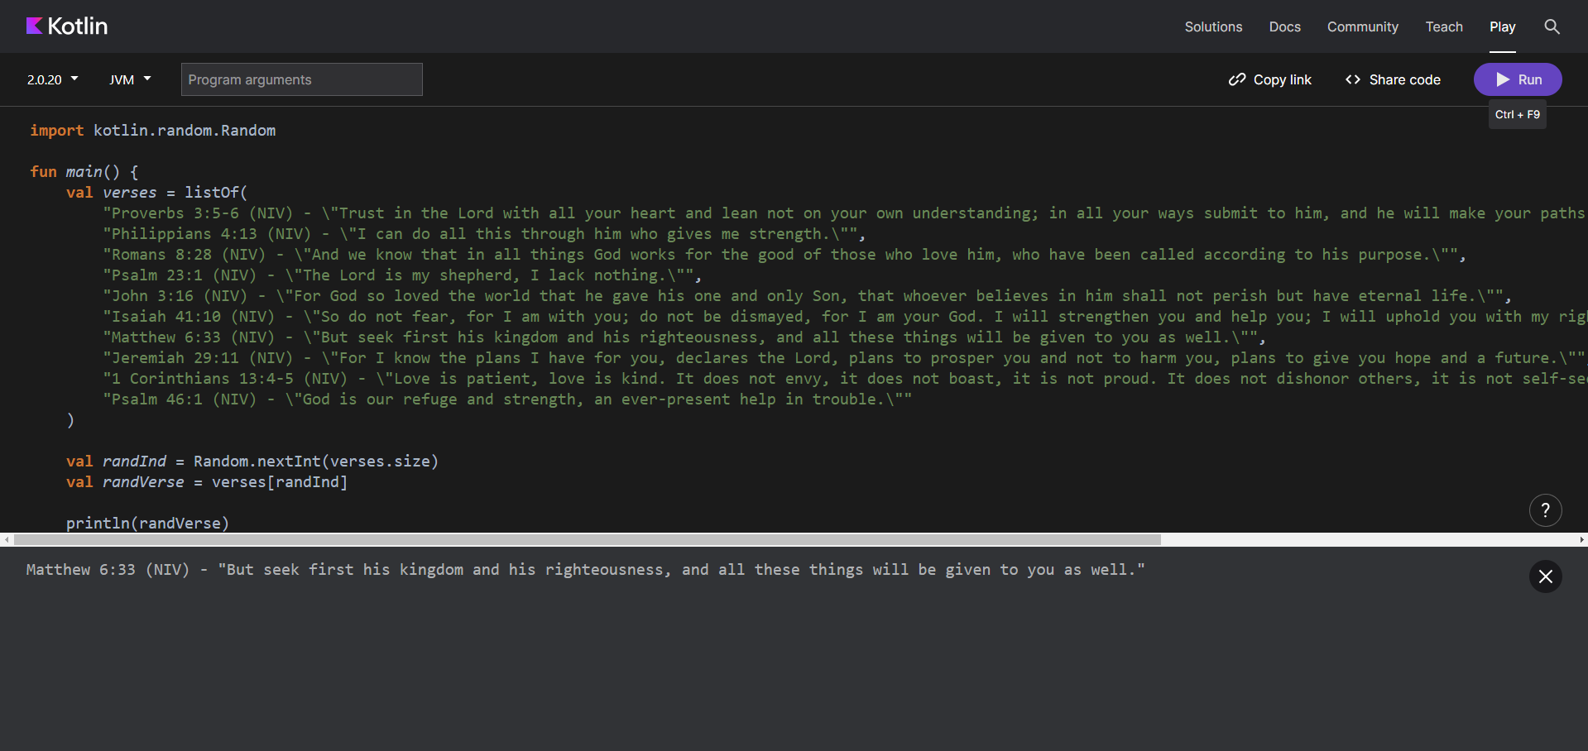

No significant problems were encountered while completing this lab. The most time-consuming part was ensuring that the Kotlin syntax was correctly applied, particularly with the List and Random classes, though this lab was fairly simple.

The estimated time to complete this lab was approximately 30 minutes, including the time spent generating the Bible verses, writing the code, and testing the program.
This lab was a valuable exercise in understanding the basics of Kotlin, mainly in using functions, data structures, and random selection.

