Lab Report: OOP in Kotlin
Joshua Easo
COMP-322-01
9/4/24

This lab aimed to demonstrate object-oriented programming concepts in Kotlin by creating two classes: BibleVerse and VerseOfTheDay. The BibleVerse class is responsible for storing and managing Bible verse data, while VerseOfTheDay holds an array of Bible verses and provides methods to randomly display one verse and to display all the verses sequentially.

Source Code:
- BibleVerse Class:
  - Stores information such as the book, chapter, verse number, and text of a Bible verse.
  - Enforces data integrity by ensuring that the chapter and verse values are positive and non-zero.
  - Provides methods for setting and getting the verse details, printing a specific verse, and returning the verse as a formatted string.
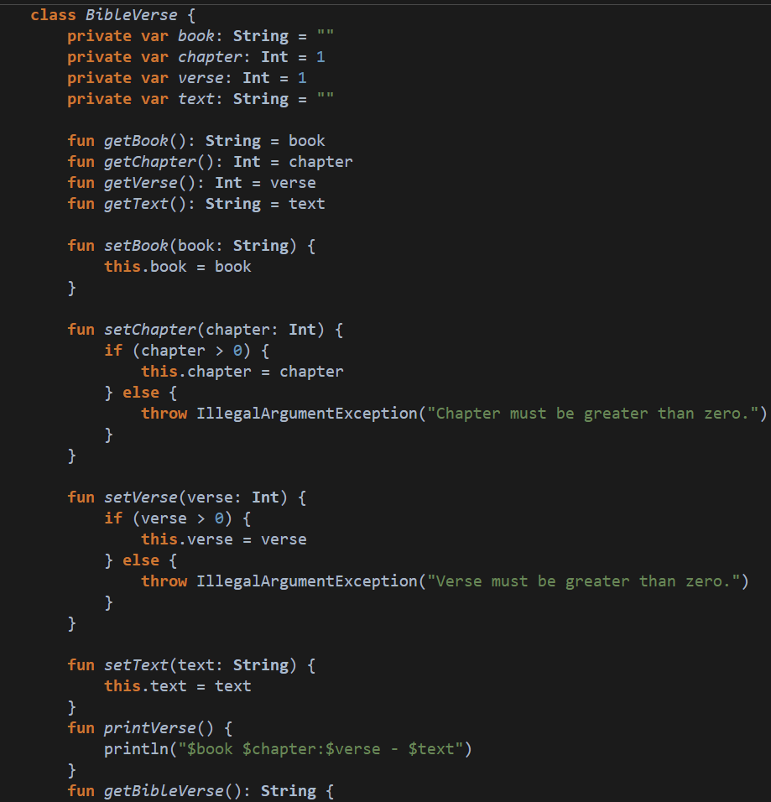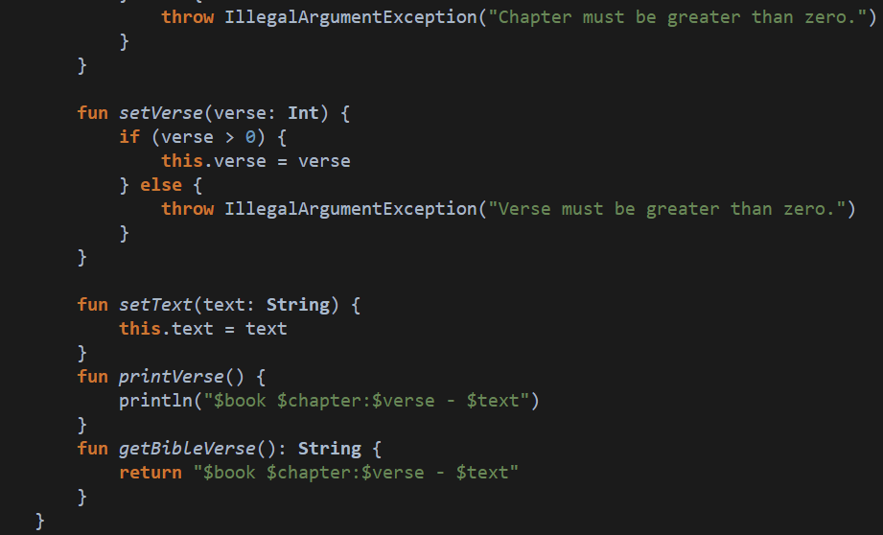

- VerseOfTheDay Class:
  - Holds an array of ten BibleVerse objects representing different Bible verses.
  - Contains a method to print a random verse using string interpolation.
  - Includes a method that loops through and prints all the verses using a for-each loop.
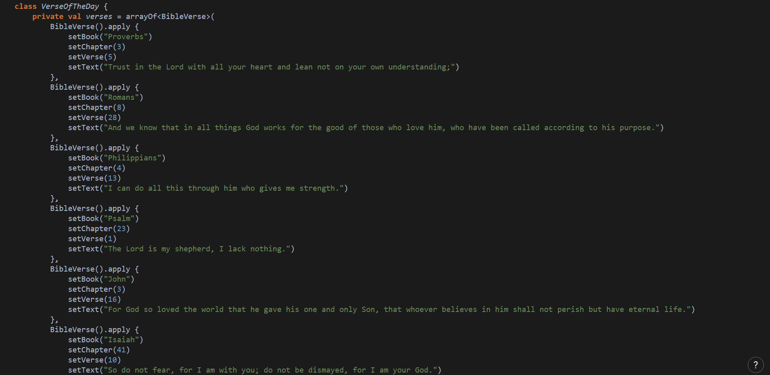
…
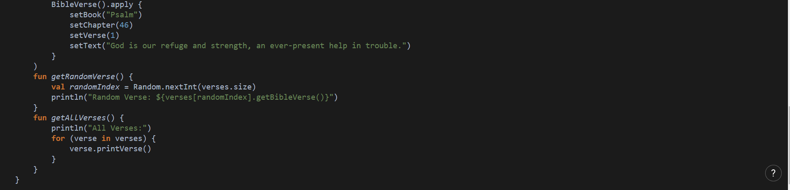
Example of Code Execution:
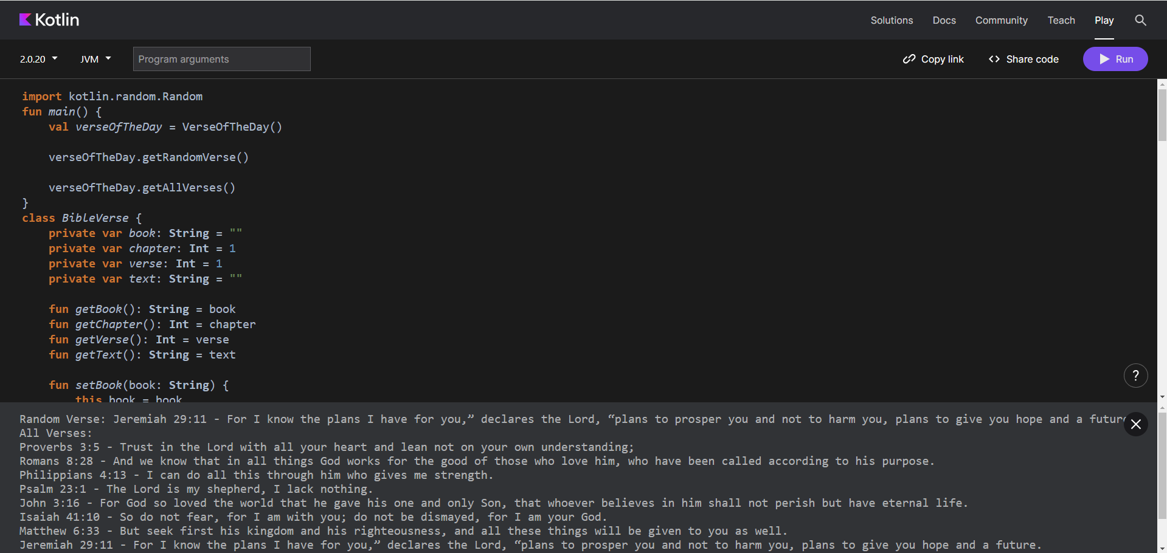

No significant problems were encountered while completing this lab.

The estimated time to complete this lab was approximately an hour, including the time spent writing the code, and testing the program.
This lab was really helpful in understanding the syntax and structure of OOP in Kotlin, which is an important step in learning the language.

