Lab Report: Intro to Jetpack Compose
Joshua Easo
COMP-322-01
9/19/24

This lab introduced the development of multiplatform mobile applications using Android Studio and Jetpack Compose. The goal was to create an application that displays a random Bible verse every time it is launched.

In this Lab I:
- Created a new Android Studio project with Jetpack Compose.
- Imported the BibleVerse and VerseOfTheDay classes from a previous lab.
- Created a function in MainActivity.kt to get a random Bible verse.
- Created a composable function to display the verse on the screen.
- Tested the display with a preview composable.
- Called the composable function from MainActivity to show the verse when the app starts.
- Tested the app on an emulator and adjusted the text display for better readability.
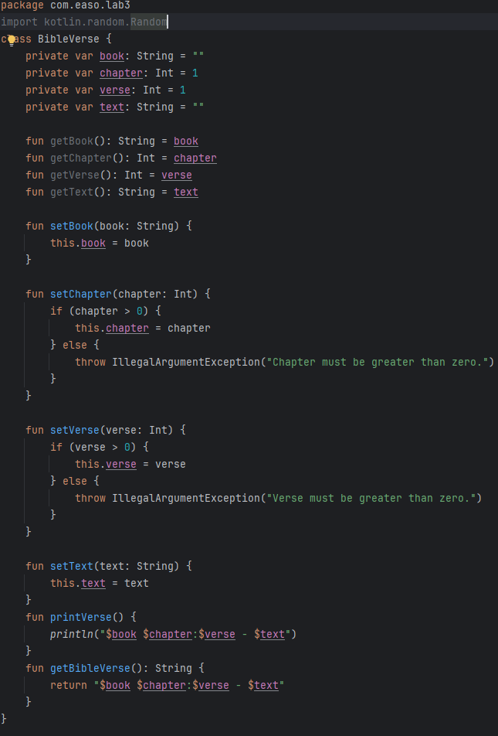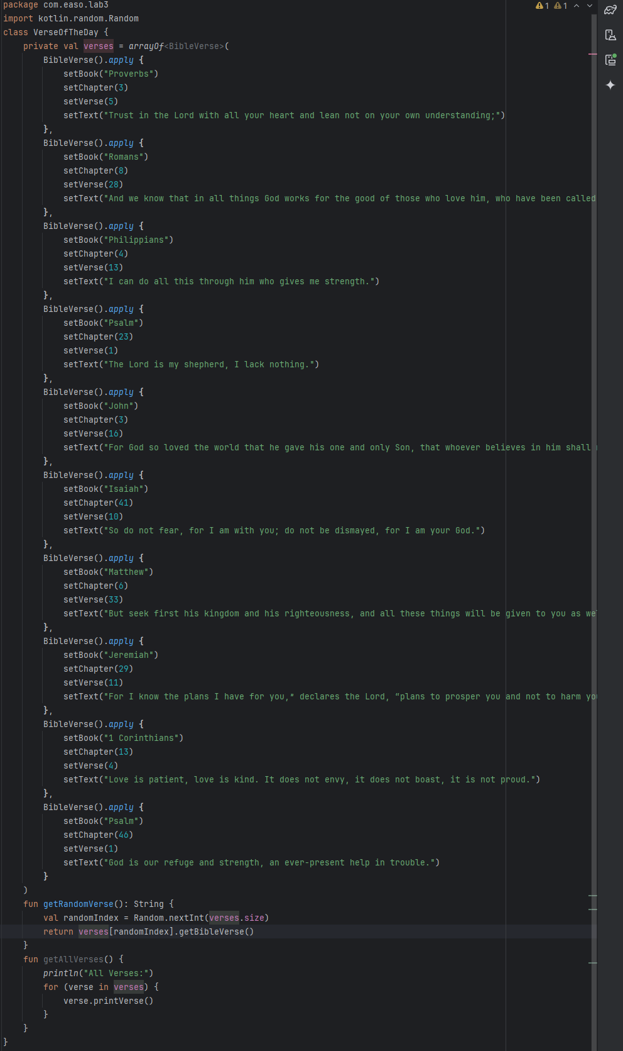
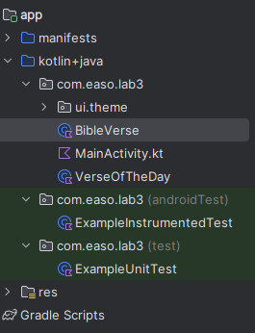
Example of Code Execution:
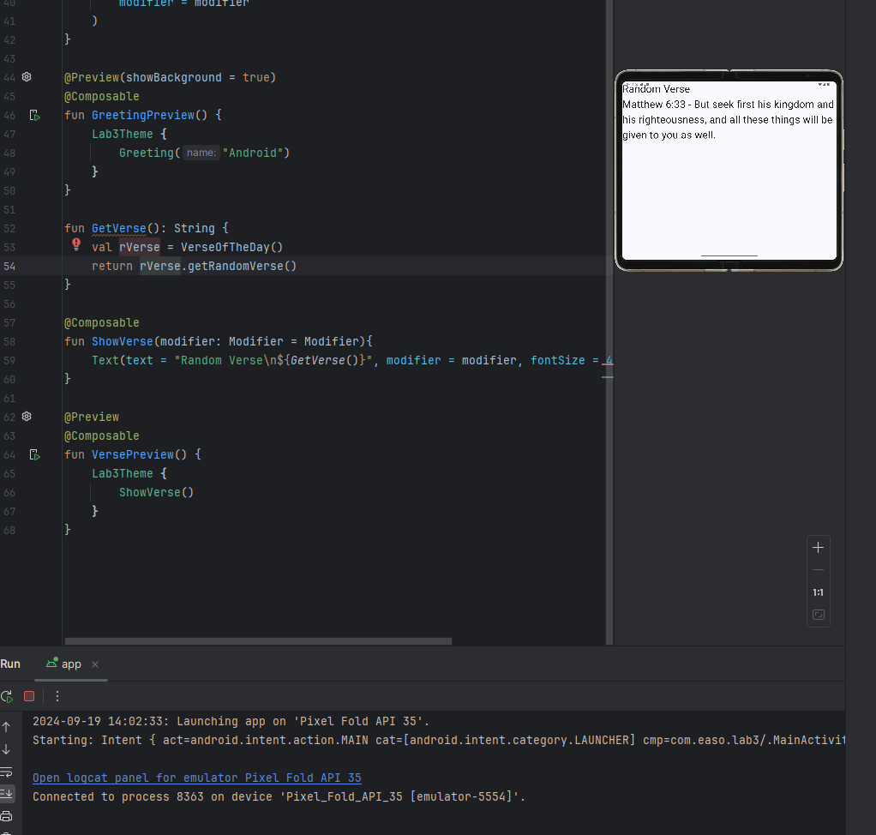
No significant problems were encountered while completing this lab.

The estimated time to complete this lab was approximately 30 minutes, including the time spent readjusting the code from Lab 2 to work with Android Studio, writing the code for the MAin Activity, and testing the program.
This lab was a valuable exercise in understanding the basics of Android Studio and using methods and classes between files.

