The purpose of this lab is to create a program that can take the user’s name in an Outlined Text Field, and when a button is pressed a string that changes based on the local time appears, in the following format: “Good {morning/afternoon/evening} {user}, here is your random Bible verse: {verse}”.

Source Code:
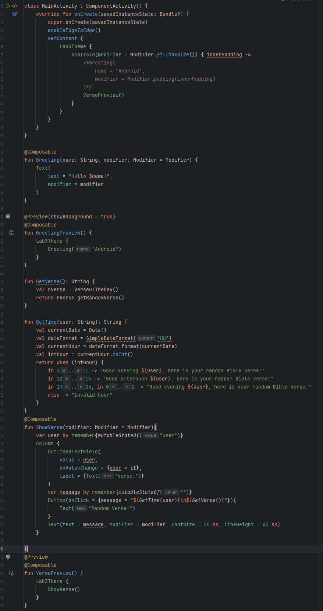
Execution:
On start:
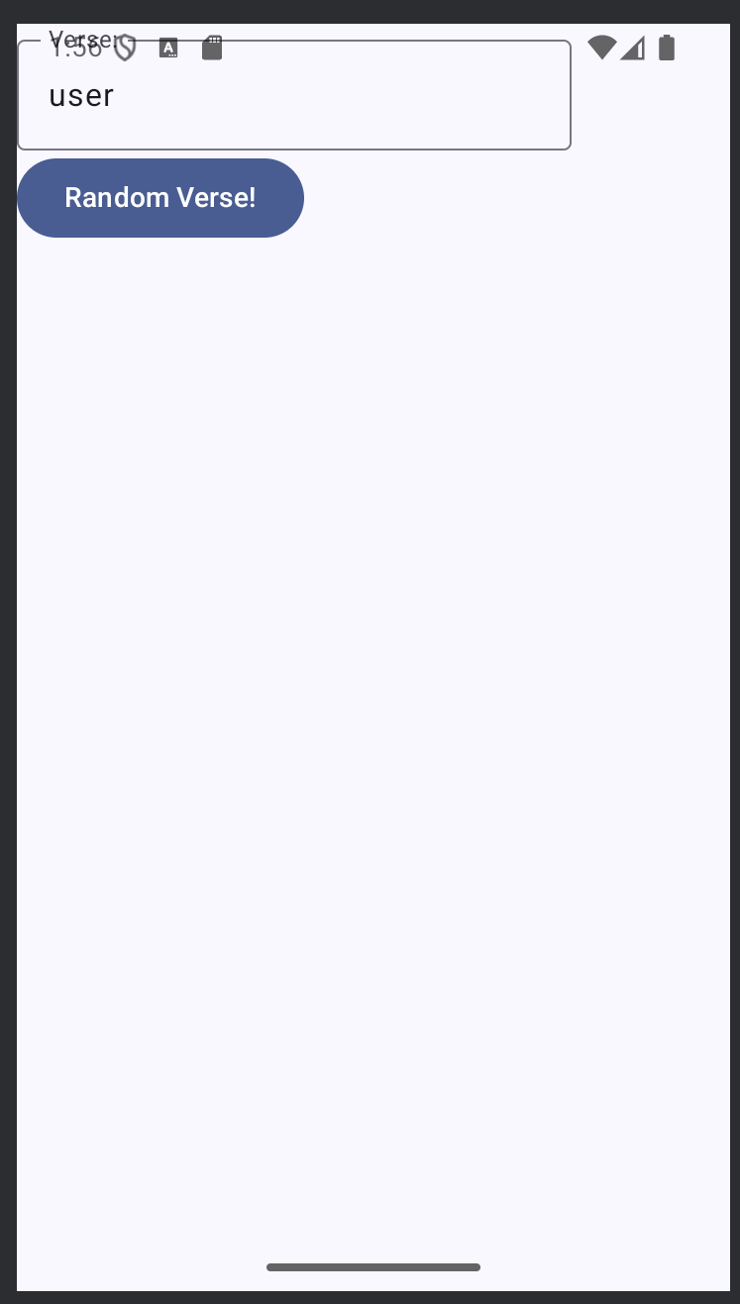

Outlined Text Edited:
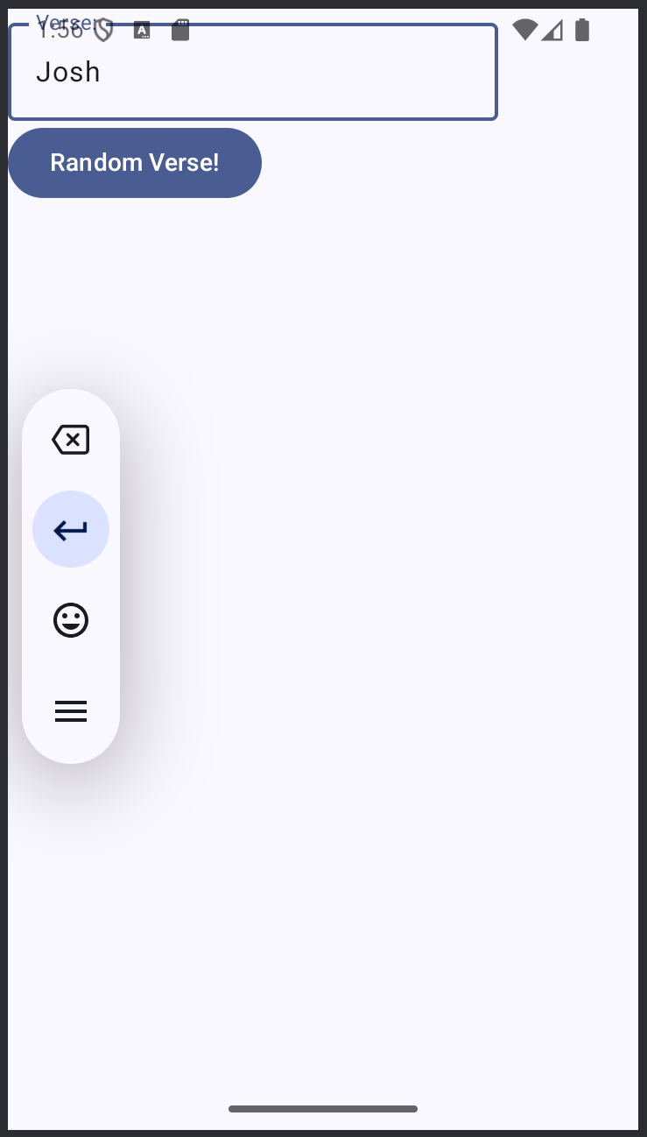
Button Clicked:
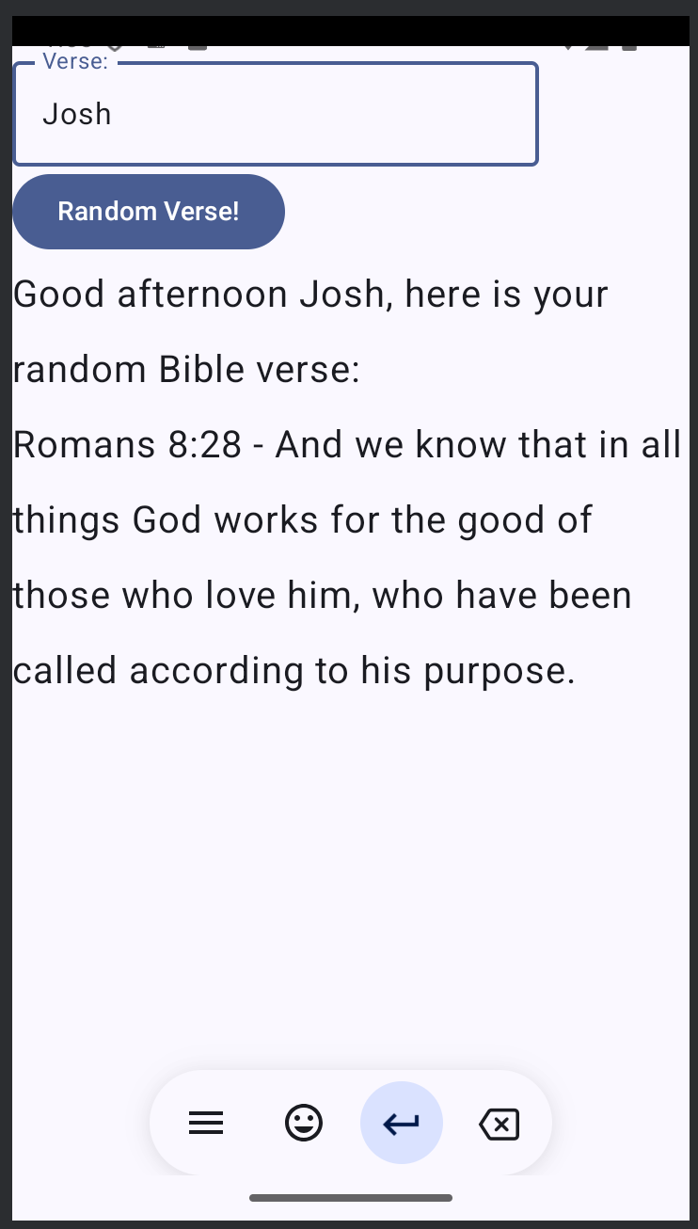

Name Changes (within same execution instance):
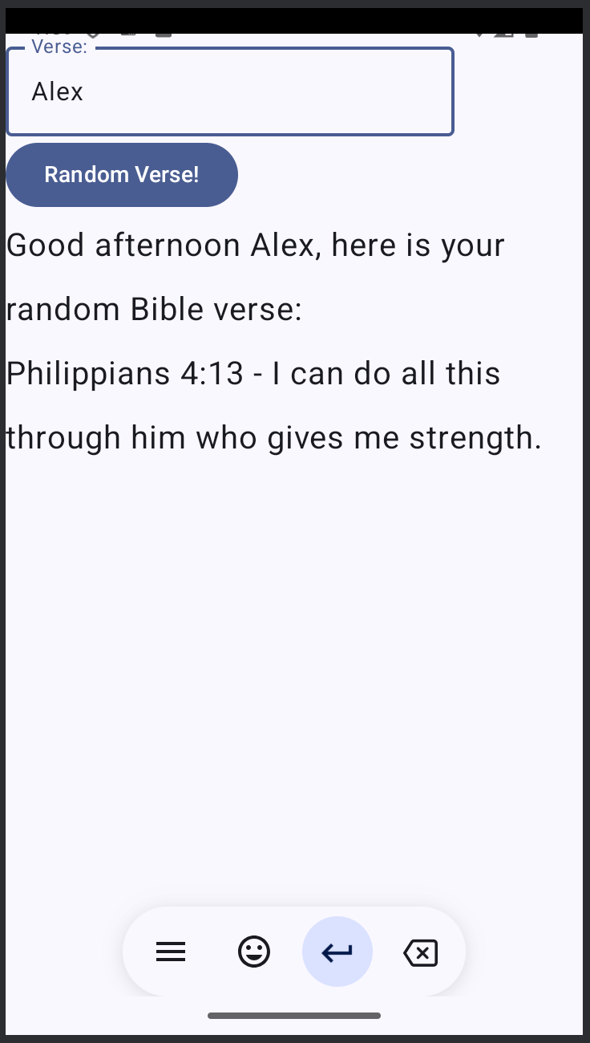
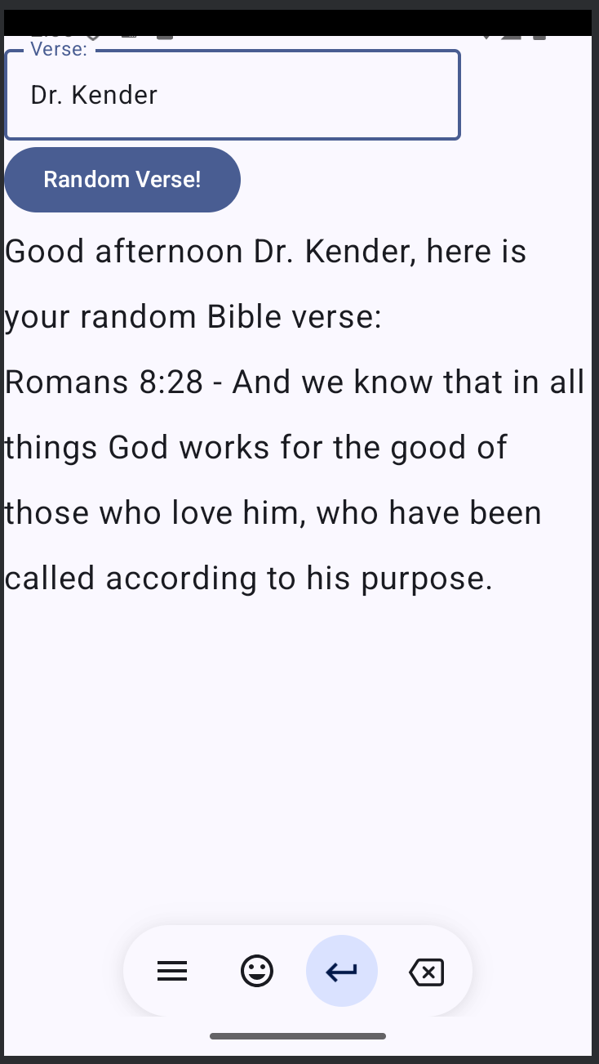
No errors in particular were encountered in the creation of this code.
Estimated time: 20 mins

