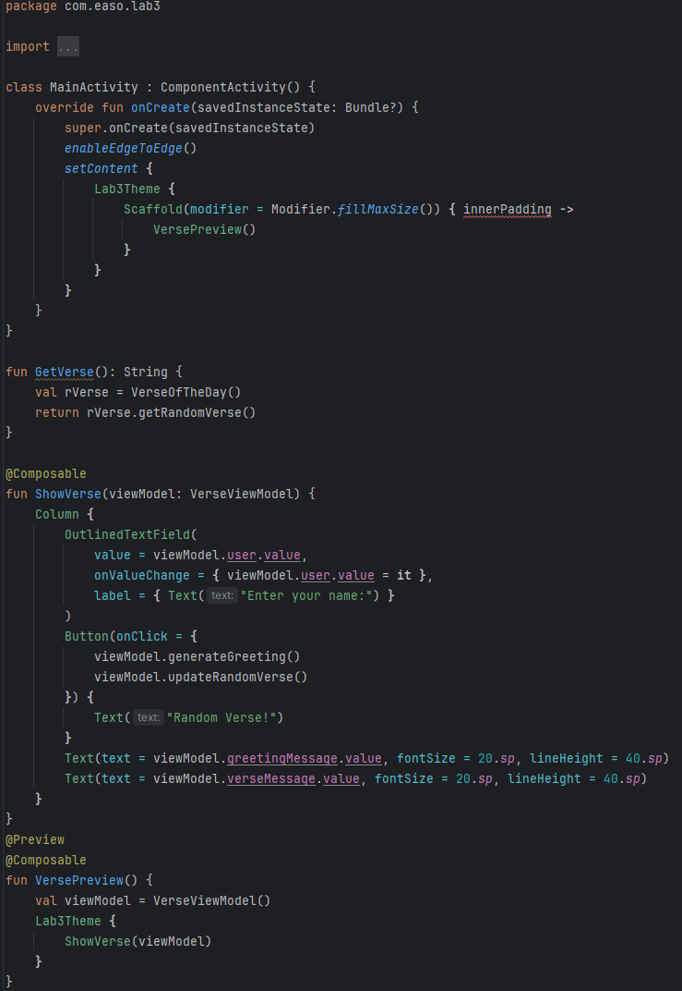
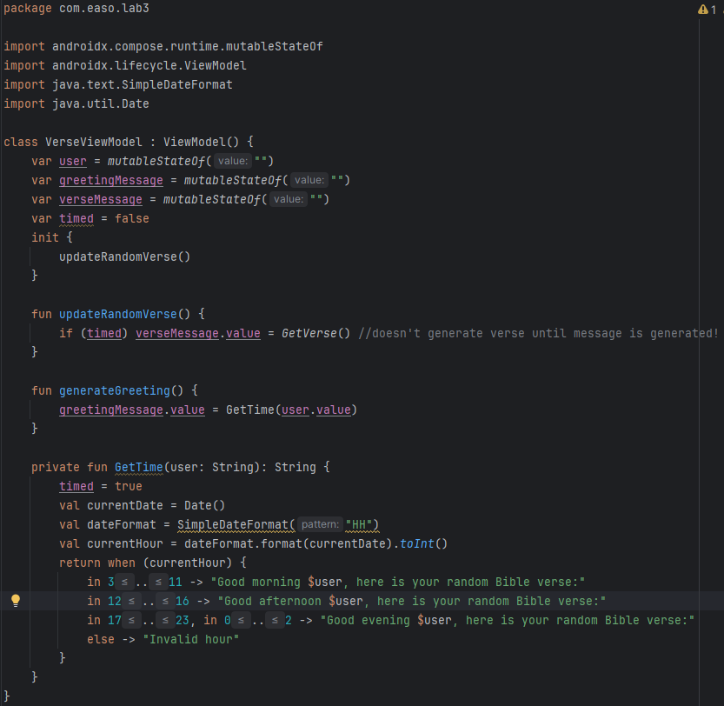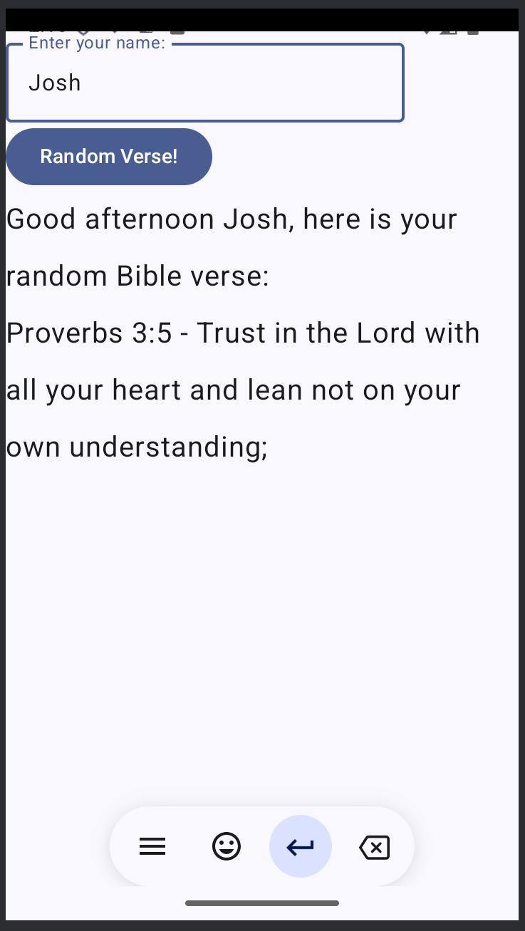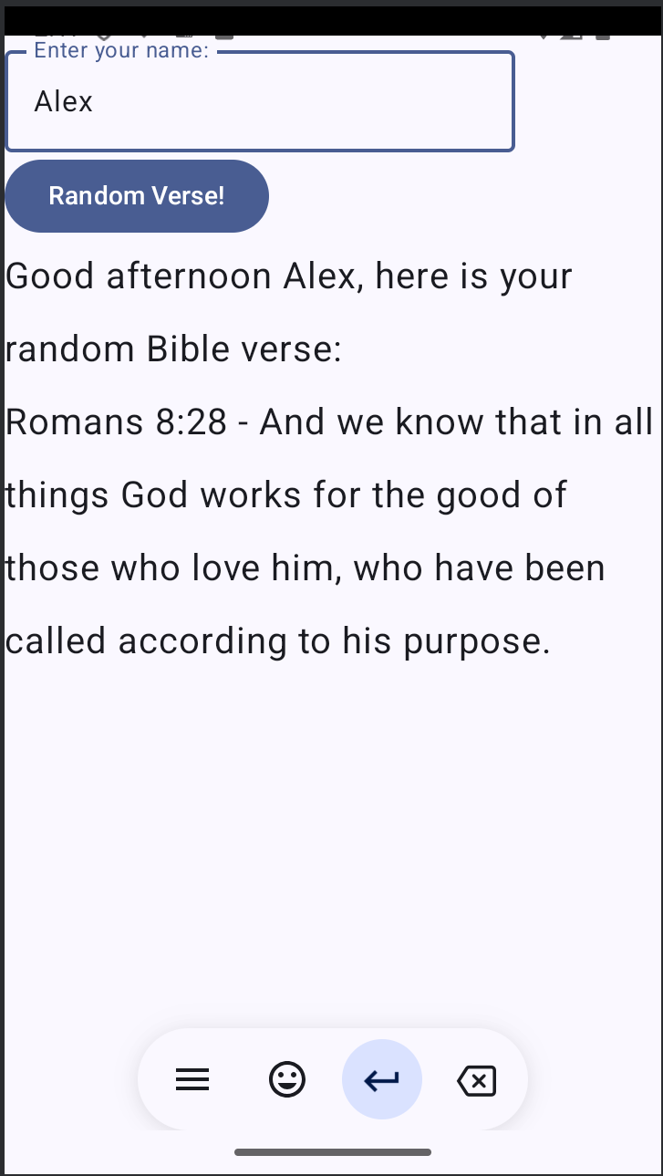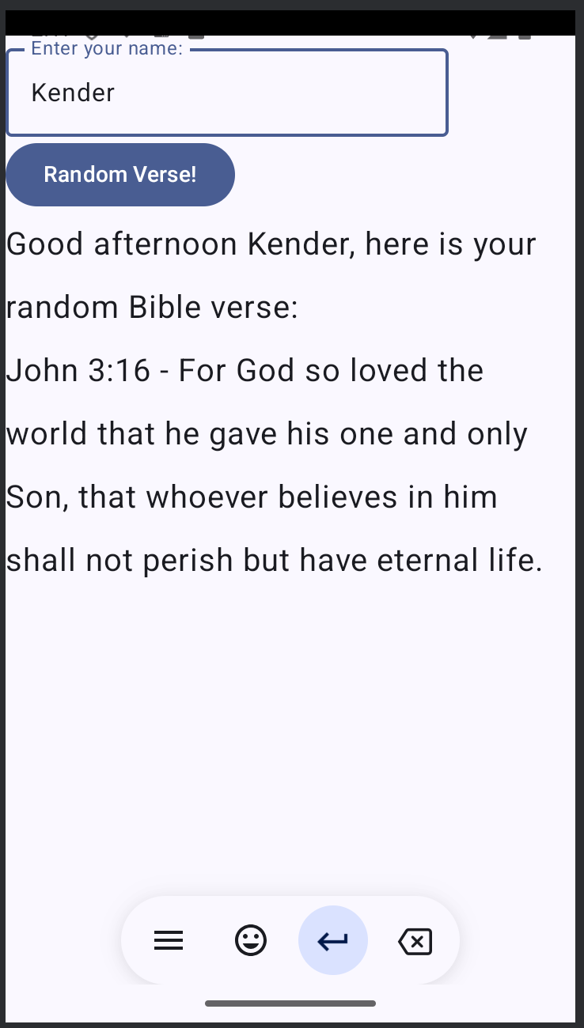
Working!
In Lab 5, we built on the application from Lab 4 by adding a ViewModel to manage the UI state in Jetpack Compose. This change helps keep the app's state intact during events like screen rotations. We created a ViewModel to generate a custom greeting based on user input and the current time, while also formatting and displaying a random Bible verse, all while keeping the architecture clean and organized.

One weird problem occurred where the verse would appear before the “Random Verse button would be clicked, since we weren’t updating the Verse in ShowVerse anymore but in the ViewModel directly now, so i just made a boolean that would check first if a greeting was made before updating the verse variable.
Other than that, no problems occurred.
This Lab took approximately 40 minutes.

