The app allows users to view a random Bible verse as well as a list of all available verses. The verses are stored in a Room database and initialized with a predefined set of verses. The app uses coroutines to perform the asynchronous database operations, such as retrieving a random verse or fetching the full list of verses. The UI components, including the main screen, verse list screen, and greeting screen, are implemented using Jetpack Compose.
No issues were faced except for some reason when generating a random verse for a couple seconds at the beginning and end of the GettingScreen lifespan it’ll scroll though a bunch of different verses, to give the visual effect that it is randomly choosing a verse.
This however is not at all intentional, and I have no idea why it occurs, but it looks cool so I kept it.
libs.versions.toml
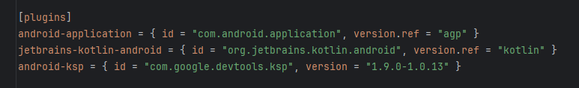
gradle
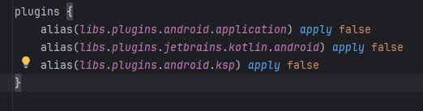
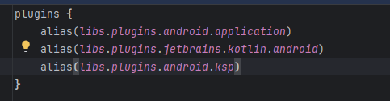
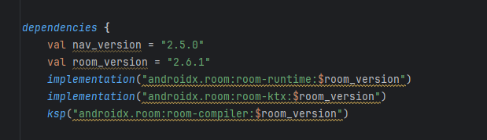
VerseEntity.kt:
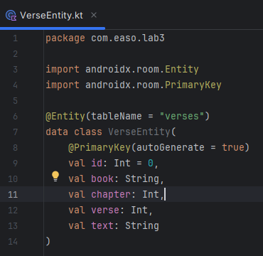

VerseDao.kt: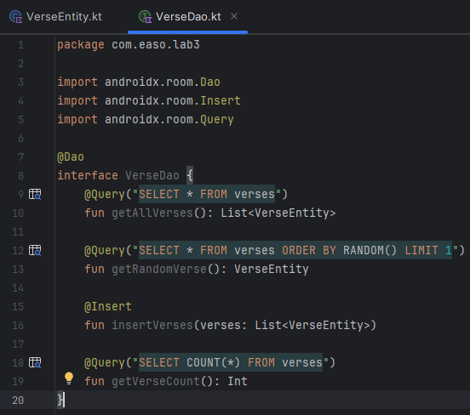

VerseDatabase.kt:
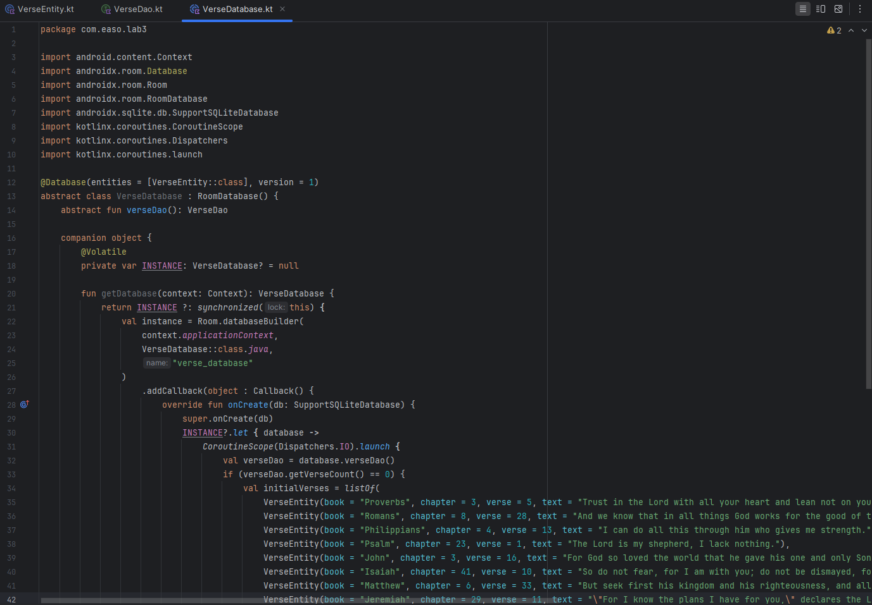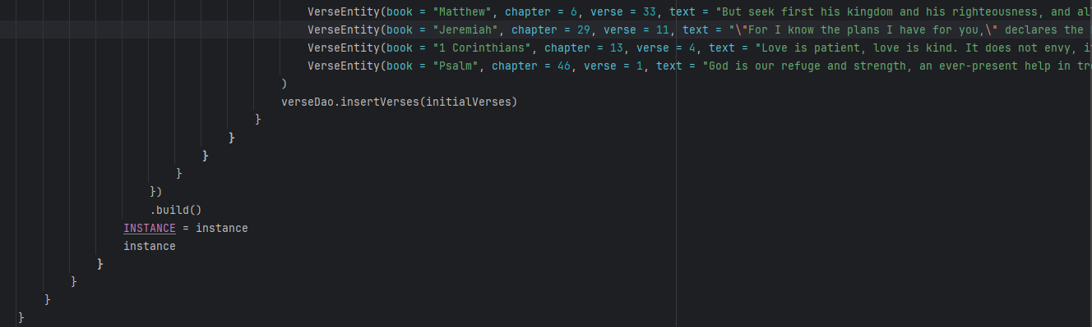

Updated; VerseOfTheDay.kt:
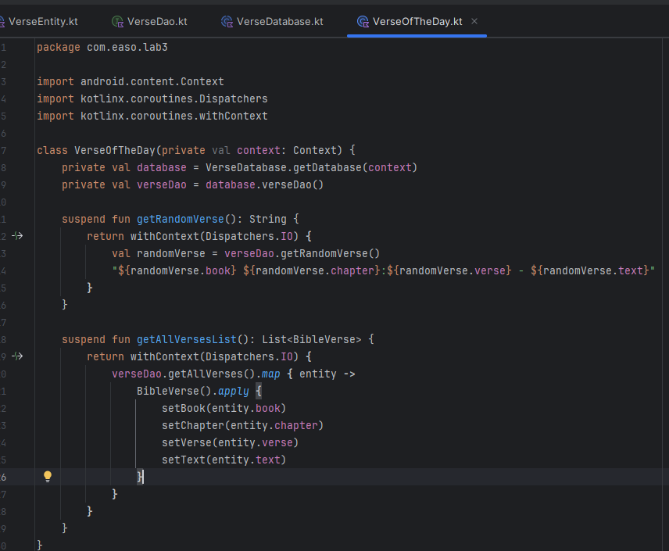
Updated; VerseViewModel.kt:
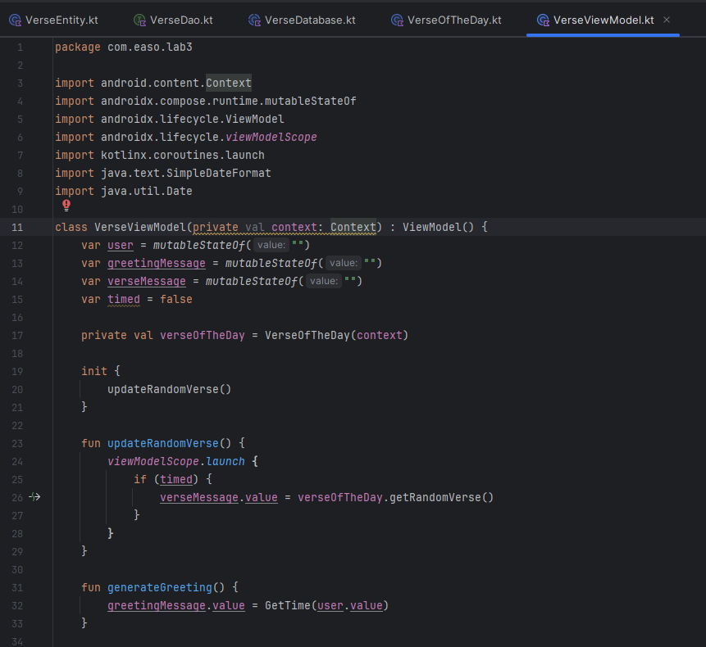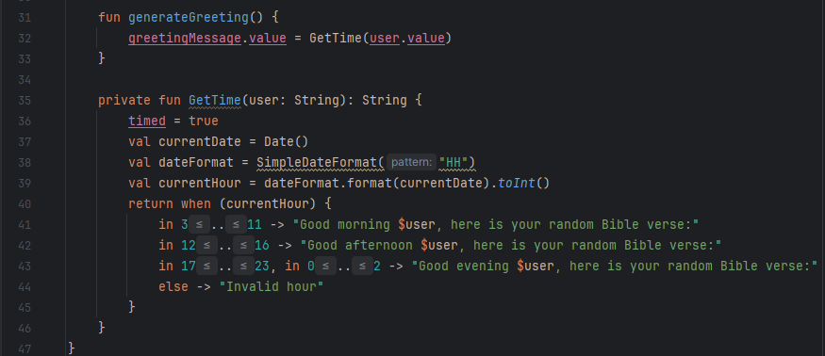
Updated; VerseListScreenl.kt:
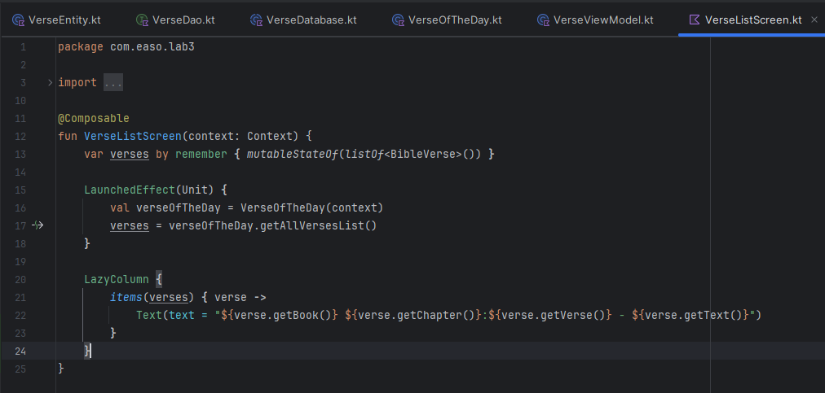
Updated; GettingScreen.kt:
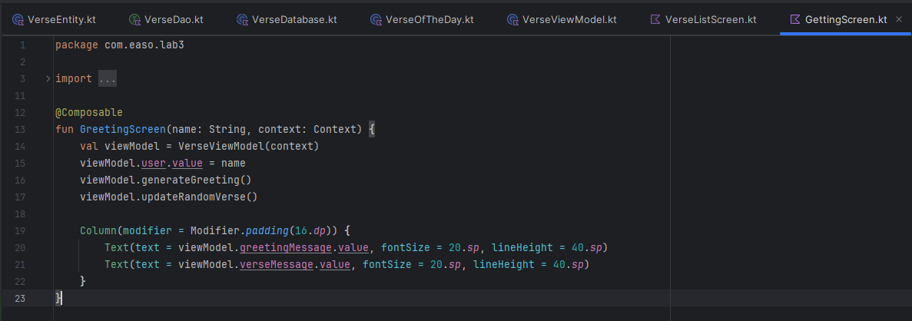
Updated; MainActivity.kt:
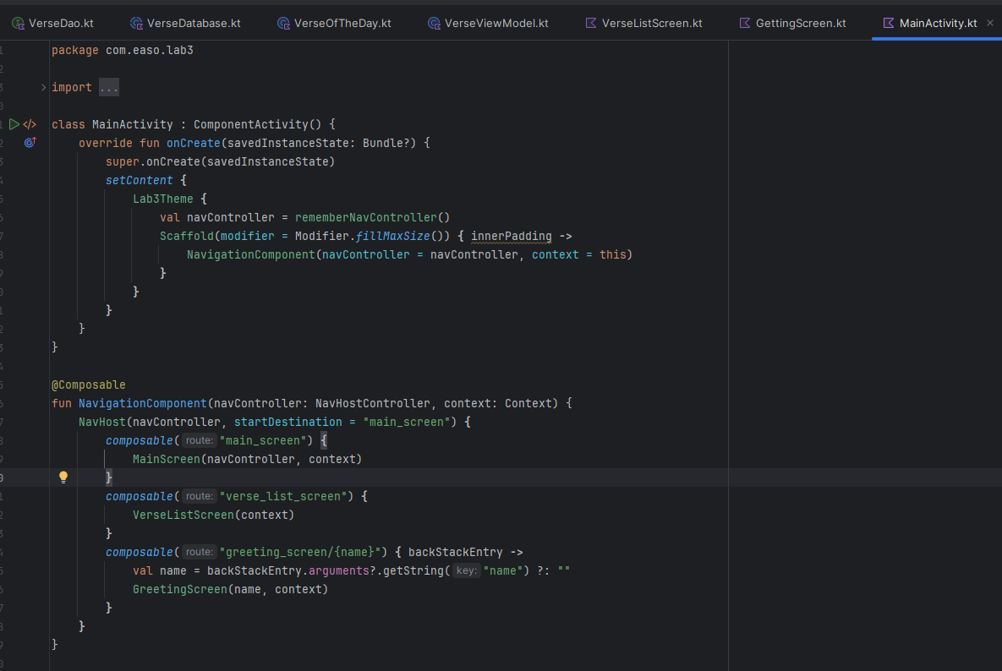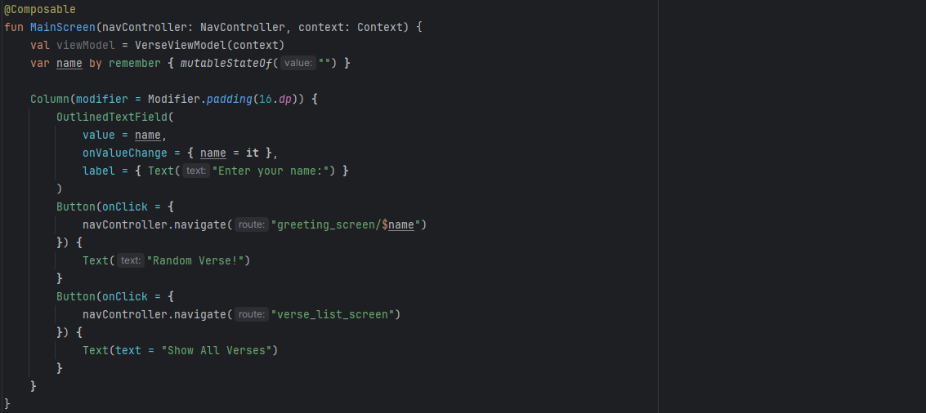

Execution:
