Bulgaria

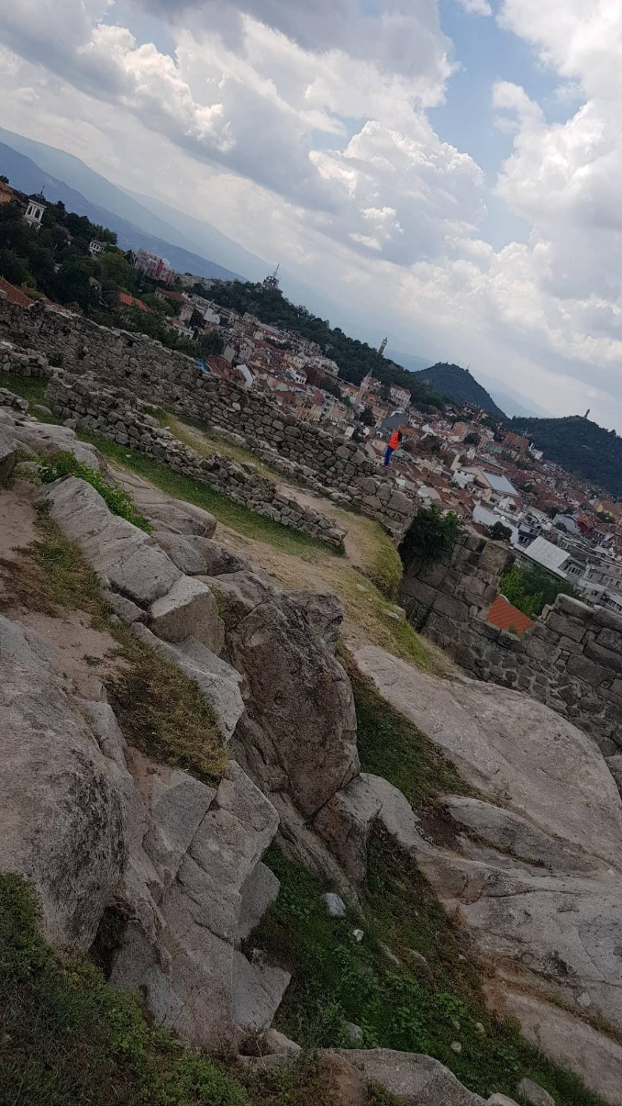During our stay in Bulgaria, we’ve seen a lot of things which don’t exist in France, like in Spain or Italy, we went to Plovdiv, a great and beautiful city, and we saw a lot of historical monuments such as “Nebet Tepe” that is a high place where we can see all Plovdiv.

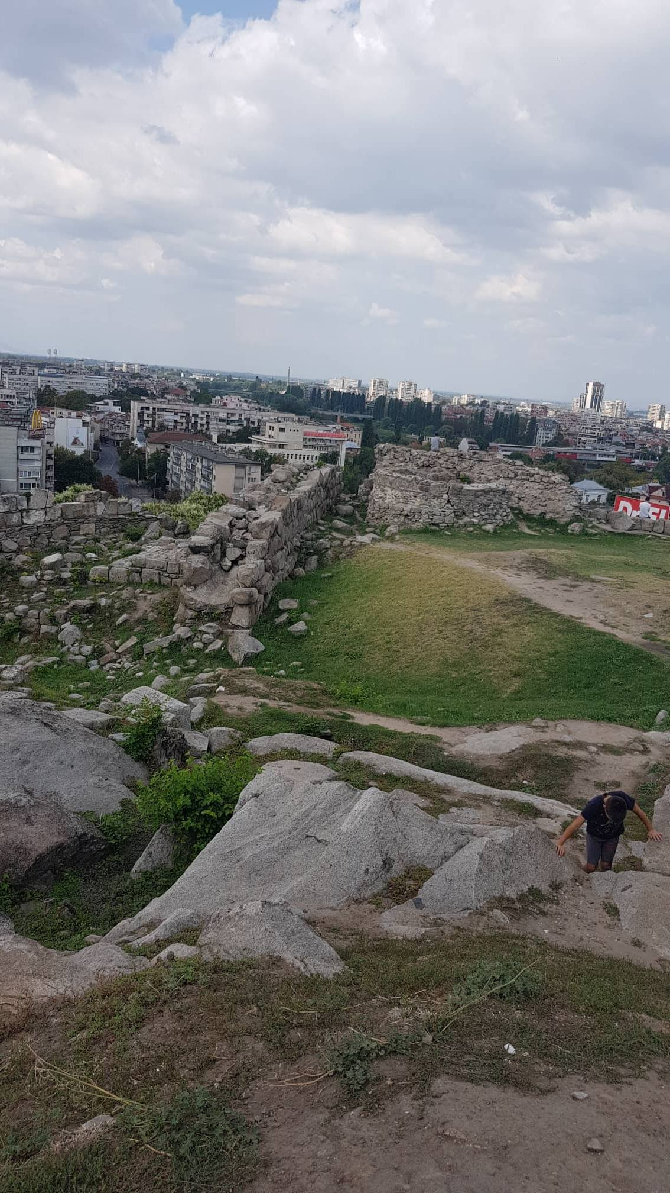

Gaston Alfonso Stefan Jessica Nikov