

Functional Safety Concept Lane Assistance

**Document Version: 1.0**

**Template Version 1.0, Released on 2017-06-21**



# Document history

|  |  |  |  |
| --- | --- | --- | --- |
| Date | Version | Editor | Description |
| 21.06.2018 | 1.0 | Malgorzata Plonka | Initial version |
|  |  |  |  |
|  |  |  |  |
|  |  |  |  |
|  |  |  |  |

# Table of Contents

Document history

Table of Contents

Purpose of the Functional Safety Concept

Inputs to the Functional Safety Analysis

Safety goals from the Hazard Analysis and Risk Assessment

Preliminary Architecture

Description of architecture elements

Functional Safety Concept

Functional Safety Analysis

Functional Safety Requirements

Refinement of the System Architecture

Allocation of Functional Safety Requirements to Architecture Elements

Warning and Degradation Concept

# Purpose of the Functional Safety Concept

The task of Functional Safety Concept is to document the safety requirements at high level and allocate these requirements to different parts of the item architecture. Technical safety requirements are derived from these safety concepts. The Functional Safety Concept provides instructions how to validate and verify the requirements.

## Safety goals from the Hazard Analysis and Risk Assessment

|  |  |
| --- | --- |
| **ID** | **Safety Goal** |
| Safety_Goal_01 | The oscillating steering torque from the Lane Departure Warning function shall be limited. |
| Safety_Goal_02 | The Lane Keeping Assistance function shall be limited to particular time interval. The steering torque shall end after a given time interval so the driver does not misuse the system as for autonomous driving. |
| Safety_Goal_03 | The Lane Departure Warning function shall be deactivated as soon as camera sensor stops to work. |
| Safety_Goal_04 | The Lane Keeping Assistance function shall be deactivated as soon as camera sensor stops to work. |

## Preliminary Architecture

Following figure describes a preliminary architecture for the lane assistance item.

### 

### Description of architecture elements

|  |  |
| --- | --- |
| **Element** | **Description** |
| Camera Sensor | Capture road images and provide them to the Camera Sensor ECU. |
| Camera Sensor ECU | Detects lane line location from camera images and generates a torque request to the Electronic Power Steering ECU. |
| Car Display | Shows warning to driver. |
| Car Display ECU | Generates visual warning signals triggered by input from Camera Sensor ECU and Electronic Power Steering ECU. |
| Driver Steering Torque Sensor | Measure the torque applied to the steering wheel by the driver. |
| Electronic Power Steering ECU | Use the information received from the Driver Steering Torque Sensor and the torque requested by the Lane Keeping Assistance and Lane Warning and request the necessary torque, which is applied by the motor actuator. |
| Motor | Applies the torque indicated by the Electronic Power Steering ECU to the steering wheel. |

# Functional Safety Concept

The functional safety concept consists of:

* Functional safety analysis
* Functional safety requirements
* Functional safety architecture
* Warning and degradation concept

## Functional Safety Analysis

|  |  |  |  |
| --- | --- | --- | --- |
| **Malfunction ID** | **Main Function of the Item Related to Safety Goal Violations** | **Guidewords (NO, WRONG, EARLY, LATE, MORE, LESS)** | **Resulting Malfunction** |
| Malfunction_01 | Lane Departure Warning (LDW) function shall apply an oscillating steering torque to provide the driver a haptic feedback | MORE | The lane departure warning function applies an oscillating  torque with very high torque amplitude (above limit) |
| Malfunction_02 | Lane Departure Warning (LDW) function shall apply an oscillating steering torque to provide the driver a haptic feedback | MORE | The lane departure warning function applies an oscillating  torque with very high torque frequency (above limit) |
| Malfunction_03 | Lane Keeping Assistance (LKA) function shall apply the steering torque when active in order to stay in ego lane | NO | The lane keeping assistance function is not limited in time duration which leads to misuse it as an autonomous driving function. |

## Functional Safety Requirements

Lane Departure Warning (LDW) Requirements:

|  |  |  |  |  |
| --- | --- | --- | --- | --- |
| **ID** | **Functional Safety Requirement** | **ASIL** | **Fault Tolerant Time Interval** | **Safe State** |
| Functional  Safety  Requirement  01-01 | The lane-keeping item shall ensure that the lane departure oscillating torque amplitude is below *Max_Torque_Amplitude.* | C | 50 ms | Turn off Lane Departure Warning |
| Functional  Safety  Requirement  01-02 | The lane-keeping item shall ensure that the  lane departure warning torque frequency is  below *Max_Torque_Frequency* | C | 50 ms | Turn off Lane Departure Warning |

Lane Departure Warning (LDW) Verification and Validation Acceptance Criteria:

|  |  |  |
| --- | --- | --- |
| **ID** | **Validation Acceptance**  **Criteria and Method** | **Verification Acceptance**  **Criteria and Method** |
| Functional  Safety Requirement  01-01 | Test how drivers react to different torque  amplitudes to prove that an appropriate  value was chosen - the best one | Verify that system turns off if lane departure warning ever exceeds *Max_Torque_Amplitude*. |
| Functional  Safety  Requirement  01-02 | Test how drivers react to different torque  frequencies to prove that an appropriate  value was chosen - the best one | Verify that system turns off if lane departure warning ever exceeds *Max_Torque_Frequency*. |

Lane Keeping Assistance (LKA) Requirements:

|  |  |  |  |  |
| --- | --- | --- | --- | --- |
| **ID** | **Functional Safety Requirement** | **ASIL** | **Fault Tolerant Time Interval** | **Safe State** |
| Functional  Safety  Requirement  02-01 | The lane keeping item shall ensure that the  lane keeping assistance torque is applied  for only Max_Duration. | B | 500 ms | Lane Assistant  functionality off |

Lane Keeping Assistance (LKA) Verification and Validation Acceptance Criteria:

|  |  |  |
| --- | --- | --- |
| **ID** | **Validation Acceptance**  **Criteria and Method** | **Verification Acceptance**  **Criteria and Method** |
| Functional  Safety  Requirement  02-01 | Test and validate that the *Max_Duration* chosen really dissuades drivers from taking their hands off the wheel. | Verify that system turns off LKA when torque application exceeded *Max_Duration.* |

## Refinement of the System Architecture

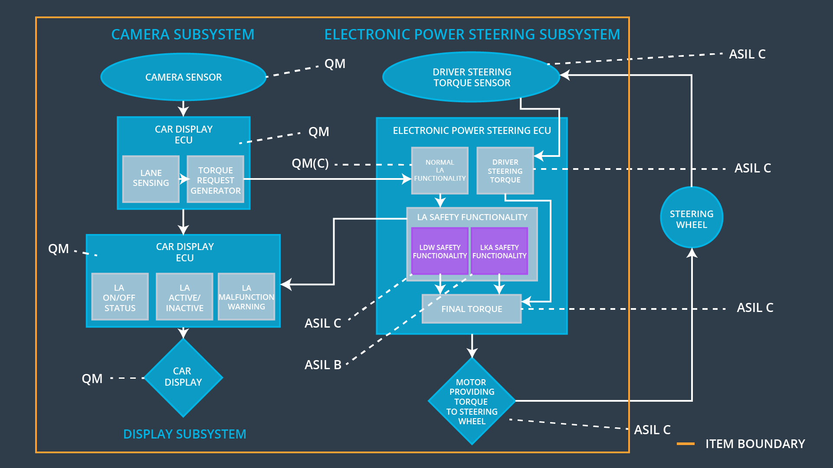

## Allocation of Functional Safety Requirements to Architecture Elements

|  |  |  |  |  |
| --- | --- | --- | --- | --- |
| **ID** | **Functional Safety Requirement** | **Electronic Power Steering ECU** | **Camera ECU** | **Car Display ECU** |
| Functional  Safety  Requirement  01-01 | The electronic power steering  ECU shall ensure that the lane  departure oscillating torque amplitudeis below  *Max_Torque_Amplitude* | **X** |  |  |
| Functional  Safety  Requirement  01-02 | The electronic power steering  ECU shall ensure that the lane  departure oscillating torque  frequencyis below  *Max_Torque_Frequency* | **X** |  |  |
| Functional  Safety  Requirement  02-01 | The electronic power steering  ECU shall ensure that the lane  keeping assistance torque is applied for only *Max_Duration*. | **X** |  |  |

|  |  |  |  |  |
| --- | --- | --- | --- | --- |
| **ID** | **Degradation Mode** | **Trigger for Degradation Mode** | **Safe State invoked ?** | **Driver Warning** |
| WDC-01 | Turn off LDW  functionality | Malfunction_01,  Malfunction_02 | YES | LDW  Malfunction  Warning on  Car Display |
| WDC-02 | Turn off LKA  functionality | Malfunction_03 | YES | LKA  Malfunction  Warning on  Car Display |