 | Gabriel GOSMANN  Felipe LORENZON
École Centrale de Lille  EBE – Electronics for biomedical engineering | May, 2024.

Operational amplifiers (Opamps)
Part 1 : Theory

Exercise 1 : In the circuits of figure 1, calculate the value of the voltage V. Use LTSpice to check your results.

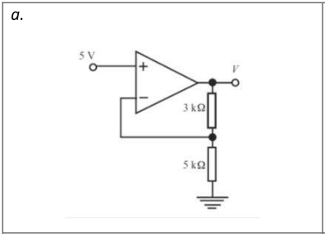

V=8V

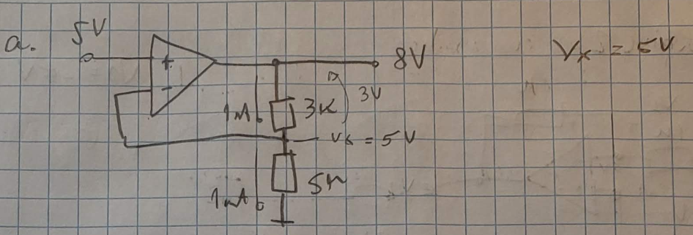

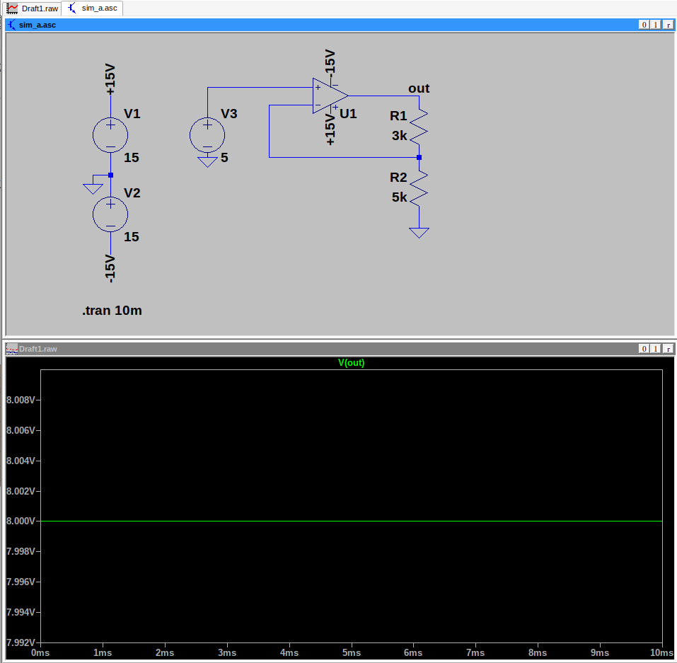

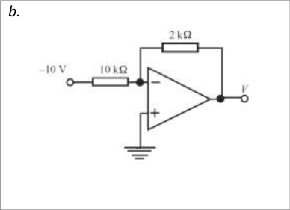

V=2V

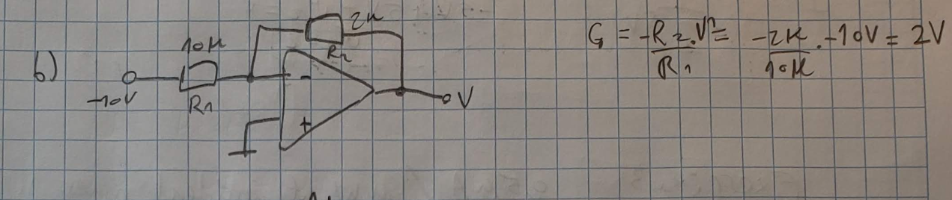
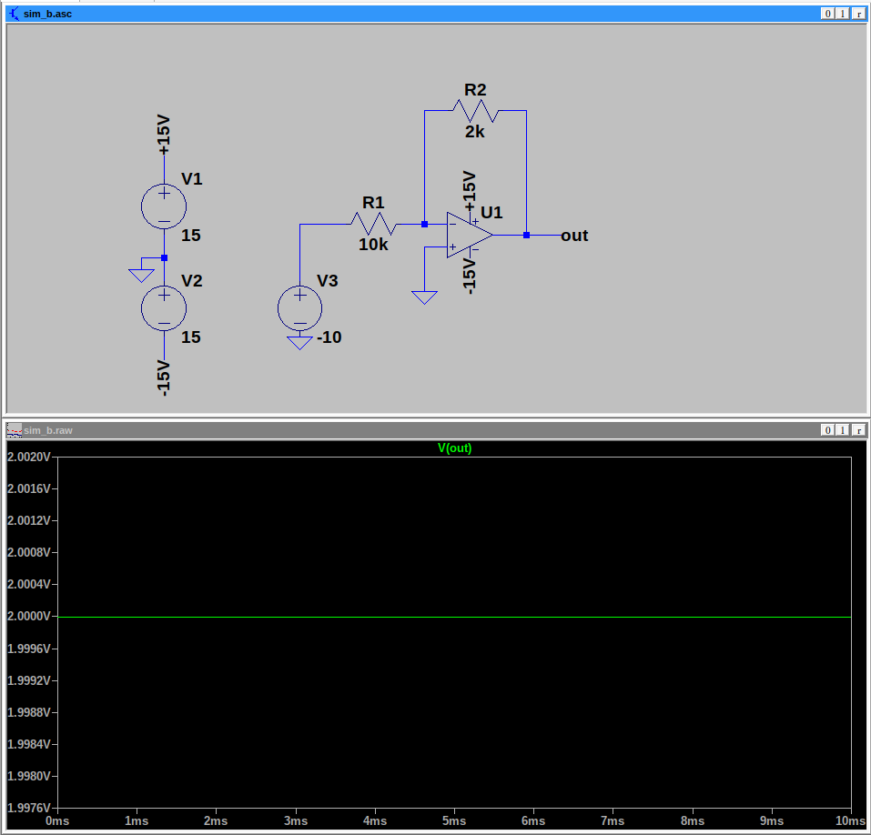
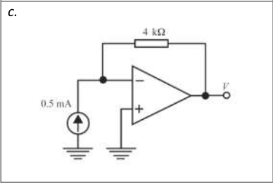

V = -2V

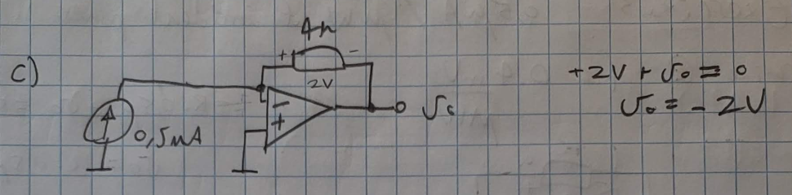
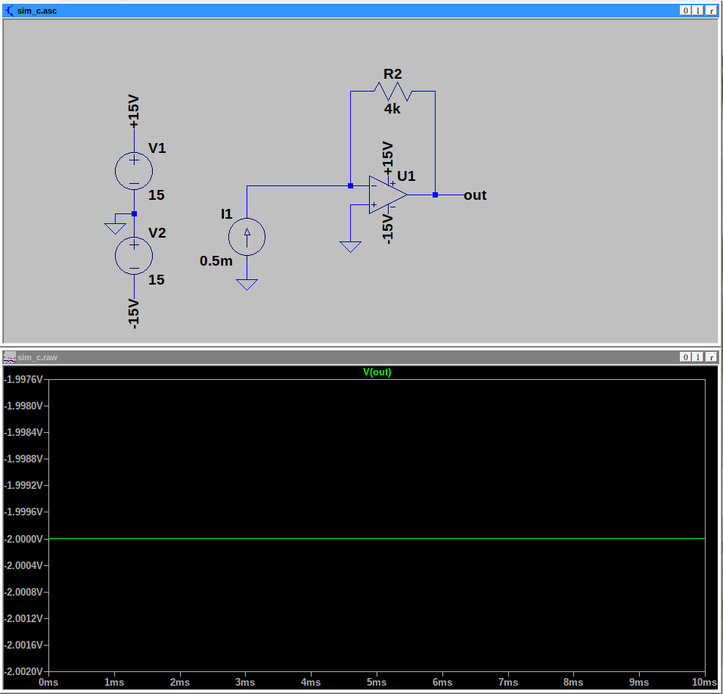

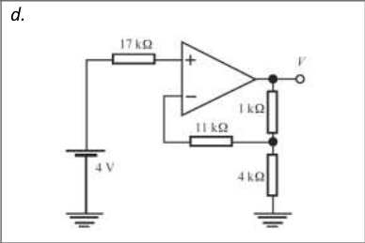

V = 5V

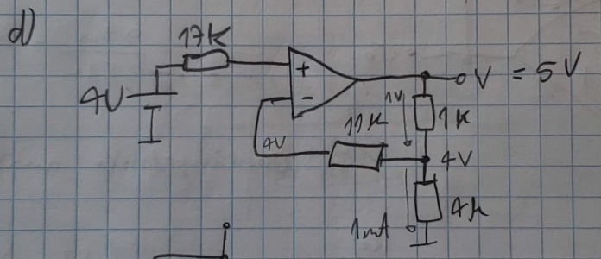

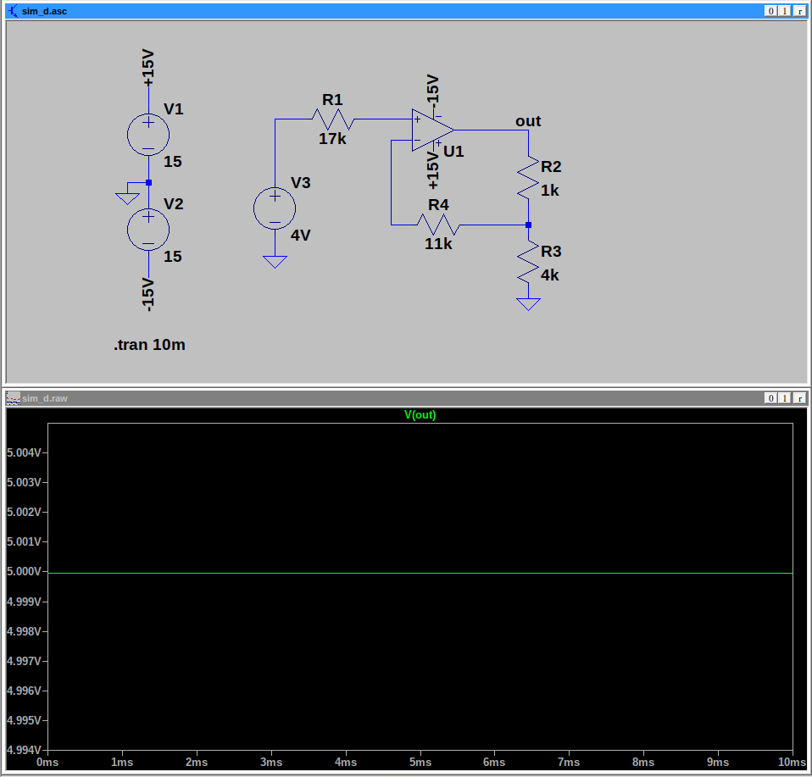
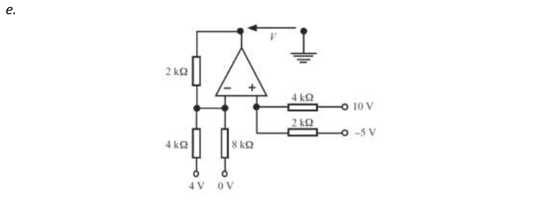

V = -2V

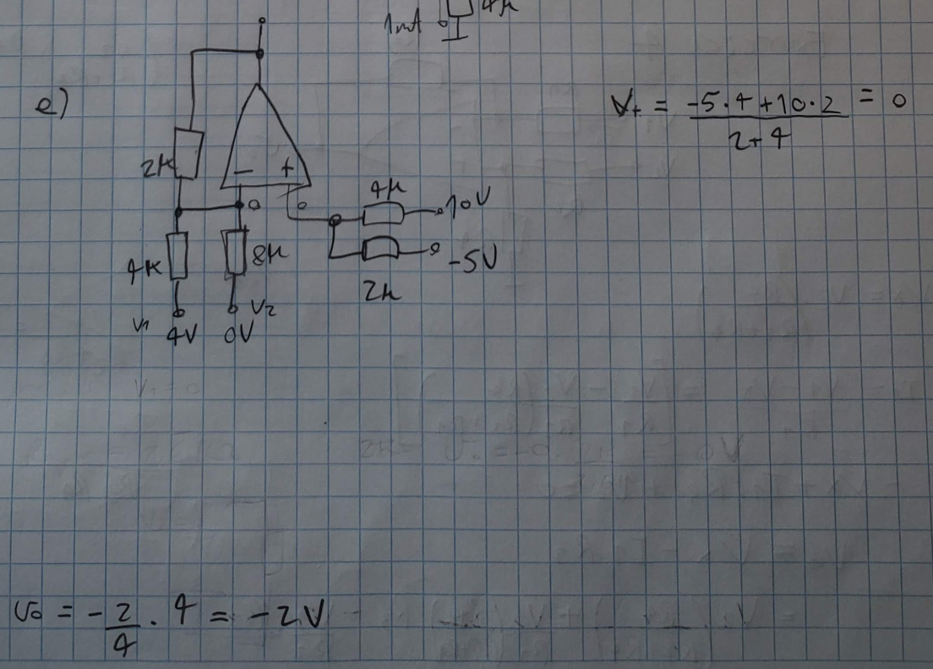

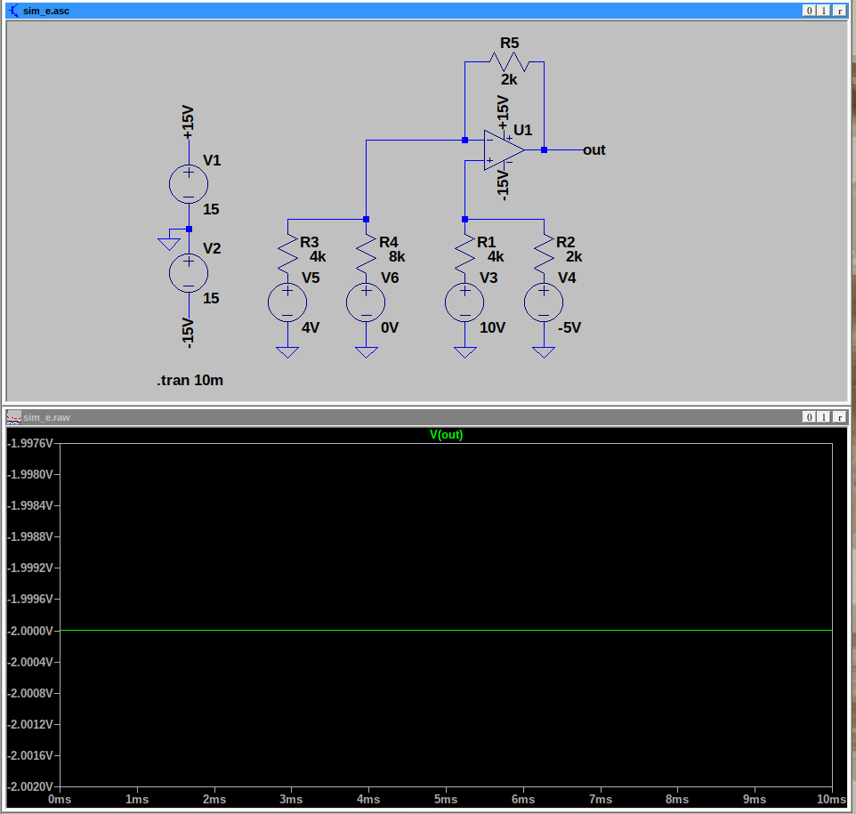

Exercise 2 : In the circuit in Figure 2, calculate the values of V1 and V2. Use LTSpice to check your results.
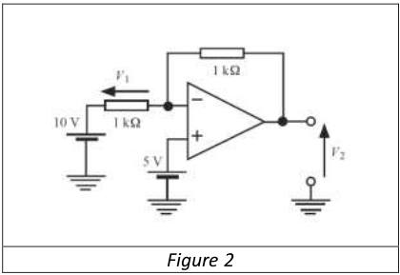
V1 = -5V
V2 = 0V

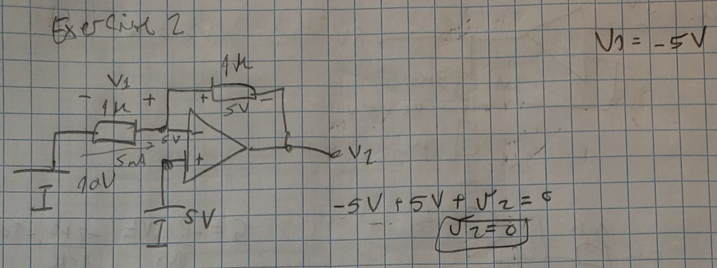

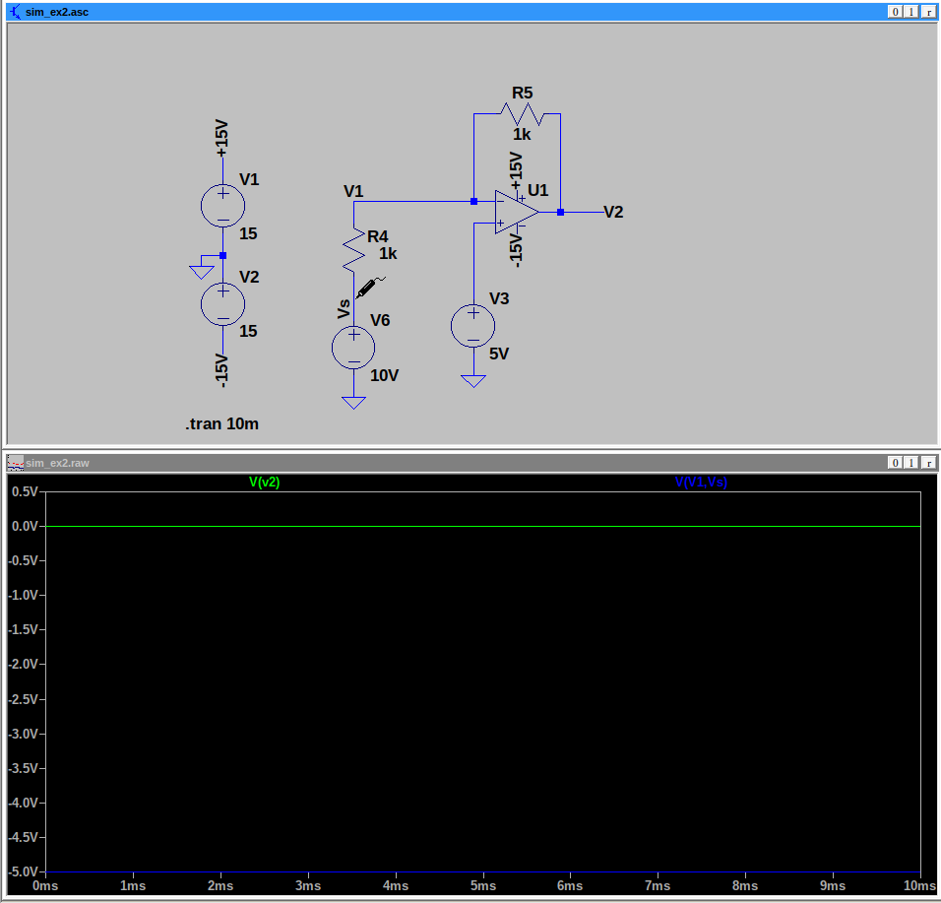
Exercise 3 : The circuit in Figure 3 measures light intensity using a photodiode. The latter, polarized in reverse, produces a current of 0.5uA per uW of incident power. Determine the value of R for which the sensitivity of the conditioner is 0.4mV/mW. Verify your result with LTSpice by replacing the{photodiode, voltage source} assembly with a suitable element.
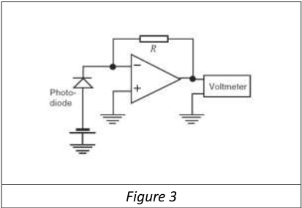
Here I suppose the sensor is submitted to exactly 1mW of power.
R = 800 Ohms

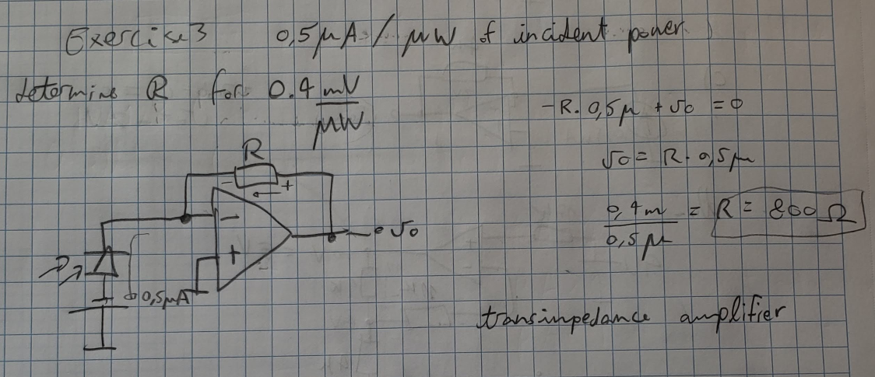

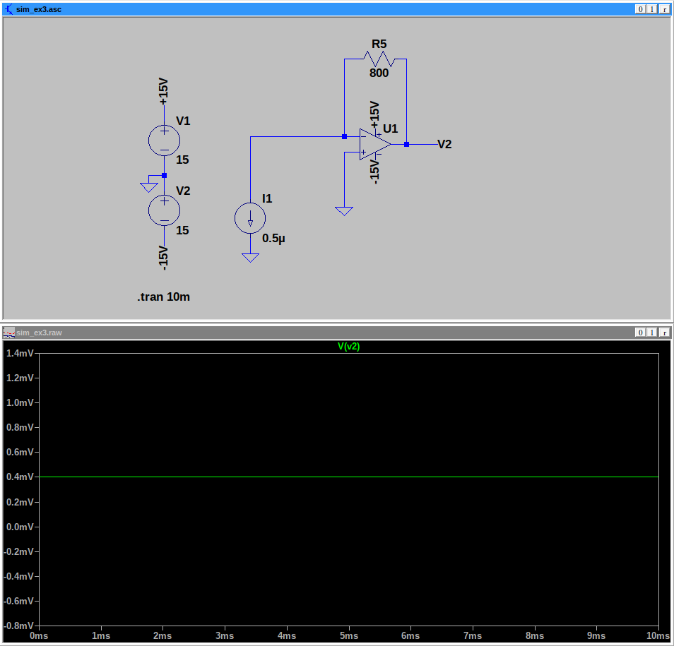

Exercise 4 : In the circuit of figure 4, give the expression of Vo as a function of V1 and V2. Under what condition on resistors R1 to R4 is there a differential amplifier?
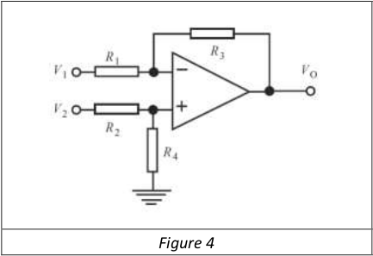
R3 / R1 = R4 / R2

