 | Gabriel GOSMANN  Felipe LORENZON
École Centrale de Lille  EBE – Electronics for biomedical engineering | May, 2024.

Operational amplifiers (Opamps)
Part 1 : Theory

Exercise 1 : In the circuits of figure 1, calculate the value of the voltage V. Use LTSpice to check your results.

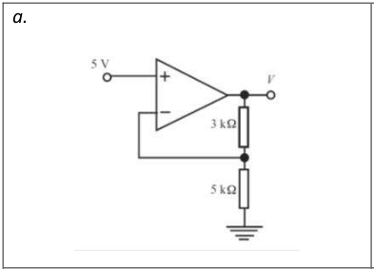

V=8V

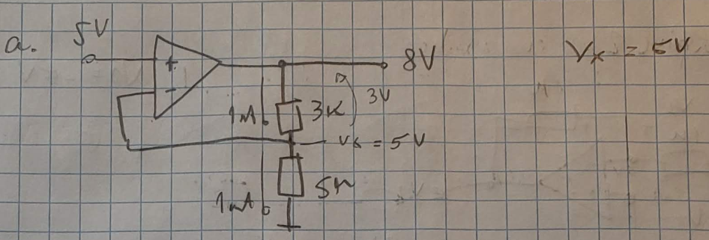

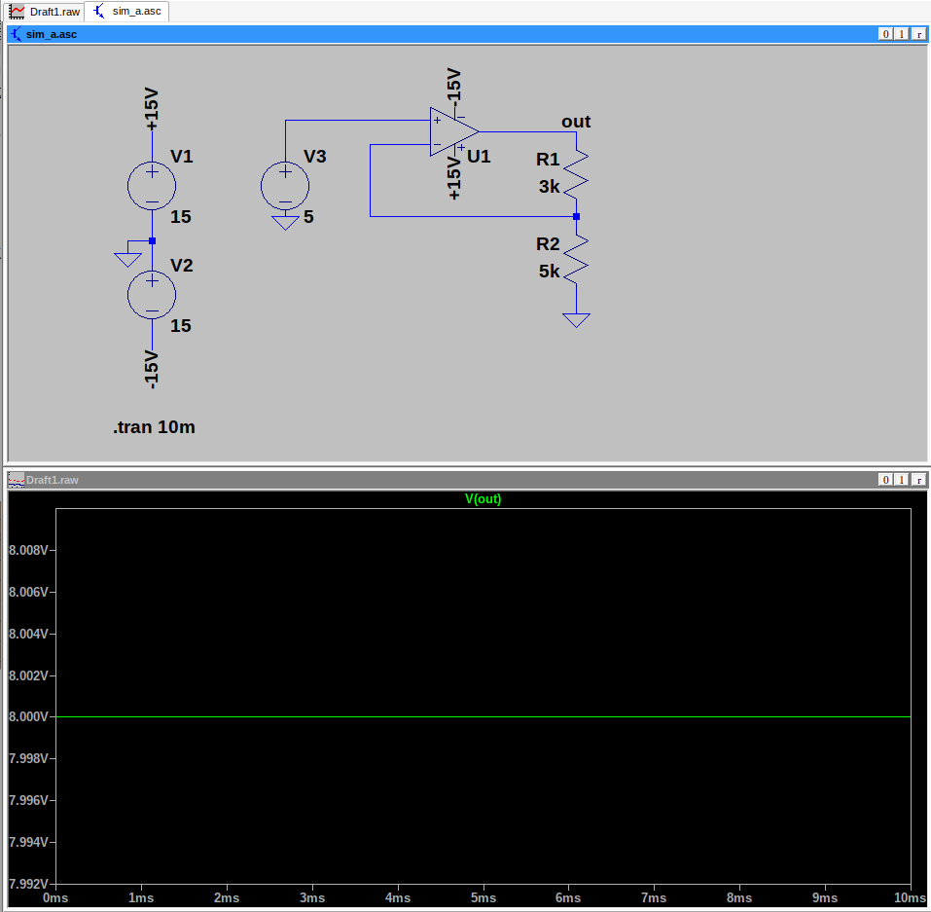
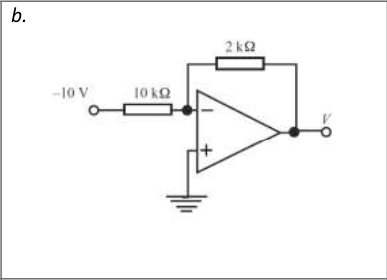

V=2V

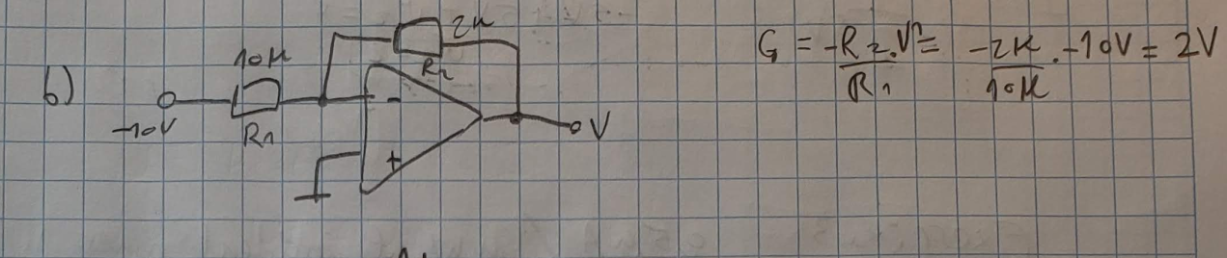
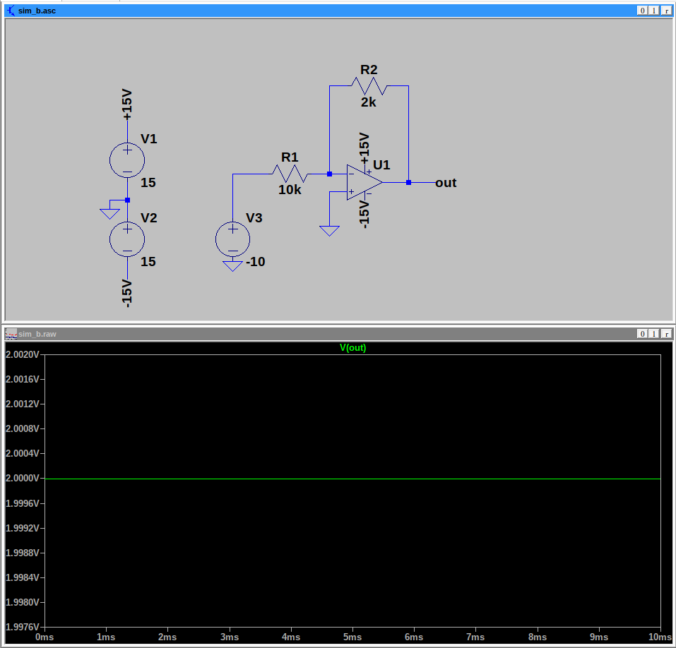
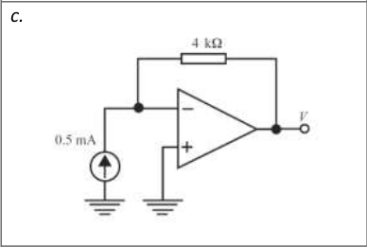
V = -2V

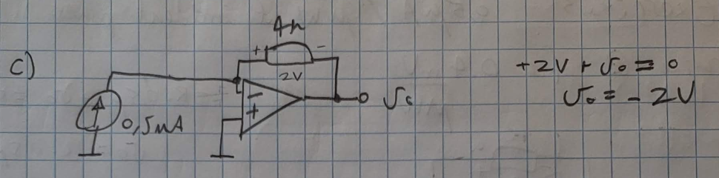
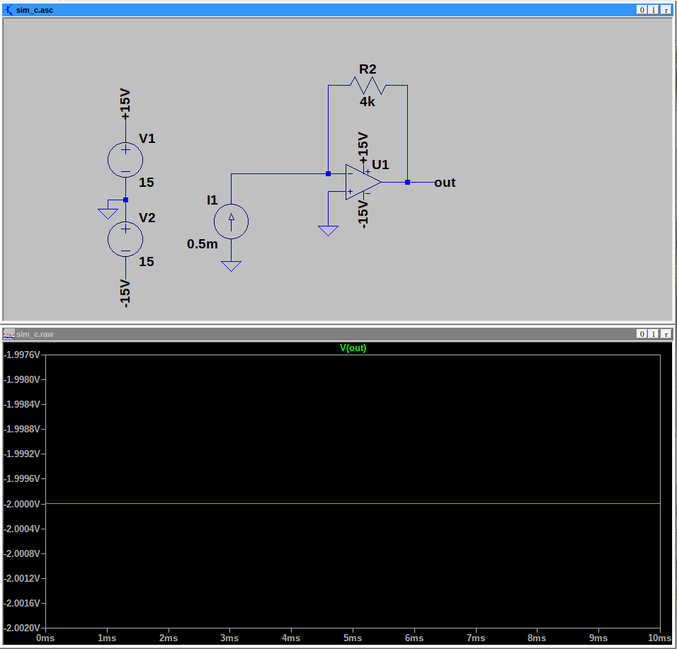

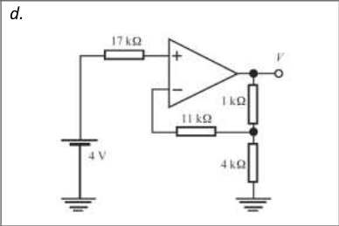

V = 5V

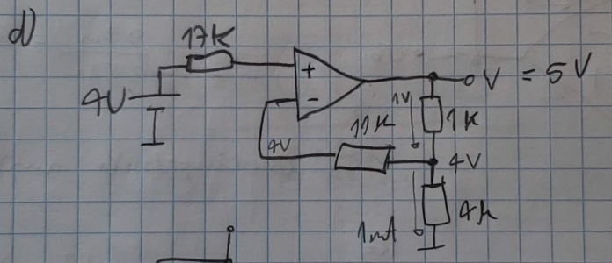

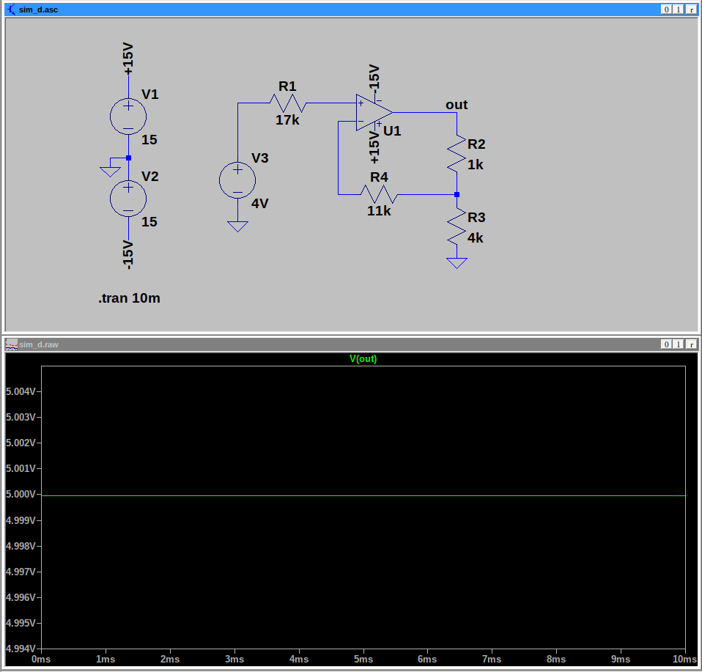

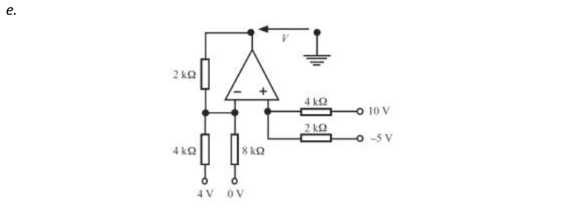
V = -2V

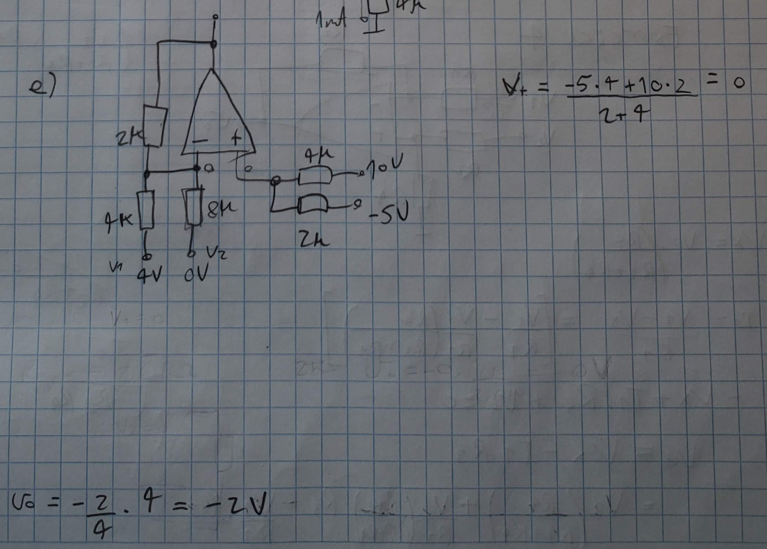

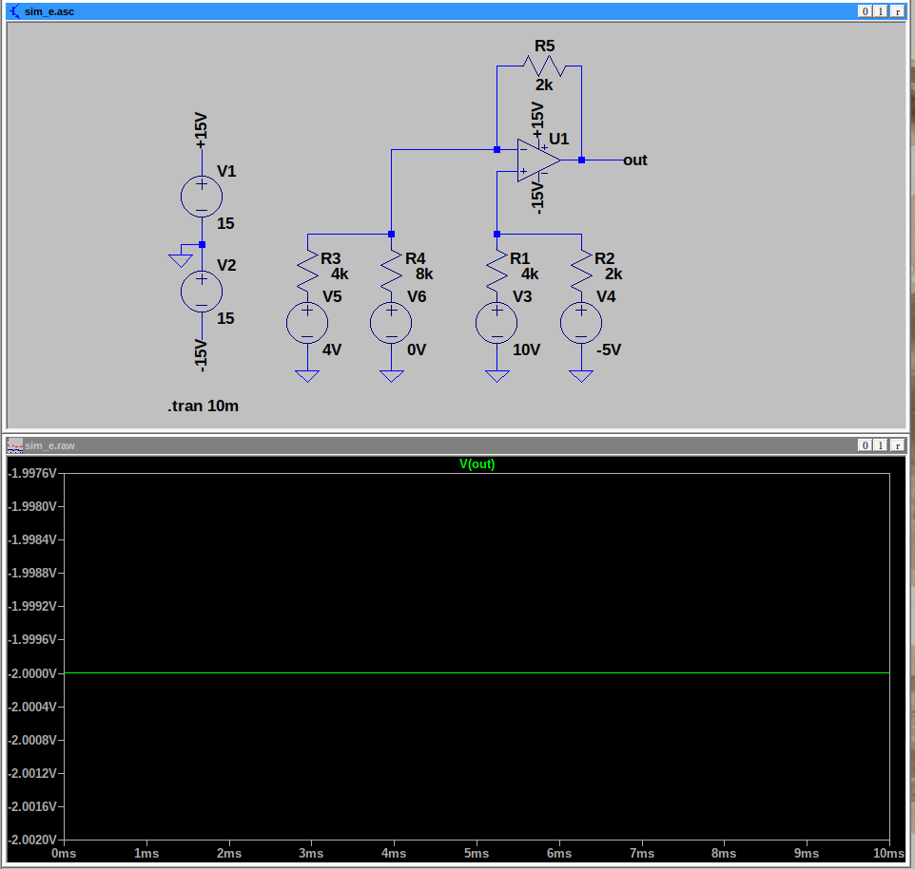

Exercise 2 : In the circuit in Figure 2, calculate the values of V1 and V2. Use LTSpice to check your results.
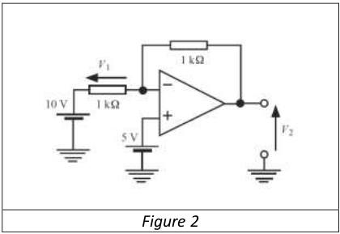
V1 = -5V
V2 = 0V

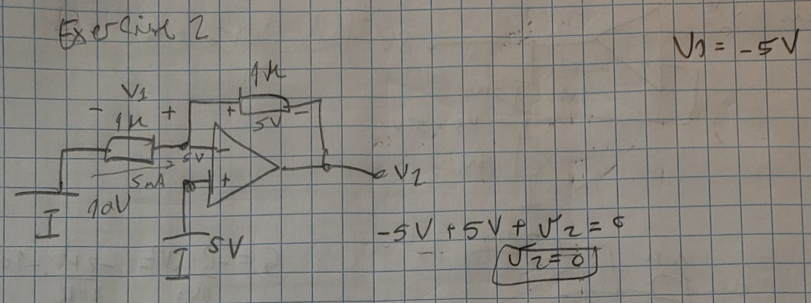

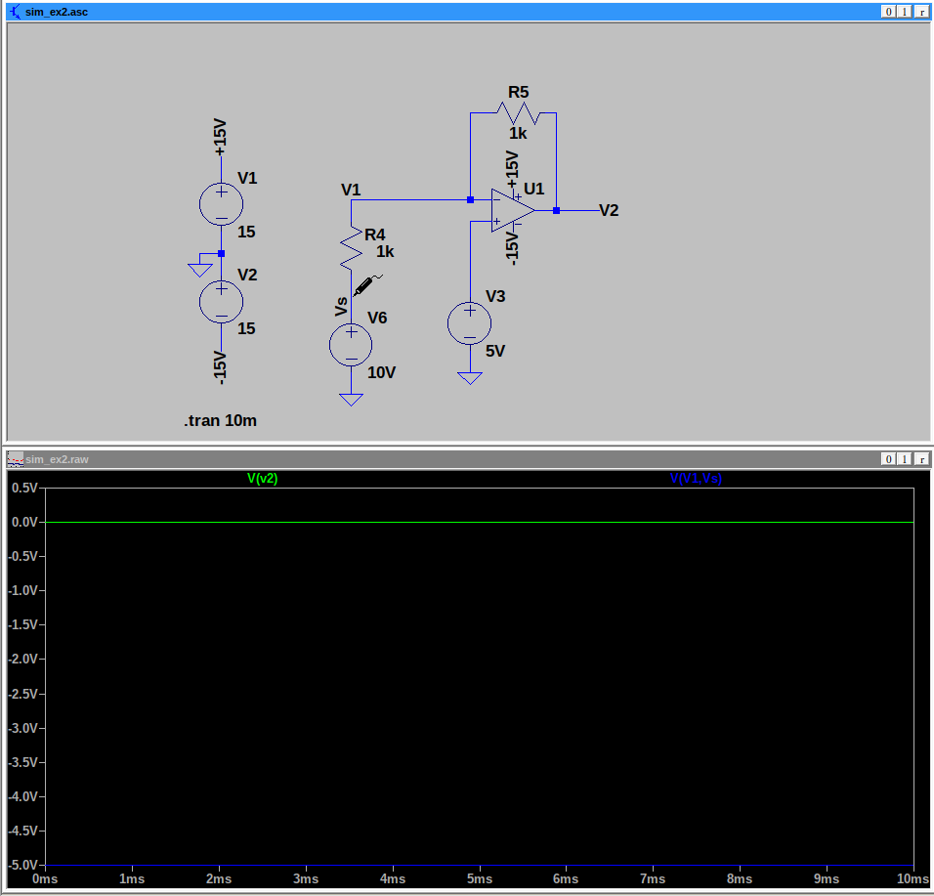
Exercise 3 : The circuit in Figure 3 measures light intensity using a photodiode. The latter, polarized in reverse, produces a current of 0.5uA per uW of incident power. Determine the value of R for which the sensitivity of the conditioner is 0.4mV/mW. Verify your result with LTSpice by replacing the{photodiode, voltage source} assembly with a suitable element.
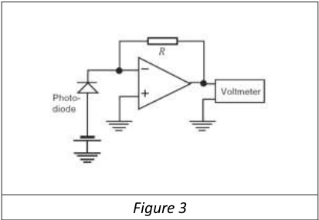
Here I suppose the sensor is submitted to exactly 1mW of power.
R = 800 Ohms

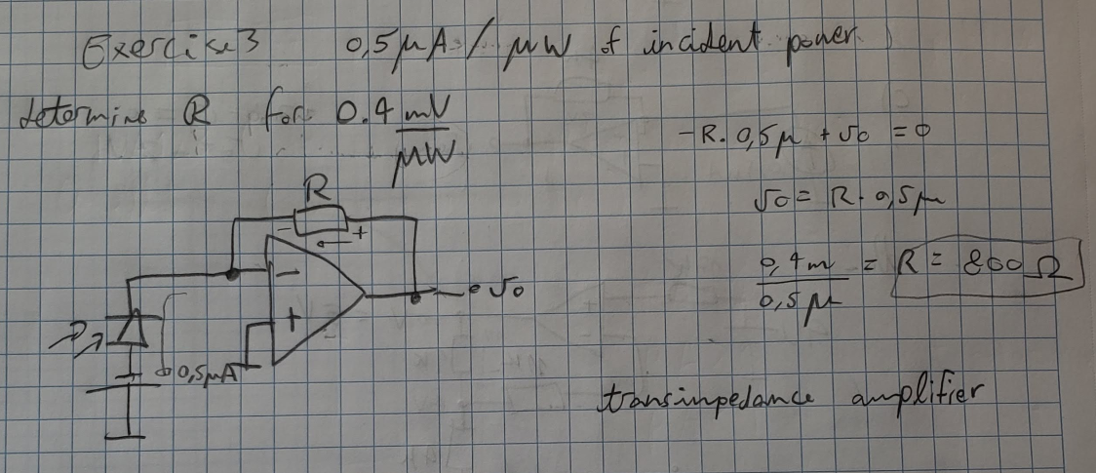

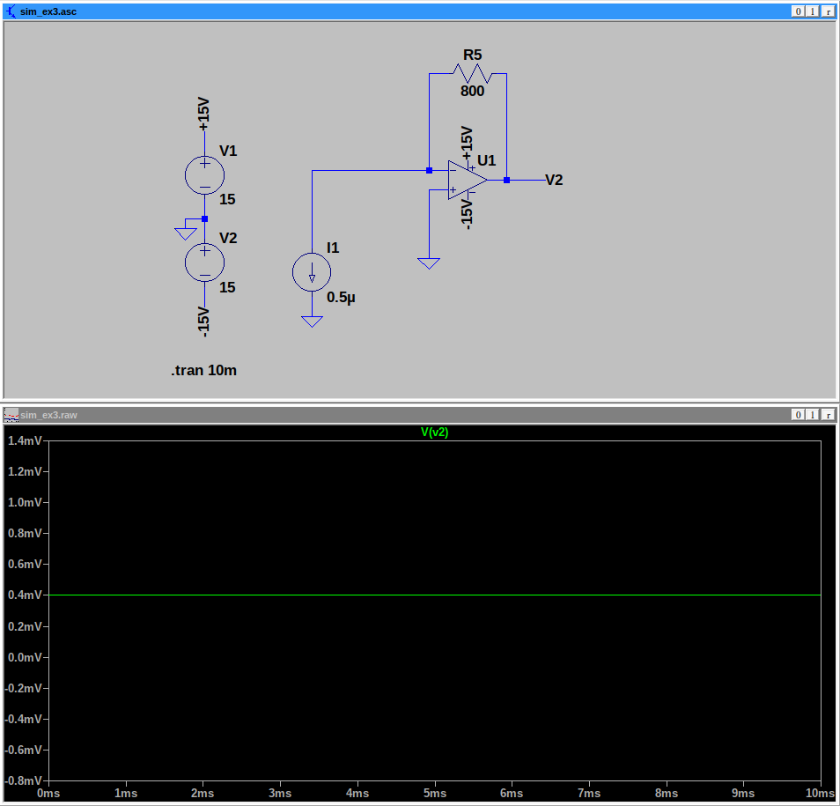

Exercise 4 : In the circuit of figure 4, give the expression of Vo as a function of V1 and V2. Under what condition on resistors R1 to R4 is there a differential amplifier?
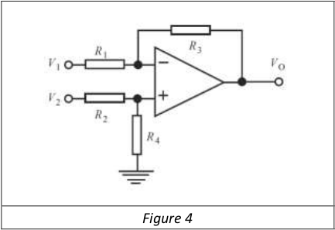
R3 / R1 = R4 / R2

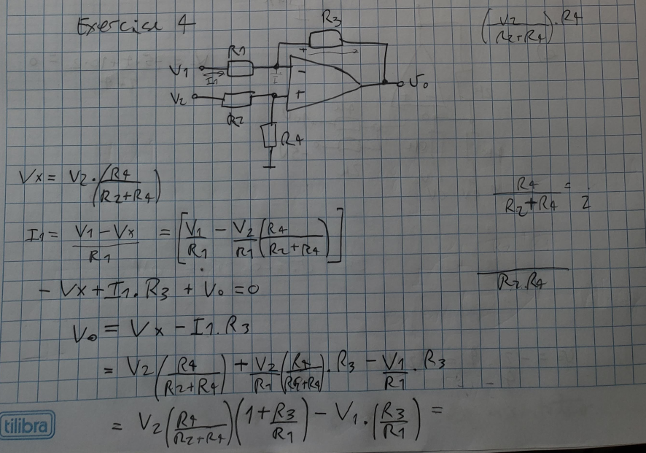

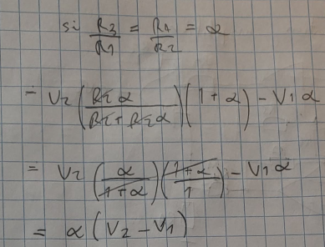

PART2: Simulation

1. Bandwidth : The objective is to verify the invariance of the GBP gain-bandwidth product. To do this we will use the AC simulation mode.
a. Simulate the opamp as buffer. Determine its cutoff frequency and its GBP product.

The bandwidth of the circuit is 1.53MHz, as defined by the frequency with -3dB attenuation.
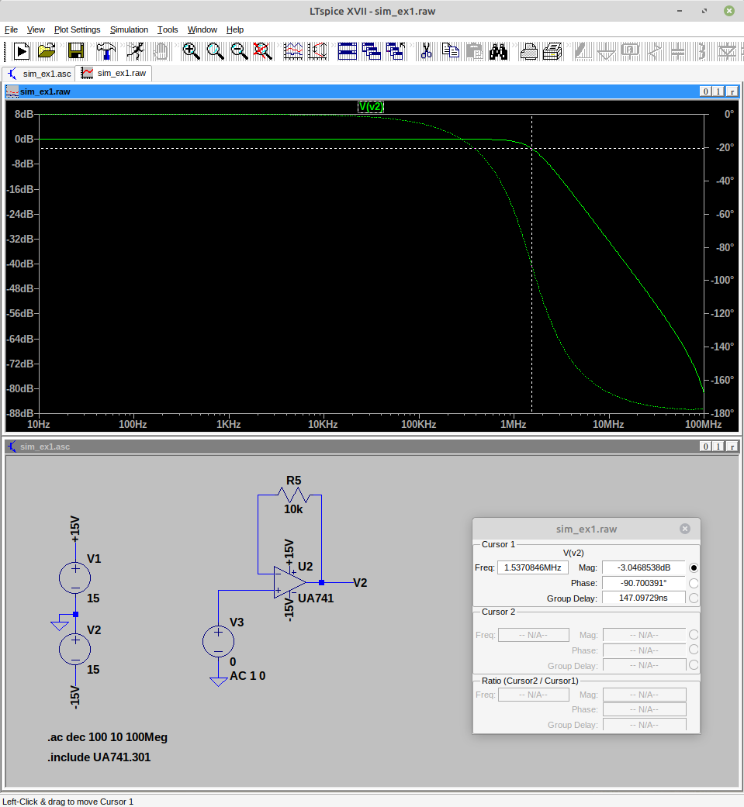

b. Simulate the opamp as buffer. Determine its cutoff frequency and its GBP product.

According to the datasheet, the typical value for the bandwidth is of around 1.5MHz, which is very close to the value found in simulation.

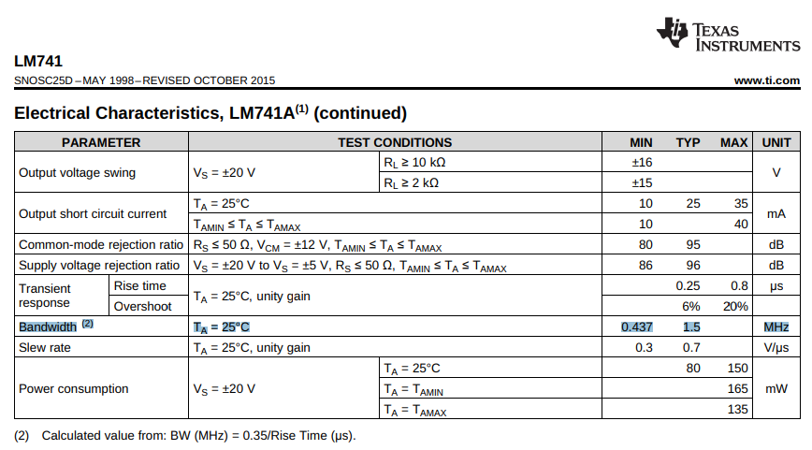

c. Do the same with an inverting amplifier of gain 10, then of gain 100.
gain 10:

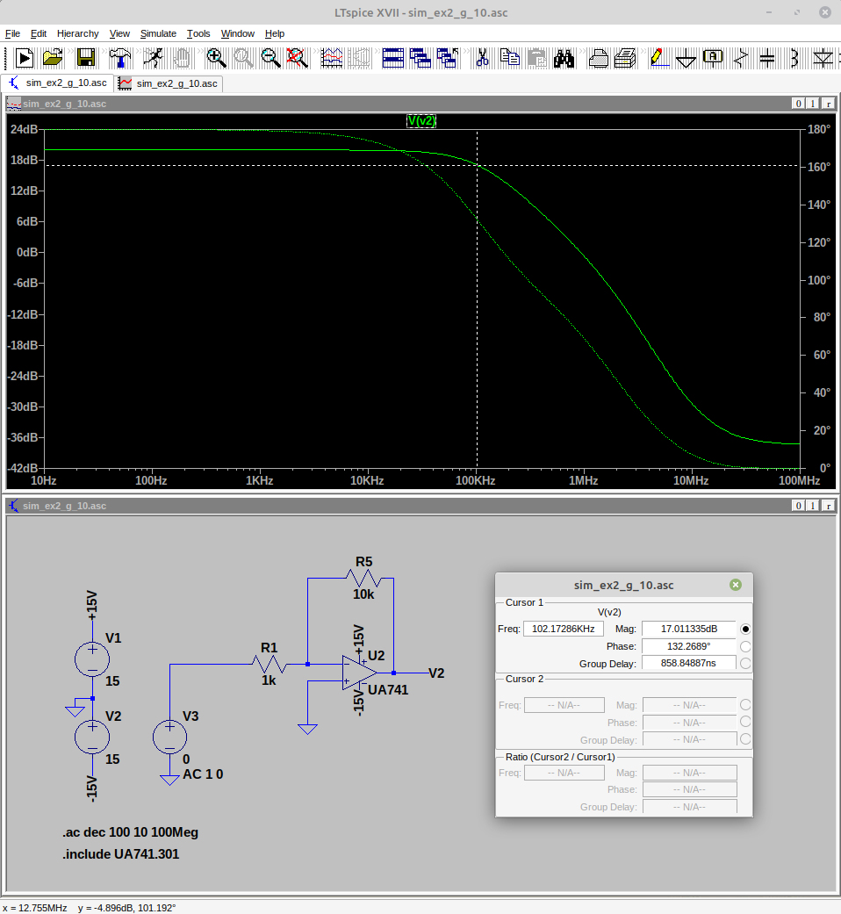
bandwidth : 102 kHz

gain 100:
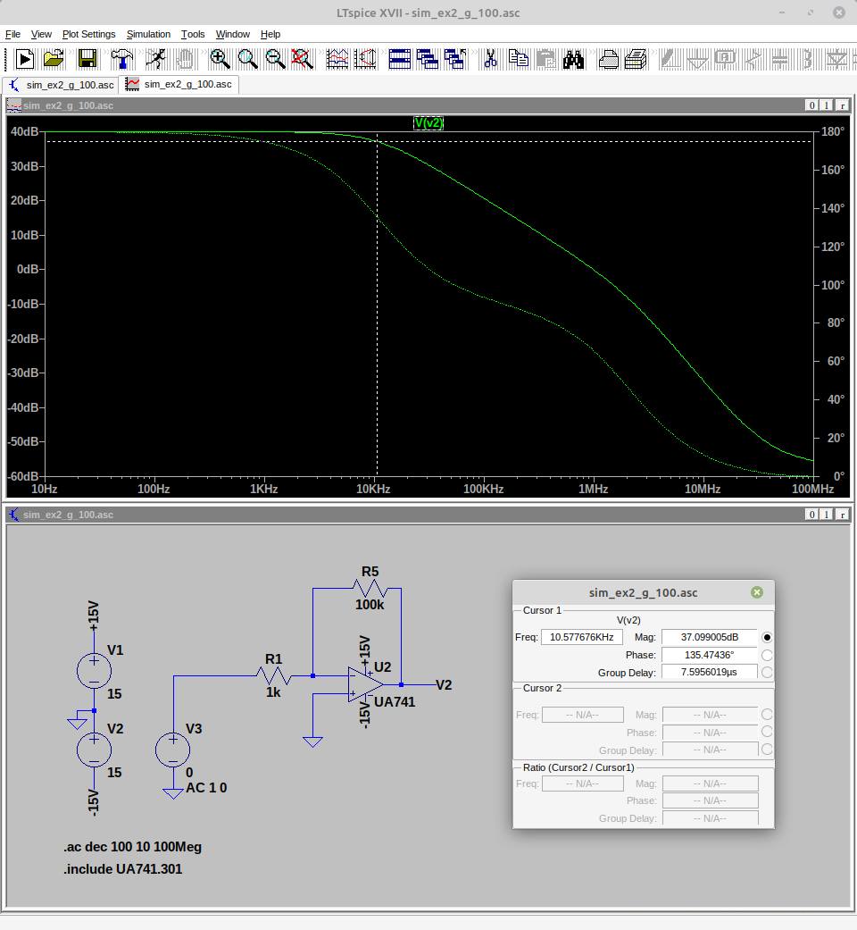
bandwidth : 10 kHz

d. Repeat the previous question with a non-inverting amplifier.
gain 10:

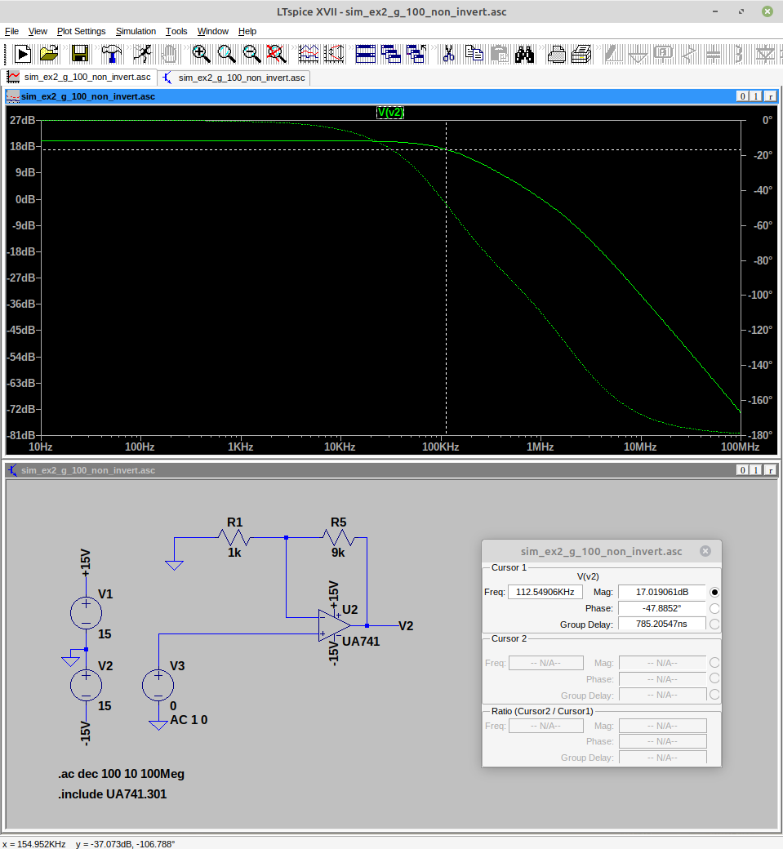

bandwidth : 112 kHz

gain 100:

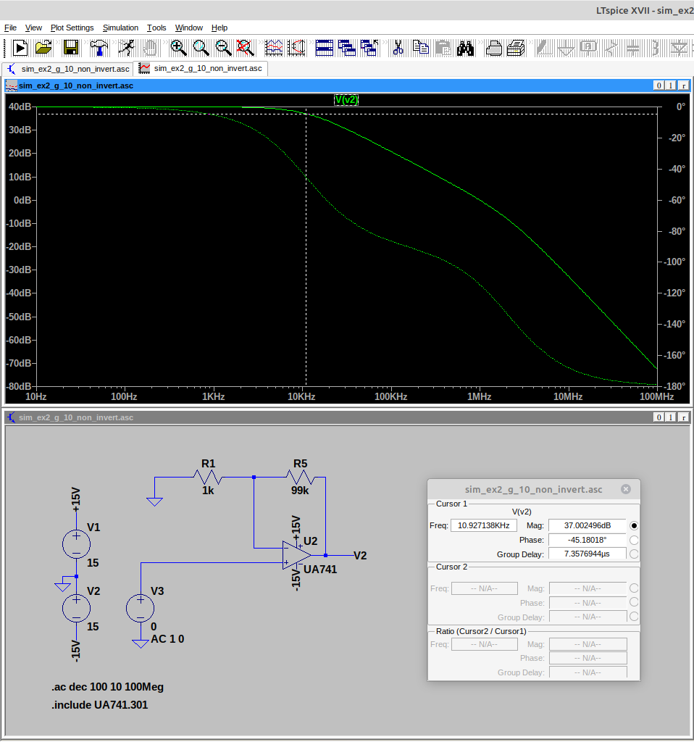
bandwidth : 11 kHz

e. Conclude

Both in the cases of the inverting and of the non-inverting amplifier the bandwidths were approximately the same. In all cases the product gain and bandwidth is approximately the same.

B. Instrumentation amplifier

PART1: Theory

Exercise 1.a

This is the expression for the output of a differential amplifier:

, where A_{d} is the differential gain and A_{mc} is the common mode gain.
In practice, a more common datasheet value is the common mode rejection ratio (CMRR), expressed as:

, or in dB,
For this amplifier,
Exercise 1.b

Using the assumption that the amplifier is ideal and has no input current, the input voltages can be calculated from the voltage divisor formula.

Exercise 1.c

Substituting all the values:

The measurement error is caused by the second term, associated with the common mode.

Exercise 1.d
It we swap resistors R1 and R9, we get:

Only the common mode has changed value.

The error has increased significantly, but remains small compared to the overall value.

Exercise 2.a

(voltage divisor)

Assuming an ideal opamp:

The gain is

Exercise 2.b
The preliminary analysis holds true:

Now assuming the only non-ideal aspect is the gain. Previously it was used to state the “virtual short circuit”.

Substituting in the gain formula:

Now, the differential gain is done by: . Note that as G goes to infinity, the limit converges to the previous value of A_{d}.

Exercise 2.c

If we now consider , with

Exercise 2.d

Exercise 3.a

Exercise 3.b

According to the datasheet, the formula is the following:

Exercise 3.c

According to the datasheet, in the table in the section 7.5, and assuming INA12xP, the CMRR should be between 106 and 125 dB in a typical chip.

Exercise 3.d

The minimum value in the range , by arbitration, is taken to be the actual value. CMRR = 106 dB

Exercise 3.e

, or in dB,

Considering the input voltages as and , we get:

This represents an error of 0.15% in the measurement.

Exercise 3.f

The amplifier must have a high input impedance, in order to avoid drawing current from the sources, and also a very small offset current. According to table in section 7.5 in the datasheet, the input impedance is of in differential mode and in common-mode. Some of the measurements in the real world present a voltage that drops very significant it current is drawn. It can be modeled as a Thévénin circuit with a very high impedance. Ideally, no current should pass.

The input bias current, i.e., the average “current source” has and the input offset current (the difference between the currents in each input) is .
Exercise 3.g
The bandwidth at -3dB, according again to section 7.5 in the datasheet is between 640 and 200 kHz.

PART2: Simulation
a. Simulate in LTSpice the AI circuit corresponding to the internal schematic of the INA 128, using the "UniversalOpamp2" AO.
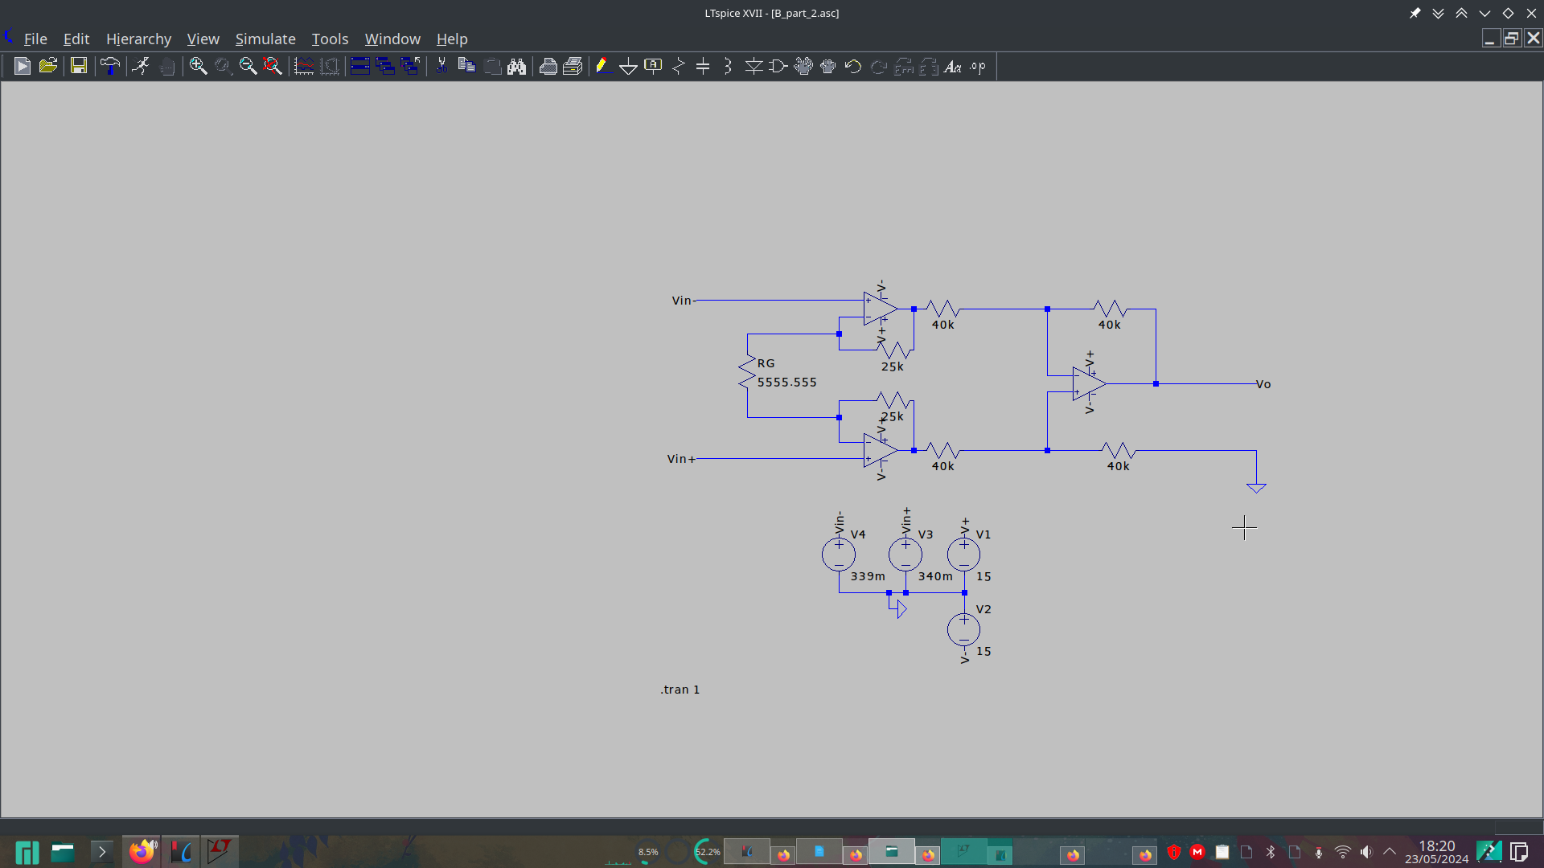
b. Set the external resistor RG so as to obtain differential gains of 10, 100 and 1000.

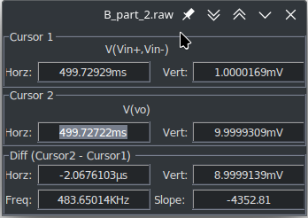

Figure: gain of 10, resistance of 5555 ohms
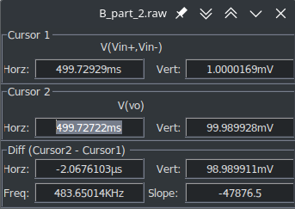

Figure: gain of 100, resistance of 505.05 ohms
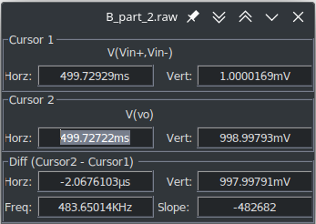

Figure: gain of 1000, resistance of 50.05 ohms

c. Display the differential and common mode gain as a function of frequency, choosing a frequency band wide enough to observe the differential gain cutoff frequency. What do you observe for each of these gains?

c.1 G = 1000 = 60dB
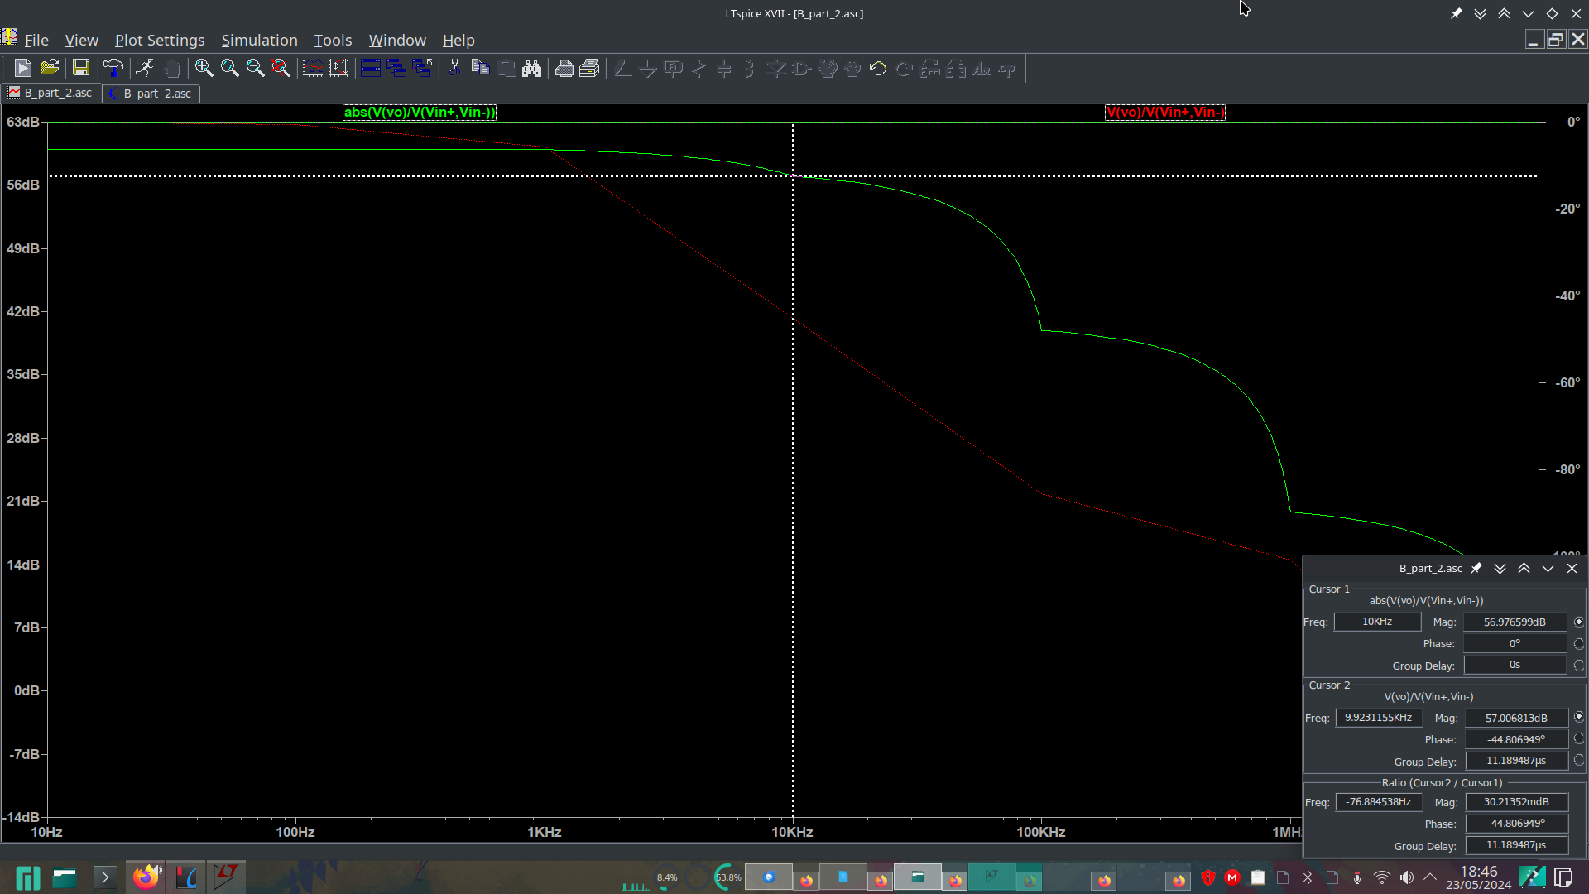
In the graph, we can see the 60 dB in the pass band, as expected. The graph in green is the magnitude of the differential gain and in red is the phase. At 10kHz, the output is reduced by 3dB.

In order to measure the common mode gain, I’ve modified both voltage inputs to be equal to 5V.

c.2 G = 100 = 40 dB

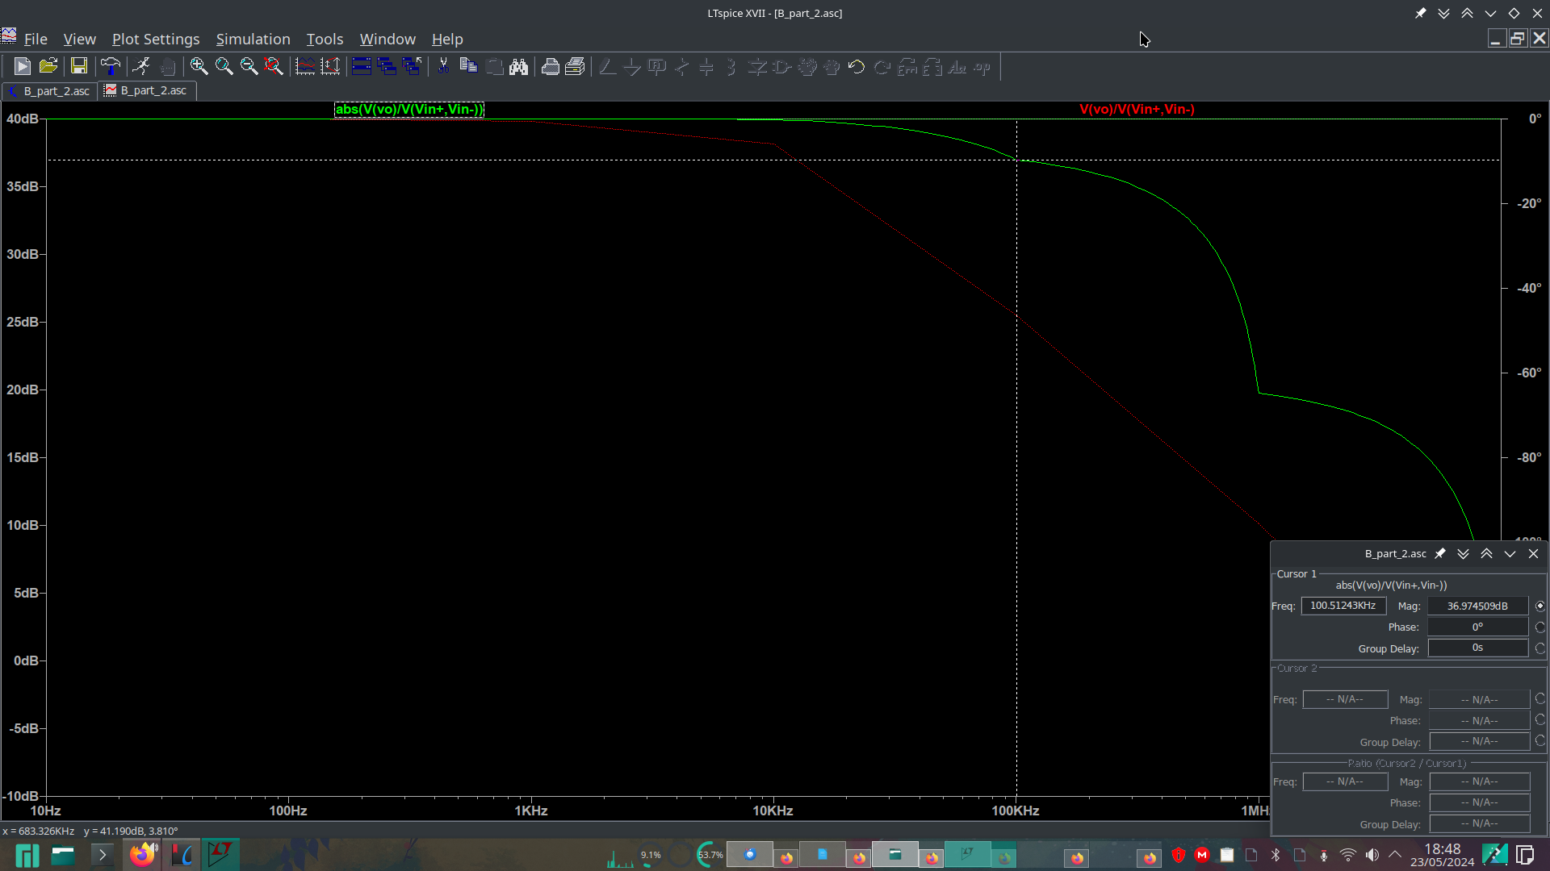
In the pass band, the magnitude is 40 dB as expected. The cutoff frequency is at 100 kHz

c.3 G = 10 = 20 dB
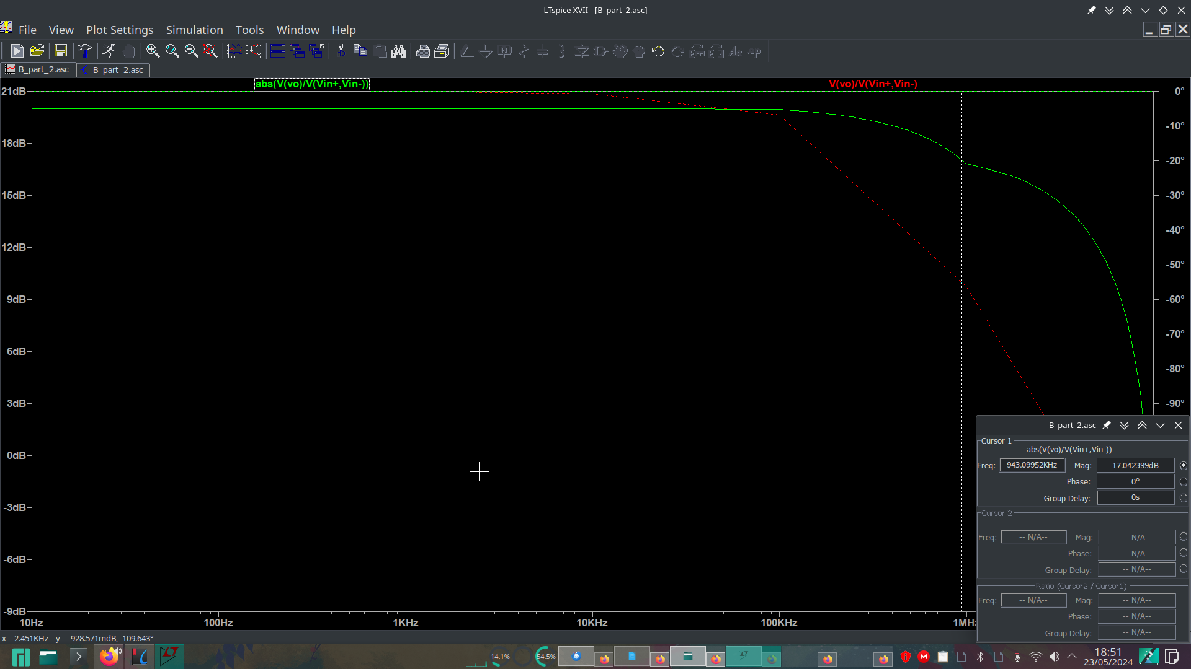
The cutoff frequency is at 943 kHz
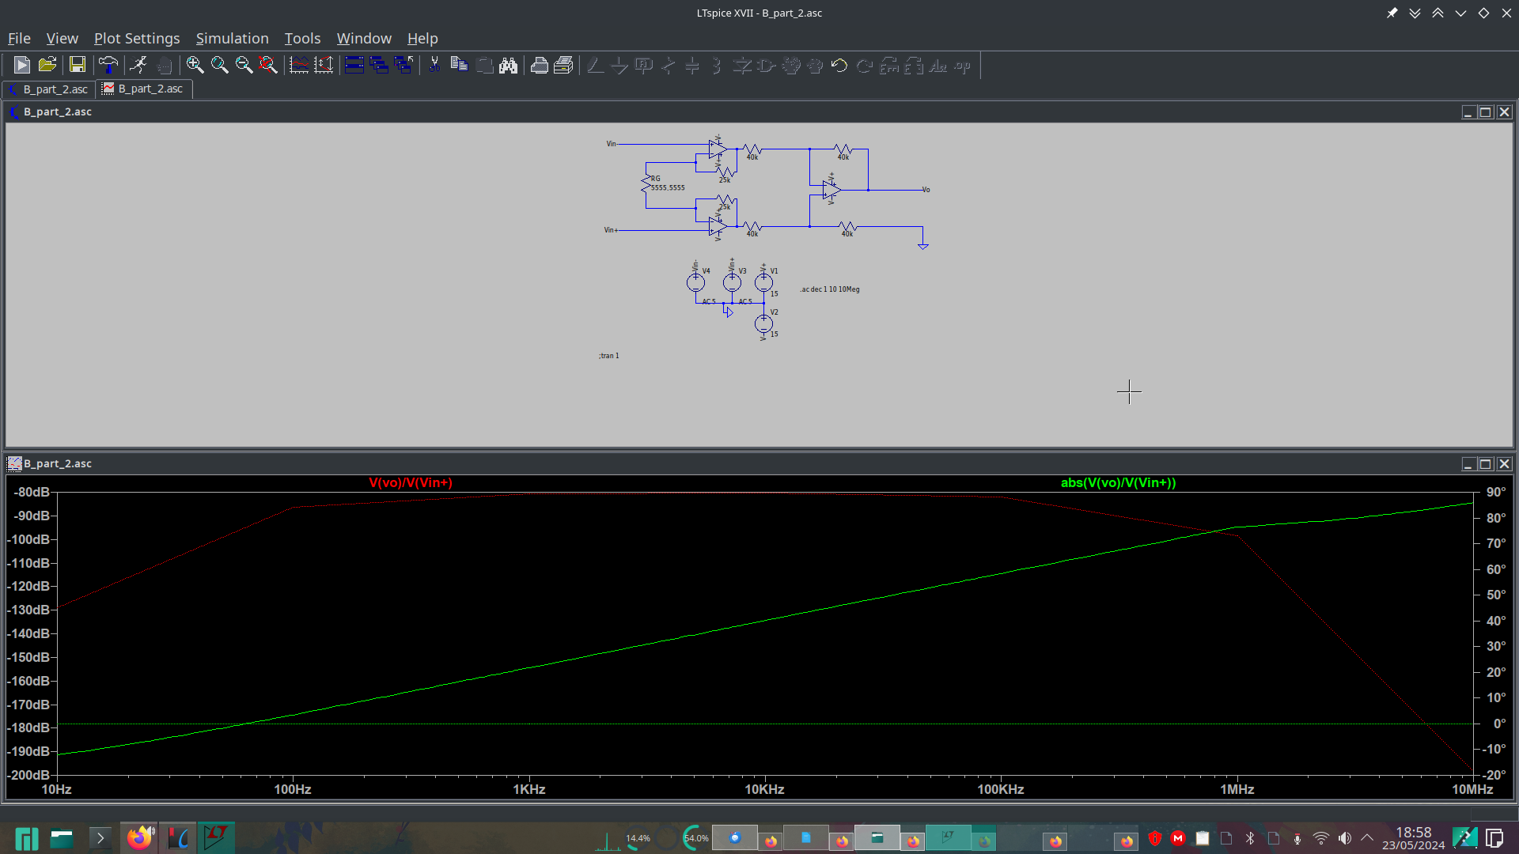
This graph shows the common mode gain behaves as a high pass filter. All 3 simulations presented visually identical graphs, so I have omitted the other screenshots for the sake of brevity.

c.conclusion

It is observed that the product of differential gain and bandwidth remains approximately constant. Raising the gain shifts the amplitude graph to the left, but doesn’t change much the general form of the graph.
The common mode gain behaves as a high pass filter and is not affected by the increase in differential gain. This is expected if all internal opamps behave ideally, because there would be no voltage across R_{G}, consequently it has no influence on the output.
This also explains why the Common mode rejection ration improves as the gain increases, the common mode gain gets smaller relative to the differential mode.

d. Compare the values of differential gain, CMRT, and cutoff frequency with the data sheet and comment on the differences.

All the differential gains are very close to values calculated.

The CMRR can be calculated, in dB, as the differential gain minus the common mode gain. I took the value, arbitrarily, at 1 kHz
At G = 10, CMRR = 20 - (-154) = 175 dB
At G = 100, CMRR = 40 - (-154) = 194 dB
At G = 1000, CMRR = 60 - (-154) = 214 dB

These values are significantly better than the datasheet. This is caused by the ideal and very precise resistances and opamps used in the simulation. Changing a resistor by 100 Ohms caused the CMRR to 80 dB at G=10, much closer to the expected value.

The bandwidth at G = 10 was measured as 943 kHz, higher than the 640 kHz from the datasheet.
At G = 100, it was simulated as 100 kHz, lower than the 200 kHz expected.
At G = 1000, it has been found to be 10 kHz, again half of the 20 kHz specification.

e. Concerning the TRMC, propose a solution so that the simulated values are close to those in the datasheet.

We can add a small random deviation in resistance values and non-ideal behaviors to the 3 internal opamps. Simply changing a single resistor by 0.25% decreased the CMRR by around 90 dB

