 | Gabriel GOSMANN  Felipe LORENZON
École Centrale de Lille  EBE – Electronics for biomedical engineering | June, 2024.

Oscillators

Part 1 : Theory
1. Give an expression for β(jω).
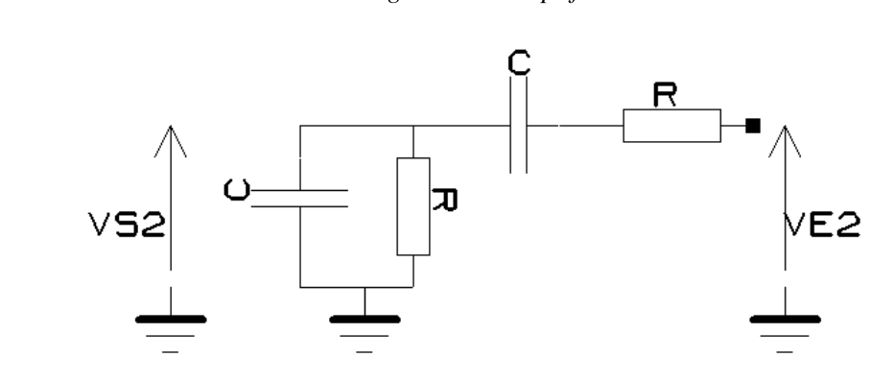
For the compontents in paralellel from Vs2 to the ground:

For the components in series from Ve2 to to Vs2

The circuit is a voltage divisor:

2. What is the condition on A₀ and β(jω) for the circuit to oscillate with a stable amplitude ?

The condition is . It can further broke down into two simpler conditions:

Assuming A is always real, this means that

3. Derive :
▪ An expression for oscillation frequency F₀.
Plotting the bode diagram for the transferfunction, it is possible to verify that the point of interest is when the phaze is 0, as it never reaches a right angle.
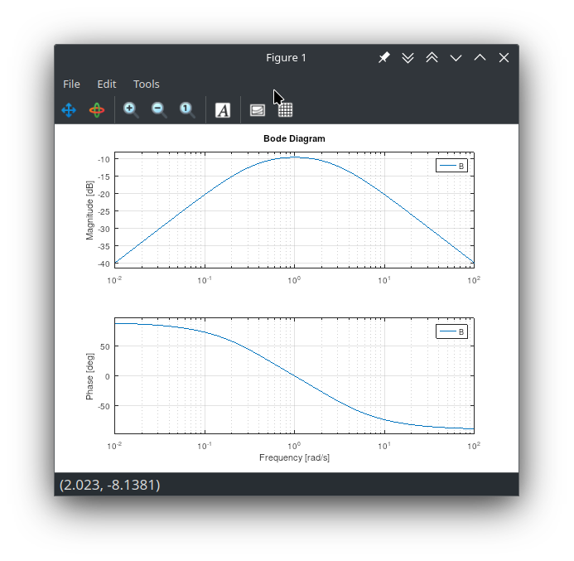

▪ The condition on R₂ et R₁ for a constant amplitude oscillation, without clipping.
Assuming, as stated, that K is closed, the diodes do not interact wit the circuit. The amplifier is a simple non-inverter, which has a gain as:

In order to know how much gain is needed, it is necessary to calculate the amplitude at F₀.

4. Calculate values for C et R₂ so as to obtain a 50 kHz, constant amplitude oscillation.
It is given that

5. What is its peak-to-peak amplitude. In practice, how can it be varied ?
Peak-to-peak voltage is the difference between the maximum and the minimum voltages in a signal. It can be varied with another amplification stage after the signal generation, or by changing the supply voltage in the opamp.
6. We want the oscillator to operate at frequency Fc, which is not a priori known. What are the values of gain and phase shift induced by the amplifier at this frequency?

7. Derive conditions on R, C and A0 for the circuit to oscillate at constant amplitude, without clipping.
We need to go back to the basic conditions

Phase condition: it must be null

Note that this formula is equivalent to what was calculated previously, if we assume the opamp is ideal:

now, we still need to use amplitude condition, in order to calculate the necessary gain.

Again, if you assume an ideal opamp,

8. The opamp has a GBP of 3 MHz. Calculate values of Fc and C. Now, switch K is open, and the oscillation frequency is the same as in question 4.

Using the desired frequency:

Substituting back into the formula:

I’m a bit stuck on this.
9. Plot the current vs. voltage characteristics of one of the diodes D1 or D2.
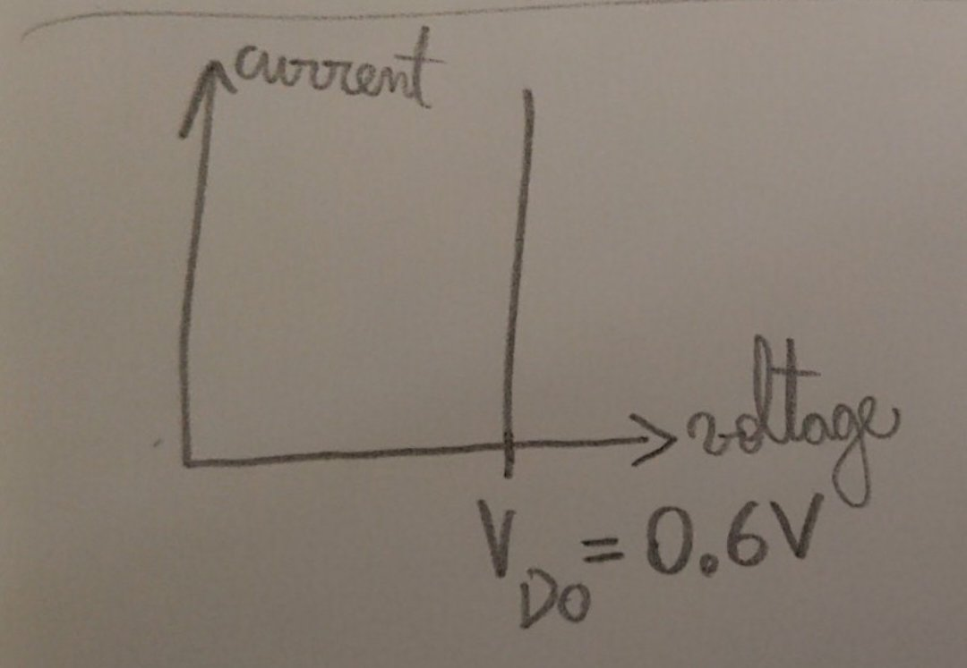
Since the series resistance is assumed to be infinite when ON and zero when off, th graph is just a straight line.
In the 2 next questions, assume that D1 and D2 are OFF.
10. Give an expression for the gain of the amplifier.
The two resistors can be associated in series.

11. Express voltage VR3 (Figure 1.2) vs. Ve.
It can be understood as a voltage divisor.

As shown before, we already have the output voltage. V_{R3} is the difference.

12. Starting with D1 and D2 OFF, what is the condition on Ve for diode D2 to become ON? What is, then, the state of D1 ?
The voltage in the resistor needs to be greater than V_{DO} in the correct orientation. In the case of D2, it means V_{R3} = -0.6 V. D1 is in reverse polarization and is OFF.
13. In that case, redraw the equivalent circuit around the amplifier, and derive a relationship between Vs, Ve and VD0 when D2 in ON and D1 OFF.
14. Plot the transfer characteristics Vs = f(Ve) of the amplifier for -15V < Ve < +15V.
15. What is the purpose of diode D1 and D2 ? Please justify your answer.
They help stabilize the output. They give a non-linear gain to the amplifier that allows small oscillations to get bigger, but once they are big enough the gain decreases to prevent saturation.
16. What is the conditions on R3 for the output oscillation to start?

17. Give an expression for output peak amplitude Vsmax vs. VD0, R1 et R2.

Part 2 : Simulation

Wien Oscillator
1. Calculate the value of oscillation frequency F₀ in Hz and of resistor R2 to maintain a stable oscillation.

2. Simulate the circuit using LTSpice, with UA741 opamp (see homework #1). Take R2 slightly higher than theory. Simulate in ‘Transient’ mode, and choose a sufficient stop time to observe steady-state. To observe the oscillation startup, select « start external voltage supply at 0V »

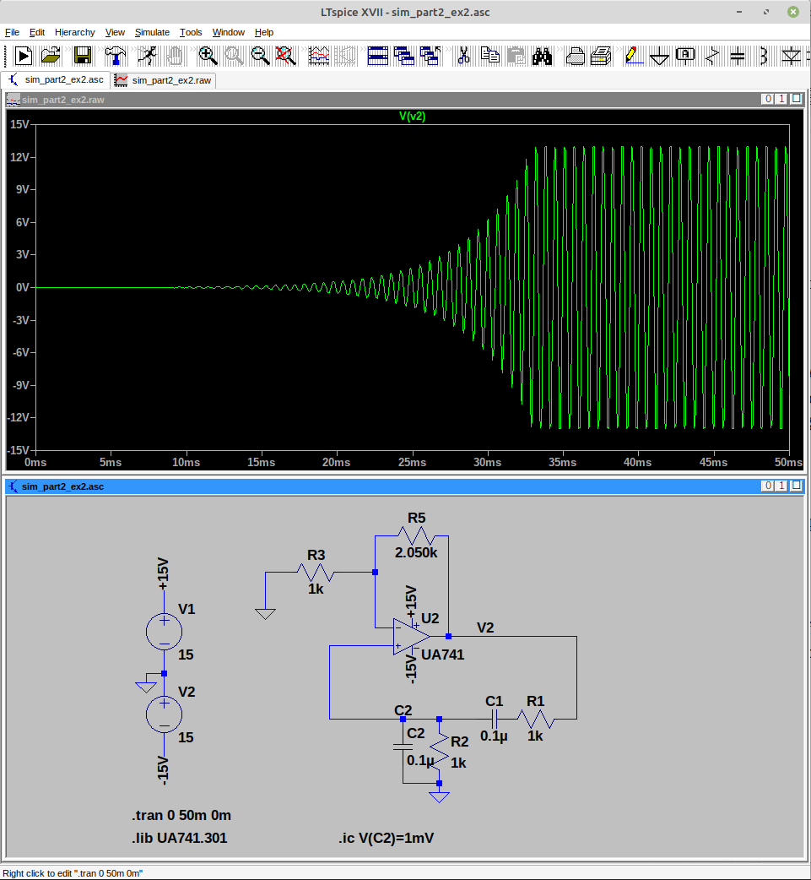

3. Compare theory with simulation and conclude.
The image below allows measuring the oscillating frequency of the circuit at around 1.56kHz.
This in inline with the theory as :

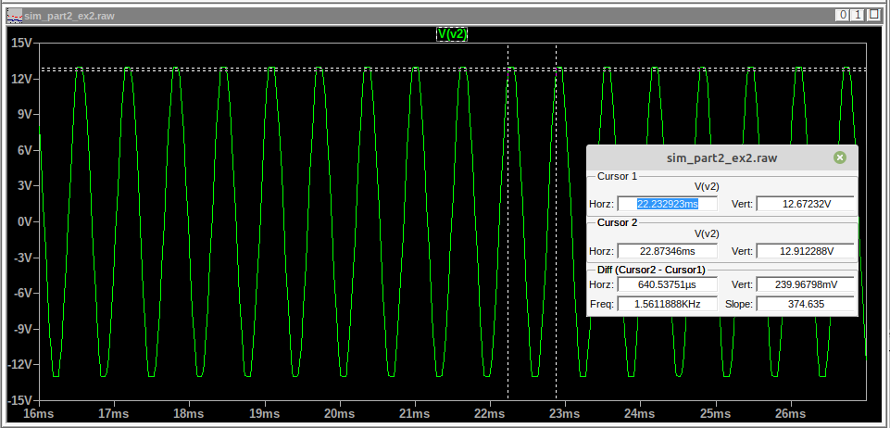

4. We know we want the oscillator to operate at the cutoff frequency of the amplifier. Run a simulation to validate the results from question 6 in part I.
Simulation shows the actual bandwidth of the operational amplifier is around 540kHz:

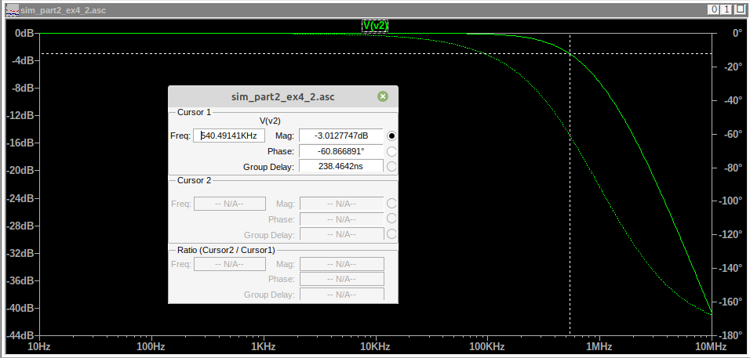

Oscillator with RC phase shifter
1. Using LTSpice, simulate TF β_{RC} ( jω ) = V₁ / V_{S} (amplitude and phase) of the RC phase shifter alone, not connected to the amplifier. Note: the RC phase shifter is loaded by R₁. which should be included in the circuit schematic.
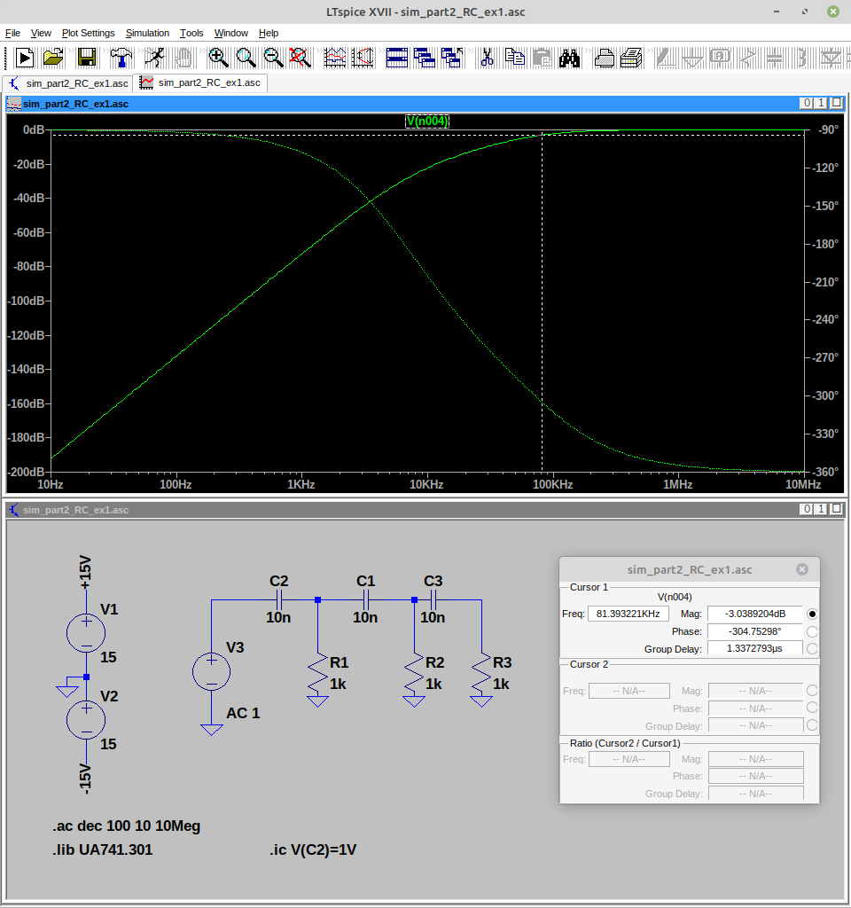

2. Compare with theory (see slides of the course on Oscillators).
3. Derive frequency F0 in Hz et the value of R2 for stable oscillations.

4. Simulate the circuit of Fig. 2.2 using LTSpice, with UA741 opamp (see homework #1). Take R2 slightly higher than theory. Simulate in ‘Transient’ mode, and choose a sufficient stop time to observe steady-state. To observe the oscillation startup, select « start external voltage supply at 0V »
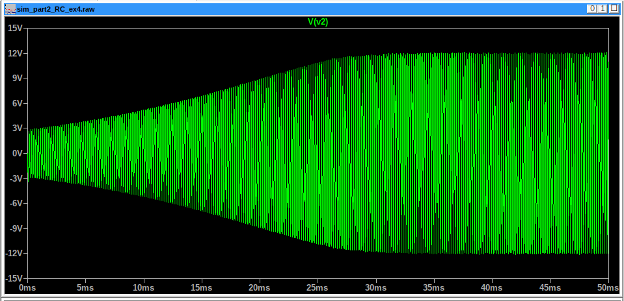

5. Compare theory with simulation and conclude.
The measured frequency corresponds well to the theoretical value of about 6.5kHz.
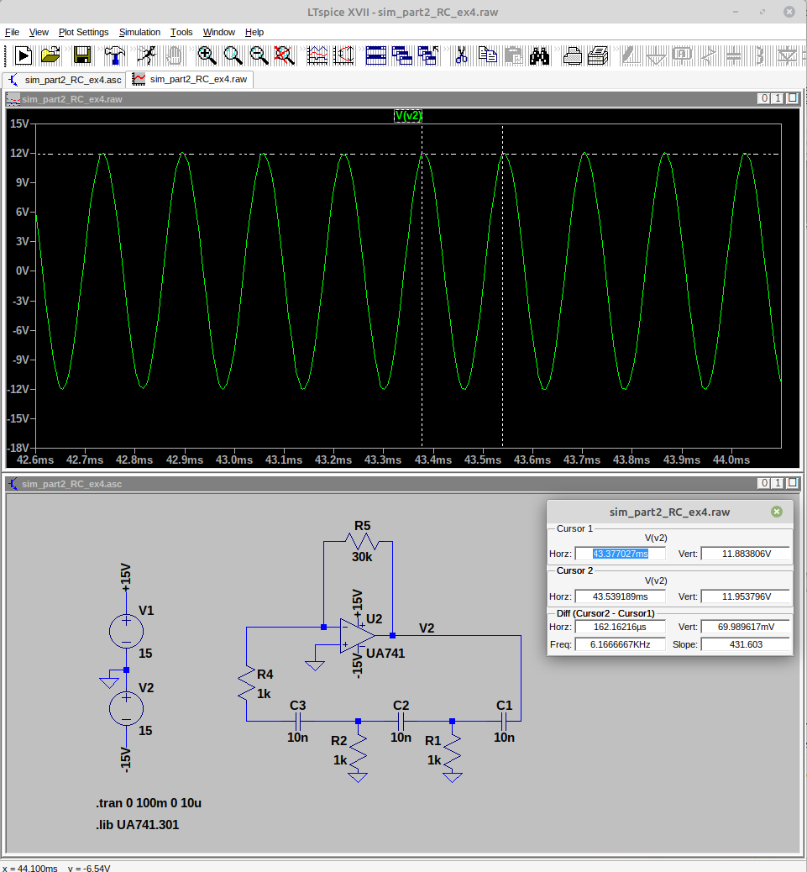

Amplitude control
1. Using LTSpice, simulate the transfer characteristics V_{S} vs. V₁ of the amplifier alone, including diodes (Fig. 2.3). For the purpose, set simulation mode to « DC sweep » corresponding to an input voltage ramp. For the diodes, use the standard model in the LTSpice library.
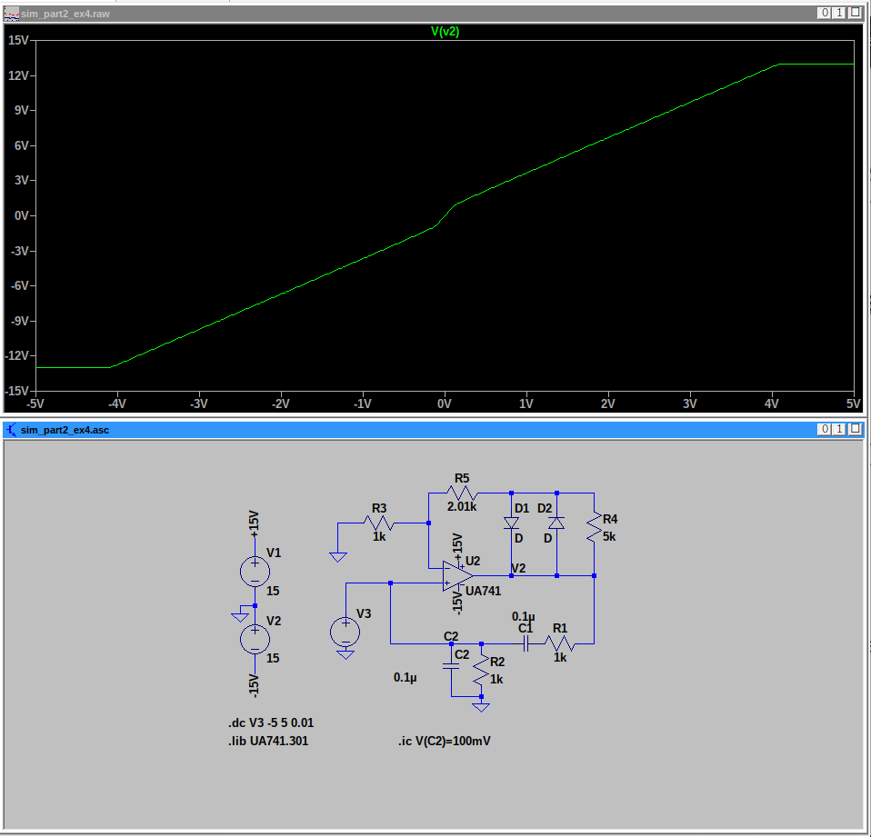

2. For R2 = 1,5 kΩ, show how the amplitude of V_{S} can be predicted from transfer characteristics.
It is the point in which the new non-linear transfer curve intersects the 1/beta transfer curve. As it can be seen in the image below, the result should be about 4V peak voltage amplitude.
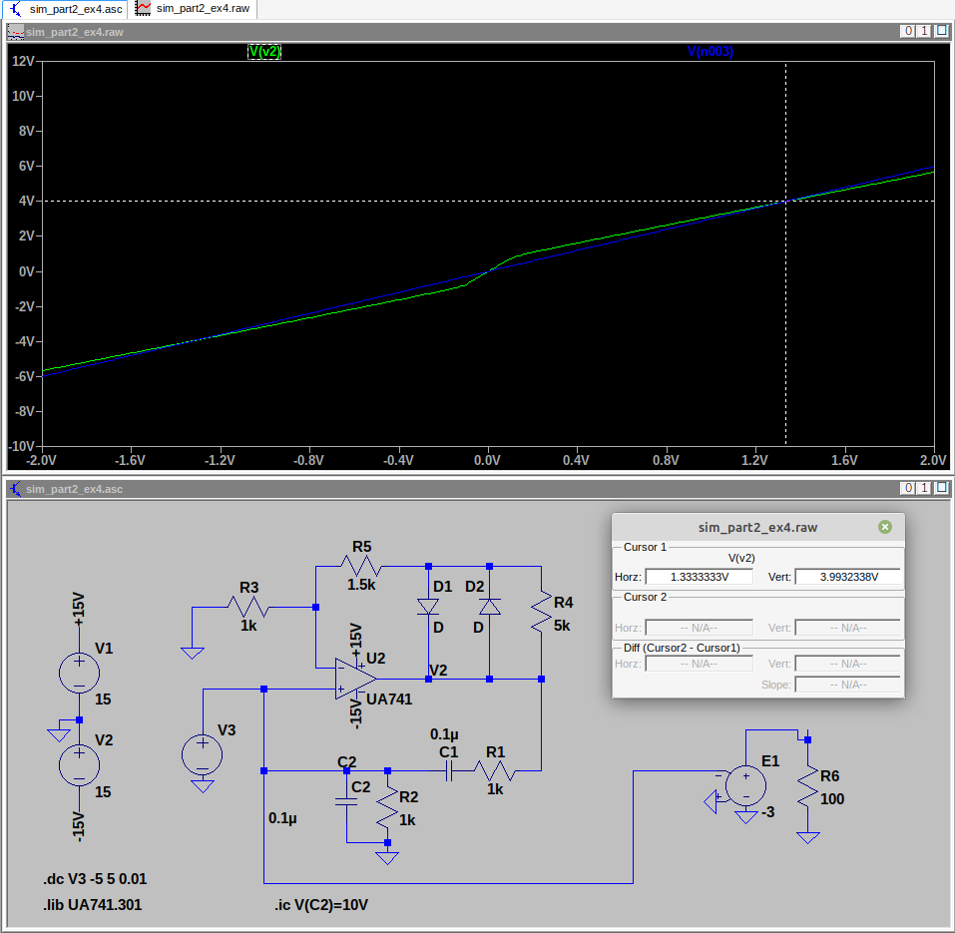

3. For R2 = 1,5 kΩ, simulate the full Wien oscillator (Fig. 2.2), including diodes.
4. Compare amplitude of Vs obtained from simulation and from the previous question.

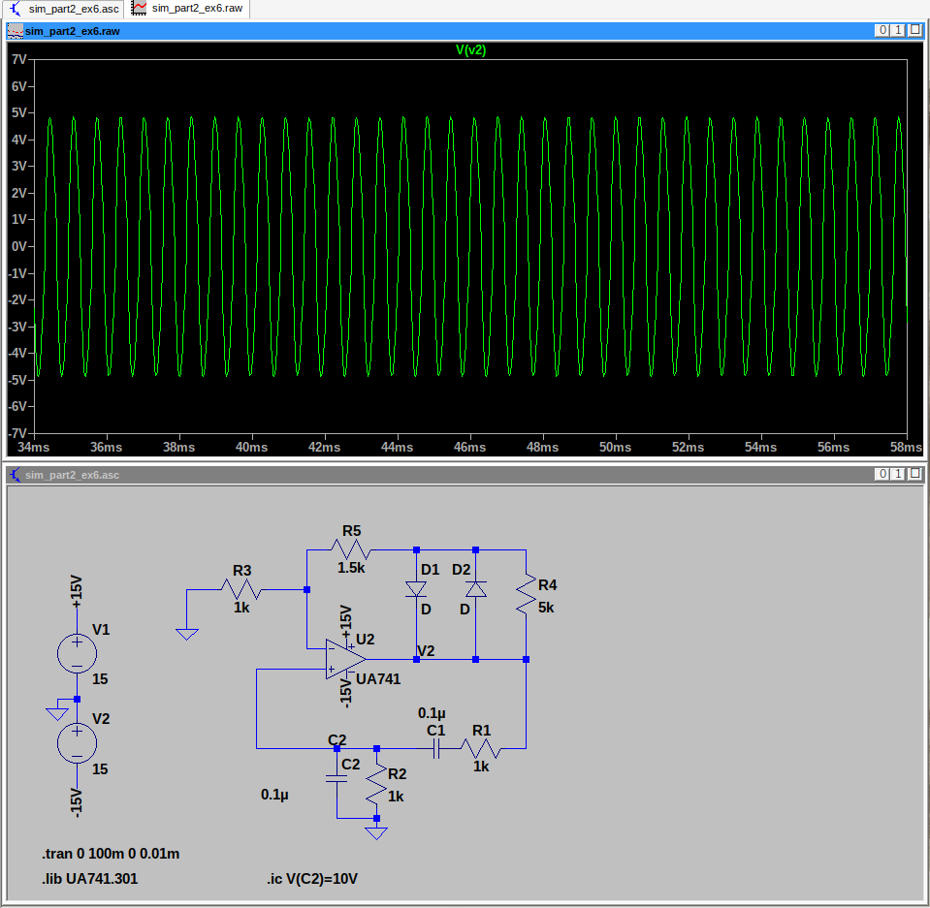
The resulting curve is well at around 4V peak.

5. Compare with theory (question 17), if you have gone that far.

