Task 1:

1. Consider influenza epidemics for 2-person families. The probability is 21% that at least one has disease. The probability that the husband has contracted influenza is 15% while the probability that both the wife and husband have contracted the disease is 10%. What is the probability that the wife has influenza?

*# A=Mother, B = Father*

*# P(AuB)= 21%, P(B)=15%, P(AnB)=10%.*

*# Since we know P(AuB)=P(A)+P(B)-P(AnB), therefore P(A)=P(AuB)-P(B)+P(AnB)*

P_AuB <- 0.21

P_B <- 0.15

P_AnB <- 0.1

P_A <- P_AuB - P_B + P_AnB

P_A

0.16

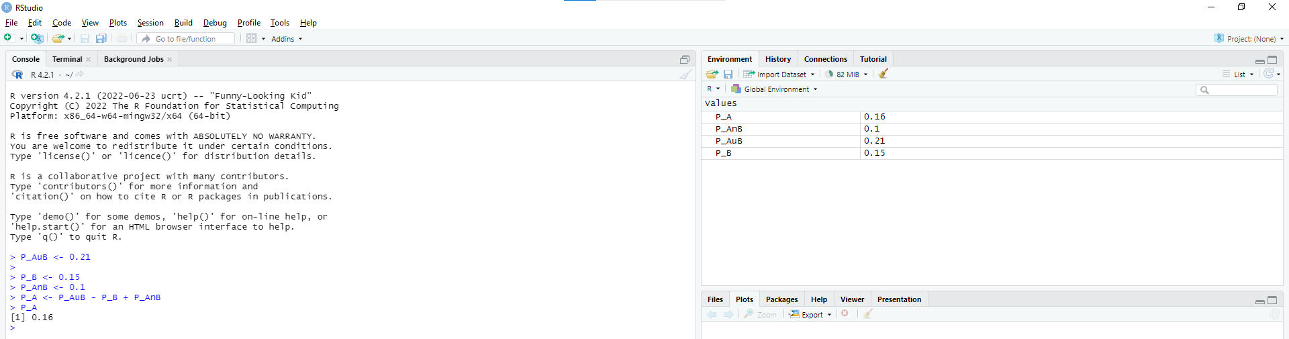

2. Here's an example of database structures:

FRUITS_EXPORT (Schema):

seller_info (table):

- seller_id

- fruit_id

- fruit_weight (tons)

consumption_info (table):

- fruit_id

- seller_id

- client_id

- quantity_purchased_fruit (tons)

Write a PostgreSQL query to find the following:

2.1. How many tons worth of fruit does an average seller have?

select *avg*(s.fruit_weight) from fruits_export.seller_info s

2.2. How many sellers have at least one client who purchased their fruit?

select *count*(distinct(c.seller_id)) from fruits_export.consumption_info c

select *count*(distinct(s.seller_id)) from fruits_export.seller_info s  
left join fruits_export.consumption_info c on s.seller_id = c.seller_id  
where c.seller_id is not null