Web Project for CRUD Operations

This is a sample web project that demonstrates CRUD (Create, Read, Update, Delete) operations and serves as a test of technical skills using C#, HTML, CSS, and a touch of JavaScript. The project is built with Microsoft Visual Studio and uses a code-first approach for the database. When run, the application will automatically create (or update) the necessary database schema on your local machine.

**Prerequisites**

Before running the project, make sure you have the following installed on your computer:

* **Visual Studio 2019 or later**

(with ASP>NET and web development workload installed)

* **SQL Server Express or LocalDB(In my case I use MSSQL)**

1. **Clone or Download the repository**

* 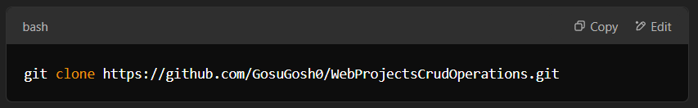Clone via Git:  
  Open CMD(command prompt) and run this command

1. **Open the Solution in Visual Studio**

* Navigate to the project folder
* Locate the solution file: **WebProjectsCrudOperations.sln**
* Double-click the solution file to open it in Visual Studio

1. **Restore NuGet Packages**

* Once the solution is loaded, Visual Studio should automatically restore the required NuGet packages.
* If not, right-click the solution in the **Solution Explorer** and select **Restore NuGet Packages.**

1. **Configure the Database Connection**

Open the **appsettings.json** file in the project’s root directory. Locate the **ConnectionStrings** section and verify that it uses LocalDB. For example:

1. **Initialize the Database (Apply Migrations)**

To apply the migrations for the database execute the following steps:

* Go to **Tools > NuGet Package Manager > Package Manager Console**
* In the **Package Manager Console**, execute this line:



1. **Build and run the project**

If everything is done properly the project should execute smoothly without any errors. To test the CRUD operations (create new students, view all students, edit existing student, delete existing student)

* Home Page

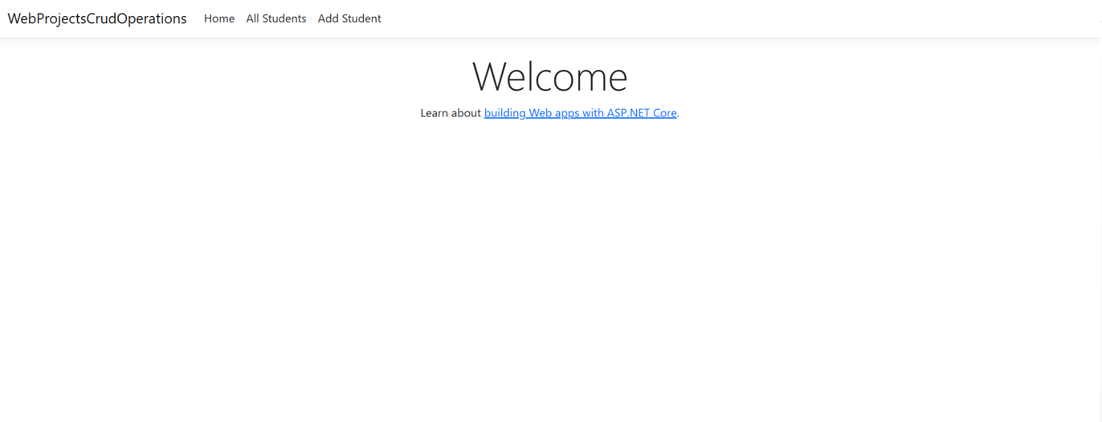

* 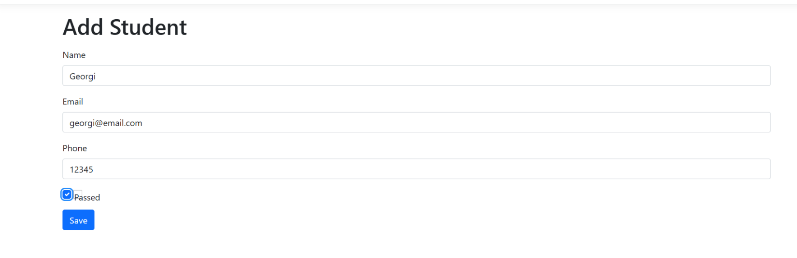Add Student Page
* 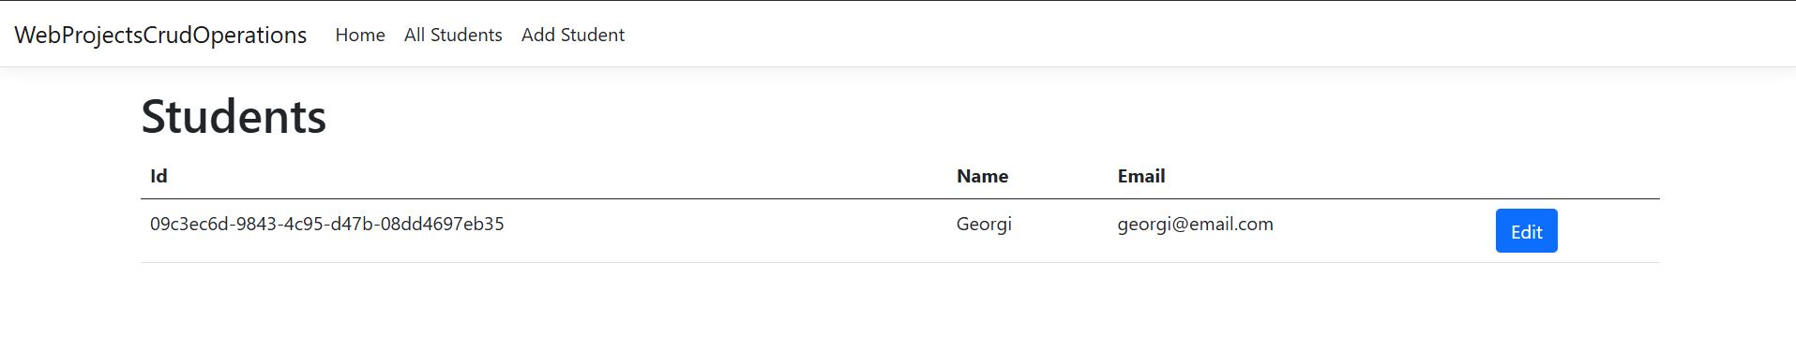All Students Page
* 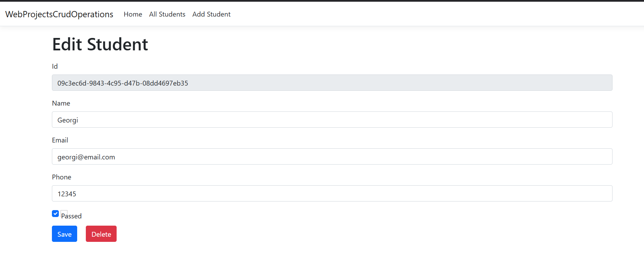Edit Student Page