**CS-504 Project - 1**

Sagar D. Goswami

Data Analytics Engineering, George Mason University

CS 504: Principles of Data Management and Data Mining

Dr. Ping Deng

March 11, 2022

**CS-504 Project - 1**

# EER Diagram

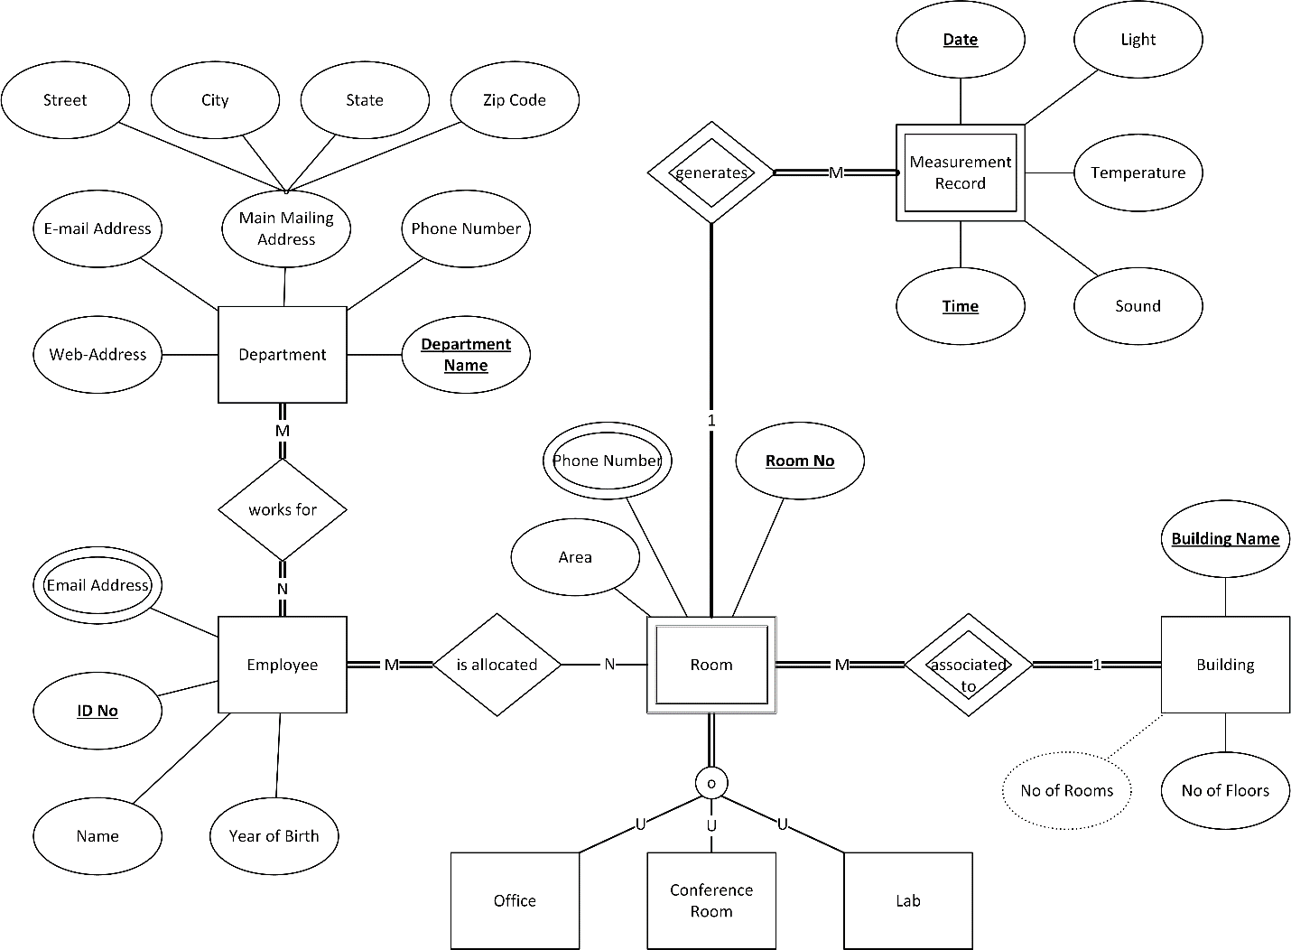

Figure EER Diagram

# Relational Schema

Following are the list of all the relations, their respective attributes and domains as well as primary and foreign keys:

Department Relation, Attributes, Domain, and Primary/Foreign Keys

## Department

Table Department Relation, Attributes, Domain, and Primary/Foreign Keys

|  |  |  |
| --- | --- | --- |
| DeptName | VARCHAR(64) | Primary Key |
| DeptPhone | CHAR(10) |  |
| DeptWebAdd | VARCHAR(128) |  |
| DeptEmail | VARCHAR(64) |  |
| DeptAddStreet | VARCHAR(128) |  |
| DeptAddCity | VARCHAR(128) |  |
| DeptAddState | VARCHAR(64) |  |
| DeptAddZip | VARCHAR(5) |  |

## Employee

Table Employee Relation, Attributes, Domain, and Primary/Foreign Keys

|  |  |  |
| --- | --- | --- |
| EmpID | INT | Primary Key |
| EmpName | VARCHAR(64) |  |
| EmpYOB | YEAR |  |

## EmployeeEmail

Table EmployeeEmail Relation, Attributes, Domain, and Primary/Foreign Keys

|  |  |  |
| --- | --- | --- |
| EmpID | INT | Primary and Foreign Key |
| EmpEmail | VARCHAR(64) | Primary Key |

## WorksFor

Table WorksFor Relation, Attributes, Domain, and Primary/Foreign Keys

|  |  |  |
| --- | --- | --- |
| DeptName | VARCHAR(64) | Primary and Foreign Key |
| EmpID | INT | Primary and Foreign Key |

## Building

Table Building Relation, Attributes, Domain, and Primary/Foreign Keys

|  |  |  |
| --- | --- | --- |
| BldgName | VARCHAR(64) | Primary Key |
| BldgFloors | INT |  |
| BldgRooms | INT |  |

## Room

Table Room Relation, Attributes, Domain, and Primary/Foreign Keys

|  |  |  |
| --- | --- | --- |
| BldgName | VARCHAR(64) | Primary and Foreign Key |
| RoomNo | INT | Primary Key |
| RoomArea | INT |  |
| RoomOfficeFlag | BOOLEAN |  |
| RoomConferenceFlag | BOOLEAN |  |
| RoomLabFlag | BOOLEAN |  |

## RoomPhone

Table RoomPhone Relation, Attributes, Domain, and Primary/Foreign Keys

|  |  |  |
| --- | --- | --- |
| BldgName | VARCHAR(64) | Primary and Foreign Key |
| RoomNo | INT | Primary and Foreign Key |
| RoomPhone | CHAR(10) | Primary Key |

## RoomAllocation

Table RoomAllocation Relation, Attributes, Domain, and Primary/Foreign Keys

|  |  |  |
| --- | --- | --- |
| EmpID | INT | Primary and Foreign Key |
| BldgName | VARCAHR(64) | Primary and Foreign Key |
| RoomNo | INT | Primary and Foreign Key |

## Measurement

Table Measurement Relation, Attributes, Domain, and Primary/Foreign Keys

|  |  |  |
| --- | --- | --- |
| BldgName | VARCAHR(64) | Primary and Foreign Key |
| RoomNo | INT | Primary and Foreign Key |
| MeasTimeStamp | TIMESTAMP | Primary Key |
| MeasLight | INT |  |
| MeasTemperature | INT |  |
| MeasSound | INT |  |

# Relational Mapping Diagram

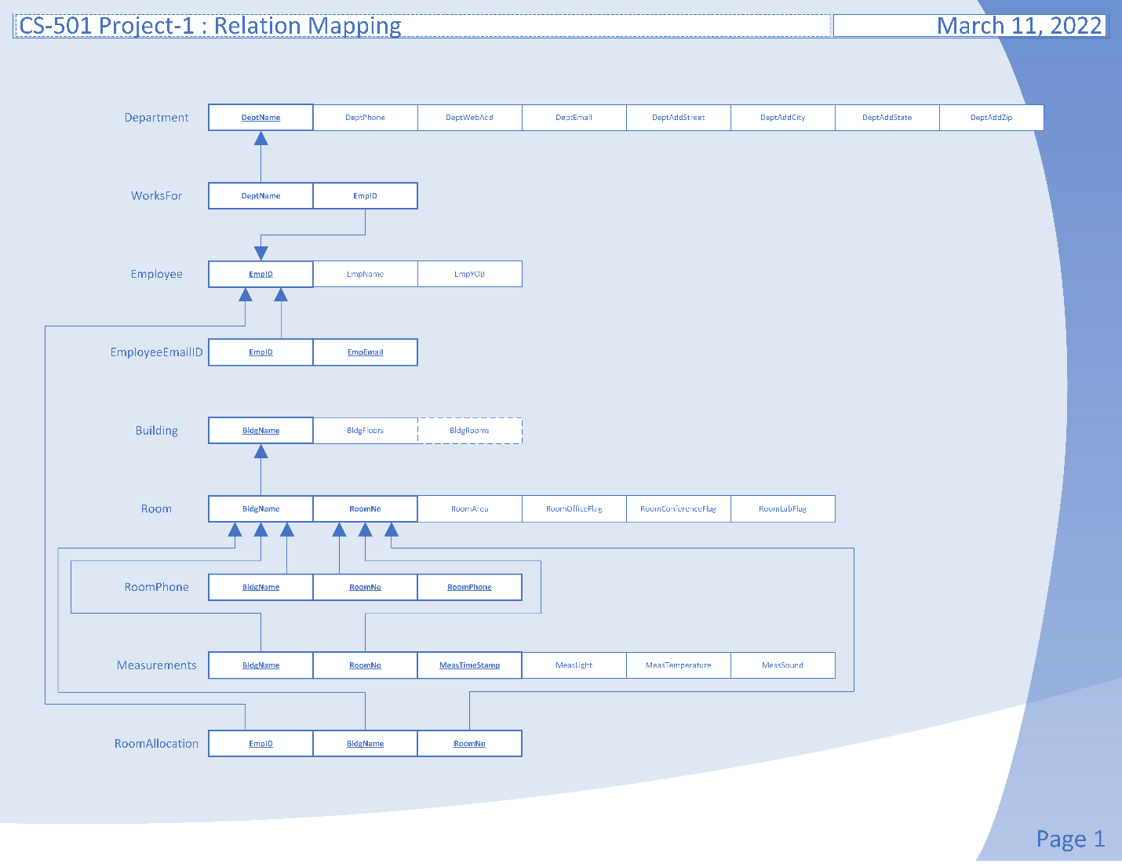

Figure Relational Mapping Diagram

# Queries

## List the phone number and department name and street address for each department.

SELECT DeptPhone, DeptName, DeptAddStreet, DeptAddCity, DeptAddState, DeptAddZip FROM sgoswam.Department;

Table 10 Query Result 1

## Count the number of rooms for each building.

SELECT Bldgname, COUNT(RoomNo) FROM sgoswam.Room GROUP BY BldgName;

Table 11 Query Result 2

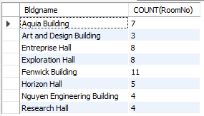

## Find the building name and the room number of each lab that is also used as office.

SELECT BldgName, RoomNo, RoomLabFlag, RoomConferenceFlag FROM sgoswam.Room WHERE RoomLabFlag = 1 AND RoomConferenceFlag =1;

Table 12 Query Result 3

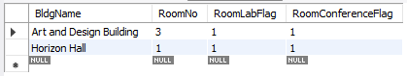

## Find the average temperature for each room.

SELECT BldgName, RoomNo, AVG(MeasTemperature) FROM sgoswam.Measurement GROUP BY BldgName, RoomNo;

Table 13 Query Result 4

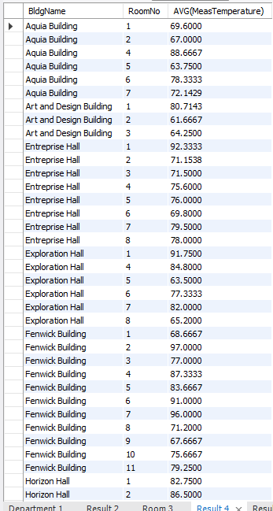

## Find the area of each conference room that hasn’t had any temperature recorded yet.

SELECT R.BldgName, R.RoomNo, R.RoomArea, M.MeasTemperature FROM sgoswam.Room R

LEFT JOIN sgoswam.Measurement M ON R.bldgname = M.bldgname AND R.RoomNo = M.RoomNo

WHERE M.measTemperature IS NULL;

Table 14 Query Result 5

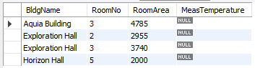

## Find the id of each employee who has exactly two email addresses.

SELECT EmpID, COUNT(EmpEmail) NoOfEmailIDs FROM sgoswam.EmployeeEmail GROUP BY EmpID HAVING NoOfEmailIDs = 2;

Table 15 Query Result 6

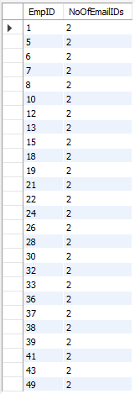

# List of Figures

Figure 1 EER Diagram 2

Figure 2 Relational Mapping Diagram 7

# List of Tables

Table 1 Department Relation, Attributes, Domain, and Primary/Foreign Keys 3

Table 2 Employee Relation, Attributes, Domain, and Primary/Foreign Keys 3

Table 3 EmployeeEmail Relation, Attributes, Domain, and Primary/Foreign Keys 4

Table 4 WorksFor Relation, Attributes, Domain, and Primary/Foreign Keys 4

Table 5 Building Relation, Attributes, Domain, and Primary/Foreign Keys 4

Table 6 Room Relation, Attributes, Domain, and Primary/Foreign Keys 5

Table 7 RoomPhone Relation, Attributes, Domain, and Primary/Foreign Keys 5

Table 8 RoomAllocation Relation, Attributes, Domain, and Primary/Foreign Keys 5

Table 9 Measurement Relation, Attributes, Domain, and Primary/Foreign Keys 6

Table 10 Query Result 1 8

Table 11 Query Result 2 8

Table 12 Query Result 3 8

Table 13 Query Result 4 9

Table 14 Query Result 5 10

Table 15 Query Result 6 10