Date: Nov 25, 2025
From: IT/Cloud Architecture
Subject: Azure Production Environment Architecture & Security Overview: rg-id001

A.
1. Executive Summary
This document provides a high-level overview of our primary production application, "CARTN", hosted in the Microsoft Azure cloud. The environment is designed for security, high availability, and scalability, supporting both internal and customer-facing services. All resources are contained within a single, well-managed resource group (rg-id001) in our cartn-production subscription.
The architecture follows industry best practices, including a hub-and-spoke network model, zero-trust security principles, and comprehensive monitoring. Key highlights include a robust security posture with a firewall, encrypted data storage, and isolated application tiers. The total environment is currently in a healthy state with all critical monitoring and backup systems operational.
2. Environment at a Glance
Category | Detail | Summary
Business Unit | DOS-CA (Department of State - CA)
Application | CARTN (Component: npc) | A multi-tier application supporting web, API, and data services.
Subscription | cartn-production | Dedicated production subscription.
Resource Group | rg-id001 | Centralized management for all related resources.
Overall Status | Healthy & Secured | Environment is deployed, monitored, and compliant with baseline security standards.

3. High-Level Architecture & Data Flow
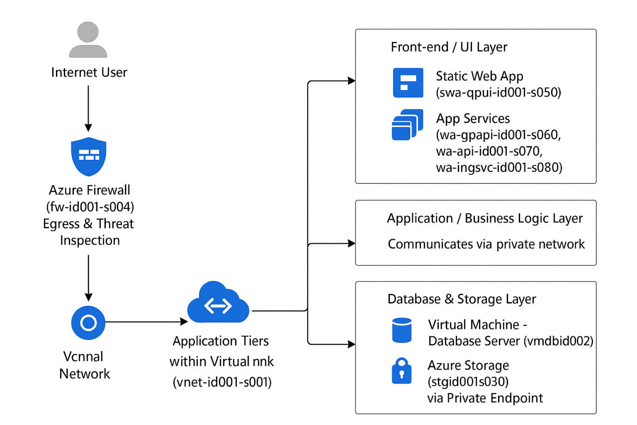Key Architectural Decisions:
- Network Isolation: All resources reside within a single, segmented Virtual Network (vnet-id001-s001) with dedicated subnets for firewalls, services, and databases.
- Security-First: A central Azure Firewall controls all inbound, outbound, and East-West traffic. Public access is minimized.
- Modern Application Hosting: We leverage Azure App Services and a Static Web App for scalable and manageable web hosting, reducing operational overhead.
- Secure Access: Administrative access is provided securely via Azure Bastion Host, eliminating the need for open RDP/SSH ports.

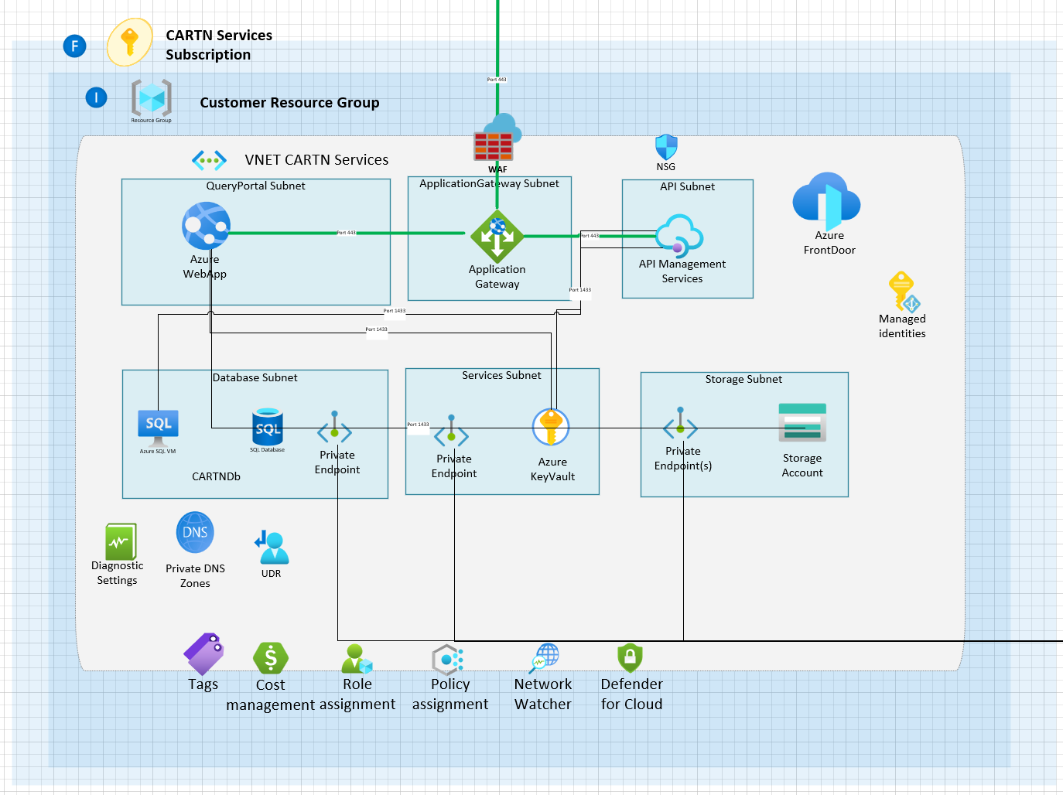

4. Key Components & Business Purpose
Resource Name | Type | Business Purpose & Criticality
vnet-id001-s001 | Virtual Network | Core Networking: The secure backbone connecting all application components. (Critical)
vmdbid002 | Virtual Machine | Database Server: Hosts the primary application database. (Critical)
vnet-fw-id001-s004 | Firewall | Security Perimeter: Central point for network security and traffic inspection. (Critical)
kv-id001-s160-001 | Key Vault | Secrets Management: Securely stores passwords, certificates, and keys. (Critical)
stgid001s030 | Storage Account | Data & Backup Storage: Stores application data, logs, and diagnostics. (High)
wa-*-id001-s0*0 | App Services | Web Application Hosting: Runs the user interface and API components of the application. (High)
law-id001-s110 | Log Analytics | Centralized Monitoring: Aggregates all logs and performance data for security and operational insights. (High)
5. Security & Compliance Posture
We have implemented a strong security baseline, as confirmed by the resource inventory.
Security Area | Status | Details
Network Security | Strong | - Default "Deny All" posture with explicit allow rules.  - Database subnet (snet-db-id001-s011) is highly restricted.  - Azure Firewall deployed for centralized control.
Data Encryption | Enabled | - All storage accounts and VM disks encrypted at rest using Microsoft Managed Keys.  - TLS 1.2 enforced for data in transit.
Secrets Management | Best Practice | - Key Vault with Purge Protection and Soft Delete enabled.  - Accessed via Private Endpoints, not public internet.  - Uses RBAC (Role-Based Access Control) for authorization.
Access Management | Managed | - All App Services and VMs use System-Assigned Managed Identities for secure, credential-free access to other Azure services.
Monitoring & Alerting | Comprehensive | - Full monitoring enabled (Application Insights, Log Analytics, VM Diagnostics).  - Alert rules configured for VM health (CPU, Memory, Disk, Network).
6. Recommendations & Strategic Roadmap
The environment is well-architected. The following are strategic recommendations to further enhance resilience and operational excellence.
- High Priority: Finalize Backup Strategy
  - Action: A Recovery Services Vault (vm-db-rec-vlt-id001-s095) is deployed. We must configure and test a regular backup policy for the critical database VM (vmdbid002).
  - Business Impact: Ensures business continuity and data recovery in case of accidental deletion or corruption.
- Medium Priority: Cost Optimization Review
  - Action: Analyze the usage of the App Service Plans (currently B1 tier) and VM size (Standard_E4s_v3). Right-sizing these resources can lead to significant cost savings.
  - Business Impact: Direct reduction in monthly Azure spend.
- Future Planning: Enhance Disaster Recovery (DR)
  - Action: Develop a formal DR plan. Consider replicating the critical database VM to a secondary Azure region.
  - Business Impact: Minimizes downtime and data loss in a major regional outage scenario.
B.

Azure Production Environment Architecture Overview
Environment: Production (cartn-production)
Resource Group: rg-id001

1. Summary
This document provides a high-level overview of the CARTN application architecture running in Microsoft Azure. The environment is designed for security, reliability, and scalability, hosting business-critical applications and data services for production use.
All infrastructure is centrally managed within the rg-id001 resource group, following modern cloud security practices including network segmentation, private connectivity, and comprehensive monitoring.
2. Environment Overview
- Subscription: cartn-production
- Resource Group: rg-id001
- Region: Primary: East US 2
- Business Unit: DOS-CA
- Application: CARTN
- Status: Production Ready
3. Core Architecture Components
3.1 Networking & Security Foundation
Component | Name | Purpose
Virtual Network | vnet-id001-s001 | Core network infrastructure (10.0.0.0/19)
Firewall | vnet-fw-id001-s004 | Central network security & traffic inspection
Bastion Host | vnet-hst-bastion-id001-s002 | Secure remote access to virtual machines
DDoS Protection | vnet-ddosp-id001-s015 | Protection against volumetric attacks
Network Security Groups | vmdbid002-nsg, snet-sg-qpui-id001-s007 | Subnet and VM-level traffic control
3.2 Compute Resources
Resource | Type | Role | Specifications
vmdbid002 | Virtual Machine | Database Server | Standard_E4s_v3, 4 vCPUs, 32GB RAM
wa-qpapi-id001-s060 | App Service | Application API | Basic B1 Plan
wa-api-id001-s070 | App Service | Main API Service | Basic B1 Plan
wa-ingsvc-id001-s080 | App Service | Ingestion Service | Basic B1 Plan
swa-qpui-id001-s050 | Static Web App | User Interface | Standard Tier
3.3 Data & Storage Services
Service | Name | Purpose
Storage Account | stgid001s030 | General storage, diagnostics, and backups
Key Vault | kv-id001-s160-001 | Secrets, certificates, and key management
Recovery Services | vm-db-rec-vlt-id001-s095 | VM backup and disaster recovery
3.4 Monitoring & Management
Service | Name | Function
Log Analytics | law-id001-s110 | Centralized logging and monitoring
Application Insights | ai-id001-s130 | Application performance monitoring
Action Groups | RecommendedAlertRules-AG-1 | Alert notifications and automation

4. Network Architecture
4.1 Subnet Structure
The virtual network contains multiple isolated subnets for different tiers:
- AzureFirewallSubnet (10.0.1.64/26) - Firewall services
- AzureBastionSubnet (10.0.1.0/26) - Secure access service
- snet-db-id001-s011 (10.0.6.0/24) - Database tier
- snet-qpui-id001-s007 (10.0.2.0/24) - User interface services
- snet-api-id001-s009 (10.0.4.0/24) - API services
- snet-stg-id001-s013 (10.0.8.0/24) - Storage connectivity

4.2 Connectivity Flow
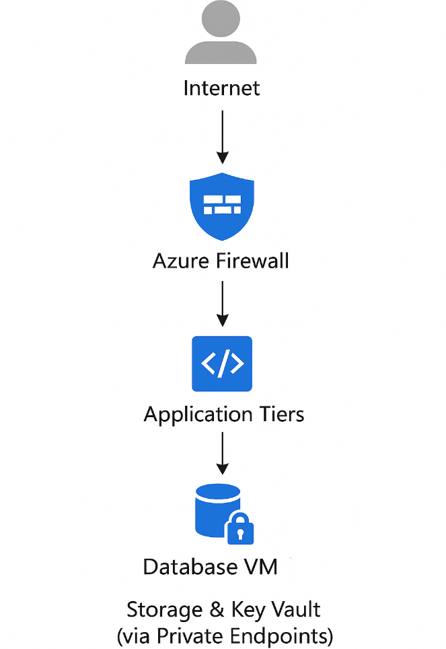
5. Security Posture
5.1 Key Security Features
- Network Security: Default deny posture with explicit allow rules
- Data Encryption: All storage encrypted at rest; TLS 1.2 enforced
- Access Control: Managed Identities for service authentication
- Secrets Management: Key Vault with private endpoints and purge protection
- Monitoring: Comprehensive logging with Security Center integration
5.2 Compliance & Protection
- Soft Delete & Purge Protection enabled on Key Vault
- Private Endpoints for Storage and Key Vault services
- Network Security Groups restricting traffic between tiers
- Azure Defender integrations enabled
6. High Availability & Disaster Recovery
6.1 Current Capabilities
- Geo-redundant Storage (GRS) for storage accounts
- Recovery Services Vault configured for VM backup
- Distributed Application Architecture across multiple subnets
6.2 Backup Strategy
- VM Backups: Configured via Recovery Services Vault
- Application Data: Stored in geo-redundant storage
- Operational Logs: 90-day retention in Log Analytics
7. Cost Management
7.1 Resource Tiering
- App Services: Basic B1 tier (development/testing level)
- Virtual Machine: Standard_E4s_v3 (production-grade)
- Storage: Standard GRS (cost-effective for backups)
8. Recommendations
- Scale App Service Plans to Standard tier for production workloads
- Implement Azure Application Gateway for web application firewall capabilities
- Configure Azure Backup policies for all critical resources
- Establish resource tagging standards for cost allocation
9. Conclusion
The Azure environment for CARTN application represents a well-architected, secure foundation for production workloads. The architecture follows cloud best practices with proper network segmentation, security controls, and monitoring in place.
The environment is currently optimized for development and testing with room for scaling as user demand increases.

Document Approval
Prepared By: _Mohd Shoaib Siddiqui
Date: 25-11-2025
Approved By: _________________________
Date: _________________________

