**American International University-Bangladesh (AIUB)**  
**Department of Computer Science  
Faculty of Science & Technology (FST)  
Spring 22_23**

**Section: C**

**AUTOMATED RAIL TICKET MANAGEMENT SYSTEM**

A Software Development Project Management Project Proposal submitted By

|  |  |
| --- | --- |
| **Student Name** | **Student ID** |
| Anamika Sarkar Tuli | 19-40222-1 |
| Mukit,MD.Abdul | 19-40921-1 |
| Matin,MD.Jubayer Ibne | 19-39632-1 |
| Arnab,Adnarul Islam Talukder | 19-40234-1 |

**1.0 Introduction**

In Bangladesh, the usage of an online train ticketing system has lately become more widespread. It's a contemporary strategy. Rail tickets may be purchased online anytime, from anywhere. The system will be available for booking around-the-clock. The main benefit of booking train tickets online is that it saves customers time. A better sales and marketing synergy is the online rail ticketing system. With the planned project, we have already begun by identifying the audience or target market. The individuals who will use the system to purchase train tickets online and those who will gain anything from it are the target audience here. Consumers can use a credit card to pay for their tickets online. The management of train ticket, booking, agent, and seat information is the system's primary goal. While purchasing tickets, customers may examine information about their rail service, arrival time, ticket price, and other important details about their trip. It oversees the management of all rail, customer, seat, and rail information. People will save time thanks to this system. If our objectives are met, consumers and users will have a reliable option for ordering train tickets online and will receive the support they require.

**2.0 Project Title: Automated Rail Ticket Management System**

**3.0 Objectives:**

1. The goal of this project is to design and develop software that will allow consumers to make reservations for seats online, saving them important time.
2. The creation of a web-based application dubbed the "Online Rail Ticket Buying System" that will enable users to look for and purchase tickets is the project's second objective.
3. The amount of time clients spend scheduling is decreased by this technique.
4. This approach shortens the lengthy client lines.

**4.0 Justification:**

The Web-based Online Rail Ticket Booking System operates inside a centralized network. Passengers will be able to purchase their tickets securely thanks to this project. The ability to reserve seats or train tickets online makes an online rail ticket booking system definitely significant. During numerous events, we observe a lengthy queue while purchasing tickets manually that is overflowing. This system may be applied to resolve this issue. The public will be able to save valuable time. For the purpose of reserving train seats or tickets, people are not required to physically travel to the rail counter. As the project is totally online, the system will be used to keep all data on ticket sales and available seats. Unreliable authorities won't have any opportunity to engage in the illicit market. To ensure that the consumer can take advantage of the service and advantages of an online ticket booking system, the online system also offers a variety of incentives on a monthly or daily basis.

**5.0 Systems Overview: use case diagram**

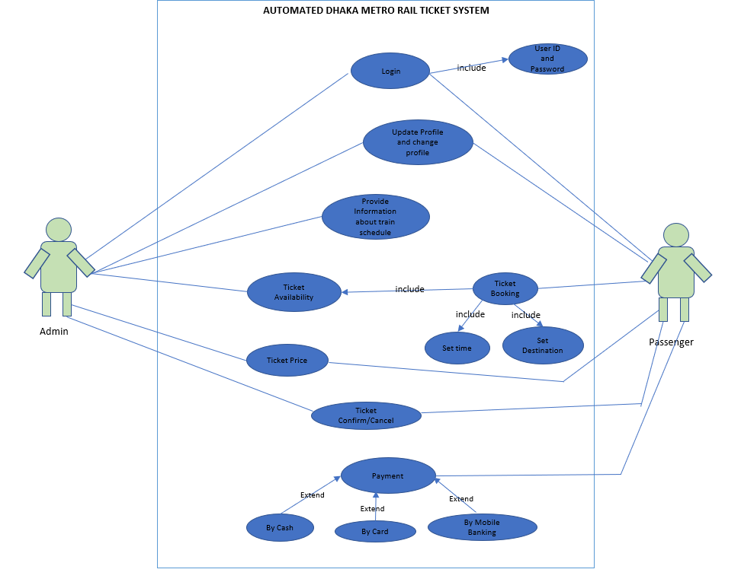

**6.0 Stakeholders analysis:**

Our system has two stakeholders. First one is internal, and another is external stakeholder.

**Internal Stakeholder**

Internal stakeholders include managers, owners, shareholders, and employees. They might be any employee of the business. There will be internal stakeholders in our project,

**Employee**

Internal stakeholders will mostly be employees. Since employees put a lot of time and money into the company, and because they are crucial to the organization's operations, strategy, and tactics**.**

**Developer**

They are equipped with the technical know-how to advise executives on which features are practical and how long each would take to create.

**Manager**

As the success of the business impacts employees' capacity to get paid and maintain their jobs, managers play a crucial role in the organization. Depending on the nature of the organization, employees may pay different attention to health and safety.

**Investors**

Investors include all shareholders and equity holders. Investors fund the business with the hope of earning a specified rate of return. Investors typically have worries about the concept of shareholder value. Although not necessarily shareholders, all stakeholders are inherently shareholders.

**Suppliers and Vendors**

Businesses that depend on them for revenue and recurring income are supplied with goods and/or services by vendors and suppliers. Many organizations put the health and safety of their suppliers at risk since they could be directly involved in corporate operations.

**Communities**

Communities have a significant impact in the success of major businesses that choose to set up shop there. They are affected by a number of variables, including the creation of jobs, economic growth, health, and safety.

**External stakeholder**

External stakeholders are individuals who are not affiliated with a firm directly but are still impacted in some way by its decisions and results.

**Suppliers**

Suppliers give the components or raw materials that a business needs to make its products. When a company relies on a single supplier to provide a superior or uncommon item, the supplier's significance is increased.

**Government**

All firms have the government as an external shareholder. As it collects taxes from these businesses in the form of corporate income tax and income tax from the company's employees, it is really regarded as one of the primary stakeholders**.**

**Passenger**

The most important external stakeholders are the travelers. These people are the target market for the business's goods and services. Thus, they assess a company's success.

**7.0 Feasibility study:**Everyone will benefit from this system. Setting the technical and financial viability for adding new modules and fixing broken systems is the primary goal of the feasibility study. If given endless time and infinite resources, all systems are possible.

There are aspects in the feasibility study:

* Technical Feasibility
* Financial Feasibility

**Financial Feasibility:** Even though a system may be created technically, the company must still consider it a wise investment. While assessing a system's financial feasibility, the development expenses are contrasted with the eventual advantages of the new systems. Rewards must be equal to or greater than costs. The system's components all function properly. It does not require any additional software or hardware.

**Technical Feasibility:** A technical feasibility study is an in-depth examination of tech factors related to the intended project. It touches things on our donation funding project like

* Hardware and software components,
* Technical risks and constraints,
* Compatibility with other IT systems, and
* Capabilities of our team.

**8.0 Systems component:**

The application will have three different sorts of users. They are customer (passengers), manager & stuff, and admin. These users can use the different components of the system application.

**Registration & Login**

Users must create an account with specific details in order to use the Automated Rail ticket booking application. Users can connect to their accounts once the registration procedure is complete. Customers may use their accounts to view the rail timetable for various locations after logging in.

**Manage Account**

Customers can modify and delete their account. The information on the customer's account can be updated as needed.

**Reservation / Booking**

After comparing multiple rail timetables for various destinations, customers may purchase rail tickets. Customers have three payment options for purchasing tickets: mobile banking, card payments, and bank transfers. If a customer has any problems, they may also cancel their ticket. The reservation options are also accessible to the personnel. The personnel can also reserve tickets for customers using this application as a client of the rail firm. Managers are also in charge of the function for buying tickets.

**Reports**

Managers of rail companies would be able to report the timetables of various rail destinations in advance. They can also inform if the rail timetable is canceled due to unforeseen circumstances. If the rail company management has any problems using this system, he may also report them.

**Manage Bookings**

Rail company manager can only use this feature. In some specific cases they can book the tickets for the passengers.

**Check Booking Record**

The rail company manager can see the booking records of the rail. This features only for the managers. By this features they can monitor the profit of for the railings.

**Update Rail Schedule**

This feature can only use by the managers and admin. The managers of the rail company can update the schedule of the rail. The admin can also the update the rail schedule. They can change the rail schedule according to their needs.

**Update Users Credentials**

Only admin can use these features. Admin can update the credentials of the passengers and customers. Admin can update the account information of the customers.

**Delete User Account**

These features can only use by the admin. Admin can remove the user account from the system if he finds the absence of the user or any irrelevant activities.

**9.0 Process Model to be followed:**

We wish to use the Waterfall methodology for our project. A well-known paradigm for developing systems in a linear and sequential fashion throughout their life cycles is the waterfall model. As the model consistently grows downward from one phase to the next, it is known as a waterfall model. With this Waterfall approach, the results of one phase usually serve as the sequential input for the following phase.

We intend to use the waterfall process methodology in our project. Stakeholder analysis is the first stage of our project. We determine the project's stakeholders during this step. The next phase is finishing the project's feasibility study. This section looks at the system's viability from an economic and technological standpoint.

Following a thorough analysis of the feasibility study, we carefully gather the user needs. A successful project must start with accurate requirement gathering from the user.

We will look at the system design once we have examined the user needs. After that, we'll begin designing the system's program for our project. The work on the system's coding will start when the program design has been examined.

The program will be provided for testing when the project's software system has been created. The program will be updated to address any flaws that are discovered during testing. Throughout the operation phase, the necessary procedures will be made to correct the flaws in this program.

The waterfall process paradigm also outlines these steps for successful project completion. Our project phases are being guided by the waterfall process paradigm. We are correctly identifying user needs. The purpose of our project is to adapt the operating system to user needs. We estimate the effort to assess how much time, effort, and money will be required to construct and maintain software before starting the project. This process will help to lessen the risk and uncertainty associated with the project. We can go back to the earlier phase of our project while working on the present phase if we run into problems while developing it. For this project, the phases outlined in the waterfall process model will be gradually implemented. For this reason, we want to apply the waterfall process model in our project.

1. **Efforts estimation:**This is an estimation of each task using the COCOMO model. When the needed team size is small enough, the problem is well understood and has already been addressed, and team members have just a limited amount of prior knowledge about the topic at hand, software projects are said to be organic.
   * 1. Since this is an organic system, the value of coefficient (c) is 2.4, project complexity (p) is 1.05, size (SLOC) is 9000, T is 0.38  
          
        Persons-months, PM = Coefficient * (SLOC/1000) ^P

= 2.4 * (9000/1000) ^1.05

= 24.10

* + 1. Development Time = DM = 2.50 * (PM) T

= 2.50 * (24.10) 0.38

= 8.37 Months ~ 9 month

~ 36 Weeks

* + 1. Required number of people = ST = PM / DM

= 24.10 / 8.37

= 2.87 ~ 3 Person

**Work Break Down Structure**

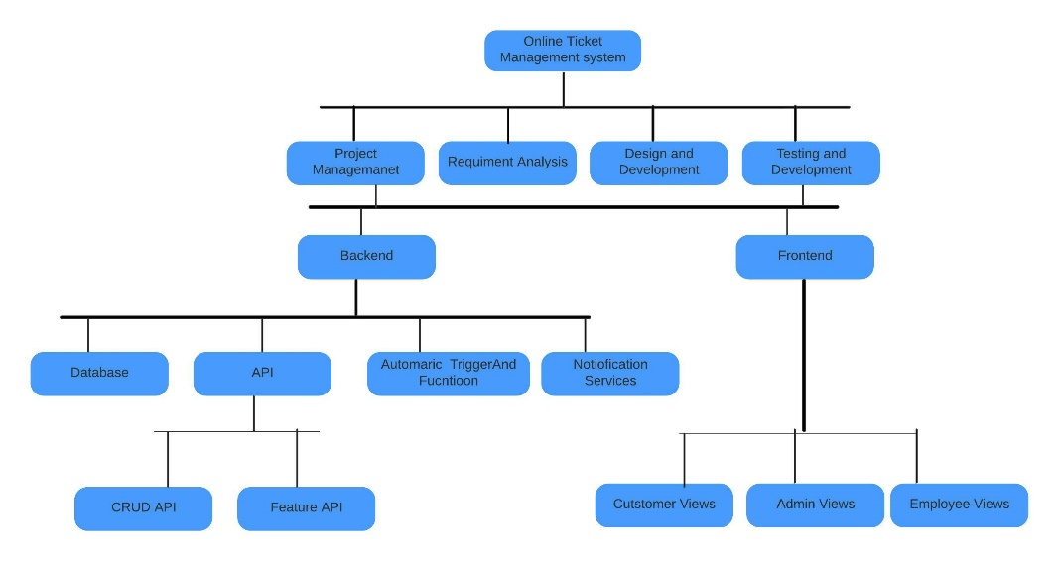

**11. 0 Activity Network Diagram:  
  
11.0.1 Precedence Network:**

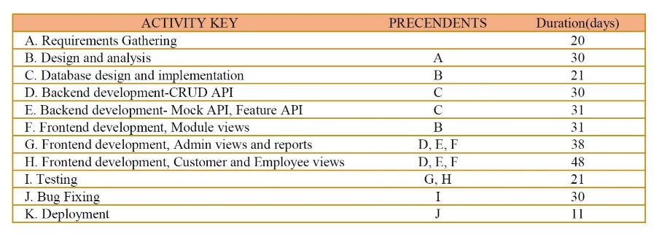

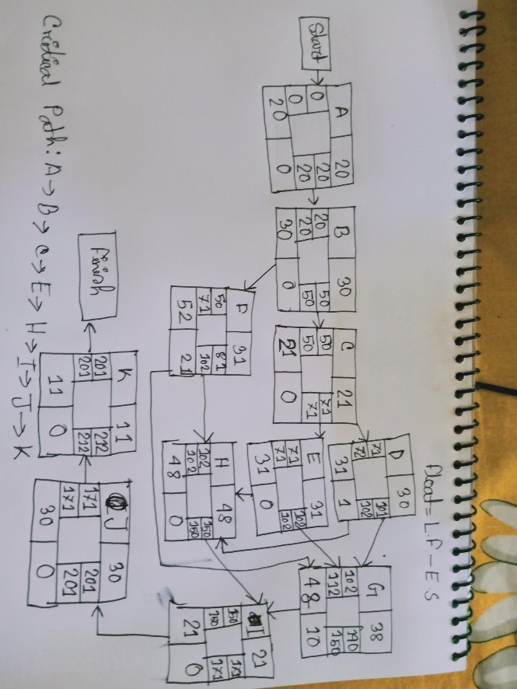

**11.0.2 Activity Diagram (Schedule activity):**

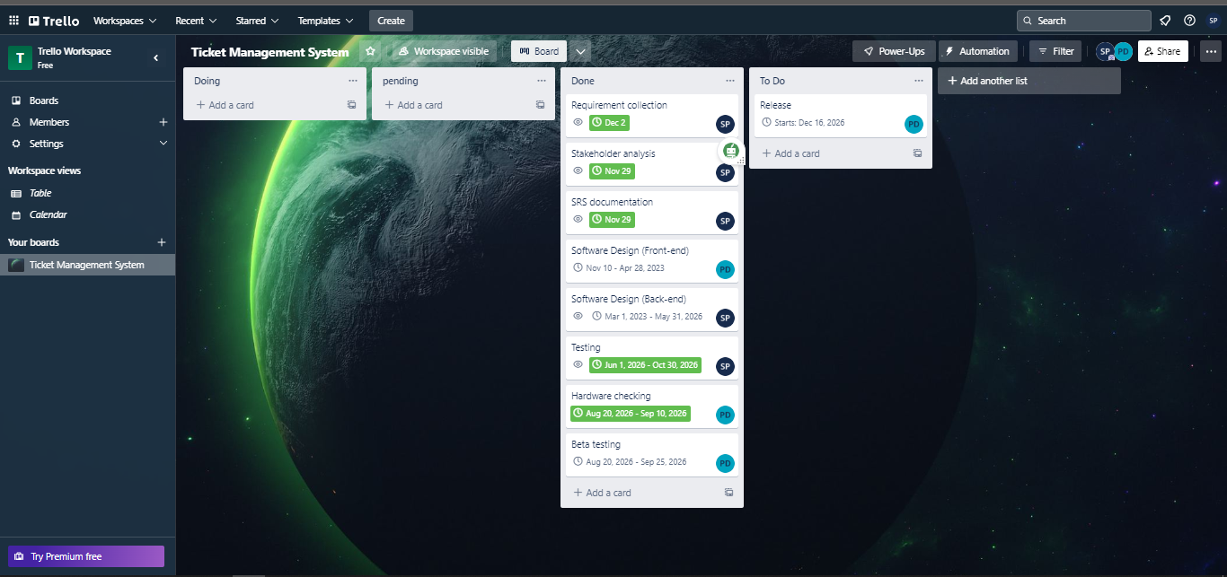

**11.0.3 Activity Diagram (Software work activity):**

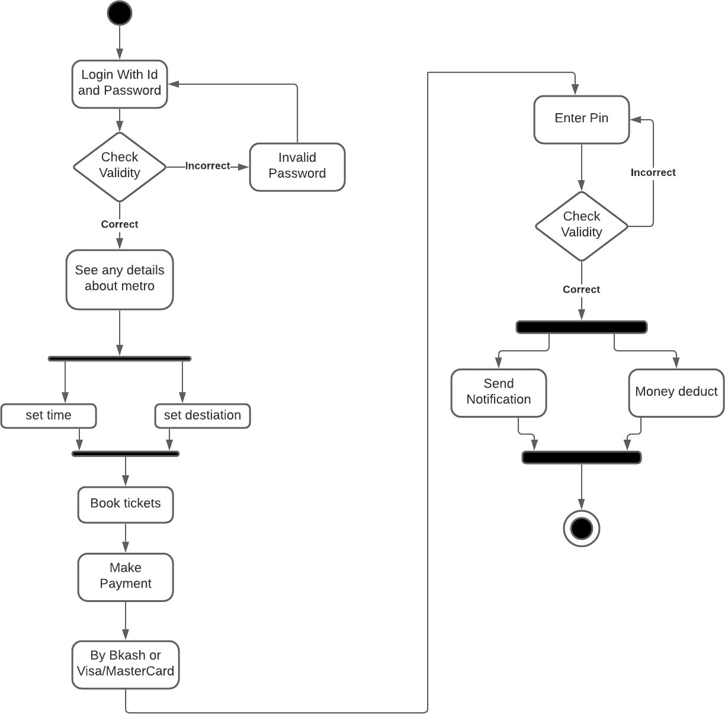

**12.0 Risk Analysis:**

The risk for this system is very low. Without some resource problem there is no risk or problem present.

|  |  |  |  |  |
| --- | --- | --- | --- | --- |
| S/N | Risk Description | Probability | Impact | Mitigation Plan |
| 1 | Unrealistic time estimate | 40% | High | Take multiple estimations. |
| 2 | Loss of work due to equipment failure/loss | 30% | High | Weekly data backup to Hard drive. |
| 3 | Unavailability of API’s | 20% | Medium | Alternative API’s will be checked for. |
| 4 | Developers needs to hardware or software requirements | 5% | Medium | Select the best available hardware or software components. |
| 5 | Exceeding budget | 15% | Medium | Some extra budget needs to be added. |
| 6 | Testing and debugging error | 10% | Medium | Adopting qualitative testers. |
| 7 | Failure of server | 10% | Low | Backup system database regularly. |
| 8 | Staff/Personnel shortfall | 5% | Low | Take some extra members in the team. |

**13.0 Budget for the project:**

**Budget Estimation**

From the effort estimation we find that development time for the project is 9 months and required number of people needed for the project are 3 developers.

Duration in weeks = 9*4 = 36 weeks Office days

Per week working days = 5 days

Working hours = 7 Hours

So, per week working hours is = (5*7) hours = 35 hours

So Total Working hours is = 35*36= 1260 hours.

Developer salary is = 800 Taka/ Hour

Total developers Salary = (800* 1260) = 1008000 Taka

|  |  |  |
| --- | --- | --- |
| **Expanse** | **Amount** | **Total Amount** |
| Salary for 3 developers |  | 10,08,000 |
| For Requirement analysis  Cost for 1 months | 22*8*400 | 70,400 |
| Transport |  | 10,000 |
| 9 months office rent | 9*25000 | 2,25,000 |
| Hardware Expanse |  | 80,000 |
| 4 months maintenance cost | 16*9*1200 | 1,72,800 |
| Training Cost |  | 10,000 |
| Now Total Estimation Cost is |  | 15,76,200 |

**Profit**

15% of total estimation cost = 15,76,200 *15% = 2,36,430

Total budget of the project = 15,76,200 + 2,36,430

= 18,12,630

**The total budget for the project is 18, 12,630 Taka.**

**14.0 Conclusion:**

Eventually, we will get user feedback after completing a whole project module. A software program for an online railway ticket administration system should provide online ticketing and management. Customer iteration will be a part of this project, thus project management must accurately measure, objectively divide, and allocate duties. The most challenging part of this project is remaining on track and completing the assignment on time given the project's lengthy timeline of 9–11 months. These days, people desire for an online system. because it is the easiest and most practical way to get knowledge. In Bangladesh, there are several websites that offer online ticket sales. A web-based application that offers customer-requested services is what we envisage for our system. Owners will also profit from it in addition to customers.