Software Requirements Specification

for

ClickEat

Version 1.0 approved

Prepared by Namira Khorshed Khan, Tabammum Haque Pranty, Adnarul Islam Talukder Arnab, Israt Jahan Mitu, Sabbir Ahamed Sezan

Pi Technology

25-10-2022

Table of Contents

Table of Contents ii

Revision History ii

1. Introduction 1

1.1 Purpose 1

1.2 Document Conventions 1

1.3 Intended Audience and Reading Suggestions 1

1.4 Product Scope 1

1.5 References 1

2. Overall Description 2

2.1 Product Perspective 2

2.2 Product Functions 2

2.3 User Classes and Characteristics 2

2.4 Operating Environment 2

2.5 Design and Implementation Constraints 2

2.6 User Documentation 2

2.7 Assumptions and Dependencies 3

3. External Interface Requirements 3

3.1 User Interfaces 3

3.2 Hardware Interfaces 3

3.3 Software Interfaces 3

3.4 Communications Interfaces 3

4. System Features 4

4.1 System Feature 1 4

4.2 System Feature 2 (and so on) 4

5. Other Nonfunctional Requirements 4

5.1 Performance Requirements 4

5.2 Safety Requirements 5

5.3 Security Requirements 5

5.4 Software Quality Attributes 5

5.5 Business Rules 5

6. Other Requirements 5

Appendix A: Glossary 5

Appendix B: Analysis Models 5

Appendix C: To Be Determined List 6

Revision History

|  |  |  |  |
| --- | --- | --- | --- |
| **Name** | **Date** | **Reason For Changes** | **Version** |
| First draft | 25/8/22 | Initial version draft sent out for comments | Version 1.0 |
|  |  |  |  |

# Introduction

## Purpose

The application that has been described in this document is currently called ClickEat. The name might be subject to changes in the future. The first release of the ClickEat application is estimated to have the version number 1.0. The document describes the functionalities of ClickEat and the version of this document is 1.0.

## Document Conventions

This template is fetched at <https://web.cs.dal.ca/~hawkey/3130/srs_template-ieee.doc>. **Bolding** is used to highlight defined phrases. Priority numbers will be assigned to requirements to show how they will be implemented. Versions might be made available with only a portion of the requirements' full list implemented.

## Intended Audience and Reading Suggestions

To explain the purpose and appearance of the software, this paper is prepared for system users, testers, and software developers. Additionally, those designing surveys or using the results could have functional wishes. With a less evident user interface, administrators of ClickEat will be able to undertake unique and specialized tasks.

The people who contributed to this document are listed below. This email group will receive the draft for comments and input.

|  |  |
| --- | --- |
| Tahmid Ahmed | tahmidahmed@gmail.com |
| Sharannaya Sithi | sharannaya@gmail.com |
| Hasibul Rahman | hasibul.rahman@gmail.com |
| Adith Ravi | adith2022@gmail.com |
| Redwan Chowdhury | redchowdhury@gmail.com |
| Tonima Hossain Pia | piatonima@gmail.com |

## Product Scope

The application is targeted to reduce the hassles of the general people. It not only helps in saving time and money of the customers in an efficient way but also assists in increasing the business of the restaurants. The customers can easily choose their desirable restaurants in their preferred location that is in their budget within a few minutes. The restaurants with better reviews and ratings also get to attract more customers through this application.

From this desktop-based application, mobile-based applications can be developed like both android and iOS application can be created. A website can also be developed for this application. By developing these, people can easily reach for new restaurant experiences which will be helpful for them and can search for food restaurants anytime.

## References

<https://web.cs.dal.ca/~hawkey/3130/srs_template-ieee.doc>

<https://github.com/NamiraKhorshedKhan>

<https://onedrive.live.com/about/en-us/signin/>

# Overall Description

## Product Perspective

This project is a very new concept-based project. Not many projects have been done yet. Harriken was the only similar application that was started in 2015. The idea of Harriken came from a basic problem that is experienced every day: restaurant discovery (what and where to eat). But it could not be developed perfectly. It provided solutions to existing problems and had both android and iOS apps. However, it lacked proper marketing tactics. Very few people knew about it and liked the concept. Much money was not spent on marketing for this project. So, this project is very new and its idea is amazing. The ClickEat will replace the Harriken app with a single, modern application where the customers can view nearby restaurants, see the details, view and leave a review or rating and also book a table online.

## Product Functions

The ClickEat application meets the following objectives:  
1. To locate nearby restaurants  
2. To allow users to view the menu, address and contact number of the restaurants

3. To allow users to view and leave a review and rating  
4. To provide an option for users to book a table

5. To allow users to make online payment

## User Classes and Characteristics

The following diagram shows system actors and the various circumstances that they might run into when utilizing the system. Each oval encircled by a separate rectangle represents a use case, which is further explained in the sections that follow.

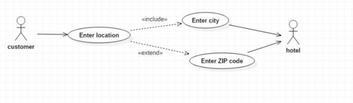

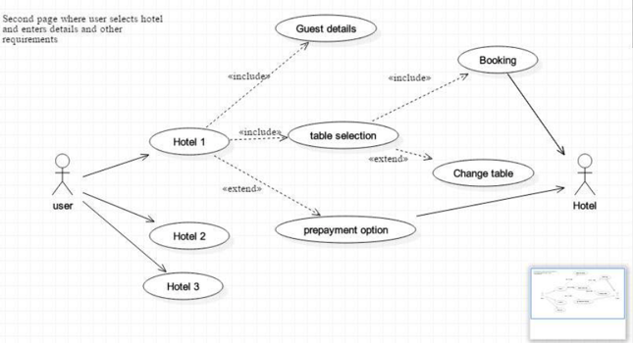

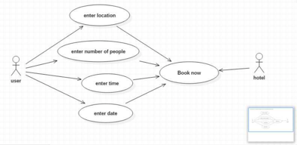

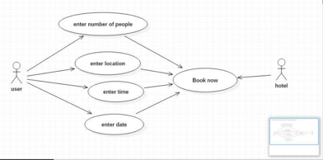

## Operating Environment

Table Reservation System is a desktop-based application. It makes the reservation process very simple and user friendly. As it’s a desktop-based application, it is easily accessible to everyone.

## Design and Implementation Constraints

The system can be accessed on all latest browsers irrespective of operating system. The interface

of the system requires mouse and keyboard to enter the details.

The system will be limited to only few restaurants in few cities. The system generates a token and is

valid for few hours within which the user has to visit the restaurant.

## User Documentation

The software has an online help feature available to assist users of various skill levels in using ClickEat. In order to give each user a visual instruction, it also includes demo films for logging in, registering, and making reservations. Users who have registered have the option to publish questions and comments in the event of a problem.

## Assumptions and Dependencies

This SRS makes the assumption that the reader is at least somewhat familiar with using a browser and is able to utilize the browser and the device it is installed on. The needs of the browser or its usability will not be covered in this text. This article will only discuss how to use the application

# External Interface Requirements

## User Interfaces

The user interface shall consist of text-fields, drop-down menus, checkboxes, pictures and buttons.

All menus shall consist of buttons that allow the user to navigate through the system. The system

shall also contain a calendar menu and time slot menu.

## Hardware Interfaces

The users of the system shall have any device which runs a browser and meets the minimum

specification requirements. The device shall have the ability to type in and navigate through the

webpages.

The device shall have the following minimum specifications:

o1 GHz CPU

o512 MB RAM

o1 GB Internal Storage

## Software Interfaces

The users of the system shall have latest browsers.

## Communications Interfaces

For interaction between the administrator and logged-in users and their reservation requests, the product needs network service communications. Data is transferred by a number of software components as bit or intensity matrices. FTP is the accepted communication standard. Additionally included are customary security measures.