Gothee House Clock Lightshows

- Madeline Usher, January 18, 2015

Lightshows for the Gothee House Clock operate over three *lightshow devices* – the left, right, and top NeoPixel strips. A lightshow consists of a set of *lightshow operations* for each lightshow device. Lightshow operations are compositional, so you can combine multiple operations together to make complex patterns.

# Lightshow Operations

## Patterns Applied Across Space

### Constant Color (LI_CONSTANT_COLOR)



Displays a constant color across the entire lightshow device for the specified duration.

* color
* duration (milliseconds)

### Rainbow (LI_RAINBOW)



Maps one or more rainbows across the length of the lightshow device for the specified duration.

* brightness
* # repetitions
* duration (milliseconds)

### Sine Wave (LI_SINE)



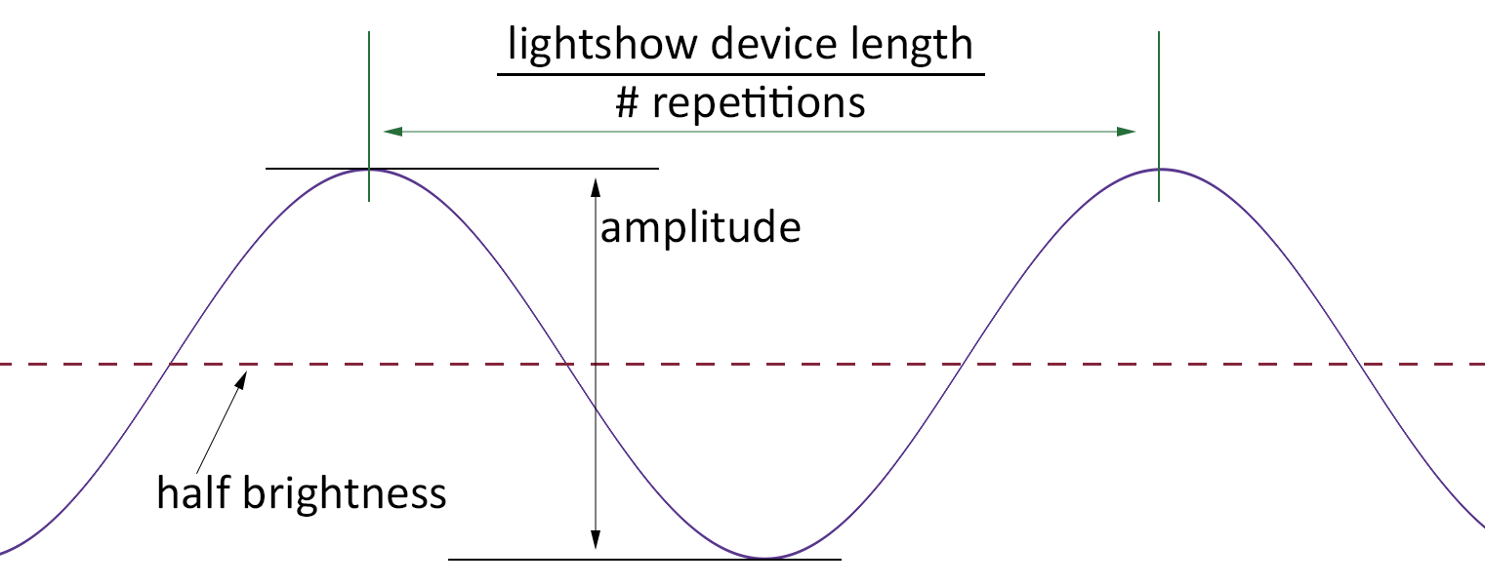

Uses a sine wave to modulate the brightness of the specified color across the length of the lightshow device. The amount the sine wave changes the brightness is centered around the middle brightness of the specified color. In other words, where the sine’s value is zero, a brightness that is half that of the color is used. Where the sine is -1, the brightness is half the color’s brightness minus half the amplitude. If the amplitude is 255 (the maximum), then the resulting brightness would be zero. The reverse is true where the sine’s value is +1 – then the resulting brightness if half the color’s brightness plus half the amplitude; so an amplitude of 255 would result in full brightness of the specified color.

* color
* # repetitions
* amplitude (0 → 255)
* phase (0 → 100) percentage of a cycle by which the wave should be shifted
* duration (milliseconds)

### Square Wave (LI_SQUARE)



Uses a square wave to modulate the brightness of the specified color across the length of the lightshow device.

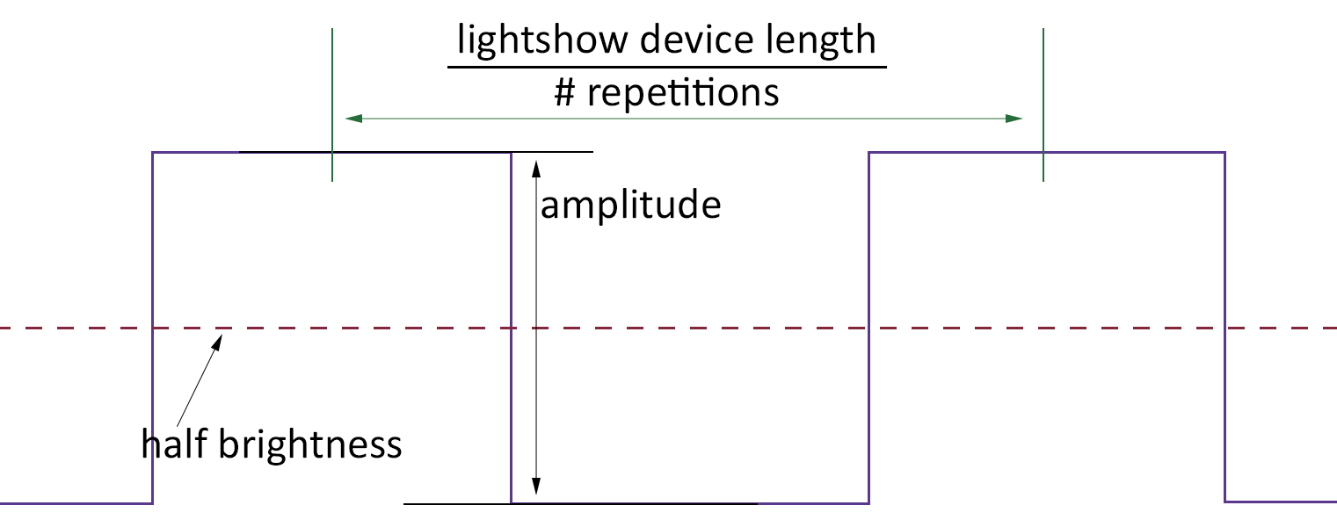

* color
* # repetitions
* amplitude (0 → 255)
* phase (0 → 100) percentage of a cycle by which the wave should be shifted
* duration (milliseconds)

### Triangle Wave (LI_TRIANGLE)



Uses a triangle wave to modulate the brightness of the specified color across the length of the lightshow device.

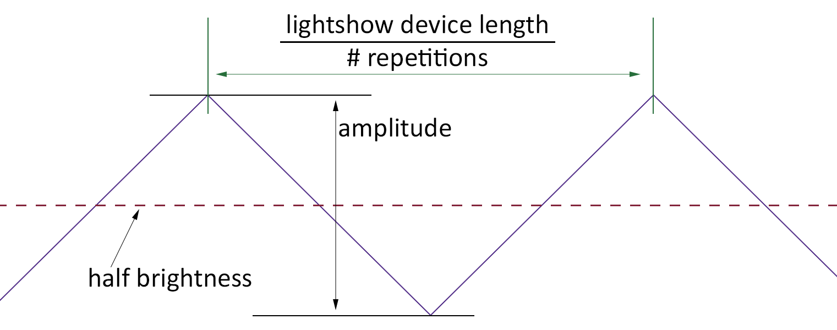

* color
* # repetitions
* amplitude (0 → 255)
* phase (0 → 100) percentage of a cycle by which the wave should be shifted
* duration (milliseconds)

### Sawtooth Wave (LI_SAWTOOTH)



Uses a sawtooth wave to modulate the brightness of the specified color across the length of the lightshow device.

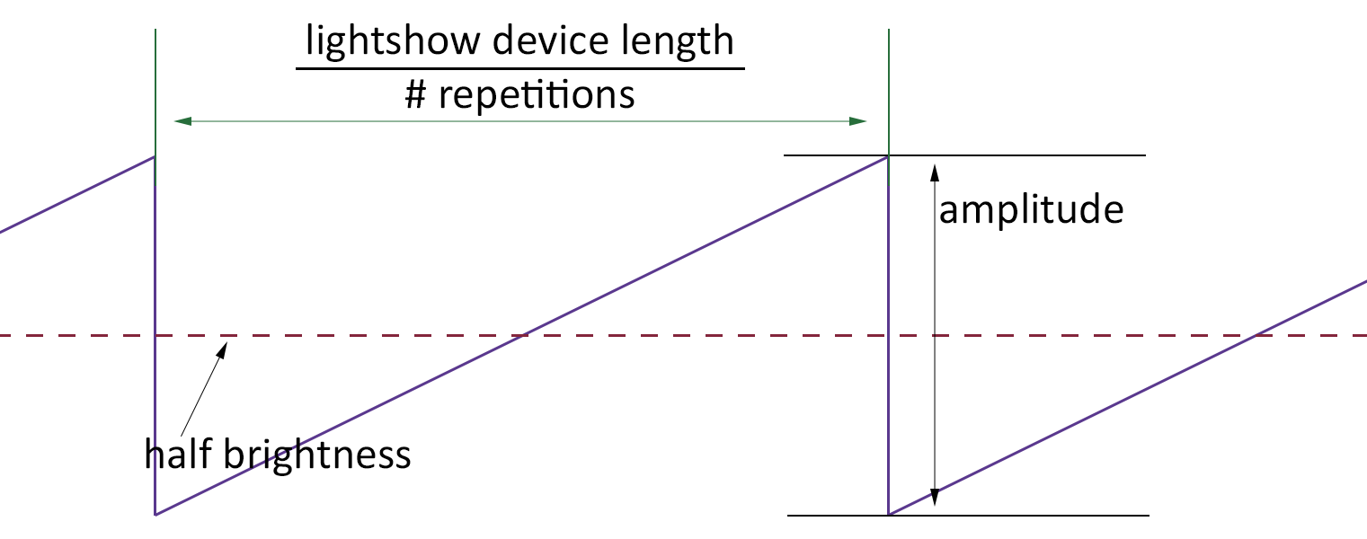

* color
* # repetitions
* amplitude (0 → 255)
* phase (0 → 100) percentage of a cycle by which the wave should be shifted
* duration (milliseconds)

### Gradient (LI_GRADIENT)



Performs a gradient blend of two colors across the length of the lightshow device.

* color 1
* color 2
* # repetitions
* c0 (0 → 100, percentage of the length of the gradient)
* c1 (0 → 100, percentage of the length of the gradient)
* c2 (0 → 100, percentage of the length of the gradient)
* duration (milliseconds)

Note that c0, c1, and c2 are control points and are specified as a percentage of the length of the gradient:

* c0 is where color 1 starts to fade and color 2 starts to contribute.
* c1 is where the two colors have equal contributions.
* c2 is where color 1 is completely off and all is color 2.

### Notch (LI_NOTCH)



This makes a pattern that is color 1 from the start of the lightshow device, then color 2 for a bit, and then back to color 1. It's often used as a notch filter to be combined with other lightshow ops, so that you can have the presence or absence of a color at one particular spot of the lightshow device.

* color 1
* color 2
* color 2 start (0 → 100, percentage of the length of the lightshow device)
* color 2 end (0 → 100, percentage of the length of the lightshow device)
* duration (milliseconds)

## Patterns Applied Across Time

### Sine Flash (LI_SINE_FLASH)

### Square Flash (LI_SQUARE_FLASH)

### Triangle Flash (LI_TRIANGLE_FLASH)

### Sawtooth Flash (LI_SAWTOOTH_FLASH)

## Patterns That Vary over Space and Time

### Cylon Eye (LI_CYLON_EYE)

### Theater Chase (LI_THEATER_CHASE)

## Second Order Operators

### Flip (LI_FLIP)

### Negative (LI_NEGATIVE)

### Shift (LI_SHIFT)

### Fade (LI_FADE)

### Multiply (LI_MULTIPLY)

### Screen (LI_SCREEN)

### Overlay (LI_OVERLAY)

### Hard Light (LI_HARDLIGHT)

### Soft Light (LI_SOFTLIGHT)

### Replace If Not Zero (LI_REPLACE)

### Color Dodge (LI_COLOR_DODGE)

### Color Burn (LI_COLOR_BURN)

### A - B (LI_A_MINUS_B)

### B - A (LI_B_MINUS_A)