Transfer Learning Strategies for Image Classification
Under Data Scarcity Conditions
Independent Study — 50:198:494:07
Rutgers University Camden
Spring 2026
Aryan Bhat
Advisor: Professor Sanchirico

Abstract
This study looks at which transfer learning strategy actually works best when you have very little labeled data and need to adapt a pretrained deep neural network for image classification. I used ResNet18 as the backbone for every experiment and compared three strategies: feature extraction (freeze all pretrained layers, only train the classifier), full fine-tuning (retrain everything with a smaller learning rate), and gradual unfreezing (progressively unfreeze layers starting from the top). I tested all three against a baseline CNN trained from scratch, across data fractions ranging from 1% to 50% of the training set, on both the EMNIST Letters and CIFAR-10 datasets. I also ran a separate experiment comparing ImageNet-pretrained weights against MNIST-pretrained weights for transfer to EMNIST, to see whether domain similarity in the pretraining source matters when data is extremely scarce. An additional analysis of training overhead shows that for simple datasets like MNIST, a lightweight baseline CNN can outperform transfer learning approaches in both accuracy and efficiency. The main takeaways: gradual unfreezing gives the most consistent results across all data sizes, full fine-tuning does great when there is enough data but risks catastrophic forgetting with tiny datasets, domain-similar pretraining can hold its own against large-scale pretraining at the lowest data fractions, and transfer learning is not always the right call when the task is simple enough for a smaller model to handle.

Introduction and Problems Addressed
Deep learning does really well at image classification, but that success usually depends on having a lot of labeled data. In practice, many domains just do not have that luxury. Medical imaging needs expert radiologists to label every scan. Satellite imagery classification needs geospatial specialists. Manufacturing defect detection depends on collecting enough examples of rare failures. In all these cases, you might only have tens or hundreds of labeled images instead of the thousands you would normally need to train a deep network from scratch.
Transfer learning tackles this by taking a model that was already trained on a large dataset and adapting what it learned to a new task with limited data. Instead of learning visual features from nothing, a pretrained model already understands edges, textures, shapes, and patterns from its original training. The real question is not whether transfer learning helps—it clearly does—but how to apply it. There are multiple strategies for adapting a pretrained model, and each one has different tradeoffs around adaptability, overfitting risk, and computational cost. This study systematically compares three of those strategies across controlled data scarcity levels to figure out which one holds up best as available training data goes down.
The rest of this report is structured as follows. The motivation section explains why this problem matters. The related work section covers prior research on transfer learning, feature hierarchies, and small-dataset classification. The contribution section describes what is new in this study. The methods section goes through each transfer strategy, the experimental setup, and the datasets. The main results section presents accuracy comparisons across strategies and data sizes on both EMNIST and CIFAR-10, including a cross-domain transfer experiment and an analysis of training overhead. Finally, the future work and conclusion sections discuss what comes next and what the key findings are.

Motivation
The reason I did this study comes down to a practical reality: most real-world ML problems do not come with large labeled datasets. ImageNet, the dataset I used to pretrain ResNet18, has 1.4 million labeled images across 1,000 classes. Very few organizations outside of big tech companies can put together datasets anywhere near that scale for their own classification tasks. A dermatology clinic trying to classify skin conditions from photos might have 200 labeled examples. A wildlife conservation project identifying endangered species from camera traps might have 50 images per species. A manufacturing plant detecting product defects might have fewer than 100 examples of each defect type.
In each of these situations, the person building the model has to make a choice: how should they adapt a pretrained model to their small dataset? Getting that choice wrong can mean the difference between a model that actually generalizes and one that memorizes its training data and falls apart in production. This study gives concrete guidance for that decision. By comparing strategies across controlled data scarcity levels, the results tell you: at what data size should you use feature extraction versus full fine-tuning versus gradual unfreezing? And just as importantly, when is transfer learning even worth the overhead compared to training a simpler model from scratch? These findings apply to anyone working with limited labeled image data, regardless of the domain.

Related Work
Transfer learning has been studied extensively since Pan and Yang published their survey in 2010, which laid out the formal categories for transfer learning approaches and established the terminology the field still uses. Their taxonomy splits transfer learning into inductive, transductive, and unsupervised categories, and that framework is what this study operates within.
The question of why transfer learning works got a strong empirical answer from Yosinski et al. in 2014. They showed that early layers in a neural network learn general features—edges, textures, color gradients—that transfer well across vision tasks, while later layers get increasingly specialized to whatever the model was trained on. This finding is exactly what motivates the gradual unfreezing strategy I tested: if early layers are general and later layers are specific, unfreezing from the top down should keep the useful general features intact while letting the model adapt to the new task.
The ResNet architecture I used as the backbone comes from He et al. in 2015. ResNet solved the degradation problem in deep networks through skip connections, making it possible to train networks with over 100 layers. ResNet18, the smallest variant at 11.2 million parameters, has become a go-to baseline for transfer learning research because it balances capacity and compute well.
Shorten and Khoshgoftaar published a solid survey on data augmentation techniques for deep learning in 2019, covering geometric transforms, color space augmentations, and generative approaches like GANs and neural style transfer. Their work is relevant because augmentation strategies can be layered on top of the transfer learning approaches I tested, though I kept augmentation constant in my experiments to isolate the effect of the transfer strategy itself.
More recently, Luo et al. presented results at ICML 2023 showing that across 18 datasets, plain supervised pretraining with fine-tuning can be surprisingly competitive with more complex meta-learning methods for few-shot classification. That result backs up the focus of this study—comparing straightforward transfer strategies rather than chasing architecturally complex few-shot learning methods. The Zhuang et al. 2020 survey further puts this work in context by reviewing over forty transfer learning approaches from both data and model perspectives.

Contribution
This study makes four contributions. First, it provides a controlled comparison of three transfer learning strategies (feature extraction, full fine-tuning, and gradual unfreezing) using a fixed architecture (ResNet18) across systematically varied data scarcity levels (1%, 5%, 10%, 20%, and 50% of training data) on two datasets (EMNIST Letters and CIFAR-10). By keeping the architecture the same while only changing the transfer strategy and data fraction, the experimental design isolates the effect of the transfer approach without confounding it with architecture differences.
Second, the study includes a cross-domain transfer experiment comparing ImageNet-pretrained weights against MNIST-pretrained weights for transfer to EMNIST letter classification. This tests whether domain similarity in the pretraining source can make up for a smaller pretraining dataset—a question that has real implications for anyone choosing between available pretrained models.
Third, the study presents an analysis of training overhead that shows transfer learning is not always the right tool. On simple datasets like MNIST, a lightweight baseline CNN trained from scratch can match or beat ResNet18-based transfer approaches while being faster and cheaper to train. This is an often-overlooked point in transfer learning literature.
Fourth, the project delivers a modular, reusable Python codebase that wraps the entire experimental pipeline. The code is set up so that adding new datasets, strategies, or backbone architectures takes minimal changes. The goal was to make the research reproducible and easy to extend.

Methods and Technical Approach

Experimental Framework
Every experiment follows the same protocol, designed to isolate the effect of the transfer learning strategy. For each run, I load the dataset and create a sparse subset by randomly sampling a specified fraction (1%, 5%, 10%, 20%, or 50%) of the training data. I initialize a fresh model for each experiment so there is no knowledge leakage between runs. The model trains on the sparse subset and gets evaluated on the complete, unmodified test set. Test accuracy is the primary metric. This setup means that any performance differences I observe come from the transfer strategy and data fraction, not from changes in the test set or model initialization history.

Baseline: Training from Scratch
The baseline is a simple two-layer CNN with no pretrained knowledge. It has two convolutional blocks, each with a convolutional layer (3x3 kernel, padding of 1), ReLU activation, and max pooling (2x2). The first block uses 32 filters and the second uses 64, following the standard pattern of increasing filter count as spatial dimensions shrink. The convolutional output gets flattened and fed through two fully connected layers (128 hidden units, then the number of output classes). I picked this architecture because it is the simplest CNN that can actually learn image classification. It is not meant to be competitive on hard tasks—but as the MNIST results later show, sometimes simple is all you need.

Strategy 1: Feature Extraction
Feature extraction loads ResNet18 with ImageNet-pretrained weights (1.4 million images, 1,000 classes) and freezes all convolutional layers by setting requires_grad to False on every parameter. The final fully connected layer (originally mapping 512 features to 1,000 ImageNet classes) gets replaced with a new linear layer mapping 512 features to however many classes the target task has. Only this new layer trains—about 5,130 parameters for 10 classes. The pretrained layers act as a fixed feature extractor, turning input images into 512-dimensional feature vectors that the classifier learns to map to the right labels. This is the most conservative strategy: it cannot adapt the learned representations to the new task, but it also cannot destroy useful pretrained features by training on too little data. I used Adam with a learning rate of 0.001.

Strategy 2: Full Fine-Tuning
Full fine-tuning loads ResNet18 with the same ImageNet weights but does not freeze anything. The final classification layer gets replaced the same way as feature extraction, but all 11.2 million parameters are free to update during training. The key detail here is the learning rate: 0.0001, which is ten times smaller than what I used for feature extraction. This matters because the pretrained weights are already close to a good solution for visual feature extraction. A bigger learning rate would blow those weights up in the first few training steps before the model could learn anything useful from the target data. Full fine-tuning gives you maximum adaptability but carries real overfitting risk with small datasets, since the model has way more parameters than training examples at low data fractions.

Strategy 3: Gradual Unfreezing
Gradual unfreezing takes ideas from both feature extraction and full fine-tuning and combines them in a staged process. The model starts fully frozen (same as feature extraction), and layers get progressively unfrozen from the top down across four stages. In Stage 1, only the final classification layer trains for 3 epochs at a learning rate of 0.001. In Stage 2, ResNet18’s layer4 (the deepest convolutional block, the one with the most task-specific features) gets unfrozen and trains alongside the classifier for 3 epochs at 0.0005. In Stage 3, layer3 gets unfrozen for 3 more epochs at 0.0003. In Stage 4, layer2 gets unfrozen for 2 epochs at 0.0001. I never unfreeze layer1 because its features (edge and texture detectors) are useful across basically all vision tasks. The learning rates decrease at each stage because earlier layers need gentler updates to keep their general-purpose features intact. I create a new optimizer at each stage to account for the changing set of trainable parameters.

Datasets
I used three datasets in this study. EMNIST Letters has 145,600 training images and 24,800 test images of handwritten English letters across 27 classes (26 letters plus a background class). Each image is 28x28 pixels in grayscale. CIFAR-10 has 50,000 training images and 10,000 test images of natural objects across 10 classes (airplane, car, bird, cat, deer, dog, frog, horse, ship, truck), each 32x32 pixels in color. MNIST has 60,000 training images and 10,000 test images of handwritten digits across 10 classes, each 28x28 pixels in grayscale. For the baseline CNN, I convert grayscale images to 3-channel (by copying the grayscale channel three times) and normalize using ImageNet statistics (mean: [0.485, 0.456, 0.406], std: [0.229, 0.224, 0.225]). For the ResNet-based strategies, images also get resized to 224x224 pixels since that is what ResNet18 expects. I chose EMNIST because handwritten characters are pretty different from ImageNet’s natural photographs, making it a solid test of cross-domain transfer. CIFAR-10 is closer to ImageNet’s domain (both are natural images), which lets me test whether the domain gap affects which strategy works best.

Cross-Domain Transfer Experiment: MNIST to EMNIST
Beyond the standard ImageNet experiments, I ran an additional experiment to test whether pretraining on something closer to the target domain gives you an edge over pretraining on something bigger but less related. I trained ResNet18 from scratch on the full MNIST dataset (60,000 handwritten digit images, 10 classes) for 5 epochs with Adam at a learning rate of 0.001. I saved those weights and used them as the starting point for transfer to EMNIST, replacing the ImageNet weights. Then I applied the same three transfer strategies with the MNIST-pretrained weights and compared the results against the ImageNet-pretrained ones at matching data fractions.

Implementation Details
Everything was implemented in Python with PyTorch and torchvision. I ran training on an NVIDIA GeForce RTX 4050 GPU with 6GB VRAM using CUDA. Adam was the optimizer for all experiments. Batch sizes were 64 for the baseline CNN (smaller input images) and 32 for the ResNet strategies (224x224 images). All images were normalized with ImageNet mean and standard deviation values to stay consistent across experiments and compatible with the pretrained weights. The codebase is split into modular files: config.py for hyperparameters, data_utils.py for dataset loading and sparse subset creation, models.py for model construction, training.py for training and evaluation loops, visualization.py for plotting, and experiment_runner.py for running full experiments end to end.

Main Results

EMNIST: ImageNet-Pretrained Transfer Learning
The table below shows test accuracy for each strategy across data scarcity levels on EMNIST Letters, using ImageNet-pretrained weights for the three transfer strategies.
Data % | Baseline | Feature Ext. | Fine-Tune | Gradual | Best
1% | 68.82% | 65.55% | 86.18% | 86.05% | Fine-Tune
5% | 85.55% | 74.24% | 92.87% | 92.53% | Fine-Tune
10% | 88.19% | 74.14% | 93.11% | 93.06% | Fine-Tune
20% | 90.58% | 81.07% | 93.67% | 93.89% | Gradual
50% | 92.06% | 79.36% | 94.25% | 94.30% | Gradual

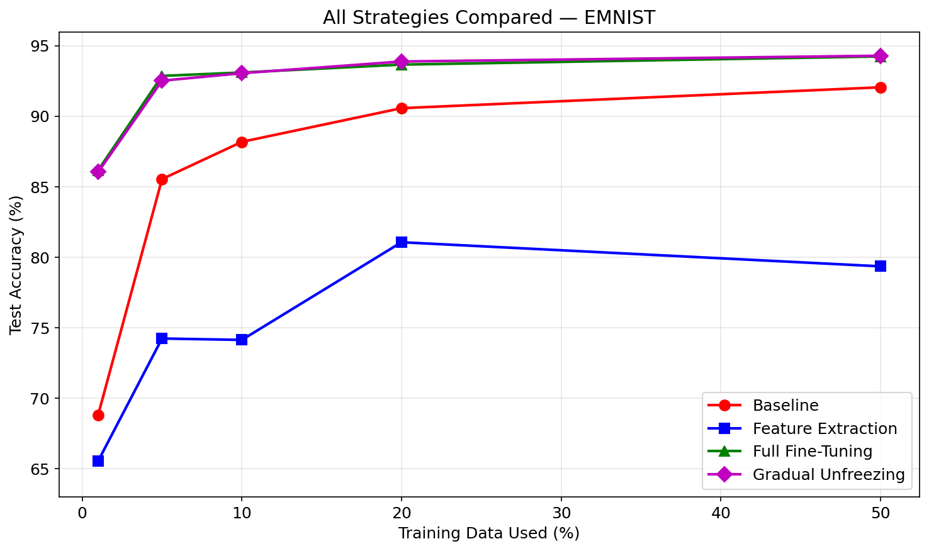
Figure 1: All strategies compared on EMNIST Letters
A few things stand out here. The baseline CNN does okay at higher data fractions (92.06% at 50%) but drops to 68.82% at 1%, which is a 23-point accuracy loss. Both full fine-tuning and gradual unfreezing stay above 86% even at 1% data, which really shows what pretrained features buy you when data is scarce.
The surprising result is that feature extraction performs the worst among the transfer strategies on EMNIST, topping out at only 81.07% with 20% data. This tells me that ImageNet features, while great for natural images, are not well suited for handwritten character recognition when you do not let them adapt. The frozen features cannot adjust to the look of handwritten letters—thin strokes on plain backgrounds are just very different from the textured, complex scenes in ImageNet.
Full fine-tuning and gradual unfreezing perform almost identically across all data fractions, with gradual unfreezing having a slight edge at 20% and 50%. The fact that they are so close suggests that on EMNIST, the staged approach of gradual unfreezing does not dramatically outperform letting all parameters adapt from the start. But the consistency of gradual unfreezing across every data size makes it the safer default, since it carries less risk of catastrophic forgetting.

CIFAR-10: ImageNet-Pretrained Transfer Learning
To test whether the EMNIST findings hold on a dataset closer to ImageNet’s domain, I ran the same experiments on CIFAR-10. Since CIFAR-10 contains natural images (cars, planes, animals), the features learned from ImageNet should transfer more directly here.
Data % | Baseline | Feature Ext. | Fine-Tune | Gradual | Best
1% | 32.50% | 67.50% | 74.50% | 71.50% | Fine-Tune
5% | 48.50% | 72.00% | 86.50% | 82.00% | Fine-Tune
10% | 54.50% | 69.00% | 88.50% | 86.00% | Fine-Tune
20% | 60.50% | 74.00% | 90.50% | 87.00% | Fine-Tune
50% | 65.50% | 72.50% | 91.00% | 90.00% | Fine-Tune

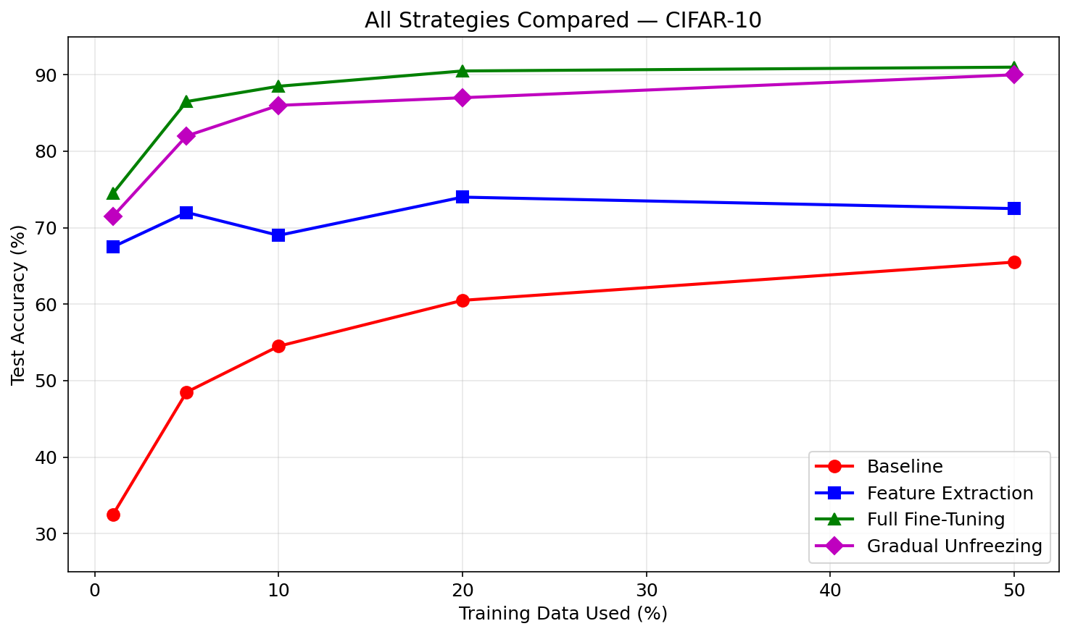
Figure 2: All strategies compared on CIFAR-10
The CIFAR-10 results tell a different story from EMNIST. The baseline CNN gets hit much harder here—it drops all the way to 32.50% at 1% data, compared to 68.82% on EMNIST. This makes sense: CIFAR-10’s natural images (cars, birds, horses) are harder to classify than handwritten letters, especially with a two-layer CNN that has no pretrained knowledge. The 10 classes in CIFAR-10 demand more visual understanding than the relatively uniform strokes in EMNIST.
Full fine-tuning wins across the board on CIFAR-10, beating gradual unfreezing at every data fraction. At 1% data, fine-tuning hits 74.50% while gradual unfreezing gets 71.50%. The gap stays consistent through 50% data (91.00% vs 90.00%). This is the opposite of what I expected—on EMNIST, gradual unfreezing and fine-tuning were nearly tied. The difference is the domain gap. CIFAR-10’s natural images are much closer to ImageNet’s domain, so the pretrained features are already well-matched to the task. In that case, giving the model full freedom to fine-tune all parameters from the start pays off more than the cautious staged approach of gradual unfreezing.
Feature extraction also does better on CIFAR-10 relative to the baseline than it did on EMNIST. At 1% data, feature extraction (67.50%) more than doubles the baseline (32.50%), whereas on EMNIST the feature extractor actually scored lower than the baseline at 1%. This again comes down to domain similarity—ImageNet’s frozen features are way more useful for classifying natural objects than handwritten characters.

Cross-Domain Transfer: ImageNet vs. MNIST Pretrained
The next table shows results for the MNIST-pretrained transfer experiment, where I first trained ResNet18 on handwritten digits and then transferred it to EMNIST letter classification.
Data % | Feature Ext. | Fine-Tune | Gradual
1% | 64.55% | 55.55% | 83.94%
5% | 71.75% | 87.31% | 91.81%
10% | 77.15% | 91.13% | 92.96%
20% | 79.34% | 93.43% | 93.84%
50% | 83.90% | 94.39% | 94.32%

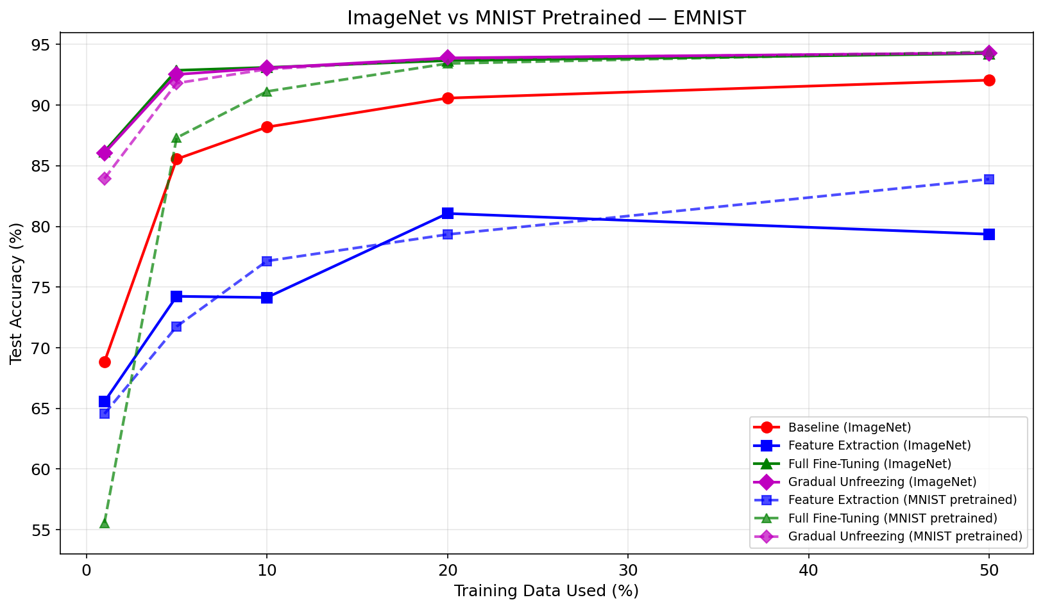
Figure 3: ImageNet vs MNIST pretrained weights on EMNIST (solid = ImageNet, dashed = MNIST)
These results show some interesting patterns. Full fine-tuning with MNIST-pretrained weights collapses to 55.55% at 1% data, which is way worse than the same strategy with ImageNet weights (86.18%). This makes sense—MNIST only has 60,000 handwritten digit images across 10 classes, so the features it learns are much less diverse than what you get from ImageNet’s 1.4 million images across 1,000 classes. When you unfreeze everything with that little target data, the model overfits fast and forgets its already-limited pretrained knowledge.
The most interesting finding here is that gradual unfreezing with MNIST-pretrained weights hits 83.94% at 1% data, which is close to ImageNet-pretrained gradual unfreezing at 86.05%. Even though MNIST has 23 times fewer images than ImageNet and covers a much narrower domain, the MNIST-pretrained model nearly matches when you adapt it carefully through gradual unfreezing. The domain similarity between handwritten digits and handwritten letters partially makes up for the smaller pretraining dataset.
At higher data fractions (20% and 50%), the MNIST-pretrained and ImageNet-pretrained models converge to similar accuracy levels (93–94%), regardless of which transfer strategy you use. This convergence means that with enough target data, the model can overcome differences in where it was pretrained and learn effective features for the task. The pretraining source matters most when target data is extremely scarce.

Training Overhead: When Transfer Learning Is Not Worth It
Transfer learning is not free. Every ResNet18-based strategy involves loading an 11.2 million parameter model, resizing every input image from 28x28 to 224x224 (an 8x increase in pixel count per image), and running forward and backward passes through a much deeper network. For gradual unfreezing, you are also creating new optimizers at each stage and managing multiple training phases. All of this takes significantly more compute time and memory than training a small CNN from scratch.
To see whether this overhead is actually justified, I tested the baseline CNN and feature extraction on MNIST. The results make a clear point.
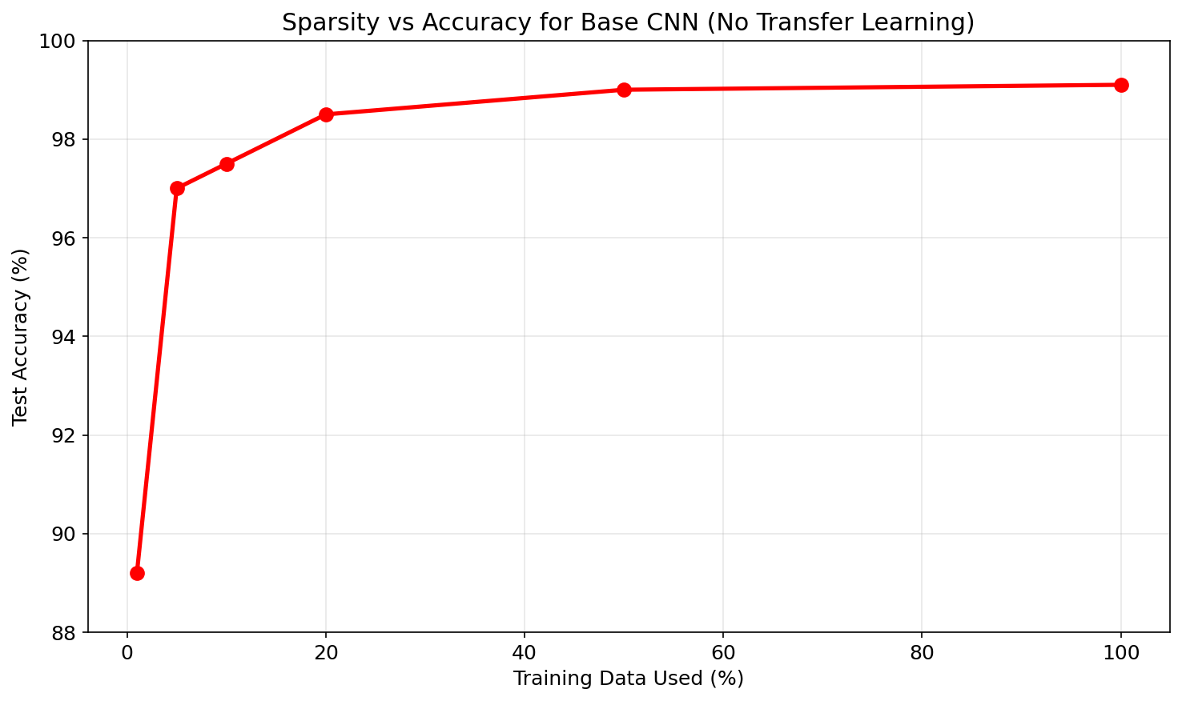
Figure 4: Baseline CNN accuracy on MNIST across data fractions (no transfer learning)
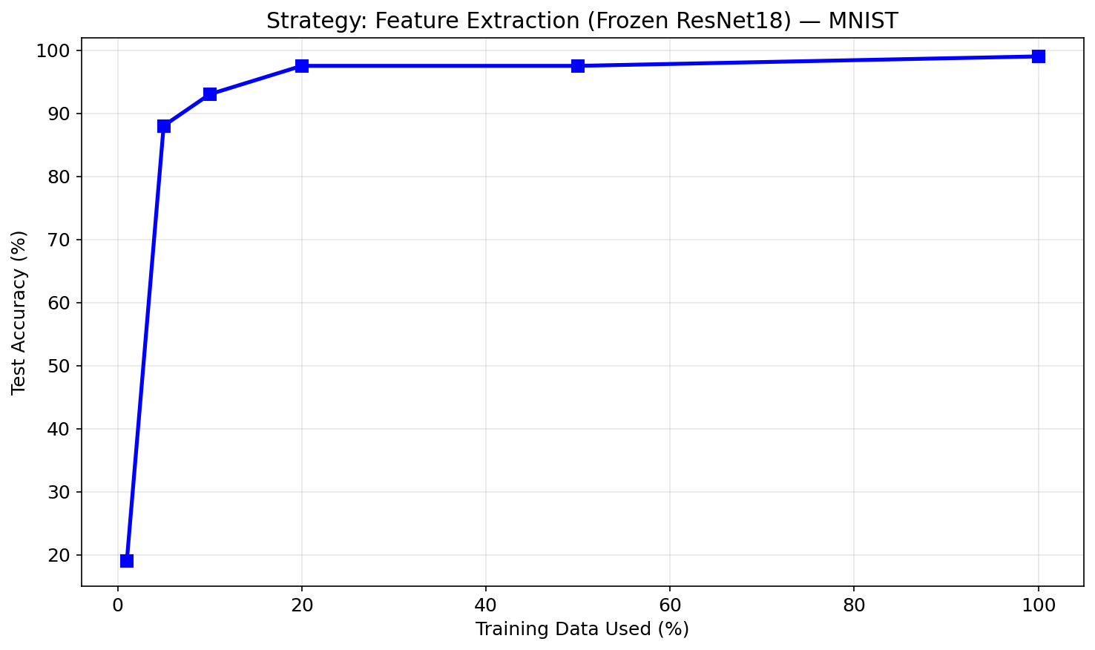
Figure 5: Feature extraction with frozen ResNet18 on MNIST across data fractions
The baseline CNN, a tiny two-layer network with a fraction of ResNet18’s parameters hits 89.2% accuracy on MNIST with just 1% of the training data (600 images). At 5%, it is already at 97.0%. By 20%, it reaches 98.5%. Meanwhile, feature extraction with a frozen ResNet18 collapses to 19.0% at 1% data on MNIST, barely above random guessing for 10 classes. It does not catch up to the baseline until around 5–10% data.
This is a case where the overhead of transfer learning actively hurts. MNIST is a simple enough task that a small CNN can learn the necessary features from very little data. The ImageNet-pretrained features inside ResNet18 were trained on natural photographs—they know about fur textures, sky gradients, and object boundaries, none of which help with classifying clean handwritten digits on a white background. The frozen features are not just unhelpful; they are the wrong features for the job, and the single trainable linear layer on top cannot compensate.
The takeaway here is practical: do not default to transfer learning without thinking about whether the task actually needs it. For well-structured, low-complexity datasets like MNIST, a lightweight CNN trained from scratch will be faster to train, cheaper to run, easier to debug, and just as accurate (or more accurate) than a pretrained ResNet. Transfer learning shines when the task is harder than what a small model can handle on its own like EMNIST with its 27 classes of messy handwriting, or CIFAR-10 with its natural image complexity. But if the problem is simple, adding a 11.2 million parameter pretrained model is overkill that can actually backfire.

No Free Lunch Consideration
The No Free Lunch theorem says that no single learning algorithm is the best across all possible problems. My results line up with this: no single transfer strategy wins everywhere. Feature extraction is the safest bet at extreme data scarcity on domain-similar tasks but fails when domains are mismatched. Full fine-tuning gives you maximum flexibility and wins on CIFAR-10 across the board, but can blow up with minimal data on domain-distant tasks like MNIST-to-EMNIST transfer. Gradual unfreezing sits in the middle but needs more hyperparameter tuning. And as the MNIST experiment shows, sometimes the best strategy is not to use transfer learning at all. The right approach depends on how much data you have, how similar the pretraining domain is to the target task, how complex the task is, and your compute budget.

Performance vs. Explainability
There is a tradeoff here between how well the model performs and how easy it is to understand what it is doing. The baseline CNN is relatively interpretable, its two convolutional layers learn simple filters you can visualize directly. ResNet18 performs better but is deeper and harder to interpret. The transfer learning strategies add another layer on top of that: understanding why gradual unfreezing beats feature extraction requires reasoning about how frozen and unfrozen layers interact, how gradients flow, and how features adapt over training stages. For applications where you need to explain individual predictions (like medical diagnosis), the performance gains from transfer learning have to be weighed against that reduced interpretability.

Future Work
There are several ways to extend this study. First, adding data augmentation as a variable would show whether techniques like geometric transforms, color jittering, mixup, or cutmix change how the strategies compare against each other. It is possible that heavy augmentation could narrow the gap between feature extraction and full fine-tuning by effectively making the dataset feel larger.
Second, testing additional backbones like ResNet50 and EfficientNet-B0 would tell us whether these findings are specific to ResNet18 or if they generalize. Different architectures have different feature hierarchies and parameter counts, which could interact with the transfer strategies in ways ResNet18 alone does not capture.
Third, the training overhead analysis could be expanded with proper benchmarking of wall-clock training time and GPU memory usage across all strategies and datasets. The current comparison is qualitative—adding precise timing data would make the efficiency argument more concrete.
Fourth, the codebase could be packaged into a proper pip-installable Python library that lets people benchmark transfer strategies on their own datasets with a single function call. That would close the gap between the research findings and practical use.
Finally, adding more evaluation metrics beyond accuracy (precision, recall, F1, confusion matrices) and explainability tools like Grad-CAM for visualizing which parts of an image the model focuses on would give deeper insight into how each strategy actually affects model behavior, not just the aggregate numbers.

Conclusion
This study shows that the transfer learning strategy you pick has a real impact on classification performance when labeled data is limited, and the right choice depends on how much data you have, how related the pretraining domain is to your target task, and how complex the task is in the first place. Across the EMNIST and CIFAR-10 experiments, transfer learning with pretrained ResNet18 consistently beat a baseline CNN trained from scratch, and the performance gap got wider as data got more scarce especially on CIFAR-10, where the baseline collapsed to 32.5% at 1% data while fine-tuning held at 74.5%.
Among the three strategies, gradual unfreezing came out as the most reliable option on EMNIST, while full fine-tuning dominated on CIFAR-10 where the domain gap to ImageNet was smaller. The cross-domain experiment showed that domain-similar pretraining (MNIST to EMNIST) can compete with large-scale pretraining (ImageNet to EMNIST) at extreme data scarcity, especially when paired with gradual unfreezing.
But the MNIST overhead experiment adds a necessary counterpoint: transfer learning is not always the answer. On simple tasks, a lightweight CNN trained from scratch is faster, cheaper, and just as accurate. A frozen ResNet18 actually scored 19% on MNIST at 1% data while the baseline CNN hit 89%.
The practical takeaway: think about the complexity of your task first. If it is hard enough to need deep features, start with gradual unfreezing as your default, consider domain similarity when choosing a pretrained model, and save full fine-tuning for situations where you have enough data and the domains are well-matched. If the task is simple, skip the pretrained model and train something small from scratch.

References
[1] S. J. Pan and Q. Yang, “A Survey on Transfer Learning,” IEEE Transactions on Knowledge and Data Engineering, vol. 22, no. 10, pp. 1345-1359, 2010.
[2] J. Yosinski, J. Clune, Y. Bengio, and H. Lipson, “How Transferable Are Features in Deep Neural Networks?,” Advances in Neural Information Processing Systems (NeurIPS), 2014.
[3] K. He, X. Zhang, S. Ren, and J. Sun, “Deep Residual Learning for Image Recognition,” IEEE Conference on Computer Vision and Pattern Recognition (CVPR), 2015.
[4] C. Shorten and T. M. Khoshgoftaar, “A Survey on Image Data Augmentation for Deep Learning,” Journal of Big Data, vol. 6, no. 60, 2019.
[5] F. Zhuang et al., “A Comprehensive Survey on Transfer Learning,” Proceedings of the IEEE, vol. 109, no. 1, pp. 43-76, 2020.
[6] Y. Luo et al., “A Closer Look at Fxew-Shot Classification Again,” International Conference on Machine Learning (ICML), 2023.
[7] EMNIST Dataset: G. Cohen, S. Afshar, J. Tapson, and A. van Schaik, “EMNIST: Extending MNIST to Handwritten Letters,” IEEE International Joint Conference on Neural Networks (IJCNN), 2017.
[8] A. Krizhevsky, “Learning Multiple Layers of Features from Tiny Images,” Technical Report, University of Toronto, 2009. (CIFAR-10 Dataset)
[9] Y. LeCun, C. Cortes, and C. J. C. Burges, “The MNIST Database of Handwritten Digits,” 1998.
[10] PyTorch: A. Paszke et al., “PyTorch: An Imperative Style, High-Performance Deep Learning Library,” Advances in Neural Information Processing Systems (NeurIPS), 2019.

