**Assignment – 02**

**Shreshta Gottiparthi**

**700746153**

**Question 1:**

Use a python code to display the following star pattern using the for loop

**Answer:**

n = 5

#Divided the pattern into 2 parts, taking first 5 lines and then next 4 lines

for i in range(0,n): #i used to iterate through the lines

for j in range(0,i+1): #j used to print the stars

print("*", end="")

print(" ")

for i in range(0,n-1):

for j in range(i,n-1):

print("*", end="")

print(" ")

**Screenshots:**

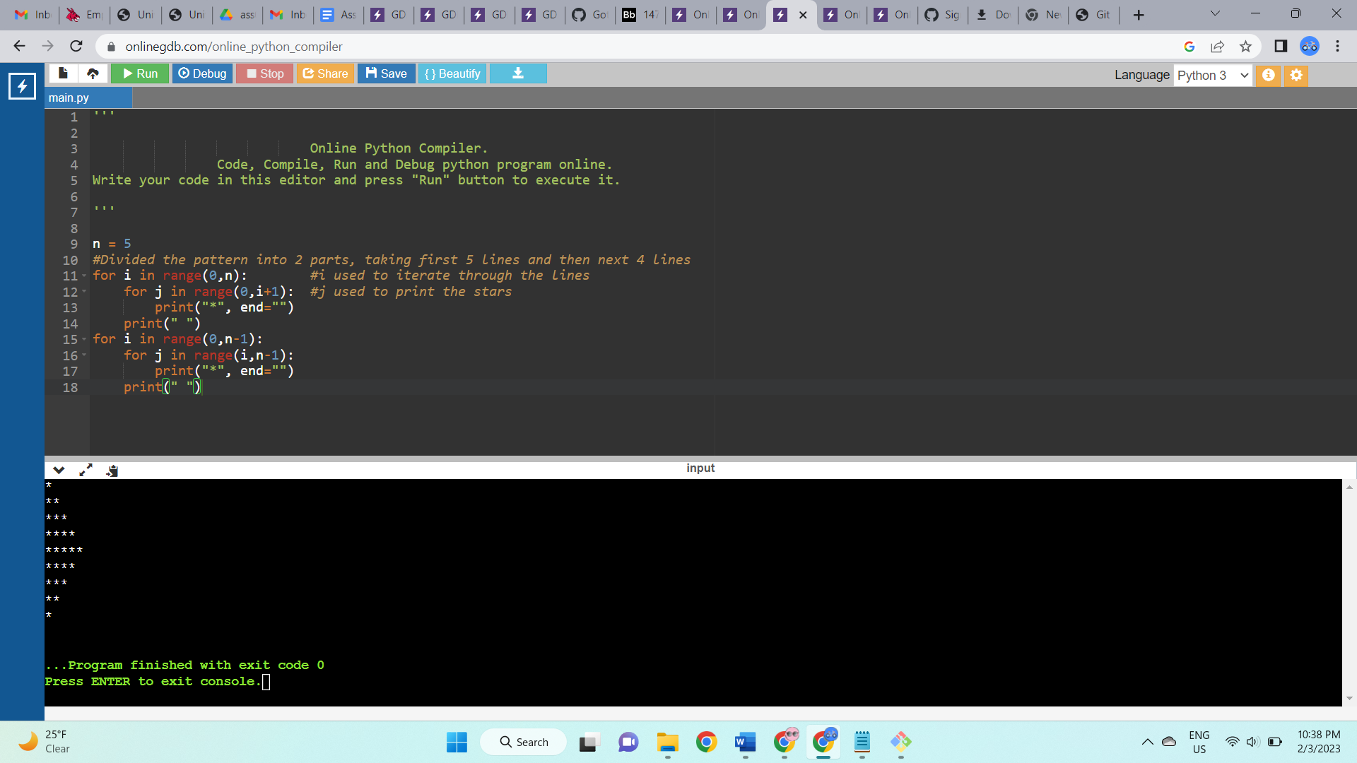

**Description:**

* Divided the pattern into 2 parts, taking first 5 lines and then next 4 lines
* i used to iterate through the lines
* j used to print the stars

**Question 2:**

Use looping to output the elements from a provided list present at odd indexes.

my_list = [10, 20, 30, 40, 50, 60, 70, 80, 90, 100]

**Answer:**

my_list = [10, 20, 30, 40, 50, 60, 70, 80, 90, 100]

x = len(my_list) #checking the length of list

for i in range(0,x): #i gets iterated through the indexes

if i%2!=0: #checks if index is odd, then prints the element at odd position

print(my_list[i])

**Screenshots:**

**Description:**

* Checking the length of list
* i gets iterated through the indexes
* Checks if index is odd, then prints the element at odd position

**Question 3:**

Write a code that appends the type of elements from a given list.

Input

x = [23, ‘Python’, 23.98]

Expected output

[23, 'Python', 23.98]

[<class 'int'>, <class 'str'>, <class 'float'>]

**Answer:**

x = [23, 'Python', 23.98]

a = [] #Created empty list

for i in x:

a.append(type(i)) #appended the type of element to the empty list

print(x)

print(a)

**Screenshots:**

**Description:**

* Created empty list
* Appended the type of element to the empty list
* Printed the same

**Question 4:**

Write a function that takes a list and returns a new list with unique items of the first list.

Sample List: [1,2,3,3,3,3,4,5]

Unique List: [1, 2, 3, 4, 5]

**Answer:**

def unique(list1): #defined a function named unique for the list

a = set(list1) #converted the list to set as it gives unique elements

return list(a)

print(unique([1,2,3,3,3,3,4,5])) #function call

**Screenshots:**

**Description:**

* Defined a function named unique for the list
* Converted the list to set as it gives unique elements

**Question 5:**

Write a function that accepts a string and calculate the number of upper-case letters and lower-case letters. Input String: 'The quick Brow Fox'

Expected Output:

No. of Upper-case characters: 3

No. of Lower-case Characters: 12

**Answer:**

x = "The quick Brow Fox"

ucount =0 #created counter for upper elements

lcount = 0 #created counter for lower elements

for i in x: # i gets iterated through the given string

if i.isupper(): #checking the upper case elements and incrementing the count value

ucount = ucount+1

elif i.islower(): #checking the lower case elements and incrementing the count value

lcount = lcount+1

print("No. of Upper-case characters:",ucount)

print("No. of Upper-case characters:",lcount)

**Screenshots:**

**Description:**

* Created counters for upper and lower elements
* Checking the upper and lower case elements and incrementing their count value by 1