# **Assignment - 03**

# **Github link -**

<https://github.com/GottiparthiShreshta/Assignment_03_MachineLearning/tree/master>

**Video Link -** <https://drive.google.com/file/d/1OPtRkHAhZrRiwFSzhZa5zeIbju58HmLt/view?usp=share_link>

**Shreshta Gottiparthi**

**700746153**

**Question 1 a. -**

Numpy:

a. Using NumPy create random vector of size 15 having only Integers in the range 1-20.

1. Reshape the array to 3 by 5

2. Print array shape.

3. Replace the max in each row by 0

**Answer:**

import numpy as np

array = np.random.randint(20,size=(15))

print("Random elements from range 1 to 20:")

print(array)

x=array.reshape(3,5)

print("After reshape:")

print(x)

print("Shape:", x.shape)

a=x.max(axis=1).reshape(-1,1)

result = np.where(x == a,0,x)

print(result)

**Screenshots:**

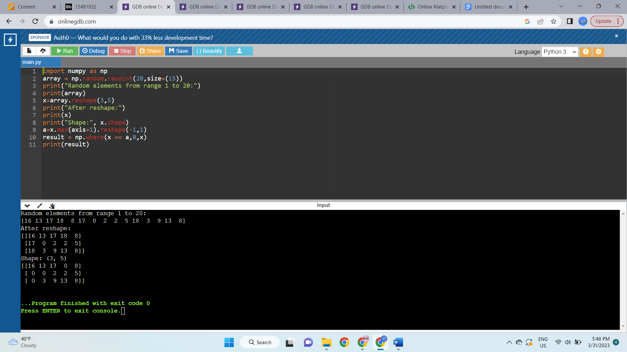

**1.**

Create a 2-dimensional array of size 4 x 3 (composed of 4-byte integer elements), also print the shape, type and data type of the array.

**Answer:**

import numpy as np

x = np.array([[1,2,3], [4,5,6], [7,8,9], [10,11,1]], np.int32)

print(x.shape)

print(type(x))

print(x.dtype)

**Screenshots:**

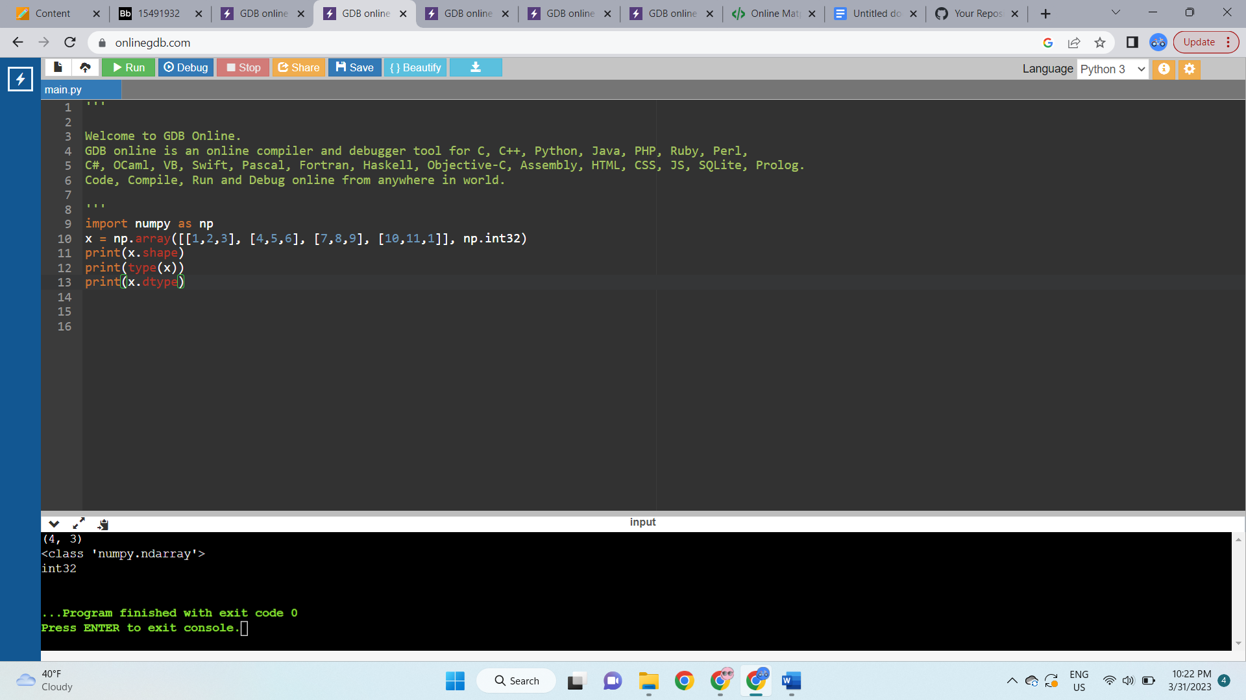

**1 b. -**

Write a program to compute the eigenvalues and right eigenvectors of a given square array given below: [[ 3 -2] [ 1 0]]

**Answer:**

import numpy as np

m = np.array([[3, -2],

[1, 0]])

print("Original square array:\n",

m)

w, v = np.linalg.eig(m)

print("Eigen values of the given square array:\n",

w)

print("Right eigenvectors of the given square array:\n",

v)

**Screenshots:**

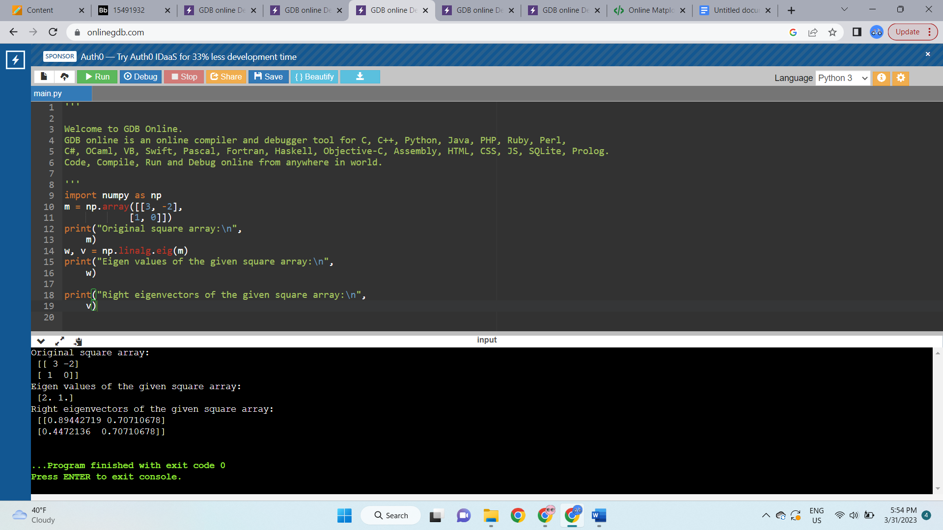

**1 c. -**

Compute the sum of the diagonal element of a given array.

[[0 1 2] [3 4 5]]

**Answer:**

import numpy as np

array = np.arange(6).reshape(2,3)

print("Original matrix:")

print(array)

result = np.trace(array)

print("Sum of the diagonal element in given matrix:")

print(result)

**Screenshots:**

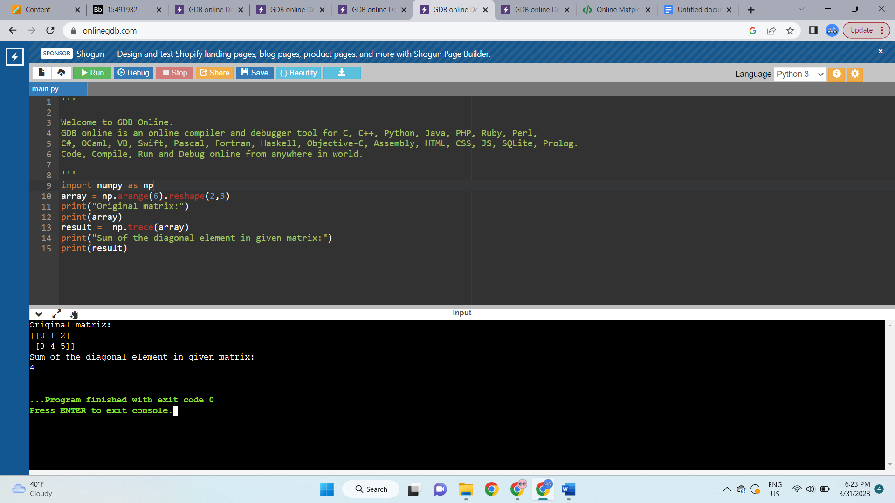

**1 d. -**

Write a NumPy program to create a new shape to an array without changing its data.

Reshape 3x2: [[1 2] [3 4] [5 6]]

Reshape 2x3: [[1 2 3] [4 5 6]]

**Answer:**

import numpy as np

a = np.array([1, 2, 3, 4, 5, 6])

b = np.reshape(a,(3,2))

print("Reshape to 3x2:")

print(b)

res = np.reshape(a,(2,3))

print("Reshape to 2x3:")

print(res)

**Screenshots:**

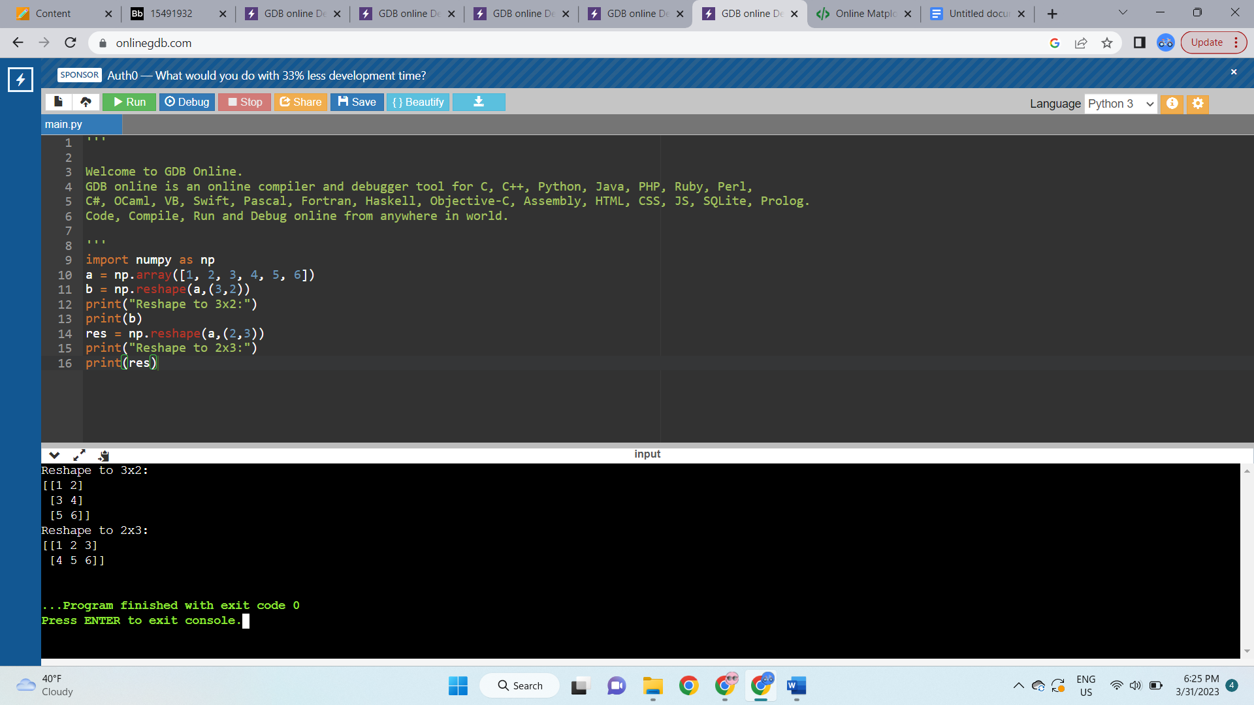

**Question 2 -**

Matplotlib

1. Write a Python programming to create a below chart of the popularity of programming Languages.

2. Sample data: Programming languages: Java, Python, PHP, JavaScript, C#, C++ Popularity: 22.2, 17.6, 8.8, 8, 7.7, 6.7

**Answer:**

import matplotlib.pyplot as plt

import numpy as np

y = np.array([22.2, 17.6, 8.8, 8, 7.7, 6.7])

mylabels = ["Java", "Python", "PHP", "JavaScript","C#","C++"]

plt.pie(y,labels=mylabels, shadow=True,explode=(0.1, 0, 0, 0,0,0), autopct='%1.2f%%')

plt.show()

**Screenshots:**

