LE BRAY Loïc
SUY Léo

The Color Annotator

What is the Color Annotator ?

The Color Annotator is a tool that let you grade a random set of four colors with diffrent concepts and let you download those as a CSV format.
You are able to grade up to a hundred random set of four colors before being invited to download your data and reload the page (Reloading the page without downloading your data will result in the loss of said data).

Where can I find the Color Annotator ?

You can find the Color Annotator on github at:
https://github.com/Goubeline/algo_esthetic
You can use online at:
https://goubeline.github.io/algo_esthetic/

Functionalities

- Download CSV: Download a file containing up to a hundred set of graded colors

- Make the colors move / stop: Make the colors slide from left to right, following a given cycle. This tool may help you visualize better the association of colors.

- Validate current association and get new colors: Save your grading of a set and let you get a new one.

- Randomness mod: Let you change the way the colors are selected between completely random and a gaussian distribution of colors.

- Each concept can be graded using a slider, a plus button and a minus button.

Design choices
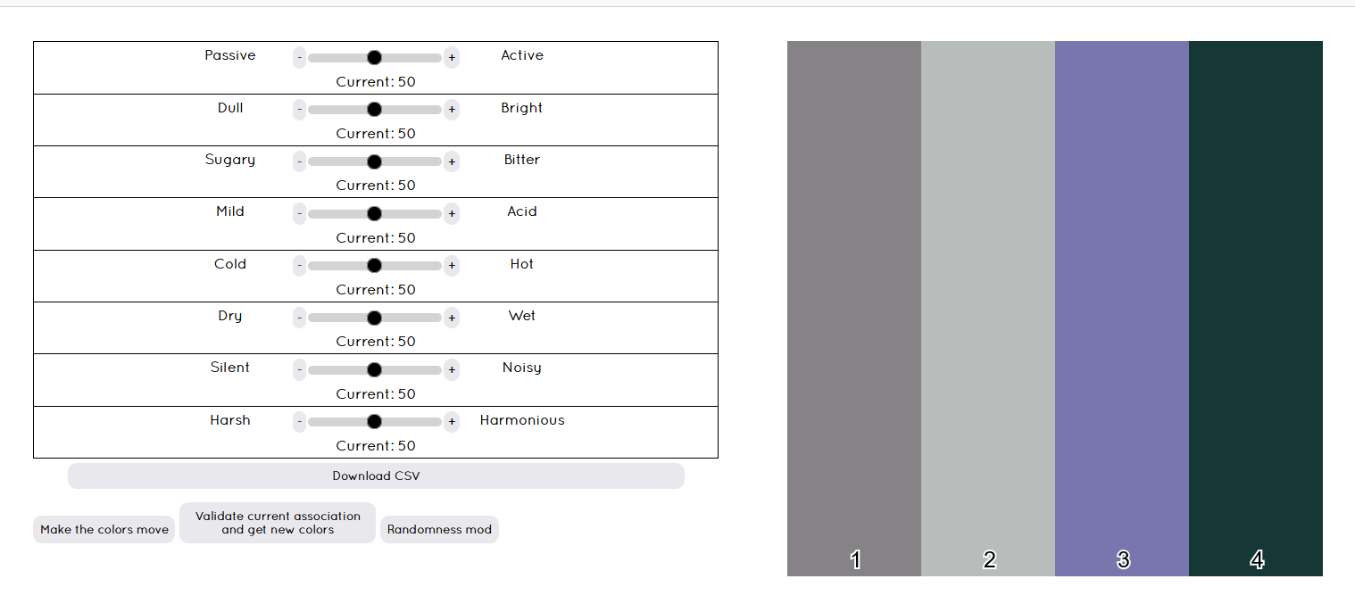
The font used is Quicksand_book for it's readability.
The color of every element, aside from the color set, is on the grey scale to prevent it from affecting your decision too much.
The layout is as simple as possible to let you focus on the task at hand.

