Agents
Core of agents is agentic loop -> it runs till it gets final answer for given question
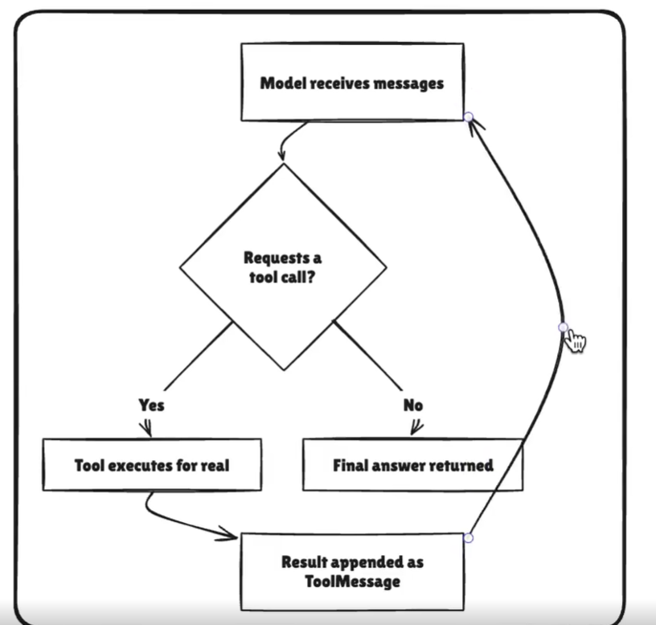

It has Brain, Memory and required tools to complete the task
Agent = Model _ Harness
Providing harness to model, when you give tool, you get much better results

