Agents
Core of agents is agentic loop -> it runs till it gets final answer for given question
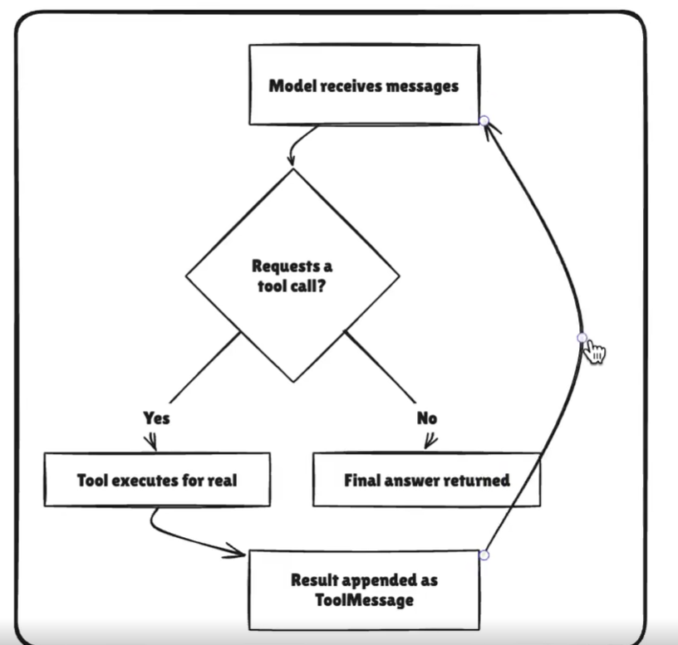

It has Brain, Memory and required tools to complete the task
Agent = Model _ Harness
Providing harness to model, when you give tool, you get much better results

Long-Term Memory
Let your agent store and recall information across conversations and session unlike short term memory can be scoped to single thread, long term persists across different threads and can be called at any time
It stores data using langgraph store

Runtime:

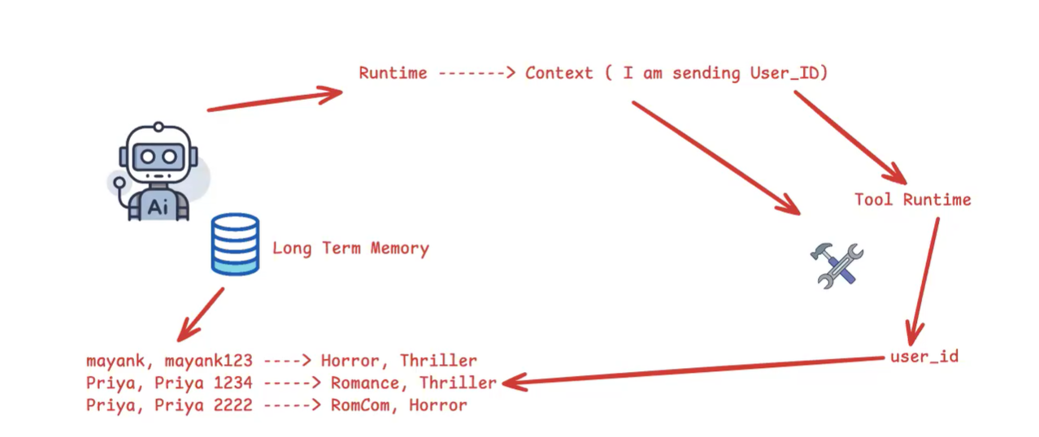

When you add tool to an agent -> toolruntime is optional but incase of middleware state and runtime is mandatory
Ex:
@before_model
Def log_model_call() -> str:
Pass
This will give error, as middleware does not capture state and runtime as input the correct way is
Def log_model_call(state,runtime): -> str:
Pass
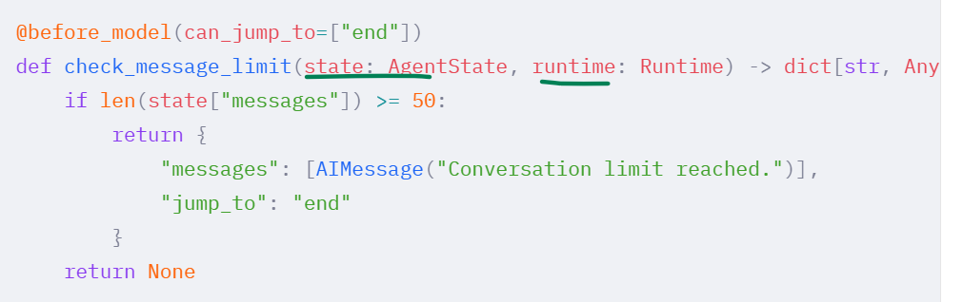

Inmiddleware:
