Middleware
It provides a way to have tight control of what happens inside the agent
Human in the loop
Summarization
Guardrails
Dynamic tool loading
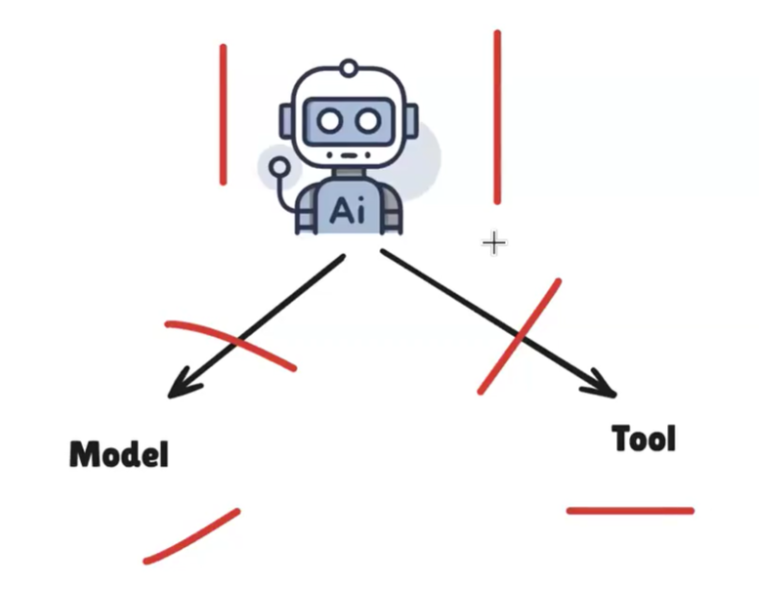
- Before agent call
- After agent call
- Before model call
- After model call
- Before tool call
- After tool call
