BDA Thermal Performance Curves

Gould, Katelyn

18 October, 2019

Table of Contents

# Description

Thermal Performance Curves are fitted to the Sharpe-Schoolfield equation, TPC parameters (E, Eh, Th, lnc, Topt, and Pmax) will be estmated and compared using Anovas and Tukeys HSD tests. System: At the Bermuda Insitute of Ocean Sciences (funded by BIOS’ “Grant in aid award”) in December 2018 respirometry data was collected from 3 genotypes of 4 species of stony coral at two sites North of Bermuda: Hog Breaker; 8-10m depth; 32°27’26’N, 64°50’05’W “Shallow” Hog Beacon; 30-33m depth; 32°29’18’N, 64°51’18’W “deep” Respirometry data consists of change in oxygen (umol/cm2/hr) during: Photosynthesis (NP & GP) & dark Respiration (R) Logging the change in oxygen consumption or production over a 20 min sampling period yielded the metabolic rates used in these analyses.

logged gross photosynthesis (GP) (|NP|+|R|) & logged |R| respiration rates

TPC parameters were then estimated and compared: No difference in the following TPC parameters between Treatment (depth), species, or treatment*species E Eh Th lnc Topt

(Tukeys HSD) Differences (p-value <0.05) in Pmax (performance maximums) were found between the following species: MCAV-DLAB PAST-DLAB OFRA-MCAV PAST_OFRA Pmax did not differ across treatment (depth)

# Raw Data

Data consists of metabolic rates for each individuals Net Photosynthesis, Dark Respiration, and Gross Photosynthesis

raw.data<-read.csv("C:/Github/TPC_BDA_github/R_output/Final/final_NP_R_GP_edited.csv")  
View(raw.data)

## Gross Photosynthesis=[|NP|+|R|]

#filterng out NP, removes it from the list   
mydata<-raw.data  
mydata<-filter(mydata, rate.type !="NP")   
  
mydataP<-subset(mydata,rate.type=="GP")  
mydataR<-subset(mydata,rate.type=="R")  
  
#Take absolute values of Respiration to log it, then combine dataframes and log both R and GP  
mydataR$umol.cm2.hr<-abs(mydataR$umol.cm2.hr)  
mydataP$umol.cm2.hr<-abs(mydataP$umol.cm2.hr)  
Mydata<-rbind(mydataP,mydataR)  
  
mydata<-Mydata  
  
mydata$log.rate <- log(mydata$umol.cm2.hr + 1)   
  
mydata%<>%  
 mutate(K=mydata$Temp.C + 273.15)  
  
#save  
#write.csv(mydata,"C:/Github/TPC_BDA_github/R_output/Final/October_RmarkdownFinal/mydata.csv")

## Equation and TPC modelling

Defining the sharpe-schoolfield equation:

#Define the Schoolfield equation:  
schoolfield_high <- function(lnc, E, Eh, Th, temp, Tc) {  
 Tc <- 273.15 + Tc  
 k <- 8.62e-5  
 boltzmann.term <- lnc + log(exp(E/k*(1/Tc - 1/temp)))  
 inactivation.term <- log(1/(1 + exp(Eh/k*(1/Th - 1/temp))))  
 return(boltzmann.term + inactivation.term)  
}

# TPC graphs

Varitions on Thermal Performance Graphs

## TPC1

knitr::opts_chunk$set(warning= FALSE)  
  
TPCall<-ggplot() +  
 geom_ribbon(data=subset(All.CIT, lwr_CI>0),  
 aes(x=K - 273.15, ymin = lwr_CI, ymax = upr_CI, group=group),fill = 'grey', alpha = .4) +  
 geom_point(data=All.fittedT, aes(x=(K - 273.15), y=log.rate, shape=treatment)) +  
 geom_line(data=All.fittedT, aes(x=(K - 273.15), y=fitted, colour=group)) +  
 ylab('log Metabolic rate') +  
 xlab('Temperature (ºC)') +  
 theme_bw(base_size = 12, base_family = 'Helvetica') +  
 facet_wrap(~species)  
  
TPCall

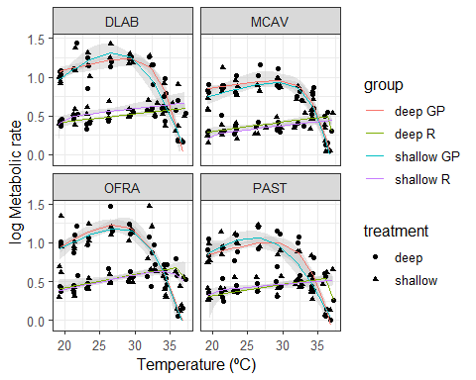

## TPC2

knitr::opts_chunk$set(warning= FALSE)  
  
STPCall<-ggplot() +  
 geom_ribbon(data=subset(All.CIT, lwr_CI>0),  
 aes(x=K - 273.15, ymin = lwr_CI, ymax = upr_CI, group=group),fill = 'grey', alpha = .4) +  
 geom_point(data=All.fittedT, aes(x=(K - 273.15), y=log.rate, shape=treatment)) +  
 geom_smooth(data=All.fittedT, aes(x=(K - 273.15), y=fitted, colour=group,se=F)) +  
 ylab('log Metabolic rate') +  
 xlab('Temperature (ºC)') +  
 theme_bw(base_size = 12, base_family = 'Helvetica') +  
 facet_wrap(~species)  
  
STPCall

## `geom_smooth()` using method = 'loess' and formula 'y ~ x'

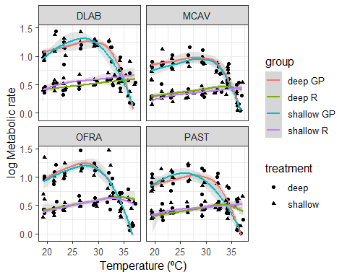

## TPC3

knitr::opts_chunk$set(warning= FALSE)  
  
TPC<-ggplot() +  
 geom_ribbon(data=subset(All.CIT, lwr_CI>0),  
 aes(x=K - 273.15, ymin = lwr_CI, ymax = upr_CI, group=group),fill = 'grey', alpha = .4) +  
 geom_point(data=All.fittedT, aes(x=(K - 273.15), y=log.rate, shape=treatment)) +  
 geom_smooth(data=All.fittedT, aes(x=(K - 273.15), y=fitted, colour=group,se=F)) +  
 ylab('log Metabolic rate') +  
 xlab('Temperature (ºC)') +  
 facet_wrap(~species)+  
 theme_classic()+  
 labs(title="Thermal Performance Curves Across Depth")  
  
TPC

## `geom_smooth()` using method = 'loess' and formula 'y ~ x'

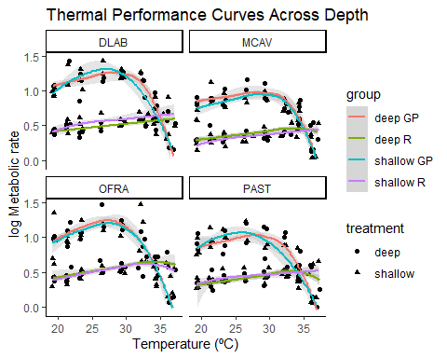

# TPC graphs

## TPC by Depth

knitr::opts_chunk$set(warning= FALSE)  
  
TPCallr<-ggplot() +  
 geom_ribbon(data=subset(All.CIr, lwr_CI>0),  
 aes(x=K - 273.15, ymin = lwr_CI, ymax = upr_CI, group=group),fill = 'grey', alpha = .4) +  
 geom_point(data=All.fittedr, aes(x=(K - 273.15), y=log.rate, shape=rate.type)) +  
 geom_line(data=All.fittedr, aes(x=(K - 273.15), y=fitted, colour=group)) +  
 ylab('log Metabolic rate') +  
 xlab('Temperature (ºC)') +  
 theme_bw(base_size = 12, base_family = 'Helvetica') +  
 facet_wrap(~treatment)  
  
TPCallr

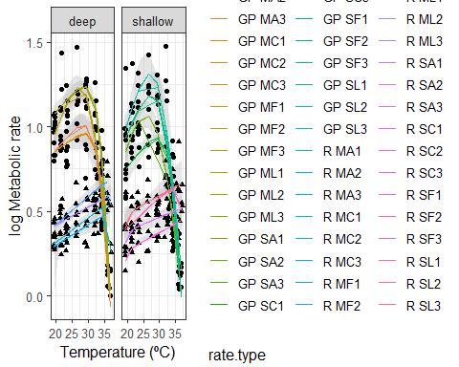

## TPC by Species

knitr::opts_chunk$set(warning= FALSE)  
  
TPCs<-ggplot() +  
 geom_ribbon(data=subset(All.CIr, lwr_CI>0),  
 aes(x=K - 273.15, ymin = lwr_CI, ymax = upr_CI, group=group),fill = 'grey', alpha = .4) +  
 geom_point(data=All.fittedr, aes(x=(K - 273.15), y=log.rate, shape=rate.type))+   
 geom_line(data=All.fittedr, aes(x=(K - 273.15), y=fitted, colour=group)) +  
 ylab('log Metabolic rate') +  
 xlab('Temperature (ºC)') +  
 theme_bw(base_size = 12, base_family = 'Helvetica')+  
 facet_wrap(~species)  
TPCs

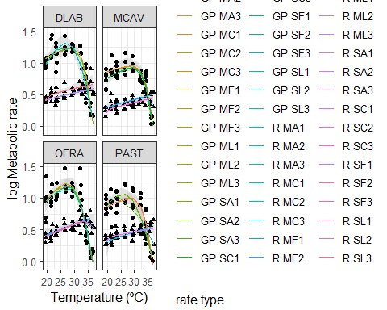

# TPC Parameters across species

Count data for TPC parameters

## Topt

knitr::opts_chunk$set(warning= FALSE)  
  
Toptmeaspp<-ggplot(topt_nonegspp, aes(topt_C)) +  
 geom_histogram(col = 'black', fill = 'white') +  
 facet_wrap(~species)+  
 xlab('Optimum Temperature (ºC)') +  
 ggtitle('Distribution of optimum temperatures')  
  
Toptmeaspp

## `stat_bin()` using `bins = 30`. Pick better value with `binwidth`.

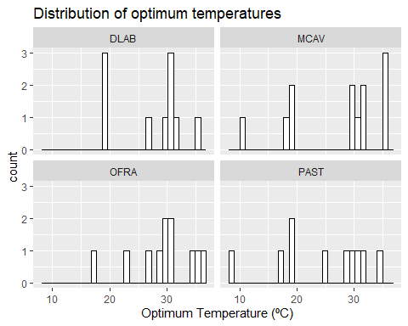

## E

knitr::opts_chunk$set(warning= FALSE)  
  
# plot distribution of estimated parameters E, Eh, lnc, Th  
p1sp <- ggplot(topt_nonegspp, aes(E)) +  
 geom_histogram(col = 'black', fill = 'white') +  
 facet_wrap(~ species, scales = 'free_x')  
p1sp

## `stat_bin()` using `bins = 30`. Pick better value with `binwidth`.

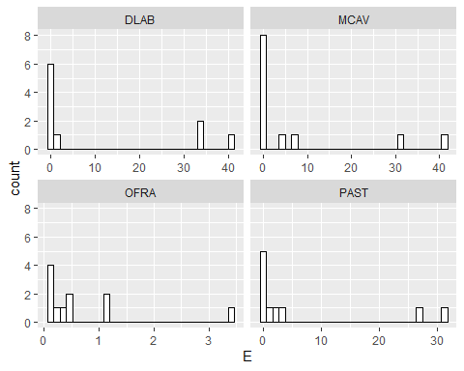

## Eh

knitr::opts_chunk$set(warning= FALSE)  
  
  
# plot distribution of estimated parameters E, Eh, lnc, Th  
p2sp <- ggplot(topt_nonegspp, aes(Eh)) +  
 geom_histogram(col = 'black', fill = 'white') +  
 facet_wrap(~ species)  
p2sp

## `stat_bin()` using `bins = 30`. Pick better value with `binwidth`.

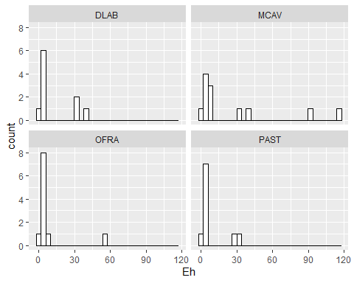

## lnc

knitr::opts_chunk$set(warning= FALSE)  
  
# plot distribution of estimated parameters E, Eh, lnc, Th  
p3sp <- ggplot(topt_nonegspp, aes(lnc)) +  
 geom_histogram(col = 'black', fill = 'white') +  
 facet_wrap(~ species)  
p3sp

## `stat_bin()` using `bins = 30`. Pick better value with `binwidth`.

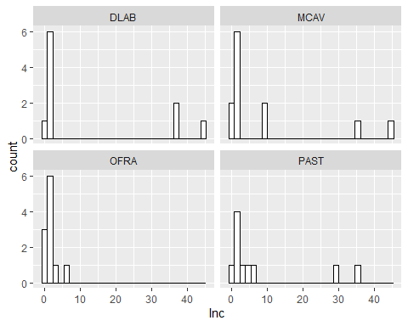

## Th

knitr::opts_chunk$set(warning= FALSE)  
  
p4asp <- ggplot(subset(topt_nonegspp, rate.type=="GP"), aes(Th_C)) +  
 geom_histogram(col = 'black', fill = 'white') +  
 facet_wrap(~ species)  
p4asp

## `stat_bin()` using `bins = 30`. Pick better value with `binwidth`.

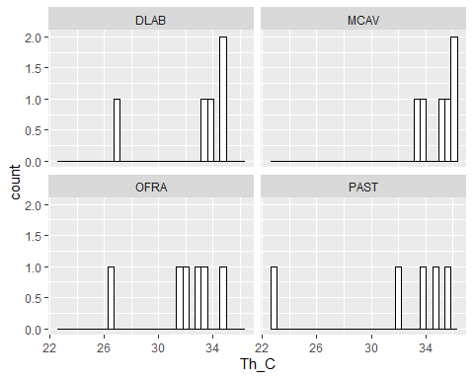

# Parameter graphs

Mean parameters for all species

# lnc

## lnc for GP across depth

lnc<-ggplot(subset(topt_nonegspp,rate.type=="GP"), aes(x=treatment, lnc, colour=treatment))+  
 geom_boxplot()+  
 geom_point()+  
 ylab("lnc")  
  
lnc

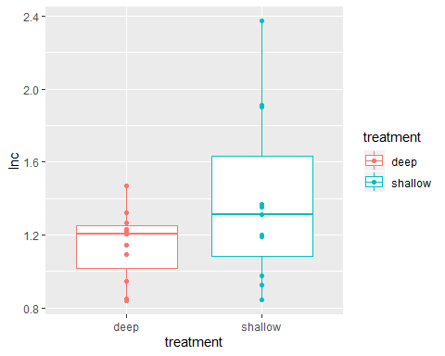

## lnc for GP across species and depth

lnc2<-ggplot(subset(topt_nonegspp,rate.type=="GP"), aes(x=fragment.ID2, lnc, colour=fragment.ID2))+  
 geom_boxplot()+  
 geom_point()+  
 ylab("lnc")  
lnc2

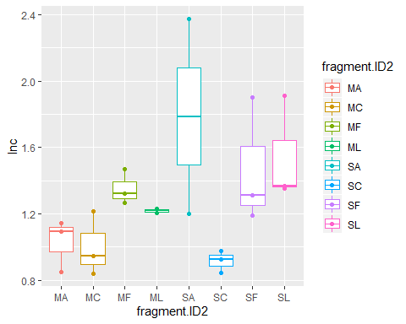

## lnc for GP across species and depth

lnc2spp<-ggplot(subset(topt_nonegspp,rate.type=="GP"), aes(x=species, lnc, colour=fragment.ID2))+  
 geom_boxplot()+  
 geom_point()+  
 ylab("lnc")  
  
lnc2spp

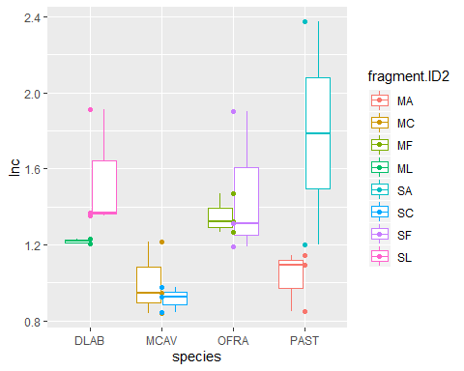

# E

## E for GP across depth

E<-ggplot(subset(topt_nonegspp,rate.type=="GP"), aes(x=treatment, E, colour=treatment))+  
 geom_boxplot()+  
 geom_point()+  
 ylab("E")  
  
E

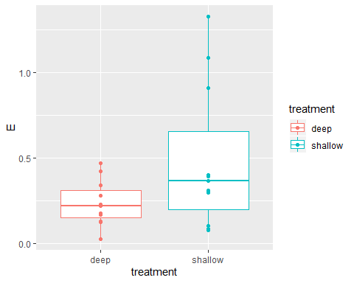

## E for GP across species and depth

E2<-ggplot(subset(topt_nonegspp,rate.type=="GP"), aes(x=fragment.ID2, E, colour=fragment.ID2))+  
 geom_boxplot()+  
 geom_point()+  
 ylab("E")  
E2

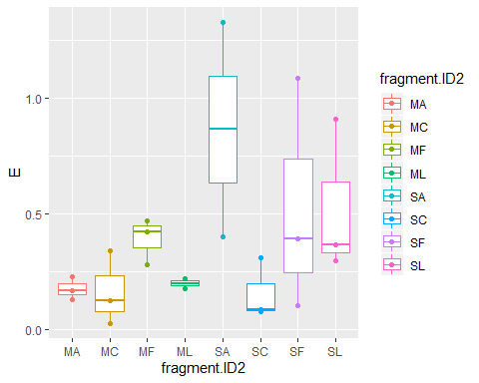

## E for GP across species and depth

E2spp<-ggplot(subset(topt_nonegspp,rate.type=="GP"), aes(x=species, E, colour=fragment.ID2))+  
 geom_boxplot()+  
 geom_point()+  
 ylab("E")  
  
E2spp

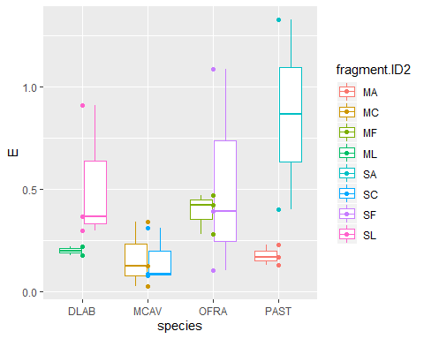

# Eh

## Eh for GP across depth

#remove outlier for eh (MC- MCAV- MC2- Deep eh= 111.)  
test <- topt_nonegspp[-c(5),]   
  
topt_nonegspp<-test  
  
Eh<-ggplot(subset(topt_nonegspp,rate.type=="GP"), aes(x=treatment, Eh, colour=treatment))+  
 geom_boxplot()+  
 geom_point()+  
 ylab("Eh")  
  
Eh

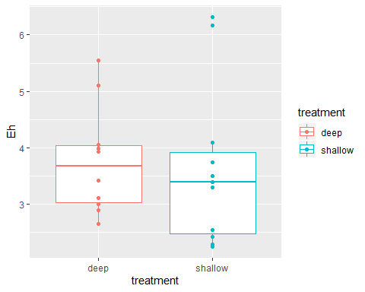

## Eh for GP across species and depth

Eh2<-ggplot(subset(topt_nonegspp,rate.type=="GP"), aes(x=fragment.ID2, Eh, colour=fragment.ID2))+  
 geom_boxplot()+  
 geom_point()+  
 ylab("Eh")  
Eh2

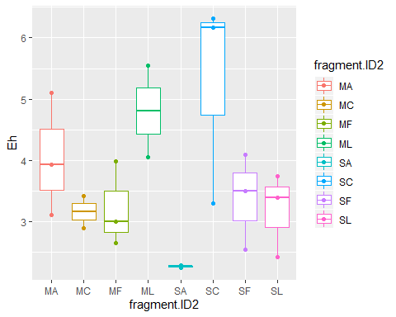

## Eh for GP across species and depth

Eh2spp<-ggplot(subset(topt_nonegspp,rate.type=="GP"), aes(x=species, Eh, colour=fragment.ID2))+  
 geom_boxplot()+  
 geom_point()+  
 ylab("Eh")  
  
Eh2spp

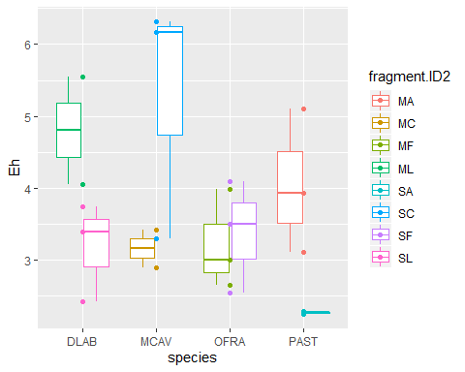

# Th

## Th for GP across depth

Th<-ggplot(subset(topt_nonegspp,rate.type=="GP"), aes(x=treatment, Th_C, colour=treatment))+  
 geom_boxplot()+  
 geom_point()+  
 ylab("Th")  
Th

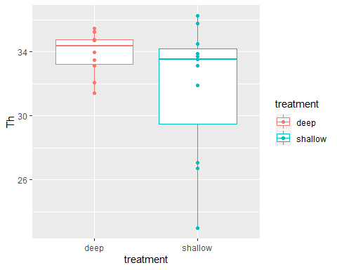

## Th for GP across species and depth

Th2<-ggplot(subset(topt_nonegspp,rate.type=="GP"), aes(x=fragment.ID2, Th_C, colour=fragment.ID2))+  
 geom_boxplot()+  
 geom_point()+  
 ylab("Th")  
Th2

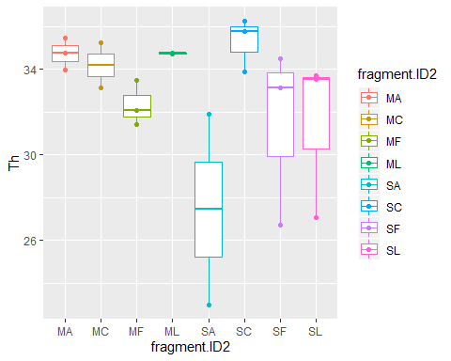

## Th for GP across species and depth

Th2spp<-ggplot(subset(topt_nonegspp,rate.type=="GP"), aes(x=species, Th_C, colour=fragment.ID2))+  
 geom_boxplot()+  
 geom_point()+  
 ylab("Th")  
  
Th2spp

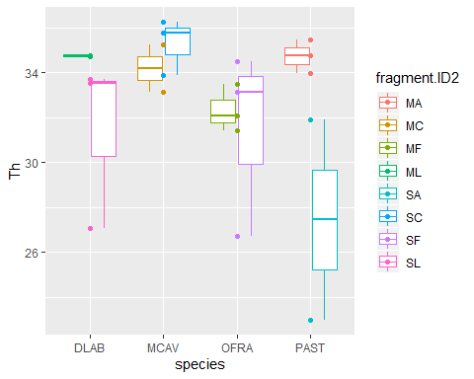

# Pmax

Calculate Pmax values between sites species

## Pmax across depth

Pmax<-ggplot(subset(Pmax_data,rate.type=="GP"), aes(x=treatment, Pmax, colour=treatment))+  
 geom_boxplot()+  
 geom_point()+  
 ylab("Pmax")  
Pmax

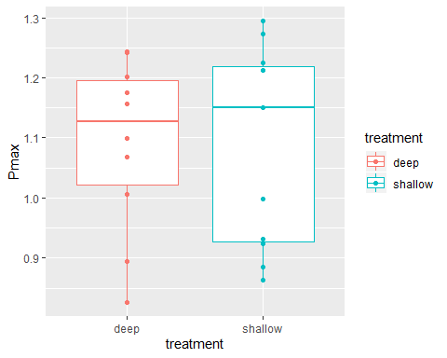

## Pmax across species and depth

Pmax2<-ggplot(subset(Pmax_data,rate.type=="GP"), aes(x=fragment.ID2, Pmax, colour=fragment.ID2))+  
 geom_boxplot()+  
 geom_point()+  
 ylab("Pmax")  
Pmax2

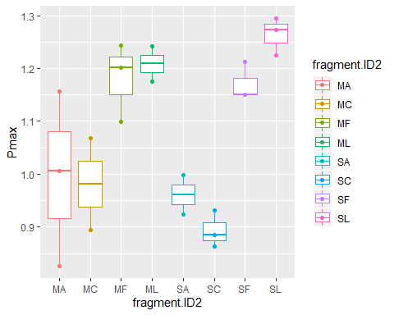

## Pmax across species and depth

Pmaxspp<-ggplot(subset(Pmax_data,rate.type=="GP"), aes(x=species, Pmax, colour=fragment.ID2))+  
 geom_boxplot()+  
 geom_point()+  
 ylab("Pmax")  
  
Pmaxspp

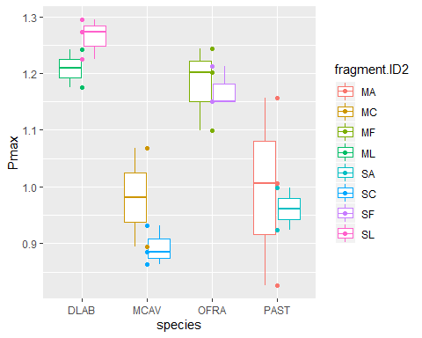

## Pmax across species

Pmaxspp2<-ggplot(subset(Pmax_data,rate.type=="GP"), aes(x=species, Pmax, colour=species))+  
 geom_boxplot()+  
 geom_point()+  
 ylab("Pmax")  
Pmaxspp2

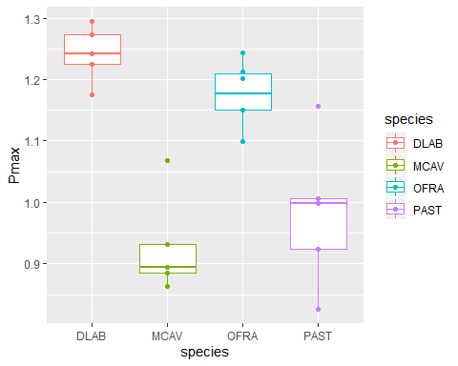

## Pmax across genotype

Pmaxspp3<-ggplot(subset(Pmax_data,rate.type=="GP"), aes(x=genotype, Pmax, colour=species))+  
 geom_boxplot()+  
 geom_point()+  
 ylab("Pmax")  
Pmaxspp3

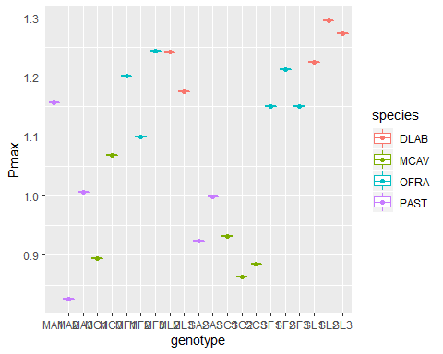

# Pmax

Models

## Pmax Anova and Tukey HSD tests

#linear model  
##Depth * species  
  
Pmax.GP.mod<-Anova(lm(Pmax~fragment.ID2, data=subset(Pmax_data,rate.type=="GP")))  
Pmax.GP.mod

## Anova Table (Type II tests)  
##   
## Response: Pmax  
## Sum Sq Df F value Pr(>F)   
## fragment.ID2 0.3630 7 7.2179 0.001192 **  
## Residuals 0.0934 13   
## ---  
## Signif. codes: 0 '***' 0.001 '**' 0.01 '*' 0.05 '.' 0.1 ' ' 1

summary(Pmax.GP.mod)

## Sum Sq Df F value Pr(>F)   
## Min. :0.0934 Min. : 7.0 Min. :7.218 Min. :0.001192   
## 1st Qu.:0.1608 1st Qu.: 8.5 1st Qu.:7.218 1st Qu.:0.001192   
## Median :0.2282 Median :10.0 Median :7.218 Median :0.001192   
## Mean :0.2282 Mean :10.0 Mean :7.218 Mean :0.001192   
## 3rd Qu.:0.2956 3rd Qu.:11.5 3rd Qu.:7.218 3rd Qu.:0.001192   
## Max. :0.3630 Max. :13.0 Max. :7.218 Max. :0.001192   
## NA's :1 NA's :1

#depth  
Pmax.GP.modt<-Anova(lm(Pmax~treatment, data=subset(Pmax_data,rate.type=="GP")))  
Pmax.GP.modt

## Anova Table (Type II tests)  
##   
## Response: Pmax  
## Sum Sq Df F value Pr(>F)  
## treatment 0.00039 1 0.0162 0.9  
## Residuals 0.45601 19

summary(Pmax.GP.modt)

## Sum Sq Df F value Pr(>F)   
## Min. :0.0003889 Min. : 1.0 Min. :0.01621 Min. :0.9   
## 1st Qu.:0.1142952 1st Qu.: 5.5 1st Qu.:0.01621 1st Qu.:0.9   
## Median :0.2282015 Median :10.0 Median :0.01621 Median :0.9   
## Mean :0.2282015 Mean :10.0 Mean :0.01621 Mean :0.9   
## 3rd Qu.:0.3421078 3rd Qu.:14.5 3rd Qu.:0.01621 3rd Qu.:0.9   
## Max. :0.4560141 Max. :19.0 Max. :0.01621 Max. :0.9   
## NA's :1 NA's :1

#species  
Pmax.GP.modsp<-Anova(lm(Pmax~species, data=subset(Pmax_data,rate.type=="GP")))  
Pmax.GP.modsp

## Anova Table (Type II tests)  
##   
## Response: Pmax  
## Sum Sq Df F value Pr(>F)   
## species 0.34838 3 18.275 1.46e-05 ***  
## Residuals 0.10802 17   
## ---  
## Signif. codes: 0 '***' 0.001 '**' 0.01 '*' 0.05 '.' 0.1 ' ' 1

summary(Pmax.GP.modsp)

## Sum Sq Df F value Pr(>F)   
## Min. :0.1080 Min. : 3.0 Min. :18.28 Min. :1.46e-05   
## 1st Qu.:0.1681 1st Qu.: 6.5 1st Qu.:18.28 1st Qu.:1.46e-05   
## Median :0.2282 Median :10.0 Median :18.28 Median :1.46e-05   
## Mean :0.2282 Mean :10.0 Mean :18.28 Mean :1.46e-05   
## 3rd Qu.:0.2883 3rd Qu.:13.5 3rd Qu.:18.28 3rd Qu.:1.46e-05   
## Max. :0.3484 Max. :17.0 Max. :18.28 Max. :1.46e-05   
## NA's :1 NA's :1

mPGP<-aov(Pmax~fragment.ID2, data=subset(Pmax_data,rate.type=="GP"))  
TukeyHSD(mPGP)

## Tukey multiple comparisons of means  
## 95% family-wise confidence level  
##   
## Fit: aov(formula = Pmax ~ fragment.ID2, data = subset(Pmax_data, rate.type == "GP"))  
##   
## $fragment.ID2  
## diff lwr upr p adj  
## MC-MA -0.014551852 -0.290806873 0.26170317 0.9999993  
## MF-MA 0.185140351 -0.061949651 0.43223035 0.2132560  
## ML-MA 0.212619553 -0.063635469 0.48887457 0.1911500  
## SA-MA -0.035459468 -0.311714489 0.24079555 0.9996876  
## SC-MA -0.102480292 -0.349570295 0.14460971 0.8046018  
## SF-MA 0.175335199 -0.071754804 0.42242520 0.2622318  
## SL-MA 0.268093095 0.021003093 0.51518310 0.0297139  
## MF-MC 0.199692203 -0.076562818 0.47594722 0.2449845  
## ML-MC 0.227171405 -0.075450809 0.52979362 0.2116796  
## SA-MC -0.020907616 -0.323529830 0.28171460 0.9999952  
## SC-MC -0.087928440 -0.364183462 0.18832658 0.9365166  
## SF-MC 0.189887050 -0.086367971 0.46614207 0.2932128  
## SL-MC 0.282644947 0.006389926 0.55889997 0.0434255  
## ML-MF 0.027479201 -0.248775820 0.30373422 0.9999426  
## SA-MF -0.220599819 -0.496854841 0.05565520 0.1631099  
## SC-MF -0.287620644 -0.534710647 -0.04053064 0.0182588  
## SF-MF -0.009805153 -0.256895156 0.23728485 0.9999999  
## SL-MF 0.082952744 -0.164137259 0.33004275 0.9186262  
## SA-ML -0.248079021 -0.550701234 0.05454319 0.1448290  
## SC-ML -0.315099845 -0.591354866 -0.03884482 0.0210949  
## SF-ML -0.037284354 -0.313539375 0.23897067 0.9995665  
## SL-ML 0.055473543 -0.220781479 0.33172856 0.9947743  
## SC-SA -0.067020824 -0.343275846 0.20923420 0.9844363  
## SF-SA 0.210794666 -0.065460355 0.48704969 0.1981021  
## SL-SA 0.303552563 0.027297542 0.57980758 0.0272925  
## SF-SC 0.277815491 0.030725488 0.52490549 0.0233193  
## SL-SC 0.370573388 0.123483385 0.61766339 0.0023891  
## SL-SF 0.092757897 -0.154332106 0.33984790 0.8677587

summary(mPGP)

## Df Sum Sq Mean Sq F value Pr(>F)   
## fragment.ID2 7 0.3630 0.05186 7.218 0.00119 **  
## Residuals 13 0.0934 0.00718   
## ---  
## Signif. codes: 0 '***' 0.001 '**' 0.01 '*' 0.05 '.' 0.1 ' ' 1

mPGPt<-aov(Pmax~treatment, data=subset(Pmax_data,rate.type=="GP"))  
TukeyHSD(mPGPt)

## Tukey multiple comparisons of means  
## 95% family-wise confidence level  
##   
## Fit: aov(formula = Pmax ~ treatment, data = subset(Pmax_data, rate.type == "GP"))  
##   
## $treatment  
## diff lwr upr p adj  
## shallow-deep -0.008617003 -0.1502942 0.1330602 0.9000401

summary(mPGPt)

## Df Sum Sq Mean Sq F value Pr(>F)  
## treatment 1 0.0004 0.000389 0.016 0.9  
## Residuals 19 0.4560 0.024001

mPGPsp<-aov(Pmax~species, data=subset(Pmax_data,rate.type=="GP"))  
TukeyHSD(mPGPsp)

## Tukey multiple comparisons of means  
## 95% family-wise confidence level  
##   
## Fit: aov(formula = Pmax ~ species, data = subset(Pmax_data, rate.type == "GP"))  
##   
## $species  
## diff lwr upr p adj  
## MCAV-DLAB -0.31321259 -0.45652147 -0.16990371 0.0000513  
## OFRA-DLAB -0.06566590 -0.20287371 0.07154190 0.5394136  
## PAST-DLAB -0.26008747 -0.40339635 -0.11677859 0.0004163  
## OFRA-MCAV 0.24754669 0.11033888 0.38475450 0.0004431  
## PAST-MCAV 0.05312513 -0.09018375 0.19643401 0.7210818  
## PAST-OFRA -0.19442156 -0.33162937 -0.05721376 0.0043854

summary(mPGPsp)

## Df Sum Sq Mean Sq F value Pr(>F)   
## species 3 0.3484 0.11613 18.27 1.46e-05 ***  
## Residuals 17 0.1080 0.00635   
## ---  
## Signif. codes: 0 '***' 0.001 '**' 0.01 '*' 0.05 '.' 0.1 ' ' 1

#linear model for R Pmax  
  
  
#linear model  
##Depth * species  
  
Pmax.R.mod<-Anova(lm(Pmax~fragment.ID2, data=subset(Pmax_data,rate.type=="R")))  
Pmax.R.mod

## Anova Table (Type II tests)  
##   
## Response: Pmax  
## Sum Sq Df F value Pr(>F)  
## fragment.ID2 0.57107 7 1.1962 0.3697  
## Residuals 0.88662 13

#summary(Pmax.R.mod)  
  
#depth  
Pmax.R.modt<-Anova(lm(Pmax~treatment, data=subset(Pmax_data,rate.type=="R")))  
Pmax.R.modt

## Anova Table (Type II tests)  
##   
## Response: Pmax  
## Sum Sq Df F value Pr(>F)  
## treatment 0.02797 1 0.3717 0.5493  
## Residuals 1.42972 19

#summary(Pmax.R.modt)  
  
#species  
Pmax.R.modsp<-Anova(lm(Pmax~species, data=subset(Pmax_data,rate.type=="R")))  
Pmax.R.modsp

## Anova Table (Type II tests)  
##   
## Response: Pmax  
## Sum Sq Df F value Pr(>F)   
## species 0.52292 3 3.17 0.0512 .  
## Residuals 0.93476 17   
## ---  
## Signif. codes: 0 '***' 0.001 '**' 0.01 '*' 0.05 '.' 0.1 ' ' 1

#summary(Pmax.R.modsp)  
  
  
mPR<-aov(Pmax~fragment.ID2, data=subset(Pmax_data,rate.type=="R"))  
TukeyHSD(mPR)

## Tukey multiple comparisons of means  
## 95% family-wise confidence level  
##   
## Fit: aov(formula = Pmax ~ fragment.ID2, data = subset(Pmax_data, rate.type == "R"))  
##   
## $fragment.ID2  
## diff lwr upr p adj  
## MC-MA -0.01017101 -0.8613228 0.8409808 1.0000000  
## MF-MA 0.42207145 -0.5103186 1.3544615 0.7343883  
## ML-MA 0.17568487 -0.7567052 1.1080750 0.9964381  
## SA-MA -0.09329941 -0.9444512 0.7578524 0.9998900  
## SC-MA -0.07996297 -0.9311148 0.7711888 0.9999609  
## SF-MA 0.27129489 -0.5798569 1.1224467 0.9360880  
## SL-MA 0.12476862 -0.7263832 0.9759204 0.9992605  
## MF-MC 0.43224247 -0.4189093 1.2833943 0.6230751  
## ML-MC 0.18585589 -0.6652959 1.0370077 0.9914437  
## SA-MC -0.08312839 -0.8444217 0.6781649 0.9998928  
## SC-MC -0.06979195 -0.8310853 0.6915014 0.9999669  
## SF-MC 0.28146590 -0.4798274 1.0427592 0.8758795  
## SL-MC 0.13493963 -0.6263537 0.8962329 0.9975509  
## ML-MF -0.24638658 -1.1787767 0.6860035 0.9752060  
## SA-MF -0.51537086 -1.3665227 0.3357809 0.4287652  
## SC-MF -0.50203442 -1.3531862 0.3491174 0.4581827  
## SF-MF -0.15077657 -1.0019284 0.7003752 0.9975599  
## SL-MF -0.29730284 -1.1484546 0.5538490 0.9027895  
## SA-ML -0.26898428 -1.1201361 0.5821675 0.9386384  
## SC-ML -0.25564784 -1.1067996 0.5955040 0.9520800  
## SF-ML 0.09561001 -0.7555418 0.9467618 0.9998705  
## SL-ML -0.05091626 -0.9020681 0.8002355 0.9999982  
## SC-SA 0.01333644 -0.7479569 0.7746298 1.0000000  
## SF-SA 0.36459429 -0.3966990 1.1258876 0.6822537  
## SL-SA 0.21806802 -0.5432253 0.9793613 0.9622367  
## SF-SC 0.35125785 -0.4100355 1.1125512 0.7173067  
## SL-SC 0.20473158 -0.5565617 0.9660249 0.9727876  
## SL-SF -0.14652627 -0.9078196 0.6147670 0.9959487

#summary(mPR)  
  
mPRt<-aov(Pmax~treatment, data=subset(Pmax_data,rate.type=="R"))  
TukeyHSD(mPRt)

## Tukey multiple comparisons of means  
## 95% family-wise confidence level  
##   
## Fit: aov(formula = Pmax ~ treatment, data = subset(Pmax_data, rate.type == "R"))  
##   
## $treatment  
## diff lwr upr p adj  
## shallow-deep -0.07374412 -0.3269189 0.1794307 0.5493152

#summary(mPRt)  
  
mPRsp<-aov(Pmax~species, data=subset(Pmax_data,rate.type=="R"))  
TukeyHSD(mPRsp)

## Tukey multiple comparisons of means  
## 95% family-wise confidence level  
##   
## Fit: aov(formula = Pmax ~ species, data = subset(Pmax_data, rate.type == "R"))  
##   
## $species  
## diff lwr upr p adj  
## MCAV-DLAB -0.19020211 -0.5938213 0.21341709 0.5517587  
## OFRA-DLAB 0.18647039 -0.2350961 0.60803690 0.6007728  
## PAST-DLAB -0.20111476 -0.6226813 0.22045174 0.5419663  
## OFRA-MCAV 0.37667250 -0.0269467 0.78029171 0.0720491  
## PAST-MCAV -0.01091266 -0.4145319 0.39270655 0.9998303  
## PAST-OFRA -0.38758516 -0.8091517 0.03398135 0.0776061

#summary(mPRsp)

# anova function

linear models

## Linear model

#by genotype  
Pmax.mod <- lm(Pmax~fragment.ID2, data=subset(Pmax_data,rate.type=="GP"))  
summary(Pmax.mod)

##   
## Call:  
## lm(formula = Pmax ~ fragment.ID2, data = subset(Pmax_data, rate.type ==   
## "GP"))  
##   
## Residuals:  
## Min 1Q Median 3Q Max   
## -0.16992 -0.03319 0.00855 0.03763 0.16034   
##   
## Coefficients:  
## Estimate Std. Error t value Pr(>|t|)   
## (Intercept) 0.99617 0.04894 20.356 3.04e-11 ***  
## fragment.ID2MC -0.01455 0.07738 -0.188 0.85373   
## fragment.ID2MF 0.18514 0.06921 2.675 0.01908 *   
## fragment.ID2ML 0.21262 0.07738 2.748 0.01661 *   
## fragment.ID2SA -0.03546 0.07738 -0.458 0.65432   
## fragment.ID2SC -0.10248 0.06921 -1.481 0.16250   
## fragment.ID2SF 0.17534 0.06921 2.533 0.02496 *   
## fragment.ID2SL 0.26809 0.06921 3.874 0.00192 **   
## ---  
## Signif. codes: 0 '***' 0.001 '**' 0.01 '*' 0.05 '.' 0.1 ' ' 1  
##   
## Residual standard error: 0.08476 on 13 degrees of freedom  
## Multiple R-squared: 0.7954, Adjusted R-squared: 0.6852   
## F-statistic: 7.218 on 7 and 13 DF, p-value: 0.001192

# Respiration  
Pmax.Rmod <- lm(Pmax~fragment.ID2, data=subset(Pmax_data,rate.type=="R"))  
summary(Pmax.Rmod)

##   
## Call:  
## lm(formula = Pmax ~ fragment.ID2, data = subset(Pmax_data, rate.type ==   
## "R"))  
##   
## Residuals:  
## Min 1Q Median 3Q Max   
## -0.34746 -0.14468 -0.05047 0.20105 0.36126   
##   
## Coefficients:  
## Estimate Std. Error t value Pr(>|t|)  
## (Intercept) 0.16410 0.18466 0.889 0.390  
## fragment.ID2MC -0.01017 0.23840 -0.043 0.967  
## fragment.ID2MF 0.42207 0.26115 1.616 0.130  
## fragment.ID2ML 0.17568 0.26115 0.673 0.513  
## fragment.ID2SA -0.09330 0.23840 -0.391 0.702  
## fragment.ID2SC -0.07996 0.23840 -0.335 0.743  
## fragment.ID2SF 0.27129 0.23840 1.138 0.276  
## fragment.ID2SL 0.12477 0.23840 0.523 0.610  
##   
## Residual standard error: 0.2612 on 13 degrees of freedom  
## Multiple R-squared: 0.3918, Adjusted R-squared: 0.06425   
## F-statistic: 1.196 on 7 and 13 DF, p-value: 0.3697

#by Species  
Pmax.mods <- lm(Pmax~species, data=subset(Pmax_data,rate.type=="GP"))  
summary(Pmax.mods)

##   
## Call:  
## lm(formula = Pmax ~ species, data = subset(Pmax_data, rate.type ==   
## "GP"))  
##   
## Residuals:  
## Min 1Q Median 3Q Max   
## -0.155741 -0.043541 -0.000096 0.030739 0.174518   
##   
## Coefficients:  
## Estimate Std. Error t value Pr(>|t|)   
## (Intercept) 1.24208 0.03565 34.842 < 2e-16 ***  
## speciesMCAV -0.31321 0.05042 -6.213 9.46e-06 ***  
## speciesOFRA -0.06567 0.04827 -1.360 0.191   
## speciesPAST -0.26009 0.05042 -5.159 7.87e-05 ***  
## ---  
## Signif. codes: 0 '***' 0.001 '**' 0.01 '*' 0.05 '.' 0.1 ' ' 1  
##   
## Residual standard error: 0.07971 on 17 degrees of freedom  
## Multiple R-squared: 0.7633, Adjusted R-squared: 0.7215   
## F-statistic: 18.28 on 3 and 17 DF, p-value: 1.46e-05

# Respiration and Sepcies  
Pmax.Rmods <- lm(Pmax~species, data=subset(Pmax_data,rate.type=="R"))  
summary(Pmax.Rmods)

##   
## Call:  
## lm(formula = Pmax ~ species, data = subset(Pmax_data, rate.type ==   
## "R"))  
##   
## Residuals:  
## Min 1Q Median 3Q Max   
## -0.40777 -0.16504 -0.04711 0.14093 0.39616   
##   
## Coefficients:  
## Estimate Std. Error t value Pr(>|t|)   
## (Intercept) 0.3092 0.1049 2.949 0.00898 **  
## speciesMCAV -0.1902 0.1420 -1.340 0.19803   
## speciesOFRA 0.1865 0.1483 1.257 0.22563   
## speciesPAST -0.2011 0.1483 -1.356 0.19281   
## ---  
## Signif. codes: 0 '***' 0.001 '**' 0.01 '*' 0.05 '.' 0.1 ' ' 1  
##   
## Residual standard error: 0.2345 on 17 degrees of freedom  
## Multiple R-squared: 0.3587, Adjusted R-squared: 0.2456   
## F-statistic: 3.17 on 3 and 17 DF, p-value: 0.0512

## QQplots

qqnorm(resid(Pmax.mod))  
qqline(resid(Pmax.mod))

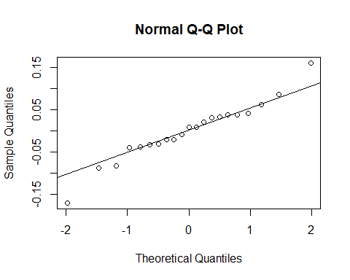

qqnorm(resid(Pmax.Rmod))  
qqline(resid(Pmax.Rmod))

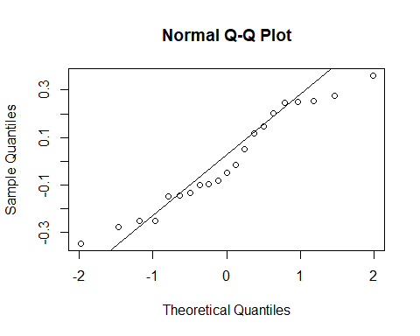

## QQplot by Species

#GP  
qqnorm(resid(Pmax.mods))  
qqline(resid(Pmax.mods))

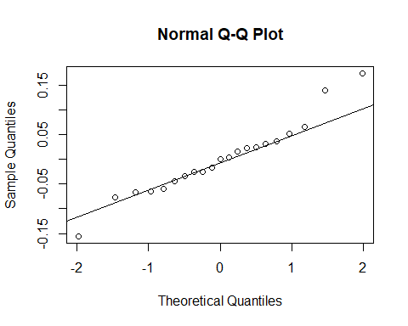

#respiration  
qqnorm(resid(Pmax.Rmods))  
qqline(resid(Pmax.Rmods))

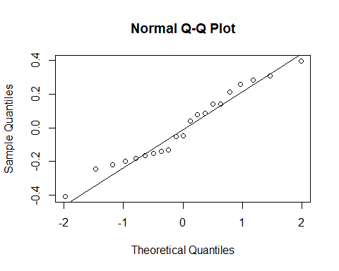

## Pmax means

Pmax.means<-Pmax_data %>%  
 group_by(species, treatment, fragment.ID2, rate.type) %>% #tells to group by these two factors  
 dplyr::summarise(mean=mean(Pmax), se=sd(Pmax)/sqrt(n())) #calculates mean and s.e.  
  
Pmax.means

## # A tibble: 16 x 6  
## # Groups: species, treatment, fragment.ID2 [8]  
## species treatment fragment.ID2 rate.type mean se  
## <fct> <fct> <chr> <fct> <dbl> <dbl>  
## 1 DLAB deep ML GP 1.21 0.0332  
## 2 DLAB deep ML R 0.340 0.250   
## 3 DLAB shallow SL GP 1.26 0.0206  
## 4 DLAB shallow SL R 0.289 0.139   
## 5 MCAV deep MC GP 0.982 0.0867  
## 6 MCAV deep MC R 0.154 0.189   
## 7 MCAV shallow SC GP 0.894 0.0202  
## 8 MCAV shallow SC R 0.0841 0.124   
## 9 OFRA deep MF GP 1.18 0.0430  
## 10 OFRA deep MF R 0.586 0.0505  
## 11 OFRA shallow SF GP 1.17 0.0207  
## 12 OFRA shallow SF R 0.435 0.174   
## 13 PAST deep MA GP 0.996 0.0955  
## 14 PAST deep MA R 0.164 0.253   
## 15 PAST shallow SA GP 0.961 0.0376  
## 16 PAST shallow SA R 0.0708 0.0630

#write.csv(Pmax.means,"C:/Github/TPC_BDA_github/R_output/Final/October_RmarkdownFinal/Pmax_means.csv")

# Summary of Parameters

Topt for GP graph

## Topt for GP across depth

GPraw<-ggplot(subset(topt_nonegspp,rate.type=="GP"), aes(x=treatment, topt_C, colour=treatment))+  
 geom_boxplot()+  
 geom_point()+  
 ylab("Topt (ºC)")  
  
GPraw

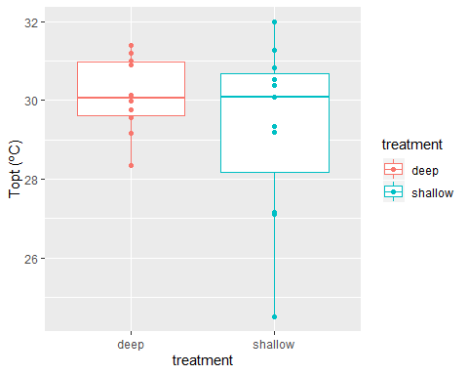

## Topt between species and depth

GPoptS<-ggplot(subset(topt_nonegspp,rate.type=="GP"), aes(x=fragment.ID2, topt_C, colour=fragment.ID2))+  
 geom_boxplot()+  
 geom_point()+  
 ylab("Topt (ºC)")  
  
GPoptS

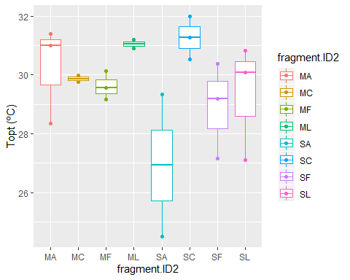

## Topt for species and depth

GPoptSp<-ggplot(subset(topt_nonegspp,rate.type=="GP"), aes(x=species, topt_C, colour=fragment.ID2))+  
 geom_boxplot()+  
 geom_point()+  
 ylab("Topt (ºC)")  
GPoptSp

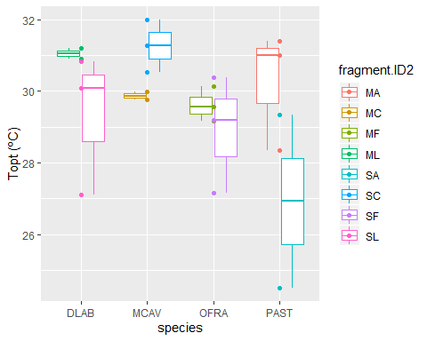

## Tpot for species

GPoptSp2<-ggplot(subset(topt_nonegspp,rate.type=="GP"), aes(x=species, topt_C, colour=species))+  
 geom_boxplot()+  
 geom_point()+  
 ylab("Topt (ºC)")  
  
GPoptSp2

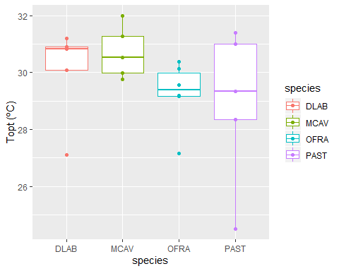

#Linear Model comparisons Anova and Tukeys {.tabset} GP parameter models

## Topt

# Fit: aov(formula = topt_C ~ treatment + fragment.ID2, data = subset(topt_nonegspp, rate.type == "GP"))  
 # treatment=depth, fragment.ID2= (species at each depth)  
  
#linear model (Treatment*Spp)  
gp.mod<-Anova(lm(topt_C~fragment.ID2 , data=subset(topt_nonegspp,rate.type=="GP")))  
gp.mod

## Anova Table (Type II tests)  
##   
## Response: topt_C  
## Sum Sq Df F value Pr(>F)  
## fragment.ID2 29.641 7 1.7344 0.1856  
## Residuals 31.739 13

summary(gp.mod)

## Sum Sq Df F value Pr(>F)   
## Min. :29.64 Min. : 7.0 Min. :1.734 Min. :0.1856   
## 1st Qu.:30.17 1st Qu.: 8.5 1st Qu.:1.734 1st Qu.:0.1856   
## Median :30.69 Median :10.0 Median :1.734 Median :0.1856   
## Mean :30.69 Mean :10.0 Mean :1.734 Mean :0.1856   
## 3rd Qu.:31.21 3rd Qu.:11.5 3rd Qu.:1.734 3rd Qu.:0.1856   
## Max. :31.74 Max. :13.0 Max. :1.734 Max. :0.1856   
## NA's :1 NA's :1

#treatment  
gp.modT<-Anova(lm(topt_C~treatment , data=subset(topt_nonegspp,rate.type=="GP")))  
gp.modT

## Anova Table (Type II tests)  
##   
## Response: topt_C  
## Sum Sq Df F value Pr(>F)  
## treatment 3.603 1 1.1847 0.29  
## Residuals 57.778 19

summary(gp.modT)

## Sum Sq Df F value Pr(>F)   
## Min. : 3.603 Min. : 1.0 Min. :1.185 Min. :0.29   
## 1st Qu.:17.146 1st Qu.: 5.5 1st Qu.:1.185 1st Qu.:0.29   
## Median :30.690 Median :10.0 Median :1.185 Median :0.29   
## Mean :30.690 Mean :10.0 Mean :1.185 Mean :0.29   
## 3rd Qu.:44.234 3rd Qu.:14.5 3rd Qu.:1.185 3rd Qu.:0.29   
## Max. :57.778 Max. :19.0 Max. :1.185 Max. :0.29   
## NA's :1 NA's :1

#Spp  
gp.modspp<-Anova(lm(topt_C~species, data=subset(topt_nonegspp,rate.type=="GP")))  
gp.modspp

## Anova Table (Type II tests)  
##   
## Response: topt_C  
## Sum Sq Df F value Pr(>F)  
## species 9.840 3 1.0818 0.3833  
## Residuals 51.541 17

summary(gp.modspp)

## Sum Sq Df F value Pr(>F)   
## Min. : 9.84 Min. : 3.0 Min. :1.082 Min. :0.3833   
## 1st Qu.:20.27 1st Qu.: 6.5 1st Qu.:1.082 1st Qu.:0.3833   
## Median :30.69 Median :10.0 Median :1.082 Median :0.3833   
## Mean :30.69 Mean :10.0 Mean :1.082 Mean :0.3833   
## 3rd Qu.:41.12 3rd Qu.:13.5 3rd Qu.:1.082 3rd Qu.:0.3833   
## Max. :51.54 Max. :17.0 Max. :1.082 Max. :0.3833   
## NA's :1 NA's :1

# No significant differnece in Topt across Treatment*Spp= fragment.ID2)  
m1N<-aov(topt_C~fragment.ID2, data=subset(topt_nonegspp,rate.type=="GP"))  
TukeyHSD(m1N)

## Tukey multiple comparisons of means  
## 95% family-wise confidence level  
##   
## Fit: aov(formula = topt_C ~ fragment.ID2, data = subset(topt_nonegspp, rate.type == "GP"))  
##   
## $fragment.ID2  
## diff lwr upr p adj  
## MC-MA -0.3738444 -5.4664093 4.718720 0.9999927  
## MF-MA -0.6266505 -5.1815790 3.928278 0.9995090  
## ML-MA 0.8095328 -4.2830320 5.902098 0.9987603  
## SA-MA -3.3184680 -8.4110328 1.774097 0.3483422  
## SC-MA 1.0266529 -3.5282755 5.581581 0.9897272  
## SF-MA -1.3275561 -5.8824846 3.227372 0.9587658  
## SL-MA -0.8973942 -5.4523227 3.657534 0.9953373  
## MF-MC -0.2528061 -5.3453709 4.839759 0.9999995  
## ML-MC 1.1833773 -4.3952480 6.762003 0.9927724  
## SA-MC -2.9446236 -8.5232488 2.634002 0.5818735  
## SC-MC 1.4004974 -3.6920674 6.493062 0.9693957  
## SF-MC -0.9537117 -6.0462765 4.138853 0.9965682  
## SL-MC -0.5235498 -5.6161146 4.569015 0.9999283  
## ML-MF 1.4361834 -3.6563815 6.528748 0.9651328  
## SA-MF -2.6918175 -7.7843823 2.400747 0.5803583  
## SC-MF 1.6533035 -2.9016250 6.208232 0.8851745  
## SF-MF -0.7009056 -5.2558340 3.854023 0.9989914  
## SL-MF -0.2707437 -4.8256721 4.284185 0.9999983  
## SA-ML -4.1280009 -9.7066261 1.450624 0.2240407  
## SC-ML 0.2171201 -4.8754447 5.309685 0.9999998  
## SF-ML -2.1370890 -7.2296538 2.955476 0.7959775  
## SL-ML -1.7069271 -6.7994919 3.385638 0.9192201  
## SC-SA 4.3451210 -0.7474439 9.437686 0.1196656  
## SF-SA 1.9909119 -3.1016529 7.083477 0.8441951  
## SL-SA 2.4210738 -2.6714910 7.513639 0.6893247  
## SF-SC -2.3542091 -6.9091375 2.200719 0.6044953  
## SL-SC -1.9240472 -6.4789756 2.630881 0.7910528  
## SL-SF 0.4301619 -4.1247665 4.985090 0.9999595

summary(m1N)

## Df Sum Sq Mean Sq F value Pr(>F)  
## fragment.ID2 7 29.64 4.234 1.734 0.186  
## Residuals 13 31.74 2.441

#Treatment  
m1NT<-aov(topt_C~treatment, data=subset(topt_nonegspp,rate.type=="GP"))  
TukeyHSD(m1NT)

## Tukey multiple comparisons of means  
## 95% family-wise confidence level  
##   
## Fit: aov(formula = topt_C ~ treatment, data = subset(topt_nonegspp, rate.type == "GP"))  
##   
## $treatment  
## diff lwr upr p adj  
## shallow-deep -0.8293087 -2.424059 0.765442 0.2900225

summary(m1N)

## Df Sum Sq Mean Sq F value Pr(>F)  
## fragment.ID2 7 29.64 4.234 1.734 0.186  
## Residuals 13 31.74 2.441

#species  
m1Nsp<-aov(topt_C~treatment+species, data=subset(topt_nonegspp,rate.type=="GP"))  
TukeyHSD(m1Nsp)

## Tukey multiple comparisons of means  
## 95% family-wise confidence level  
##   
## Fit: aov(formula = topt_C ~ treatment + species, data = subset(topt_nonegspp, rate.type == "GP"))  
##   
## $treatment  
## diff lwr upr p adj  
## shallow-deep -0.8293087 -2.396782 0.7381646 0.2785898  
##   
## $species  
## diff lwr upr p adj  
## MCAV-DLAB 0.6810774 -2.381036 3.743191 0.9187213  
## OFRA-DLAB -0.8454108 -3.777161 2.086340 0.8418335  
## PAST-DLAB -1.2786255 -4.340739 1.783488 0.6387657  
## OFRA-MCAV -1.5264882 -4.458239 1.405262 0.4660442  
## PAST-MCAV -1.9597029 -5.021816 1.102410 0.2955604  
## PAST-OFRA -0.4332148 -3.364965 2.498536 0.9737552

summary(m1Nsp)

## Df Sum Sq Mean Sq F value Pr(>F)  
## treatment 1 3.60 3.603 1.258 0.279  
## species 3 11.96 3.986 1.392 0.281  
## Residuals 16 45.82 2.864

#m1Nsp<-aov(topt_C~+rate.type, data=topt_nonegspp)  
#TukeyHSD(m1Nsp)  
#summary(m1Nsp)  
##yes difference between Respiration (topt and GP Topt)  
  
#linear model for Topt- Respiration- NO difference  
R.mod<-Anova(lm(topt_C~fragment.ID2, data=subset(topt_nonegspp,rate.type=="R")))  
R.mod

## Anova Table (Type II tests)  
##   
## Response: topt_C  
## Sum Sq Df F value Pr(>F)  
## fragment.ID2 294.32 7 0.3922 0.8906  
## Residuals 1393.56 13

summary(R.mod)

## Sum Sq Df F value Pr(>F)   
## Min. : 294.3 Min. : 7.0 Min. :0.3922 Min. :0.8906   
## 1st Qu.: 569.1 1st Qu.: 8.5 1st Qu.:0.3922 1st Qu.:0.8906   
## Median : 843.9 Median :10.0 Median :0.3922 Median :0.8906   
## Mean : 843.9 Mean :10.0 Mean :0.3922 Mean :0.8906   
## 3rd Qu.:1118.8 3rd Qu.:11.5 3rd Qu.:0.3922 3rd Qu.:0.8906   
## Max. :1393.6 Max. :13.0 Max. :0.3922 Max. :0.8906   
## NA's :1 NA's :1

#Spp*treatment  
m2N<-aov(topt_C~fragment.ID2, data=subset(topt_nonegspp,rate.type=="R"))   
TukeyHSD(m2N)

## Tukey multiple comparisons of means  
## 95% family-wise confidence level  
##   
## Fit: aov(formula = topt_C ~ fragment.ID2, data = subset(topt_nonegspp, rate.type == "R"))  
##   
## $fragment.ID2  
## diff lwr upr p adj  
## MC-MA -0.04505413 -33.78942 33.69931 1.0000000  
## MF-MA 8.07133048 -28.89377 45.03643 0.9914455  
## ML-MA 5.56359540 -31.40151 42.52870 0.9991242  
## SA-MA -3.53662589 -37.28099 30.20774 0.9999185  
## SC-MA 2.50170640 -31.24266 36.24608 0.9999922  
## SF-MA 7.18010696 -26.56426 40.92448 0.9926413  
## SL-MA 0.93930670 -32.80506 34.68368 1.0000000  
## MF-MC 8.11638461 -25.62798 41.86075 0.9851647  
## ML-MC 5.60864953 -28.13572 39.35302 0.9983586  
## SA-MC -3.49157176 -33.67345 26.69031 0.9998426  
## SC-MC 2.54676053 -27.63512 32.72864 0.9999811  
## SF-MC 7.22516109 -22.95672 37.40704 0.9855526  
## SL-MC 0.98436083 -29.19752 31.16624 1.0000000  
## ML-MF -2.50773508 -39.47284 34.45737 0.9999958  
## SA-MF -11.60795637 -45.35233 22.13641 0.9091671  
## SC-MF -5.56962408 -39.31399 28.17474 0.9984289  
## SF-MF -0.89122352 -34.63559 32.85315 1.0000000  
## SL-MF -7.13202378 -40.87639 26.61235 0.9929254  
## SA-ML -9.10022129 -42.84459 24.64415 0.9723816  
## SC-ML -3.06188900 -36.80626 30.68248 0.9999691  
## SF-ML 1.61651156 -32.12786 35.36088 0.9999996  
## SL-ML -4.62428871 -38.36866 29.12008 0.9995213  
## SC-SA 6.03833229 -24.14355 36.22021 0.9948883  
## SF-SA 10.71673285 -19.46515 40.89861 0.8955494  
## SL-SA 4.47593259 -25.70595 34.65781 0.9992034  
## SF-SC 4.67840056 -25.50348 34.86028 0.9989434  
## SL-SC -1.56239970 -31.74428 28.61948 0.9999993  
## SL-SF -6.24080026 -36.42268 23.94108 0.9937819

#Treatment  
m2NT<-aov(topt_C~treatment, data=subset(topt_nonegspp,rate.type=="R"))   
TukeyHSD(m2NT)

## Tukey multiple comparisons of means  
## 95% family-wise confidence level  
##   
## Fit: aov(formula = topt_C ~ treatment, data = subset(topt_nonegspp, rate.type == "R"))  
##   
## $treatment  
## diff lwr upr p adj  
## shallow-deep -1.243842 -9.922249 7.434565 0.767446

#Species  
m2Nspp<-aov(topt_C~species, data=subset(topt_nonegspp,rate.type=="R"))   
TukeyHSD(m2Nspp)

## Tukey multiple comparisons of means  
## 95% family-wise confidence level  
##   
## Fit: aov(formula = topt_C ~ species, data = subset(topt_nonegspp, rate.type == "R"))  
##   
## $species  
## diff lwr upr p adj  
## MCAV-DLAB -1.560696 -17.429417 14.308025 0.9920875  
## OFRA-DLAB 4.747574 -11.826764 21.321913 0.8469164  
## PAST-DLAB -4.910998 -21.485336 11.663341 0.8336695  
## OFRA-MCAV 6.308270 -9.560451 22.176991 0.6766925  
## PAST-MCAV -3.350302 -19.219023 12.518419 0.9306110  
## PAST-OFRA -9.658572 -26.232911 6.915767 0.3755643

## lnc

# Fit: aov(formula = lnc ~ treatment + fragment.ID2, data = subset(topt_nonegspp, rate.type == "GP"))  
IncGP.mod<-Anova(lm(lnc~fragment.ID2, data=subset(topt_nonegspp,rate.type=="GP")))  
IncGP.mod

## Anova Table (Type II tests)  
##   
## Response: lnc  
## Sum Sq Df F value Pr(>F)  
## fragment.ID2 1.5172 7 2.166 0.1086  
## Residuals 1.3009 13

summary(IncGP.mod)

## Sum Sq Df F value Pr(>F)   
## Min. :1.301 Min. : 7.0 Min. :2.166 Min. :0.1086   
## 1st Qu.:1.355 1st Qu.: 8.5 1st Qu.:2.166 1st Qu.:0.1086   
## Median :1.409 Median :10.0 Median :2.166 Median :0.1086   
## Mean :1.409 Mean :10.0 Mean :2.166 Mean :0.1086   
## 3rd Qu.:1.463 3rd Qu.:11.5 3rd Qu.:2.166 3rd Qu.:0.1086   
## Max. :1.517 Max. :13.0 Max. :2.166 Max. :0.1086   
## NA's :1 NA's :1

IncGP.modT<-Anova(lm(lnc~treatment, data=subset(topt_nonegspp,rate.type=="GP")))  
IncGP.modT

## Anova Table (Type II tests)  
##   
## Response: lnc  
## Sum Sq Df F value Pr(>F)  
## treatment 0.25735 1 1.9094 0.1831  
## Residuals 2.56082 19

summary(IncGP.modT)

## Sum Sq Df F value Pr(>F)   
## Min. :0.2574 Min. : 1.0 Min. :1.909 Min. :0.1831   
## 1st Qu.:0.8332 1st Qu.: 5.5 1st Qu.:1.909 1st Qu.:0.1831   
## Median :1.4091 Median :10.0 Median :1.909 Median :0.1831   
## Mean :1.4091 Mean :10.0 Mean :1.909 Mean :0.1831   
## 3rd Qu.:1.9850 3rd Qu.:14.5 3rd Qu.:1.909 3rd Qu.:0.1831   
## Max. :2.5608 Max. :19.0 Max. :1.909 Max. :0.1831   
## NA's :1 NA's :1

IncGP.modsp<-Anova(lm(lnc~species, data=subset(topt_nonegspp,rate.type=="GP")))  
IncGP.modsp

## Anova Table (Type II tests)  
##   
## Response: lnc  
## Sum Sq Df F value Pr(>F)  
## species 0.64714 3 1.6891 0.207  
## Residuals 2.17103 17

summary(IncGP.modsp)

## Sum Sq Df F value Pr(>F)   
## Min. :0.6471 Min. : 3.0 Min. :1.689 Min. :0.207   
## 1st Qu.:1.0281 1st Qu.: 6.5 1st Qu.:1.689 1st Qu.:0.207   
## Median :1.4091 Median :10.0 Median :1.689 Median :0.207   
## Mean :1.4091 Mean :10.0 Mean :1.689 Mean :0.207   
## 3rd Qu.:1.7901 3rd Qu.:13.5 3rd Qu.:1.689 3rd Qu.:0.207   
## Max. :2.1710 Max. :17.0 Max. :1.689 Max. :0.207   
## NA's :1 NA's :1

m3N<-aov(lnc~fragment.ID2, data=subset(topt_nonegspp,rate.type=="GP"))  
TukeyHSD(m3N)

## Tukey multiple comparisons of means  
## 95% family-wise confidence level  
##   
## Fit: aov(formula = lnc ~ fragment.ID2, data = subset(topt_nonegspp, rate.type == "GP"))  
##   
## $fragment.ID2  
## diff lwr upr p adj  
## MC-MA 0.05179603 -0.9792129 1.0828049 0.9999995  
## MF-MA 0.32237641 -0.5997860 1.2445388 0.9024297  
## ML-MA 0.18869614 -0.8423128 1.2197050 0.9970175  
## SA-MA 0.75766244 -0.2733465 1.7886713 0.2301190  
## SC-MA -0.11425661 -1.0364190 0.8079058 0.9997523  
## SF-MA 0.43695670 -0.4852057 1.3591191 0.6924946  
## SL-MA 0.51589892 -0.4062635 1.4380613 0.5176521  
## MF-MC 0.27058038 -0.7604285 1.3015893 0.9761002  
## ML-MC 0.13690011 -0.9925136 1.2663138 0.9997856  
## SA-MC 0.70586642 -0.4235473 1.8352801 0.3935983  
## SC-MC -0.16605264 -1.1970615 0.8649563 0.9986534  
## SF-MC 0.38516067 -0.6458482 1.4161696 0.8703968  
## SL-MC 0.46410289 -0.5669060 1.4951118 0.7392949  
## ML-MF -0.13368027 -1.1646892 0.8973286 0.9996662  
## SA-MF 0.43528603 -0.5957229 1.4662949 0.7914392  
## SC-MF -0.43663302 -1.3587954 0.4855294 0.6932006  
## SF-MF 0.11458029 -0.8075821 1.0367427 0.9997476  
## SL-MF 0.19352251 -0.7286399 1.1156849 0.9932147  
## SA-ML 0.56896630 -0.5604474 1.6983800 0.6314375  
## SC-ML -0.30295275 -1.3339617 0.7280562 0.9570393  
## SF-ML 0.24826056 -0.7827483 1.2792695 0.9850722  
## SL-ML 0.32720278 -0.7038061 1.3582117 0.9373897  
## SC-SA -0.87191905 -1.9029280 0.1590899 0.1249618  
## SF-SA -0.32070574 -1.3517146 0.7103032 0.9431314  
## SL-SA -0.24176352 -1.2727724 0.7892454 0.9871352  
## SF-SC 0.55121331 -0.3709491 1.4733757 0.4432116  
## SL-SC 0.63015553 -0.2920069 1.5523179 0.2990811  
## SL-SF 0.07894222 -0.8432202 1.0011046 0.9999792

m3N

## Call:  
## aov(formula = lnc ~ fragment.ID2, data = subset(topt_nonegspp,   
## rate.type == "GP"))  
##   
## Terms:  
## fragment.ID2 Residuals  
## Sum of Squares 1.517255 1.300915  
## Deg. of Freedom 7 13  
##   
## Residual standard error: 0.3163391  
## Estimated effects may be unbalanced

m3Nt<-aov(lnc~treatment, data=subset(topt_nonegspp,rate.type=="GP"))  
TukeyHSD(m3Nt)

## Tukey multiple comparisons of means  
## 95% family-wise confidence level  
##   
## Fit: aov(formula = lnc ~ treatment, data = subset(topt_nonegspp, rate.type == "GP"))  
##   
## $treatment  
## diff lwr upr p adj  
## shallow-deep 0.2216543 -0.1140835 0.557392 0.1830609

m3Nt

## Call:  
## aov(formula = lnc ~ treatment, data = subset(topt_nonegspp, rate.type ==   
## "GP"))  
##   
## Terms:  
## treatment Residuals  
## Sum of Squares 0.2573508 2.5608191  
## Deg. of Freedom 1 19  
##   
## Residual standard error: 0.3671239  
## Estimated effects may be unbalanced

m3Nsp<-aov(lnc~species, data=subset(topt_nonegspp,rate.type=="GP"))  
TukeyHSD(m3Nsp)

## Tukey multiple comparisons of means  
## 95% family-wise confidence level  
##   
## Fit: aov(formula = lnc ~ species, data = subset(topt_nonegspp, rate.type == "GP"))  
##   
## $species  
## diff lwr upr p adj  
## MCAV-DLAB -0.432853363 -1.0753164 0.2096097 0.2586684  
## OFRA-DLAB -0.005351253 -0.6204628 0.6097603 0.9999943  
## PAST-DLAB -0.081952830 -0.7244159 0.5605102 0.9831316  
## OFRA-MCAV 0.427502111 -0.1876095 1.0426137 0.2355181  
## PAST-MCAV 0.350900533 -0.2915625 0.9933636 0.4300802  
## PAST-OFRA -0.076601578 -0.6917131 0.5385100 0.9842624

m3Nsp

## Call:  
## aov(formula = lnc ~ species, data = subset(topt_nonegspp, rate.type ==   
## "GP"))  
##   
## Terms:  
## species Residuals  
## Sum of Squares 0.6471368 2.1710332  
## Deg. of Freedom 3 17  
##   
## Residual standard error: 0.3573623  
## Estimated effects may be unbalanced

#linear model for R lnc  
Inc.R.mod<-Anova(lm(lnc~fragment.ID2, data=subset(topt_nonegspp,rate.type=="R")))  
Inc.R.mod

## Anova Table (Type II tests)  
##   
## Response: lnc  
## Sum Sq Df F value Pr(>F)  
## fragment.ID2 1916.0 7 0.8857 0.5438  
## Residuals 4017.6 13

summary(Inc.R.mod)

## Sum Sq Df F value Pr(>F)   
## Min. :1916 Min. : 7.0 Min. :0.8857 Min. :0.5438   
## 1st Qu.:2441 1st Qu.: 8.5 1st Qu.:0.8857 1st Qu.:0.5438   
## Median :2967 Median :10.0 Median :0.8857 Median :0.5438   
## Mean :2967 Mean :10.0 Mean :0.8857 Mean :0.5438   
## 3rd Qu.:3492 3rd Qu.:11.5 3rd Qu.:0.8857 3rd Qu.:0.5438   
## Max. :4018 Max. :13.0 Max. :0.8857 Max. :0.5438   
## NA's :1 NA's :1

IncR.modT<-Anova(lm(lnc~treatment, data=subset(topt_nonegspp,rate.type=="R")))  
IncR.modT

## Anova Table (Type II tests)  
##   
## Response: lnc  
## Sum Sq Df F value Pr(>F)  
## treatment 185.1 1 0.6118 0.4438  
## Residuals 5748.5 19

summary(IncR.modT)

## Sum Sq Df F value Pr(>F)   
## Min. : 185.1 Min. : 1.0 Min. :0.6118 Min. :0.4438   
## 1st Qu.:1575.9 1st Qu.: 5.5 1st Qu.:0.6118 1st Qu.:0.4438   
## Median :2966.8 Median :10.0 Median :0.6118 Median :0.4438   
## Mean :2966.8 Mean :10.0 Mean :0.6118 Mean :0.4438   
## 3rd Qu.:4357.6 3rd Qu.:14.5 3rd Qu.:0.6118 3rd Qu.:0.4438   
## Max. :5748.5 Max. :19.0 Max. :0.6118 Max. :0.4438   
## NA's :1 NA's :1

IncR.modsp<-Anova(lm(lnc~species, data=subset(topt_nonegspp,rate.type=="R")))  
IncR.modsp

## Anova Table (Type II tests)  
##   
## Response: lnc  
## Sum Sq Df F value Pr(>F)  
## species 1275.6 3 1.5518 0.2376  
## Residuals 4658.0 17

summary(IncR.modsp)

## Sum Sq Df F value Pr(>F)   
## Min. :1276 Min. : 3.0 Min. :1.552 Min. :0.2376   
## 1st Qu.:2121 1st Qu.: 6.5 1st Qu.:1.552 1st Qu.:0.2376   
## Median :2967 Median :10.0 Median :1.552 Median :0.2376   
## Mean :2967 Mean :10.0 Mean :1.552 Mean :0.2376   
## 3rd Qu.:3812 3rd Qu.:13.5 3rd Qu.:1.552 3rd Qu.:0.2376   
## Max. :4658 Max. :17.0 Max. :1.552 Max. :0.2376   
## NA's :1 NA's :1

m4N<-aov(lnc~fragment.ID2, data=subset(topt_nonegspp,rate.type=="R"))  
TukeyHSD(m4N)

## Tukey multiple comparisons of means  
## 95% family-wise confidence level  
##   
## Fit: aov(formula = lnc ~ fragment.ID2, data = subset(topt_nonegspp, rate.type == "R"))  
##   
## $fragment.ID2  
## diff lwr upr p adj  
## MC-MA 15.4901374 -41.80548 72.78575 0.9720160  
## MF-MA -1.4042171 -64.16842 61.35999 1.0000000  
## ML-MA 15.6292208 -47.13498 78.39342 0.9820240  
## SA-MA 20.7227542 -36.57286 78.01837 0.8869047  
## SC-MA 12.0371030 -45.25851 69.33272 0.9931708  
## SF-MA -0.5021172 -57.79773 56.79350 1.0000000  
## SL-MA 25.0367796 -32.25884 82.33240 0.7643549  
## MF-MC -16.8943544 -74.18997 40.40126 0.9562852  
## ML-MC 0.1390834 -57.15653 57.43470 1.0000000  
## SA-MC 5.2326168 -46.01414 56.47937 0.9999316  
## SC-MC -3.4530344 -54.69979 47.79372 0.9999959  
## SF-MC -15.9922546 -67.23901 35.25450 0.9422406  
## SL-MC 9.5466422 -41.70011 60.79340 0.9966769  
## ML-MF 17.0334378 -45.73076 79.79764 0.9714485  
## SA-MF 22.1269712 -35.16864 79.42259 0.8516072  
## SC-MF 13.4413201 -43.85430 70.73694 0.9871030  
## SF-MF 0.9020998 -56.39352 58.19772 1.0000000  
## SL-MF 26.4409966 -30.85462 83.73661 0.7171338  
## SA-ML 5.0935334 -52.20208 62.38915 0.9999731  
## SC-ML -3.5921178 -60.88773 53.70350 0.9999975  
## SF-ML -16.1313380 -73.42695 41.16428 0.9654309  
## SL-ML 9.4075588 -47.88806 66.70317 0.9984796  
## SC-SA -8.6856512 -59.93241 42.56111 0.9981454  
## SF-SA -21.2248714 -72.47163 30.02189 0.8056105  
## SL-SA 4.3140254 -46.93273 55.56078 0.9999814  
## SF-SC -12.5392202 -63.78598 38.70754 0.9836821  
## SL-SC 12.9996766 -38.24708 64.24643 0.9801087  
## SL-SF 25.5388968 -25.70786 76.78565 0.6425825

summary(m4N)

## Df Sum Sq Mean Sq F value Pr(>F)  
## fragment.ID2 7 1916 273.7 0.886 0.544  
## Residuals 13 4018 309.1

m4Nt<-aov(lnc~treatment, data=subset(topt_nonegspp,rate.type=="R"))  
TukeyHSD(m4Nt)

## Tukey multiple comparisons of means  
## 95% family-wise confidence level  
##   
## Fit: aov(formula = lnc ~ treatment, data = subset(topt_nonegspp, rate.type == "R"))  
##   
## $treatment  
## diff lwr upr p adj  
## shallow-deep 5.999139 -10.05447 22.05274 0.4437648

m4Nt

## Call:  
## aov(formula = lnc ~ treatment, data = subset(topt_nonegspp, rate.type ==   
## "R"))  
##   
## Terms:  
## treatment Residuals  
## Sum of Squares 185.090 5748.504  
## Deg. of Freedom 1 19  
##   
## Residual standard error: 17.39405  
## Estimated effects may be unbalanced

m4Nsp<-aov(lnc~species, data=subset(topt_nonegspp,rate.type=="R"))  
TukeyHSD(m4Nsp)

## Tukey multiple comparisons of means  
## 95% family-wise confidence level  
##   
## Fit: aov(formula = lnc ~ species, data = subset(topt_nonegspp, rate.type == "R"))  
##   
## $species  
## diff lwr upr p adj  
## MCAV-DLAB -7.510136 -36.00193 20.981654 0.8757190  
## OFRA-DLAB -22.136713 -51.89542 7.621991 0.1882374  
## PAST-DLAB -8.840104 -38.59881 20.918600 0.8326317  
## OFRA-MCAV -14.626577 -43.11837 13.865212 0.4820233  
## PAST-MCAV -1.329968 -29.82176 27.161822 0.9991313  
## PAST-OFRA 13.296610 -16.46209 43.055314 0.5931396

m4Nsp

## Call:  
## aov(formula = lnc ~ species, data = subset(topt_nonegspp, rate.type ==   
## "R"))  
##   
## Terms:  
## species Residuals  
## Sum of Squares 1275.608 4657.986  
## Deg. of Freedom 3 17  
##   
## Residual standard error: 16.55292  
## Estimated effects may be unbalanced

## E

#linear model  
E.GP.mod<-Anova(lm(E~fragment.ID2, data=subset(topt_nonegspp,rate.type=="GP")))  
E.GP.mod

## Anova Table (Type II tests)  
##   
## Response: E  
## Sum Sq Df F value Pr(>F)  
## fragment.ID2 0.97926 7 1.4519 0.2663  
## Residuals 1.25256 13

summary(E.GP.mod)

## Sum Sq Df F value Pr(>F)   
## Min. :0.9793 Min. : 7.0 Min. :1.452 Min. :0.2663   
## 1st Qu.:1.0476 1st Qu.: 8.5 1st Qu.:1.452 1st Qu.:0.2663   
## Median :1.1159 Median :10.0 Median :1.452 Median :0.2663   
## Mean :1.1159 Mean :10.0 Mean :1.452 Mean :0.2663   
## 3rd Qu.:1.1842 3rd Qu.:11.5 3rd Qu.:1.452 3rd Qu.:0.2663   
## Max. :1.2526 Max. :13.0 Max. :1.452 Max. :0.2663   
## NA's :1 NA's :1

E.GP.modT<-Anova(lm(E~treatment, data=subset(topt_nonegspp,rate.type=="GP")))  
E.GP.modT

## Anova Table (Type II tests)  
##   
## Response: E  
## Sum Sq Df F value Pr(>F)  
## treatment 0.27787 1 2.702 0.1167  
## Residuals 1.95395 19

summary(E.GP.modT)

## Sum Sq Df F value Pr(>F)   
## Min. :0.2779 Min. : 1.0 Min. :2.702 Min. :0.1167   
## 1st Qu.:0.6969 1st Qu.: 5.5 1st Qu.:2.702 1st Qu.:0.1167   
## Median :1.1159 Median :10.0 Median :2.702 Median :0.1167   
## Mean :1.1159 Mean :10.0 Mean :2.702 Mean :0.1167   
## 3rd Qu.:1.5349 3rd Qu.:14.5 3rd Qu.:2.702 3rd Qu.:0.1167   
## Max. :1.9539 Max. :19.0 Max. :2.702 Max. :0.1167   
## NA's :1 NA's :1

E.GP.modspp<-Anova(lm(E~species, data=subset(topt_nonegspp,rate.type=="GP")))  
E.GP.modspp

## Anova Table (Type II tests)  
##   
## Response: E  
## Sum Sq Df F value Pr(>F)  
## species 0.2475 3 0.7068 0.5611  
## Residuals 1.9843 17

summary(E.GP.modspp)

## Sum Sq Df F value Pr(>F)   
## Min. :0.2475 Min. : 3.0 Min. :0.7068 Min. :0.5611   
## 1st Qu.:0.6817 1st Qu.: 6.5 1st Qu.:0.7068 1st Qu.:0.5611   
## Median :1.1159 Median :10.0 Median :0.7068 Median :0.5611   
## Mean :1.1159 Mean :10.0 Mean :0.7068 Mean :0.5611   
## 3rd Qu.:1.5501 3rd Qu.:13.5 3rd Qu.:0.7068 3rd Qu.:0.5611   
## Max. :1.9843 Max. :17.0 Max. :0.7068 Max. :0.5611   
## NA's :1 NA's :1

mEN<-aov(E~fragment.ID2, data=subset(topt_nonegspp,rate.type=="GP"))  
TukeyHSD(mEN)

## Tukey multiple comparisons of means  
## 95% family-wise confidence level  
##   
## Fit: aov(formula = E ~ fragment.ID2, data = subset(topt_nonegspp, rate.type == "GP"))  
##   
## $fragment.ID2  
## diff lwr upr p adj  
## MC-MA 0.058076225 -0.9535909 1.0697433 0.9999987  
## MF-MA 0.216950893 -0.6879117 1.1218134 0.9854260  
## ML-MA 0.024500496 -0.9871666 1.0361676 1.0000000  
## SA-MA 0.690429735 -0.3212373 1.7020968 0.3003755  
## SC-MA -0.016500709 -0.9213633 0.8883618 1.0000000  
## SF-MA 0.351576132 -0.5532864 1.2564387 0.8479640  
## SL-MA 0.348355312 -0.5565072 1.2532179 0.8534623  
## MF-MC 0.158874668 -0.8527924 1.1705418 0.9988522  
## ML-MC -0.033575728 -1.1418015 1.0746500 1.0000000  
## SA-MC 0.632353510 -0.4758723 1.7405793 0.4954931  
## SC-MC -0.074576934 -1.0862440 0.9370902 0.9999925  
## SF-MC 0.293499907 -0.7181672 1.3051670 0.9597142  
## SL-MC 0.290279088 -0.7213880 1.3019462 0.9619082  
## ML-MF -0.192450397 -1.2041175 0.8192167 0.9962257  
## SA-MF 0.473478842 -0.5381882 1.4851459 0.7041587  
## SC-MF -0.233451602 -1.1383142 0.6714109 0.9781976  
## SF-MF 0.134625239 -0.7702373 1.0394878 0.9991867  
## SL-MF 0.131404420 -0.7734581 1.0362670 0.9993037  
## SA-ML 0.665929238 -0.4422965 1.7741550 0.4373043  
## SC-ML -0.041001206 -1.0526683 0.9706659 0.9999999  
## SF-ML 0.327075636 -0.6845914 1.3387427 0.9316497  
## SL-ML 0.323854816 -0.6878123 1.3355219 0.9347647  
## SC-SA -0.706930444 -1.7185975 0.3047366 0.2769881  
## SF-SA -0.338853603 -1.3505207 0.6728135 0.9194779  
## SL-SA -0.342074422 -1.3537415 0.6695927 0.9159355  
## SF-SC 0.368076841 -0.5367857 1.2729394 0.8183024  
## SL-SC 0.364856022 -0.5400065 1.2697186 0.8242807  
## SL-SF -0.003220819 -0.9080834 0.9016417 1.0000000

summary(mEN)

## Df Sum Sq Mean Sq F value Pr(>F)  
## fragment.ID2 7 0.9793 0.13989 1.452 0.266  
## Residuals 13 1.2526 0.09635

mENt<-aov(E~treatment, data=subset(topt_nonegspp,rate.type=="GP"))  
TukeyHSD(mENt)

## Tukey multiple comparisons of means  
## 95% family-wise confidence level  
##   
## Fit: aov(formula = E ~ treatment, data = subset(topt_nonegspp, rate.type == "GP"))  
##   
## $treatment  
## diff lwr upr p adj  
## shallow-deep 0.2303223 -0.06294724 0.5235918 0.1166674

summary(mENt)

## Df Sum Sq Mean Sq F value Pr(>F)  
## treatment 1 0.2779 0.2779 2.702 0.117  
## Residuals 19 1.9539 0.1028

mENs<-aov(E~species, data=subset(topt_nonegspp,rate.type=="GP"))  
TukeyHSD(mENs)

## Tukey multiple comparisons of means  
## 95% family-wise confidence level  
##   
## Fit: aov(formula = E ~ species, data = subset(topt_nonegspp, rate.type == "GP"))  
##   
## $species  
## diff lwr upr p adj  
## MCAV-DLAB -0.205483322 -0.8196977 0.4087311 0.7782264  
## OFRA-DLAB 0.065450126 -0.5226154 0.6535156 0.9886422  
## PAST-DLAB 0.057358508 -0.5568559 0.6715729 0.9932036  
## OFRA-MCAV 0.270933448 -0.3171321 0.8589990 0.5695331  
## PAST-MCAV 0.262841830 -0.3513726 0.8770562 0.6252717  
## PAST-OFRA -0.008091619 -0.5961571 0.5799739 0.9999776

summary(mENs)

## Df Sum Sq Mean Sq F value Pr(>F)  
## species 3 0.2475 0.0825 0.707 0.561  
## Residuals 17 1.9843 0.1167

#linear model for R E  
E.R.mod<-Anova(lm(E~fragment.ID2, data=subset(topt_nonegspp,rate.type=="R")))  
E.R.mod

## Anova Table (Type II tests)  
##   
## Response: E  
## Sum Sq Df F value Pr(>F)  
## fragment.ID2 1656.3 7 0.8778 0.549  
## Residuals 3504.3 13

summary(E.R.mod)

## Sum Sq Df F value Pr(>F)   
## Min. :1656 Min. : 7.0 Min. :0.8778 Min. :0.549   
## 1st Qu.:2118 1st Qu.: 8.5 1st Qu.:0.8778 1st Qu.:0.549   
## Median :2580 Median :10.0 Median :0.8778 Median :0.549   
## Mean :2580 Mean :10.0 Mean :0.8778 Mean :0.549   
## 3rd Qu.:3042 3rd Qu.:11.5 3rd Qu.:0.8778 3rd Qu.:0.549   
## Max. :3504 Max. :13.0 Max. :0.8778 Max. :0.549   
## NA's :1 NA's :1

E.R.modt<-Anova(lm(E~treatment, data=subset(topt_nonegspp,rate.type=="R")))  
E.R.modt

## Anova Table (Type II tests)  
##   
## Response: E  
## Sum Sq Df F value Pr(>F)  
## treatment 176.6 1 0.6734 0.422  
## Residuals 4983.9 19

summary(E.R.modt)

## Sum Sq Df F value Pr(>F)   
## Min. : 176.6 Min. : 1.0 Min. :0.6734 Min. :0.422   
## 1st Qu.:1378.5 1st Qu.: 5.5 1st Qu.:0.6734 1st Qu.:0.422   
## Median :2580.3 Median :10.0 Median :0.6734 Median :0.422   
## Mean :2580.3 Mean :10.0 Mean :0.6734 Mean :0.422   
## 3rd Qu.:3782.1 3rd Qu.:14.5 3rd Qu.:0.6734 3rd Qu.:0.422   
## Max. :4983.9 Max. :19.0 Max. :0.6734 Max. :0.422   
## NA's :1 NA's :1

E.R.mods<-Anova(lm(E~species, data=subset(topt_nonegspp,rate.type=="R")))  
E.R.mods

## Anova Table (Type II tests)  
##   
## Response: E  
## Sum Sq Df F value Pr(>F)  
## species 1093.9 3 1.5243 0.2443  
## Residuals 4066.6 17

summary(E.R.mods)

## Sum Sq Df F value Pr(>F)   
## Min. :1094 Min. : 3.0 Min. :1.524 Min. :0.2443   
## 1st Qu.:1837 1st Qu.: 6.5 1st Qu.:1.524 1st Qu.:0.2443   
## Median :2580 Median :10.0 Median :1.524 Median :0.2443   
## Mean :2580 Mean :10.0 Mean :1.524 Mean :0.2443   
## 3rd Qu.:3323 3rd Qu.:13.5 3rd Qu.:1.524 3rd Qu.:0.2443   
## Max. :4067 Max. :17.0 Max. :1.524 Max. :0.2443   
## NA's :1 NA's :1

mER<-aov(E~fragment.ID2, data=subset(topt_nonegspp,rate.type=="R"))  
TukeyHSD(mER)

## Tukey multiple comparisons of means  
## 95% family-wise confidence level  
##   
## Fit: aov(formula = E ~ fragment.ID2, data = subset(topt_nonegspp, rate.type == "R"))  
##   
## $fragment.ID2  
## diff lwr upr p adj  
## MC-MA 14.1708593 -39.33927 67.68099 0.9749181  
## MF-MA -0.2283771 -58.84579 58.38904 1.0000000  
## ML-MA 15.6737100 -42.94370 74.29112 0.9736002  
## SA-MA 19.7101140 -33.80002 73.22025 0.8778073  
## SC-MA 11.8055007 -41.70463 65.31563 0.9909174  
## SF-MA 0.3428701 -53.16726 53.85300 1.0000000  
## SL-MA 24.2078710 -29.30226 77.71800 0.7349302  
## MF-MC -14.3992364 -67.90937 39.11090 0.9726978  
## ML-MC 1.5028507 -52.00728 55.01298 1.0000000  
## SA-MC 5.5392547 -42.32166 53.40017 0.9998421  
## SC-MC -2.3653585 -50.22628 45.49556 0.9999995  
## SF-MC -13.8279892 -61.68891 34.03293 0.9605475  
## SL-MC 10.0370117 -37.82391 57.89793 0.9932423  
## ML-MF 15.9020871 -42.71533 74.51950 0.9715047  
## SA-MF 19.9384911 -33.57164 73.44863 0.8717806  
## SC-MF 12.0338779 -41.47626 65.54401 0.9898583  
## SF-MF 0.5712472 -52.93889 54.08138 1.0000000  
## SL-MF 24.4362481 -29.07389 77.94638 0.7266087  
## SA-ML 4.0364040 -49.47373 57.54654 0.9999912  
## SC-ML -3.8682092 -57.37834 49.64192 0.9999934  
## SF-ML -15.3308399 -68.84097 38.17929 0.9621968  
## SL-ML 8.5341611 -44.97597 62.04430 0.9987343  
## SC-SA -7.9046132 -55.76553 39.95631 0.9984227  
## SF-SA -19.3672439 -67.22816 28.49367 0.8218733  
## SL-SA 4.4977570 -43.36316 52.35868 0.9999609  
## SF-SC -11.4626306 -59.32355 36.39829 0.9855149  
## SL-SC 12.4023703 -35.45855 60.26329 0.9776744  
## SL-SF 23.8650009 -23.99592 71.72592 0.6420056

summary(mER)

## Df Sum Sq Mean Sq F value Pr(>F)  
## fragment.ID2 7 1656 236.6 0.878 0.549  
## Residuals 13 3504 269.6

mERt<-aov(E~treatment, data=subset(topt_nonegspp,rate.type=="R"))  
TukeyHSD(mERt)

## Tukey multiple comparisons of means  
## 95% family-wise confidence level  
##   
## Fit: aov(formula = E ~ treatment, data = subset(topt_nonegspp, rate.type == "R"))  
##   
## $treatment  
## diff lwr upr p adj  
## shallow-deep 5.860673 -9.08718 20.80853 0.4220388

summary(mERt)

## Df Sum Sq Mean Sq F value Pr(>F)  
## treatment 1 177 176.6 0.673 0.422  
## Residuals 19 4984 262.3

mERs<-aov(E~species, data=subset(topt_nonegspp,rate.type=="R"))  
TukeyHSD(mERs)

## Tukey multiple comparisons of means  
## 95% family-wise confidence level  
##   
## Fit: aov(formula = E ~ species, data = subset(topt_nonegspp, rate.type == "R"))  
##   
## $species  
## diff lwr upr p adj  
## MCAV-DLAB -7.806027 -34.42785 18.815801 0.8378608  
## OFRA-DLAB -20.679835 -48.48543 7.125757 0.1883650  
## PAST-DLAB -8.968138 -36.77373 18.837454 0.7962841  
## OFRA-MCAV -12.873809 -39.49564 13.748019 0.5310577  
## PAST-MCAV -1.162112 -27.78394 25.459716 0.9992889  
## PAST-OFRA 11.711697 -16.09390 39.517290 0.6367141

summary(mERs)

## Df Sum Sq Mean Sq F value Pr(>F)  
## species 3 1094 364.6 1.524 0.244  
## Residuals 17 4067 239.2

## Eh

#linear model  
E.GP.mod<-Anova(lm(Eh~fragment.ID2, data=subset(topt_nonegspp,rate.type=="GP")))  
E.GP.mod

## Anova Table (Type II tests)  
##   
## Response: Eh  
## Sum Sq Df F value Pr(>F)   
## fragment.ID2 16.621 7 2.5368 0.06993 .  
## Residuals 12.168 13   
## ---  
## Signif. codes: 0 '***' 0.001 '**' 0.01 '*' 0.05 '.' 0.1 ' ' 1

summary(E.GP.mod)

## Sum Sq Df F value Pr(>F)   
## Min. :12.17 Min. : 7.0 Min. :2.537 Min. :0.06993   
## 1st Qu.:13.28 1st Qu.: 8.5 1st Qu.:2.537 1st Qu.:0.06993   
## Median :14.39 Median :10.0 Median :2.537 Median :0.06993   
## Mean :14.39 Mean :10.0 Mean :2.537 Mean :0.06993   
## 3rd Qu.:15.51 3rd Qu.:11.5 3rd Qu.:2.537 3rd Qu.:0.06993   
## Max. :16.62 Max. :13.0 Max. :2.537 Max. :0.06993   
## NA's :1 NA's :1

E.GP.modT<-Anova(lm(Eh~treatment, data=subset(topt_nonegspp,rate.type=="GP")))  
E.GP.modT

## Anova Table (Type II tests)  
##   
## Response: Eh  
## Sum Sq Df F value Pr(>F)  
## treatment 0.0929 1 0.0615 0.8068  
## Residuals 28.6960 19

summary(E.GP.modT)

## Sum Sq Df F value Pr(>F)   
## Min. : 0.09288 Min. : 1.0 Min. :0.0615 Min. :0.8068   
## 1st Qu.: 7.24367 1st Qu.: 5.5 1st Qu.:0.0615 1st Qu.:0.8068   
## Median :14.39445 Median :10.0 Median :0.0615 Median :0.8068   
## Mean :14.39445 Mean :10.0 Mean :0.0615 Mean :0.8068   
## 3rd Qu.:21.54524 3rd Qu.:14.5 3rd Qu.:0.0615 3rd Qu.:0.8068   
## Max. :28.69602 Max. :19.0 Max. :0.0615 Max. :0.8068   
## NA's :1 NA's :1

E.GP.modspp<-Anova(lm(Eh~species, data=subset(topt_nonegspp,rate.type=="GP")))  
E.GP.modspp

## Anova Table (Type II tests)  
##   
## Response: Eh  
## Sum Sq Df F value Pr(>F)  
## species 4.3608 3 1.0116 0.4119  
## Residuals 24.4281 17

summary(E.GP.modspp)

## Sum Sq Df F value Pr(>F)   
## Min. : 4.361 Min. : 3.0 Min. :1.012 Min. :0.4119   
## 1st Qu.: 9.378 1st Qu.: 6.5 1st Qu.:1.012 1st Qu.:0.4119   
## Median :14.394 Median :10.0 Median :1.012 Median :0.4119   
## Mean :14.394 Mean :10.0 Mean :1.012 Mean :0.4119   
## 3rd Qu.:19.411 3rd Qu.:13.5 3rd Qu.:1.012 3rd Qu.:0.4119   
## Max. :24.428 Max. :17.0 Max. :1.012 Max. :0.4119   
## NA's :1 NA's :1

mEN<-aov(Eh~fragment.ID2, data=subset(topt_nonegspp,rate.type=="GP"))  
TukeyHSD(mEN)

## Tukey multiple comparisons of means  
## 95% family-wise confidence level  
##   
## Fit: aov(formula = Eh ~ fragment.ID2, data = subset(topt_nonegspp, rate.type == "GP"))  
##   
## $fragment.ID2  
## diff lwr upr p adj  
## MC-MA -0.88175525 -4.0348983 2.2713878 0.9666195  
## MF-MA -0.82930100 -3.6495579 1.9909559 0.9568847  
## ML-MA 0.76251492 -2.3906282 3.9156580 0.9847118  
## SA-MA -1.77515206 -4.9282952 1.3779910 0.5105963  
## SC-MA 1.21966272 -1.6005942 4.0399196 0.7727453  
## SF-MA -0.66878749 -3.4890444 2.1514694 0.9862971  
## SL-MA -0.85538038 -3.6756373 1.9648765 0.9497193  
## MF-MC 0.05245425 -3.1006888 3.2055973 1.0000000  
## ML-MC 1.64427017 -1.8098250 5.0983654 0.6880714  
## SA-MC -0.89339681 -4.3474920 2.5606984 0.9778987  
## SC-MC 2.10141797 -1.0517251 5.2545611 0.3246809  
## SF-MC 0.21296776 -2.9401753 3.3661108 0.9999959  
## SL-MC 0.02637486 -3.1267682 3.1795180 1.0000000  
## ML-MF 1.59181592 -1.5613272 4.7449590 0.6292488  
## SA-MF -0.94585106 -4.0989942 2.2072920 0.9523827  
## SC-MF 2.04896372 -0.7712932 4.8692206 0.2403778  
## SF-MF 0.16051351 -2.6597434 2.9807704 0.9999987  
## SL-MF -0.02607938 -2.8463363 2.7941775 1.0000000  
## SA-ML -2.53766698 -5.9917622 0.9164282 0.2303497  
## SC-ML 0.45714780 -2.6959953 3.6102909 0.9993111  
## SF-ML -1.43130241 -4.5844455 1.7218407 0.7319534  
## SL-ML -1.61789530 -4.7710384 1.5352478 0.6122091  
## SC-SA 2.99481478 -0.1583283 6.1479579 0.0677329  
## SF-SA 1.10636457 -2.0467785 4.2595077 0.9008363  
## SL-SA 0.91977168 -2.2333714 4.0729148 0.9585907  
## SF-SC -1.88845021 -4.7087071 0.9318067 0.3197955  
## SL-SC -2.07504311 -4.8953000 0.7452138 0.2290484  
## SL-SF -0.18659289 -3.0068498 2.6336640 0.9999964

summary(mEN)

## Df Sum Sq Mean Sq F value Pr(>F)   
## fragment.ID2 7 16.62 2.374 2.537 0.0699 .  
## Residuals 13 12.17 0.936   
## ---  
## Signif. codes: 0 '***' 0.001 '**' 0.01 '*' 0.05 '.' 0.1 ' ' 1

mENt<-aov(Eh~treatment, data=subset(topt_nonegspp,rate.type=="GP"))  
TukeyHSD(mENt)

## Tukey multiple comparisons of means  
## 95% family-wise confidence level  
##   
## Fit: aov(formula = Eh ~ treatment, data = subset(topt_nonegspp, rate.type == "GP"))  
##   
## $treatment  
## diff lwr upr p adj  
## shallow-deep -0.1331634 -1.257048 0.9907208 0.8068011

summary(mENt)

## Df Sum Sq Mean Sq F value Pr(>F)  
## treatment 1 0.093 0.0929 0.062 0.807  
## Residuals 19 28.696 1.5103

mENs<-aov(Eh~species, data=subset(topt_nonegspp,rate.type=="GP"))  
TukeyHSD(mENs)

## Tukey multiple comparisons of means  
## 95% family-wise confidence level  
##   
## Fit: aov(formula = Eh ~ species, data = subset(topt_nonegspp, rate.type == "GP"))  
##   
## $species  
## diff lwr upr p adj  
## MCAV-DLAB 0.58731780 -1.567743 2.7423790 0.8647792  
## OFRA-DLAB -0.54082198 -2.604136 1.5224921 0.8774834  
## PAST-DLAB -0.50183856 -2.656900 1.6532227 0.9098668  
## OFRA-MCAV -1.12813978 -3.191454 0.9351743 0.4291845  
## PAST-MCAV -1.08915636 -3.244218 1.0659049 0.4949884  
## PAST-OFRA 0.03898342 -2.024331 2.1022975 0.9999420

summary(mENs)

## Df Sum Sq Mean Sq F value Pr(>F)  
## species 3 4.361 1.454 1.012 0.412  
## Residuals 17 24.428 1.437

#linear model for R E  
E.R.mod<-Anova(lm(Eh~fragment.ID2, data=subset(topt_nonegspp,rate.type=="R")))  
E.R.mod

## Anova Table (Type II tests)  
##   
## Response: Eh  
## Sum Sq Df F value Pr(>F)  
## fragment.ID2 3402.2 7 0.8393 0.5745  
## Residuals 7528.5 13

summary(E.R.mod)

## Sum Sq Df F value Pr(>F)   
## Min. :3402 Min. : 7.0 Min. :0.8393 Min. :0.5745   
## 1st Qu.:4434 1st Qu.: 8.5 1st Qu.:0.8393 1st Qu.:0.5745   
## Median :5465 Median :10.0 Median :0.8393 Median :0.5745   
## Mean :5465 Mean :10.0 Mean :0.8393 Mean :0.5745   
## 3rd Qu.:6497 3rd Qu.:11.5 3rd Qu.:0.8393 3rd Qu.:0.5745   
## Max. :7529 Max. :13.0 Max. :0.8393 Max. :0.5745   
## NA's :1 NA's :1

E.R.modt<-Anova(lm(Eh~treatment, data=subset(topt_nonegspp,rate.type=="R")))  
E.R.modt

## Anova Table (Type II tests)  
##   
## Response: Eh  
## Sum Sq Df F value Pr(>F)  
## treatment 541 1 0.9894 0.3324  
## Residuals 10390 19

summary(E.R.modt)

## Sum Sq Df F value Pr(>F)   
## Min. : 541 Min. : 1.0 Min. :0.9894 Min. :0.3324   
## 1st Qu.: 3003 1st Qu.: 5.5 1st Qu.:0.9894 1st Qu.:0.3324   
## Median : 5465 Median :10.0 Median :0.9894 Median :0.3324   
## Mean : 5465 Mean :10.0 Mean :0.9894 Mean :0.3324   
## 3rd Qu.: 7928 3rd Qu.:14.5 3rd Qu.:0.9894 3rd Qu.:0.3324   
## Max. :10390 Max. :19.0 Max. :0.9894 Max. :0.3324   
## NA's :1 NA's :1

E.R.mods<-Anova(lm(Eh~species, data=subset(topt_nonegspp,rate.type=="R")))  
E.R.mods

## Anova Table (Type II tests)  
##   
## Response: Eh  
## Sum Sq Df F value Pr(>F)  
## species 847.8 3 0.4765 0.7028  
## Residuals 10083.0 17

summary(E.R.mods)

## Sum Sq Df F value Pr(>F)   
## Min. : 847.8 Min. : 3.0 Min. :0.4765 Min. :0.7028   
## 1st Qu.: 3156.6 1st Qu.: 6.5 1st Qu.:0.4765 1st Qu.:0.7028   
## Median : 5465.4 Median :10.0 Median :0.4765 Median :0.7028   
## Mean : 5465.4 Mean :10.0 Mean :0.4765 Mean :0.7028   
## 3rd Qu.: 7774.2 3rd Qu.:13.5 3rd Qu.:0.4765 3rd Qu.:0.7028   
## Max. :10083.0 Max. :17.0 Max. :0.4765 Max. :0.7028   
## NA's :1 NA's :1

mER<-aov(Eh~fragment.ID2, data=subset(topt_nonegspp,rate.type=="R"))  
TukeyHSD(mER)

## Tukey multiple comparisons of means  
## 95% family-wise confidence level  
##   
## Fit: aov(formula = Eh ~ fragment.ID2, data = subset(topt_nonegspp, rate.type == "R"))  
##   
## $fragment.ID2  
## diff lwr upr p adj  
## MC-MA 41.656337 -36.77557 120.08824 0.5751512  
## MF-MA 25.406681 -60.51117 111.32453 0.9556542  
## ML-MA 15.787114 -70.13073 101.70496 0.9969443  
## SA-MA 17.155019 -61.27688 95.58692 0.9913600  
## SC-MA 9.727135 -68.70477 88.15904 0.9997507  
## SF-MA 2.502961 -75.92894 80.93486 1.0000000  
## SL-MA 21.745945 -56.68596 100.17785 0.9680686  
## MF-MC -16.249657 -94.68156 62.18225 0.9937089  
## ML-MC -25.869224 -104.30113 52.56268 0.9249772  
## SA-MC -24.501318 -94.65295 45.65031 0.9028293  
## SC-MC -31.929203 -102.08083 38.22242 0.7295809  
## SF-MC -39.153377 -109.30500 30.99825 0.5202952  
## SL-MC -19.910393 -90.06202 50.24123 0.9639724  
## ML-MF -9.619567 -95.53741 76.29828 0.9998733  
## SA-MF -8.251662 -86.68357 70.18024 0.9999164  
## SC-MF -15.679546 -94.11145 62.75236 0.9949115  
## SF-MF -22.903720 -101.33562 55.52818 0.9583609  
## SL-MF -3.660736 -82.09264 74.77117 0.9999997  
## SA-ML 1.367905 -77.06400 79.79981 1.0000000  
## SC-ML -6.059979 -84.49188 72.37192 0.9999897  
## SF-ML -13.284153 -91.71606 65.14775 0.9981532  
## SL-ML 5.958831 -72.47307 84.39073 0.9999908  
## SC-SA -7.427884 -77.57951 62.72374 0.9999127  
## SF-SA -14.652058 -84.80369 55.49957 0.9934018  
## SL-SA 4.590926 -65.56070 74.74255 0.9999967  
## SF-SC -7.224174 -77.37580 62.92745 0.9999275  
## SL-SC 12.018810 -58.13282 82.17044 0.9980163  
## SL-SF 19.242984 -50.90864 89.39461 0.9698019

summary(mER)

## Df Sum Sq Mean Sq F value Pr(>F)  
## fragment.ID2 7 3402 486.0 0.839 0.575  
## Residuals 13 7529 579.1

mERt<-aov(Eh~treatment, data=subset(topt_nonegspp,rate.type=="R"))  
TukeyHSD(mERt)

## Tukey multiple comparisons of means  
## 95% family-wise confidence level  
##   
## Fit: aov(formula = Eh ~ treatment, data = subset(topt_nonegspp, rate.type == "R"))  
##   
## $treatment  
## diff lwr upr p adj  
## shallow-deep -10.25686 -31.83912 11.32541 0.332383

summary(mERt)

## Df Sum Sq Mean Sq F value Pr(>F)  
## treatment 1 541 541.0 0.989 0.332  
## Residuals 19 10390 546.8

mERs<-aov(Eh~species, data=subset(topt_nonegspp,rate.type=="R"))  
TukeyHSD(mERs)

## Tukey multiple comparisons of means  
## 95% family-wise confidence level  
##   
## Fit: aov(formula = Eh ~ species, data = subset(topt_nonegspp, rate.type == "R"))  
##   
## $species  
## diff lwr upr p adj  
## MCAV-DLAB 6.329324 -35.59010 48.24875 0.9726547  
## OFRA-DLAB -7.697964 -51.48138 36.08545 0.9580157  
## PAST-DLAB -9.069401 -52.85282 34.71401 0.9340946  
## OFRA-MCAV -14.027288 -55.94672 27.89214 0.7781069  
## PAST-MCAV -15.398725 -57.31815 26.52070 0.7265459  
## PAST-OFRA -1.371437 -45.15485 42.41198 0.9997364

summary(mERs)

## Df Sum Sq Mean Sq F value Pr(>F)  
## species 3 848 282.6 0.476 0.703  
## Residuals 17 10083 593.1

## Th

#linear model  
Th.GP.mod<-Anova(lm(Th~fragment.ID2, data=subset(topt_nonegspp,rate.type=="GP")))  
Th.GP.mod

## Anova Table (Type II tests)  
##   
## Response: Th  
## Sum Sq Df F value Pr(>F)  
## fragment.ID2 110.00 7 1.8339 0.1637  
## Residuals 111.39 13

summary(Th.GP.mod)

## Sum Sq Df F value Pr(>F)   
## Min. :110.0 Min. : 7.0 Min. :1.834 Min. :0.1637   
## 1st Qu.:110.3 1st Qu.: 8.5 1st Qu.:1.834 1st Qu.:0.1637   
## Median :110.7 Median :10.0 Median :1.834 Median :0.1637   
## Mean :110.7 Mean :10.0 Mean :1.834 Mean :0.1637   
## 3rd Qu.:111.0 3rd Qu.:11.5 3rd Qu.:1.834 3rd Qu.:0.1637   
## Max. :111.4 Max. :13.0 Max. :1.834 Max. :0.1637   
## NA's :1 NA's :1

Th.GP.modT<-Anova(lm(Th~treatment, data=subset(topt_nonegspp,rate.type=="GP")))  
Th.GP.modT

## Anova Table (Type II tests)  
##   
## Response: Th  
## Sum Sq Df F value Pr(>F)  
## treatment 23.901 1 2.2995 0.1459  
## Residuals 197.489 19

summary(Th.GP.modT)

## Sum Sq Df F value Pr(>F)   
## Min. : 23.9 Min. : 1.0 Min. :2.299 Min. :0.1459   
## 1st Qu.: 67.3 1st Qu.: 5.5 1st Qu.:2.299 1st Qu.:0.1459   
## Median :110.7 Median :10.0 Median :2.299 Median :0.1459   
## Mean :110.7 Mean :10.0 Mean :2.299 Mean :0.1459   
## 3rd Qu.:154.1 3rd Qu.:14.5 3rd Qu.:2.299 3rd Qu.:0.1459   
## Max. :197.5 Max. :19.0 Max. :2.299 Max. :0.1459   
## NA's :1 NA's :1

Th.GP.modspp<-Anova(lm(Th~species, data=subset(topt_nonegspp,rate.type=="GP")))  
Th.GP.modspp

## Anova Table (Type II tests)  
##   
## Response: Th  
## Sum Sq Df F value Pr(>F)  
## species 30.833 3 0.9169 0.4537  
## Residuals 190.557 17

summary(Th.GP.modspp)

## Sum Sq Df F value Pr(>F)   
## Min. : 30.83 Min. : 3.0 Min. :0.9169 Min. :0.4537   
## 1st Qu.: 70.76 1st Qu.: 6.5 1st Qu.:0.9169 1st Qu.:0.4537   
## Median :110.70 Median :10.0 Median :0.9169 Median :0.4537   
## Mean :110.70 Mean :10.0 Mean :0.9169 Mean :0.4537   
## 3rd Qu.:150.63 3rd Qu.:13.5 3rd Qu.:0.9169 3rd Qu.:0.4537   
## Max. :190.56 Max. :17.0 Max. :0.9169 Max. :0.4537   
## NA's :1 NA's :1

mThN<-aov(Th~fragment.ID2, data=subset(topt_nonegspp,rate.type=="GP"))  
TukeyHSD(mThN)

## Tukey multiple comparisons of means  
## 95% family-wise confidence level  
##   
## Fit: aov(formula = Th ~ fragment.ID2, data = subset(topt_nonegspp, rate.type == "GP"))  
##   
## $fragment.ID2  
## diff lwr upr p adj  
## MC-MA -0.53641867 -10.076816 9.003979 0.9999988  
## MF-MA -2.39643285 -10.929624 6.136758 0.9658773  
## ML-MA 0.02244224 -9.517955 9.562840 1.0000000  
## SA-MA -7.26361300 -16.804010 2.276784 0.1999145  
## SC-MA 0.56906041 -7.964130 9.102251 0.9999962  
## SF-MA -3.27405659 -11.807247 5.259134 0.8554403  
## SL-MA -3.29798045 -11.831171 5.235210 0.8511465  
## MF-MC -1.86001418 -11.400412 7.680383 0.9956219  
## ML-MC 0.55886091 -9.892121 11.009843 0.9999992  
## SA-MC -6.72719433 -17.178176 3.723787 0.3614692  
## SC-MC 1.10547908 -8.434918 10.645877 0.9998408  
## SF-MC -2.73763793 -12.278035 6.802760 0.9618942  
## SL-MC -2.76156178 -12.301959 6.778836 0.9601727  
## ML-MF 2.41887508 -7.121522 11.959273 0.9801632  
## SA-MF -4.86718016 -14.407578 4.673217 0.6182684  
## SC-MF 2.96549325 -5.567698 11.498684 0.9049484  
## SF-MF -0.87762375 -9.410815 7.655567 0.9999281  
## SL-MF -0.90154760 -9.434738 7.631643 0.9999140  
## SA-ML -7.28605524 -17.737037 3.164927 0.2792395  
## SC-ML 0.54661817 -8.993779 10.087016 0.9999987  
## SF-ML -3.29649883 -12.836896 6.243899 0.9073467  
## SL-ML -3.32042268 -12.860820 6.219975 0.9043248  
## SC-SA 7.83267341 -1.707724 17.373071 0.1438221  
## SF-SA 3.98955641 -5.550841 13.529954 0.7985872  
## SL-SA 3.96563256 -5.574765 13.506030 0.8029965  
## SF-SC -3.84311700 -12.376308 4.690074 0.7388535  
## SL-SC -3.86704085 -12.400232 4.666150 0.7334175  
## SL-SF -0.02392385 -8.557115 8.509267 1.0000000

summary(mThN)

## Df Sum Sq Mean Sq F value Pr(>F)  
## fragment.ID2 7 110.0 15.714 1.834 0.164  
## Residuals 13 111.4 8.569

mThNt<-aov(Th~treatment, data=subset(topt_nonegspp,rate.type=="GP"))  
TukeyHSD(mThNt)

## Tukey multiple comparisons of means  
## 95% family-wise confidence level  
##   
## Fit: aov(formula = Th ~ treatment, data = subset(topt_nonegspp, rate.type == "GP"))  
##   
## $treatment  
## diff lwr upr p adj  
## shallow-deep -2.136107 -5.084479 0.8122651 0.145879

summary(mThNt)

## Df Sum Sq Mean Sq F value Pr(>F)  
## treatment 1 23.9 23.90 2.299 0.146  
## Residuals 19 197.5 10.39

mThNs<-aov(Th~species, data=subset(topt_nonegspp,rate.type=="GP"))  
TukeyHSD(mThNs)

## Tukey multiple comparisons of means  
## 95% family-wise confidence level  
##   
## Fit: aov(formula = Th ~ species, data = subset(topt_nonegspp, rate.type == "GP"))  
##   
## $species  
## diff lwr upr p adj  
## MCAV-DLAB 2.09668015 -3.922362 8.115722 0.7568770  
## OFRA-DLAB -0.86543335 -6.628227 4.897360 0.9730706  
## PAST-DLAB -0.93563383 -6.954676 5.083408 0.9703014  
## OFRA-MCAV -2.96211350 -8.724907 2.800680 0.4809785  
## PAST-MCAV -3.03231398 -9.051356 2.986728 0.4976197  
## PAST-OFRA -0.07020048 -5.832994 5.692593 0.9999844

summary(mThNs)

## Df Sum Sq Mean Sq F value Pr(>F)  
## species 3 30.83 10.28 0.917 0.454  
## Residuals 17 190.56 11.21

#linear model for R Th  
Th.R.mod<-Anova(lm(Th~fragment.ID2, data=subset(topt_nonegspp,rate.type=="R")))  
Th.R.mod

## Anova Table (Type II tests)  
##   
## Response: Th  
## Sum Sq Df F value Pr(>F)  
## fragment.ID2 425.5 7 0.3505 0.9152  
## Residuals 2254.6 13

summary(Th.R.mod)

## Sum Sq Df F value Pr(>F)   
## Min. : 425.5 Min. : 7.0 Min. :0.3505 Min. :0.9152   
## 1st Qu.: 882.8 1st Qu.: 8.5 1st Qu.:0.3505 1st Qu.:0.9152   
## Median :1340.1 Median :10.0 Median :0.3505 Median :0.9152   
## Mean :1340.1 Mean :10.0 Mean :0.3505 Mean :0.9152   
## 3rd Qu.:1797.3 3rd Qu.:11.5 3rd Qu.:0.3505 3rd Qu.:0.9152   
## Max. :2254.6 Max. :13.0 Max. :0.3505 Max. :0.9152   
## NA's :1 NA's :1

Th.R.modt<-Anova(lm(Th~treatment, data=subset(topt_nonegspp,rate.type=="R")))  
Th.R.modt

## Anova Table (Type II tests)  
##   
## Response: Th  
## Sum Sq Df F value Pr(>F)  
## treatment 3.46 1 0.0246 0.877  
## Residuals 2676.64 19

summary(Th.R.modt)

## Sum Sq Df F value Pr(>F)   
## Min. : 3.465 Min. : 1.0 Min. :0.02459 Min. :0.877   
## 1st Qu.: 671.758 1st Qu.: 5.5 1st Qu.:0.02459 1st Qu.:0.877   
## Median :1340.052 Median :10.0 Median :0.02459 Median :0.877   
## Mean :1340.052 Mean :10.0 Mean :0.02459 Mean :0.877   
## 3rd Qu.:2008.345 3rd Qu.:14.5 3rd Qu.:0.02459 3rd Qu.:0.877   
## Max. :2676.639 Max. :19.0 Max. :0.02459 Max. :0.877   
## NA's :1 NA's :1

Th.R.mods<-Anova(lm(Th~species, data=subset(topt_nonegspp,rate.type=="R")))  
Th.R.mods

## Anova Table (Type II tests)  
##   
## Response: Th  
## Sum Sq Df F value Pr(>F)  
## species 272.65 3 0.6418 0.5986  
## Residuals 2407.45 17

summary(Th.R.mods)

## Sum Sq Df F value Pr(>F)   
## Min. : 272.7 Min. : 3.0 Min. :0.6418 Min. :0.5986   
## 1st Qu.: 806.4 1st Qu.: 6.5 1st Qu.:0.6418 1st Qu.:0.5986   
## Median :1340.1 Median :10.0 Median :0.6418 Median :0.5986   
## Mean :1340.1 Mean :10.0 Mean :0.6418 Mean :0.5986   
## 3rd Qu.:1873.8 3rd Qu.:13.5 3rd Qu.:0.6418 3rd Qu.:0.5986   
## Max. :2407.4 Max. :17.0 Max. :0.6418 Max. :0.5986   
## NA's :1 NA's :1

mThR<-aov(Th~fragment.ID2, data=subset(topt_nonegspp,rate.type=="R"))  
TukeyHSD(mThR)

## Tukey multiple comparisons of means  
## 95% family-wise confidence level  
##   
## Fit: aov(formula = Th ~ fragment.ID2, data = subset(topt_nonegspp, rate.type == "R"))  
##   
## $fragment.ID2  
## diff lwr upr p adj  
## MC-MA -0.4928564 -43.41415 42.42843 1.0000000  
## MF-MA 6.0641541 -40.95376 53.08207 0.9996776  
## ML-MA 7.7532613 -39.26466 54.77118 0.9984381  
## SA-MA -4.3884570 -47.30975 38.53283 0.9999309  
## SC-MA 4.4218178 -38.49947 47.34311 0.9999273  
## SF-MA 8.9110605 -34.01023 51.83235 0.9936310  
## SL-MA -0.6024669 -43.52376 42.31882 1.0000000  
## MF-MC 6.5570105 -36.36428 49.47830 0.9990369  
## ML-MC 8.2461177 -34.67517 51.16741 0.9959928  
## SA-MC -3.8956006 -42.28557 34.49437 0.9999343  
## SC-MC 4.9146742 -33.47530 43.30464 0.9996929  
## SF-MC 9.4039169 -28.98605 47.79389 0.9835805  
## SL-MC -0.1096105 -38.49958 38.28036 1.0000000  
## ML-MF 1.6891072 -45.32881 48.70703 0.9999999  
## SA-MF -10.4526111 -53.37390 32.46868 0.9841039  
## SC-MF -1.6423363 -44.56363 41.27895 0.9999999  
## SF-MF 2.8469064 -40.07438 45.76820 0.9999964  
## SL-MF -6.6666210 -49.58791 36.25467 0.9989297  
## SA-ML -12.1417183 -55.06301 30.77957 0.9645779  
## SC-ML -3.3314435 -46.25273 39.58985 0.9999893  
## SF-ML 1.1577993 -41.76349 44.07909 1.0000000  
## SL-ML -8.3557282 -51.27702 34.56556 0.9956605  
## SC-SA 8.8102748 -29.57969 47.20024 0.9886133  
## SF-SA 13.2995175 -25.09045 51.68949 0.9062668  
## SL-SA 3.7859901 -34.60398 42.17596 0.9999458  
## SF-SC 4.4892427 -33.90073 42.87921 0.9998309  
## SL-SC -5.0242847 -43.41425 33.36568 0.9996453  
## SL-SF -9.5135274 -47.90350 28.87644 0.9824960

summary(mThR)

## Df Sum Sq Mean Sq F value Pr(>F)  
## fragment.ID2 7 425.5 60.79 0.35 0.915  
## Residuals 13 2254.6 173.43

mTht<-aov(Th~treatment, data=subset(topt_nonegspp,rate.type=="R"))  
TukeyHSD(mTht)

## Tukey multiple comparisons of means  
## 95% family-wise confidence level  
##   
## Fit: aov(formula = Th ~ treatment, data = subset(topt_nonegspp, rate.type == "R"))  
##   
## $treatment  
## diff lwr upr p adj  
## shallow-deep -0.8207627 -11.7752 10.13367 0.877041

summary(mTht)

## Df Sum Sq Mean Sq F value Pr(>F)  
## treatment 1 3.5 3.46 0.025 0.877  
## Residuals 19 2676.6 140.88

mThRs<-aov(Th~species, data=subset(topt_nonegspp,rate.type=="R"))  
TukeyHSD(mThRs)

## Tukey multiple comparisons of means  
## 95% family-wise confidence level  
##   
## Fit: aov(formula = Th ~ species, data = subset(topt_nonegspp, rate.type == "R"))  
##   
## $species  
## diff lwr upr p adj  
## MCAV-DLAB -0.7753437 -21.25861 19.70793 0.9995355  
## OFRA-DLAB 5.0324736 -16.36160 26.42655 0.9074384  
## PAST-DLAB -5.3728986 -26.76698 16.02118 0.8902157  
## OFRA-MCAV 5.8078172 -14.67545 26.29109 0.8507239  
## PAST-MCAV -4.5975549 -25.08083 15.88572 0.9182380  
## PAST-OFRA -10.4053722 -31.79945 10.98871 0.5264103

summary(mThRs)

## Df Sum Sq Mean Sq F value Pr(>F)  
## species 3 272.7 90.88 0.642 0.599  
## Residuals 17 2407.4 141.61