1. **Compile and deploy contracts in Remix IDE**

* Compile Version: **0.6.12**
* Enable Optimization: **true / 200**
* Metamask **:**Smart chain testnet
* **Connect Metamask and select Smart chain testnet.**

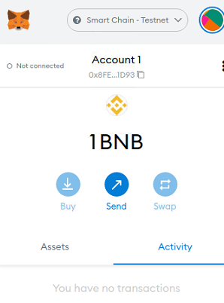

* **Set the option for compile and deploy in Remix**

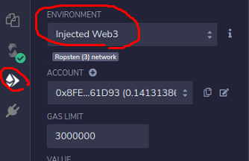

* **Compile**
* Confirm the parameters of BestToken contract

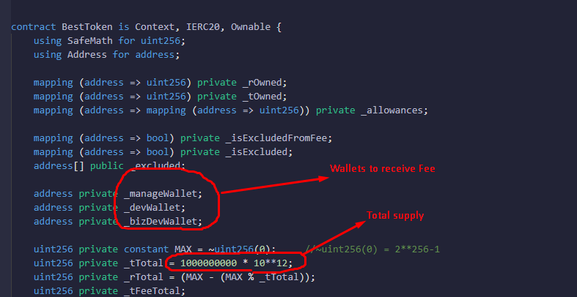

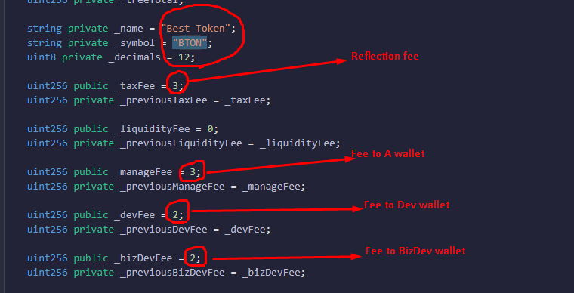

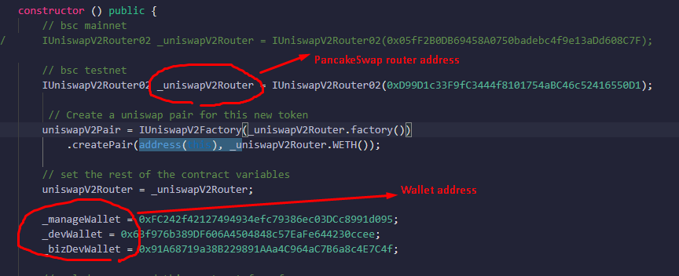

* Compile the contract

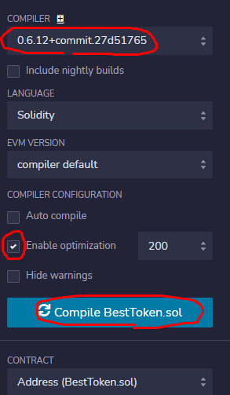

* **Deploy**

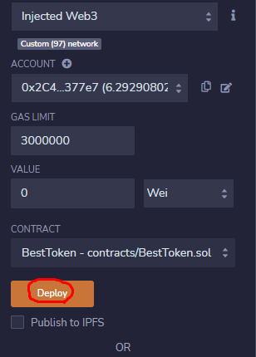

After finished the deploying, copy the address of deployed contract.

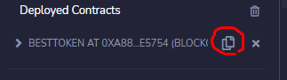

Address : 0xA88ad1817e01bE44C920F05De5C228991fCe5754

1. **Verify the contracts in the testnet (**https://testnet.bscscan.com/**)**

* Call the bscscan testnet.

https://testnet.bscscan.com/

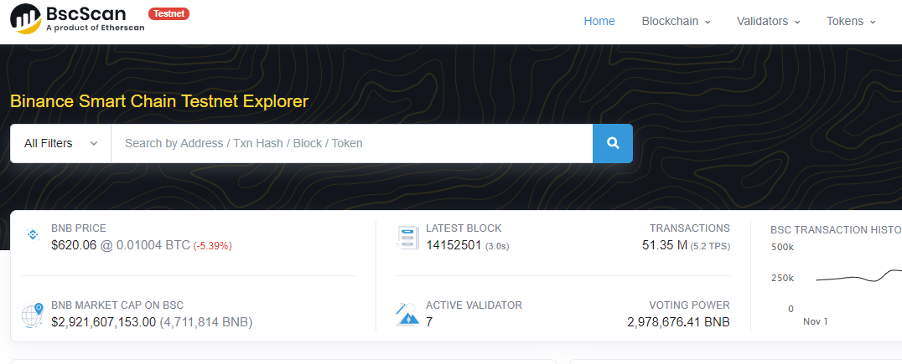

* Copy the address of deployed contract and search.

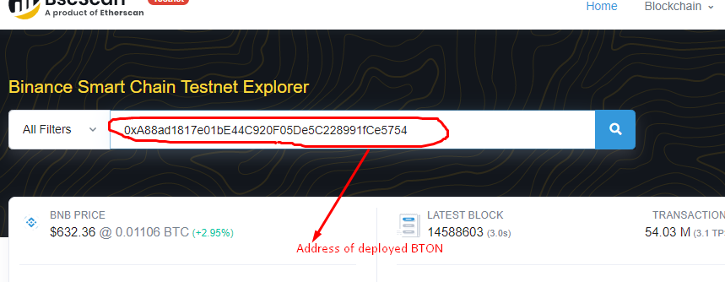

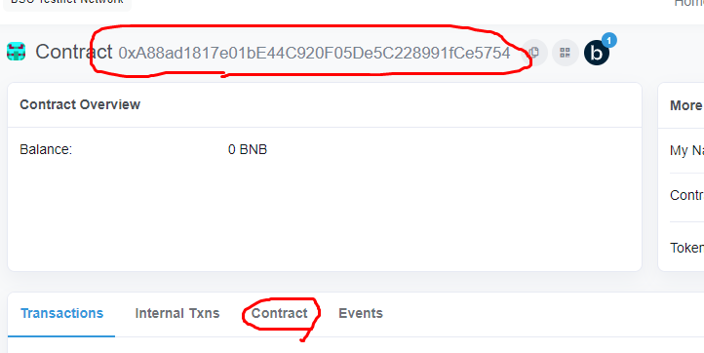

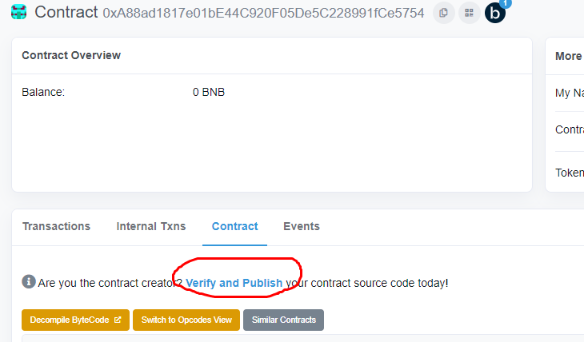

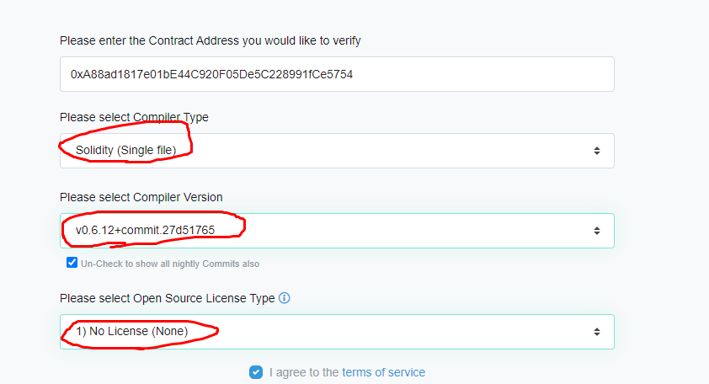

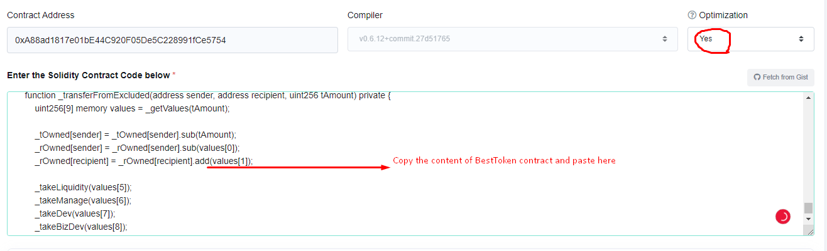

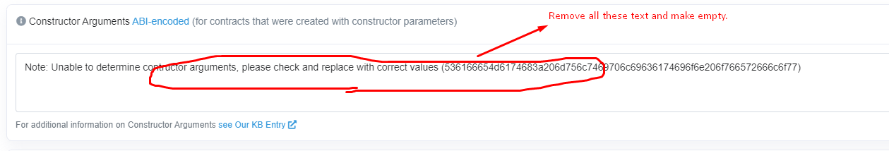

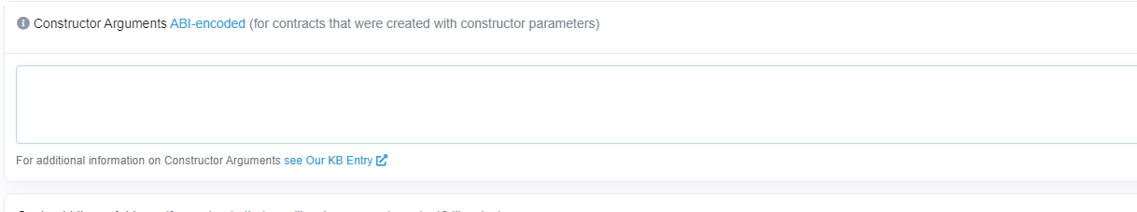

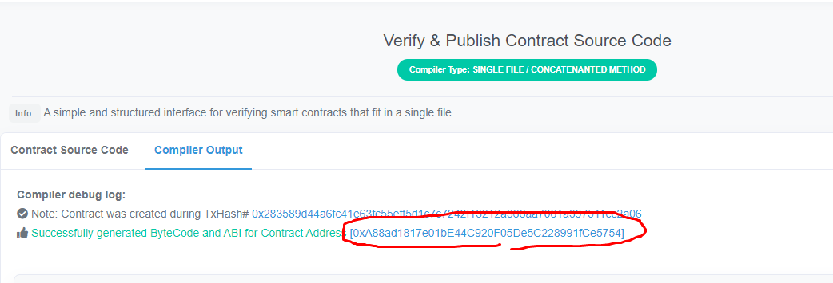

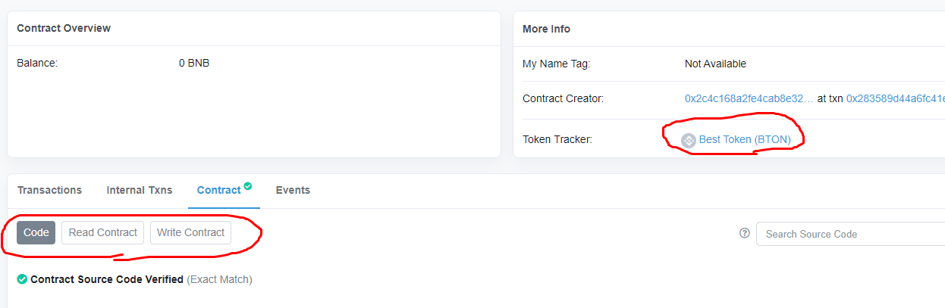

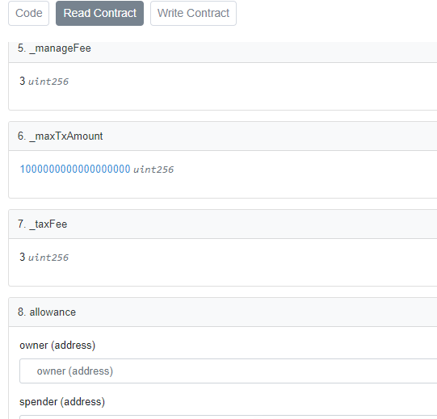

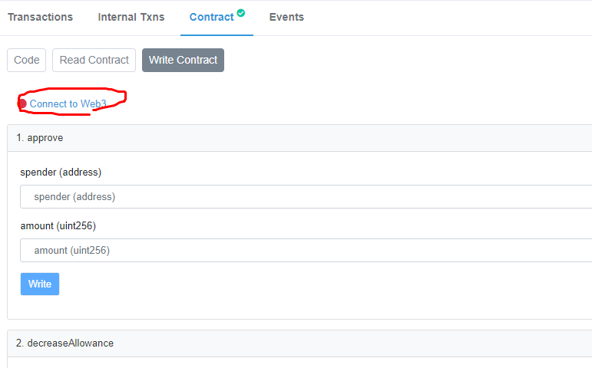

Verification finished.

1. Test

* Insert the token into Metamask

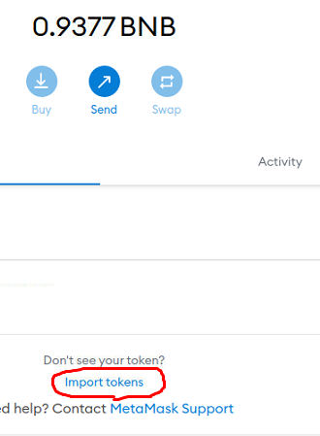

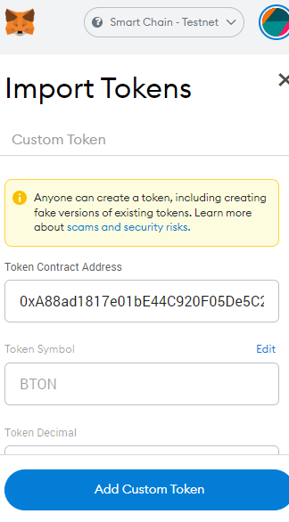

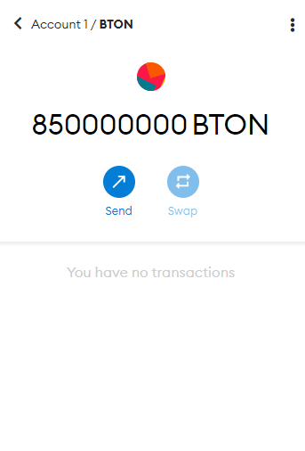

You receive 85% of total supply and other wallets (Manage, Dev, BizDev) have remains separately.

* Confirm the initial parameters of contract.
* Get the address of PancakeSwap Pair and exclude this address from reflection.

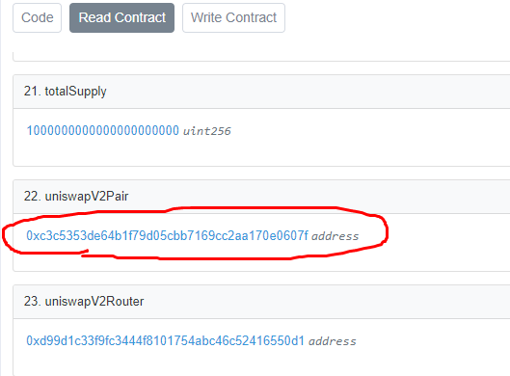

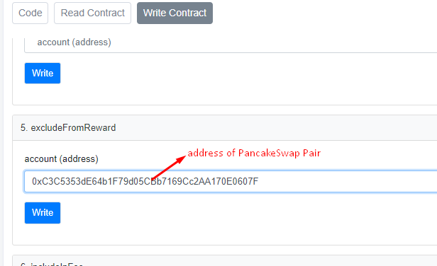

* Test Transfer

*(For every transaction explained bellow, you have to check transaction log in testnet.bscscan.com)*

1. Test of P2P transfer

* Transfer BTON from msg.sender to another wallet (Normal Transfer)

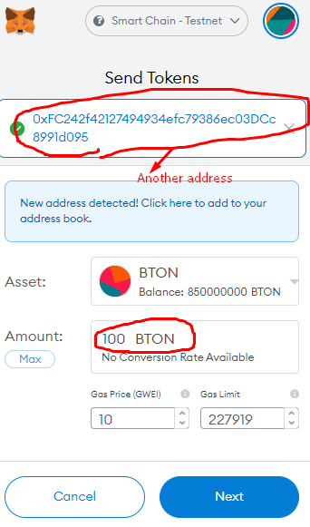

Check the transaction log in testnet.bscscan.com

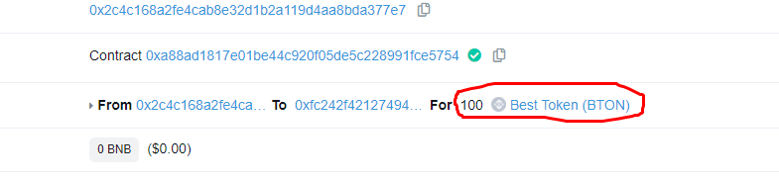

1. Test of Sell Transfer

* Include your address into list of fee wallet.

By default, your address is excluded from fee transfer, so in order to check sell/buy transfer fee, we have to include your address into fee wallets

* 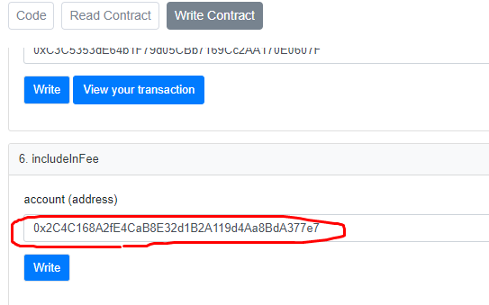

1. Transfer BTON from msg.sender to PancakeSwapPair (Sell transaction)

* Get the address of PancakeSwapPair

We have already get the address of PancakeSwap Pair at the above stage.

* Send BTON token to PancakeSwapPair in the metamask.

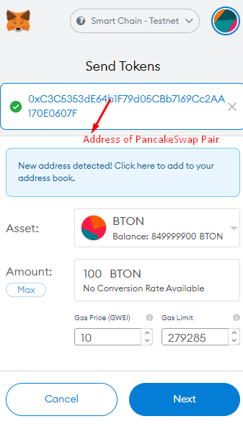

1. Check the transaction logs.

