1. **Compile and deploy contracts in Remix IDE**

* Compile Version: **0.8.7**
* Enable Optimization: **true / 200**
* Metamask **:**Ropsten testnet
* **Connect Metamask and select Ropsten testnet.**

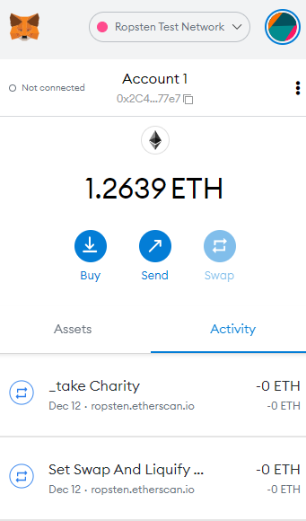

* **Set the option for compile and deploy in Remix**
* **Compile**
* Compile the contract

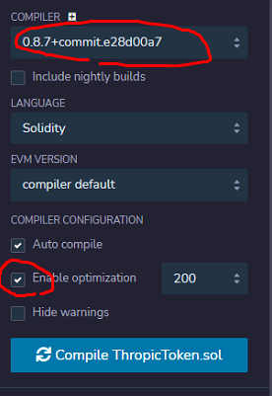

* **Deploy**

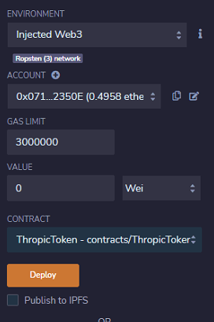

After finished the deploying, copy the address of deployed contract.

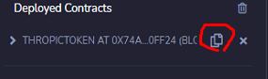

Address : 0x2d15918ef12d837A8e16E6F0097e435D2e79Cd2B

1. **Verify the contracts in the testnet (**https://ropsten.etherscan.io/)

* Call the ropsten testnet.

<https://ropsten.etherscan.io/>

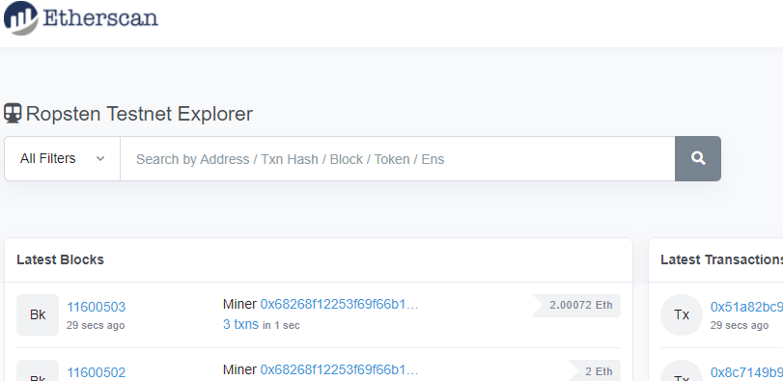

* Copy the address of deployed contract and search.

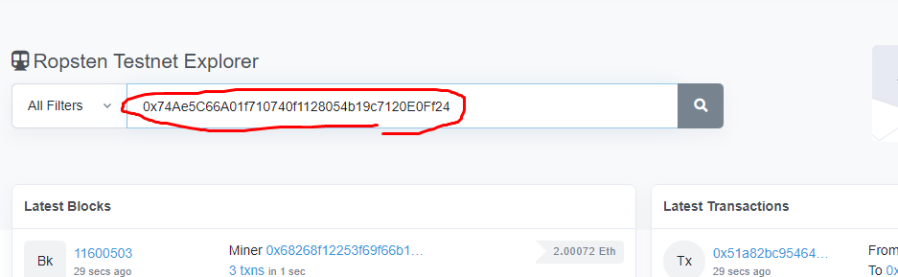

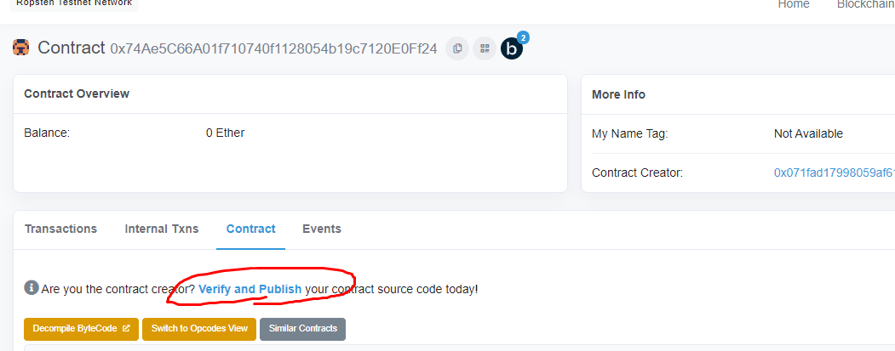

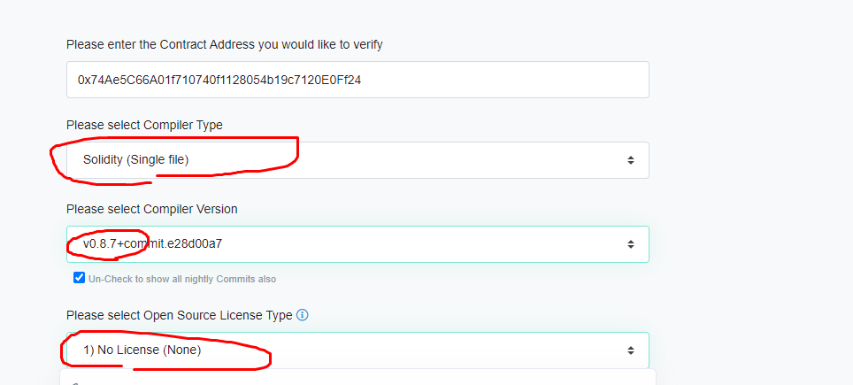

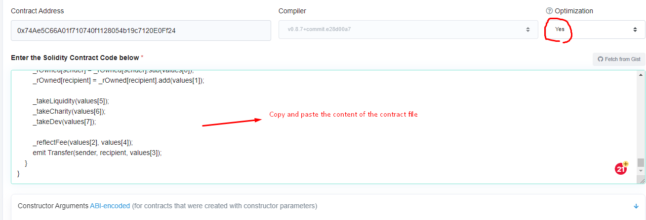

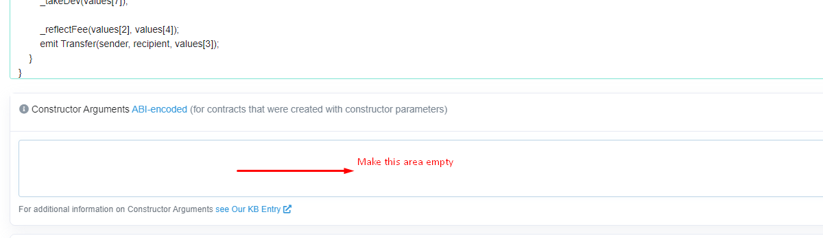

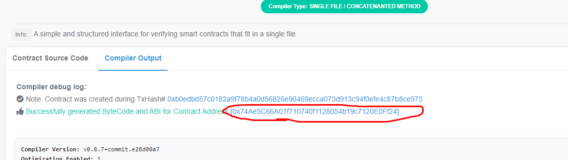

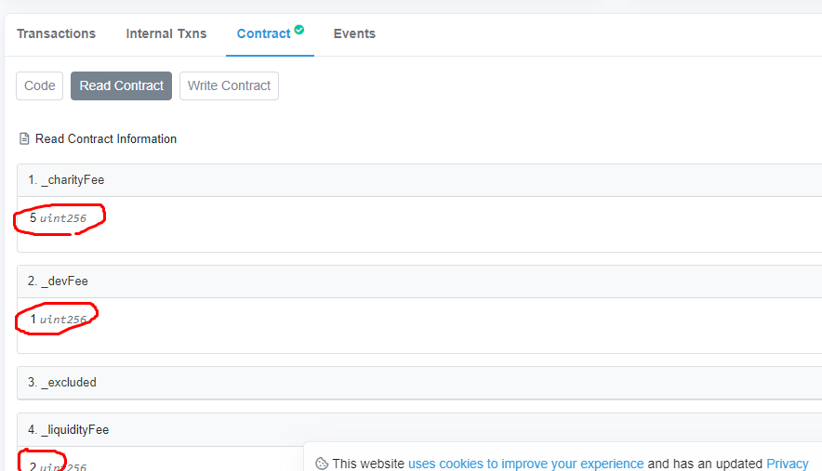

Verification finished.

1. Test

* Insert the token into Metamask

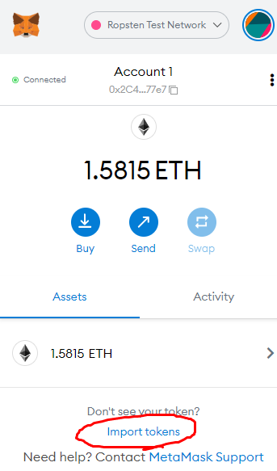

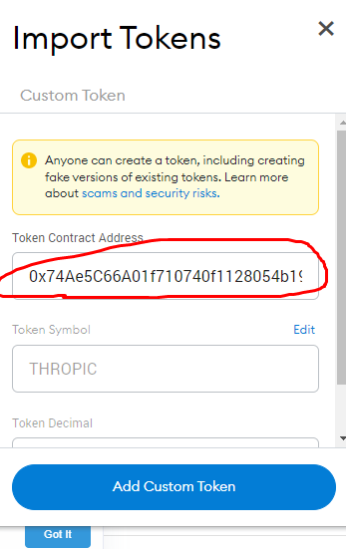

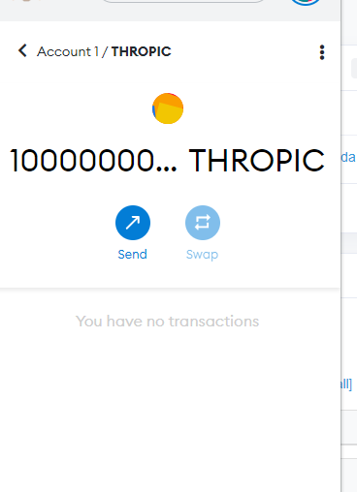

* Test Transfer

*(For every transaction explained bellow, you have to check transaction log in testnet.bscscan.com)*

1. Approve UniswapSwap Router for msg.sender at THROPIC token

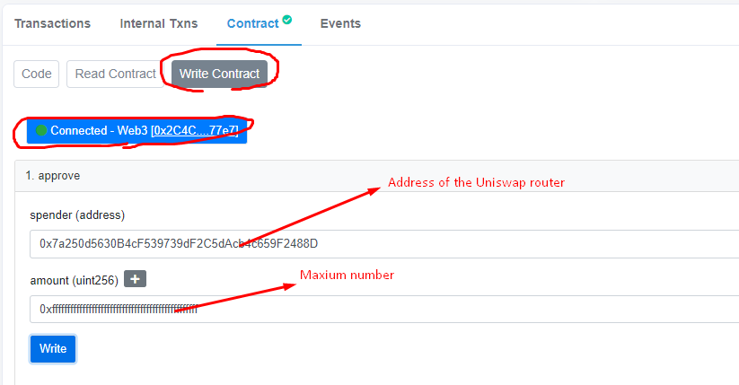

1. Approve UniswapSwap Router for msg.sender at WETH token

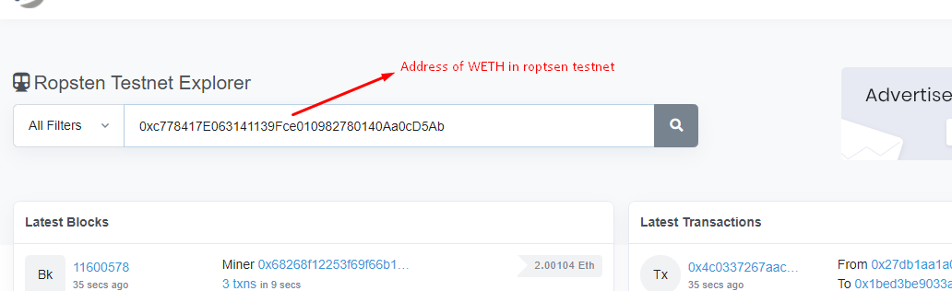

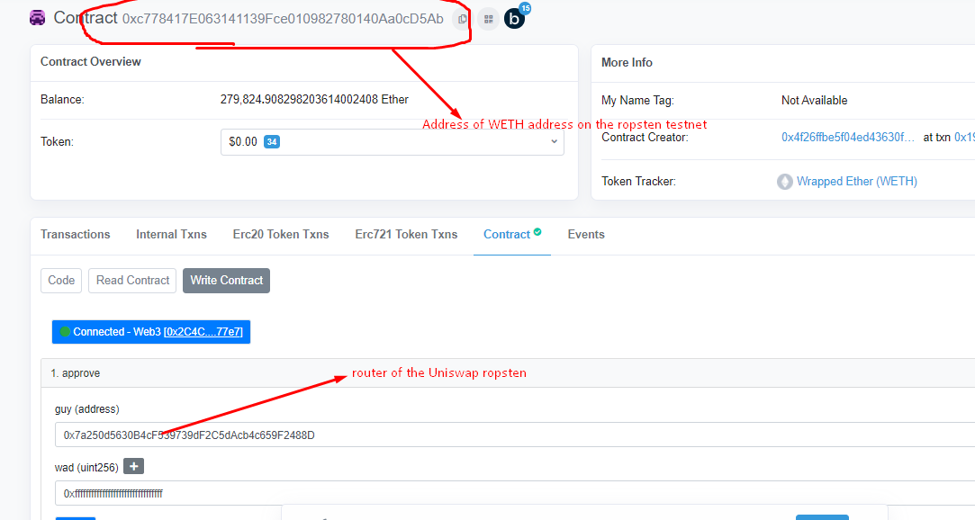

1. Add liquidity THROPIC/WETH to UniswapSwap Router.

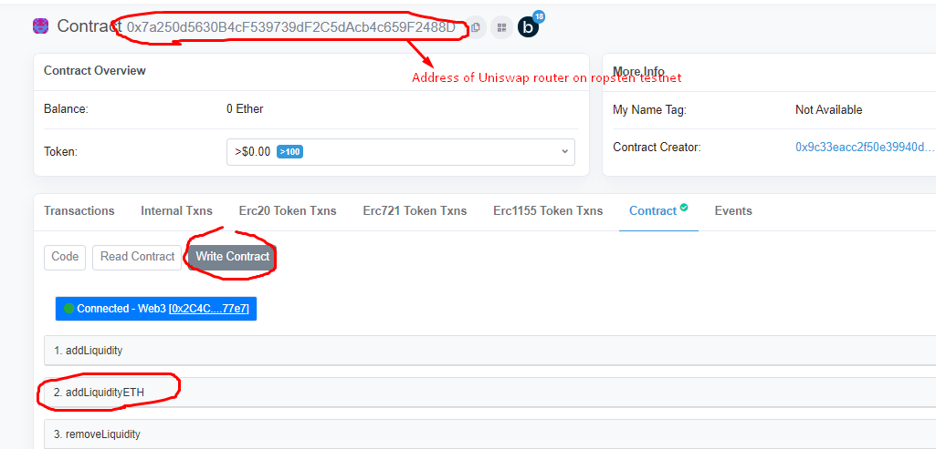

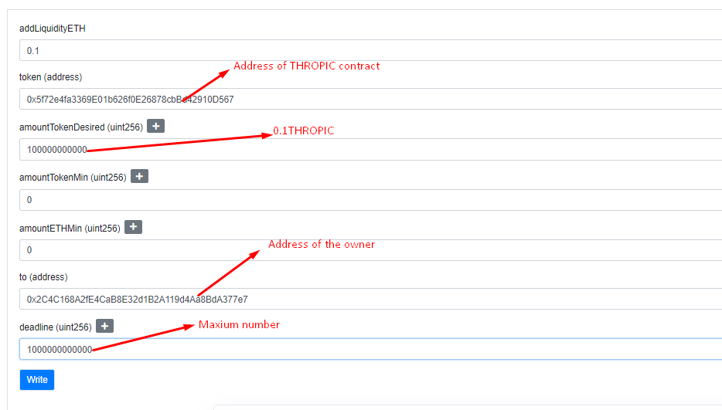

1. Transfer THROPIC from msg.sender to another wallet (Normal Transfer)

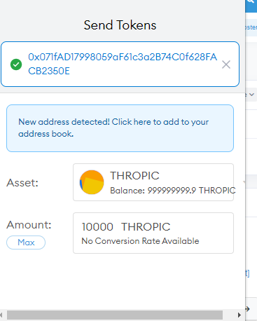

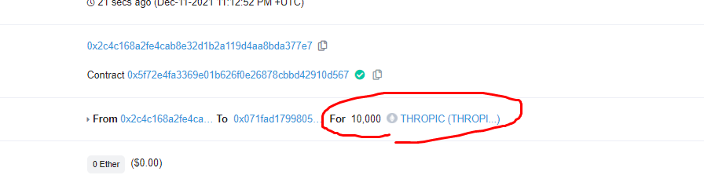

1. Call includeInFee(account) for the msg.sender and repeat 4th stage

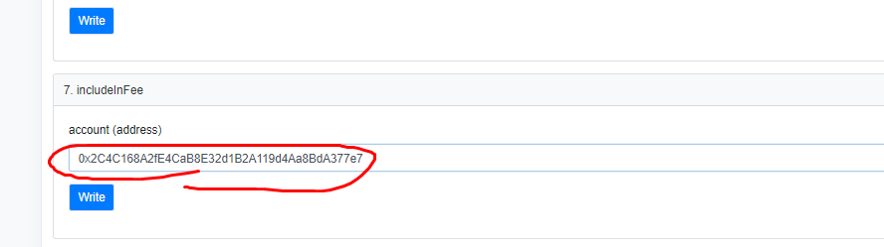

1. Transfer THROPIC from msg.sender to UniswapSwapPair (Sell transaction)

* Get the address of UniSwapPair

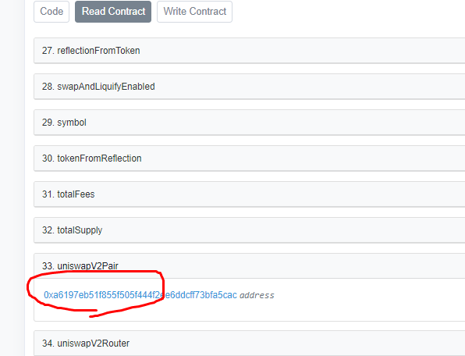

* Send THROPIC token to UniswapSwapPair in the metamask.

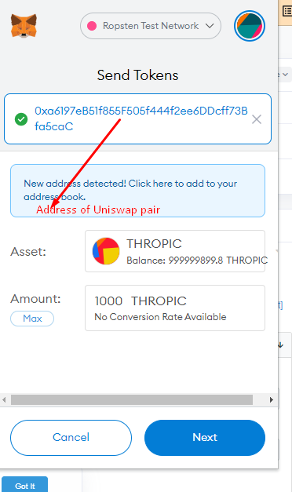

1. Example of the transaction logs are as bellow.

